­­

Course code 206

Course Name   
Software engineering Theory

Phase 2: Software Design Document  
TEAM Name:  
Sci-Sickurity

Github Account:  
<https://github.com/sci-Sickurity>  
Project Link :   
https://github.com/sci-Sickurity/SW_FitnessProject

26/December/2020  
  
  
Contents

Team .............................................................................................................................................................. 3

Document Purpose and Audience ................................................................................................................. 3

System Models ............................................................................................................................................... 4

System Decomposition ..................................................................................... Error! Bookmark not defined.

Class diagrams ................................................................................................................................................ 4

Sequence diagrams ......................................................................................................................................... 6

Class - Sequence Usage Table ..................................................................................................................... 13

Physical Entity-Relationship Diagram ......................................................................................................... 14

User Interface Design ............................................................................................................................ 15

Data flow diagram…………………. ............................................................................................................. 21

Algorithms and Data Structures ............................................................................................................ 22

Ownership Report ............................................................................................................................................ 26

Policy Regarding Plagiarism: ............................................................................................................................. 26

References ........................................................................................................... Error! Bookmark not defined.

Authors ................................................................................................................ Error! Bookmark not defined.

# Team

|  |  |  |  |
| --- | --- | --- | --- |
| ID | Name | Email | Mobile |
| 203130 | Mahmoud Hussienn Mahmoud | [Sim.mahmoudhussein3130@alexu.edu.eg](mailto:Sim.mahmoudhussein3130@alexu.edu.eg) | 01092879689 |
| 203133 | Mahmoud Mohamed   El-sayed | [Sim.mahmoudmohamed3133@alexu.edu.eg](mailto:Sim.mahmoudmohamed3133@alexu.edu.eg) | 01203359068 |
| 203081 | Omar Anan |  | 01211690901 |

# Document Purpose and Audience

* This provided document shows how the software designing model is being processed   
  To Automate Gym & Fitness admission Process.
* Targeted audience : fitness club owner , online stores owners , project managers , CEO’s of company

# System Models

## I. Class diagrams

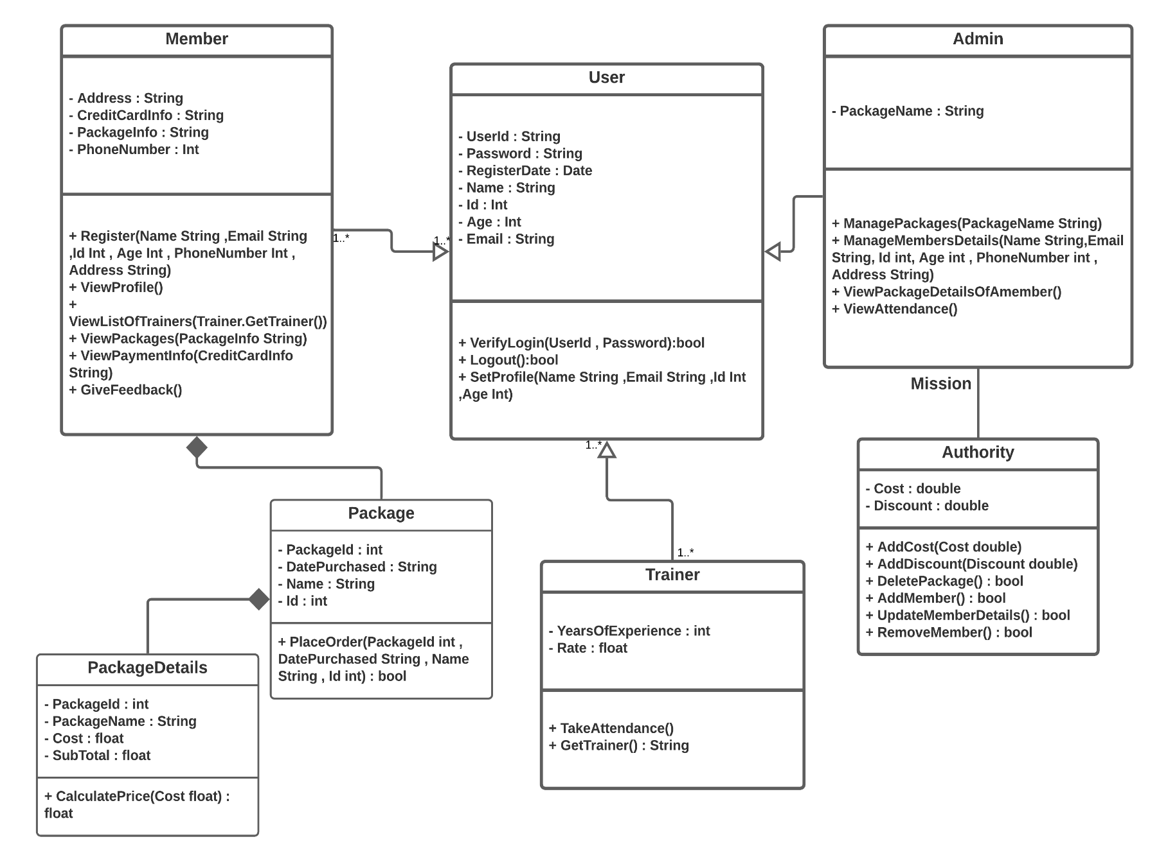

|  |  |  |  |
| --- | --- | --- | --- |
| Class ID | Class Name | Subsystem ID | Description & Responsibility |
| 1 | User | None | Set up profile and take the data of the users |
| 2 | Admin | 3 | Manage the whole system |
| 3 | Authority | None | Let the admin add and remove packages |
| 4 | Trainer | None | Take attendance and years of exp. |
| 5 | Member | 6,7 | View List of trainers and Enroll in Specific Package |
| 6 | Package | 7 | Placing order and save purchasing date |
| 7 | PackageDetails | None | Calculate the price of the package |

## I. Sequence diagrams

## 

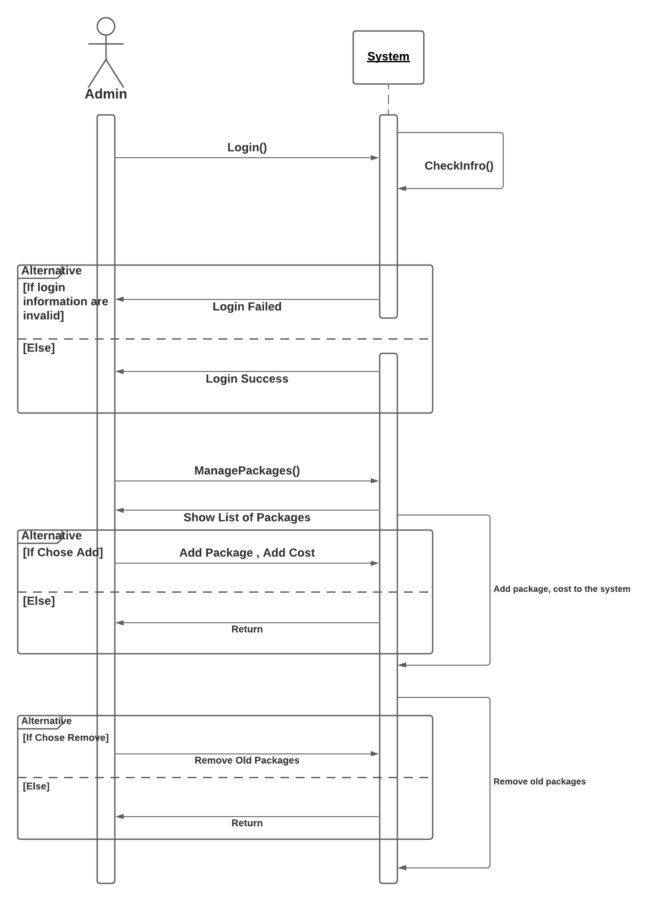

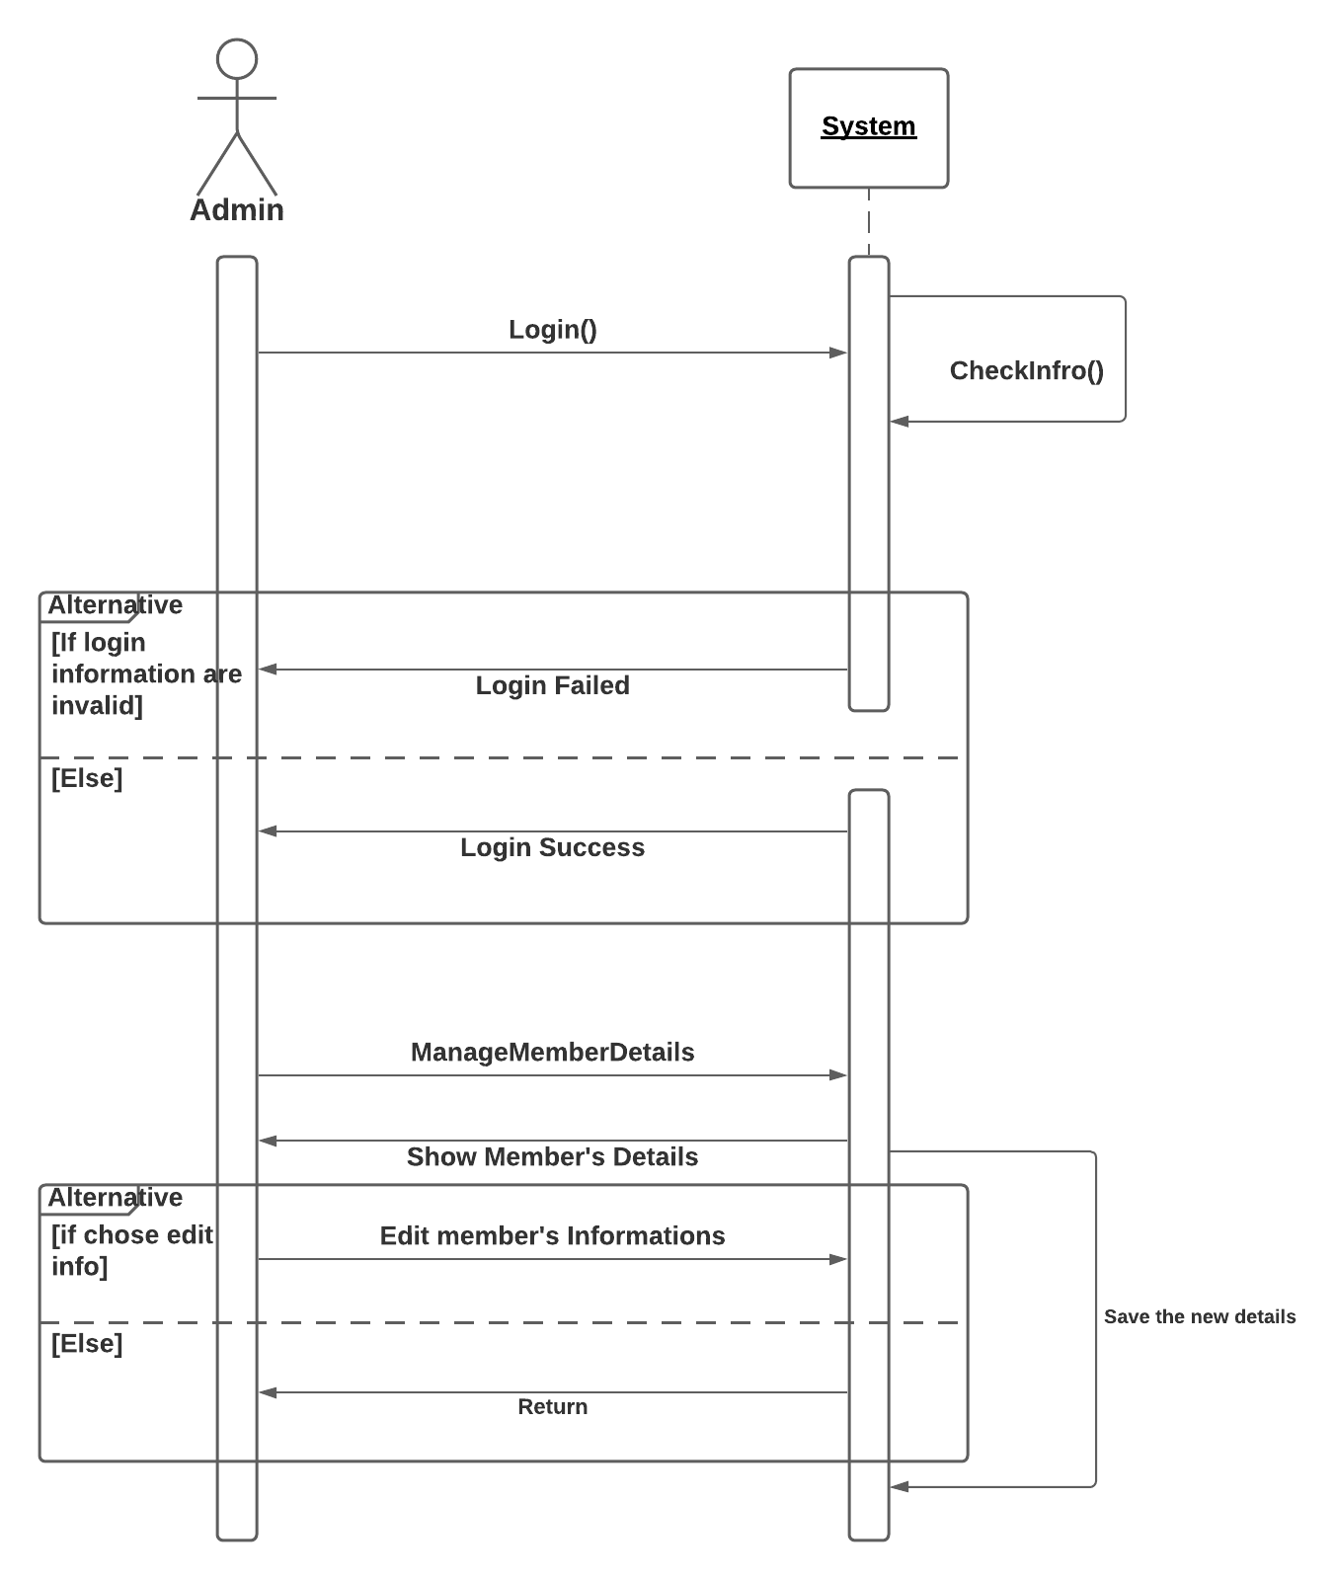

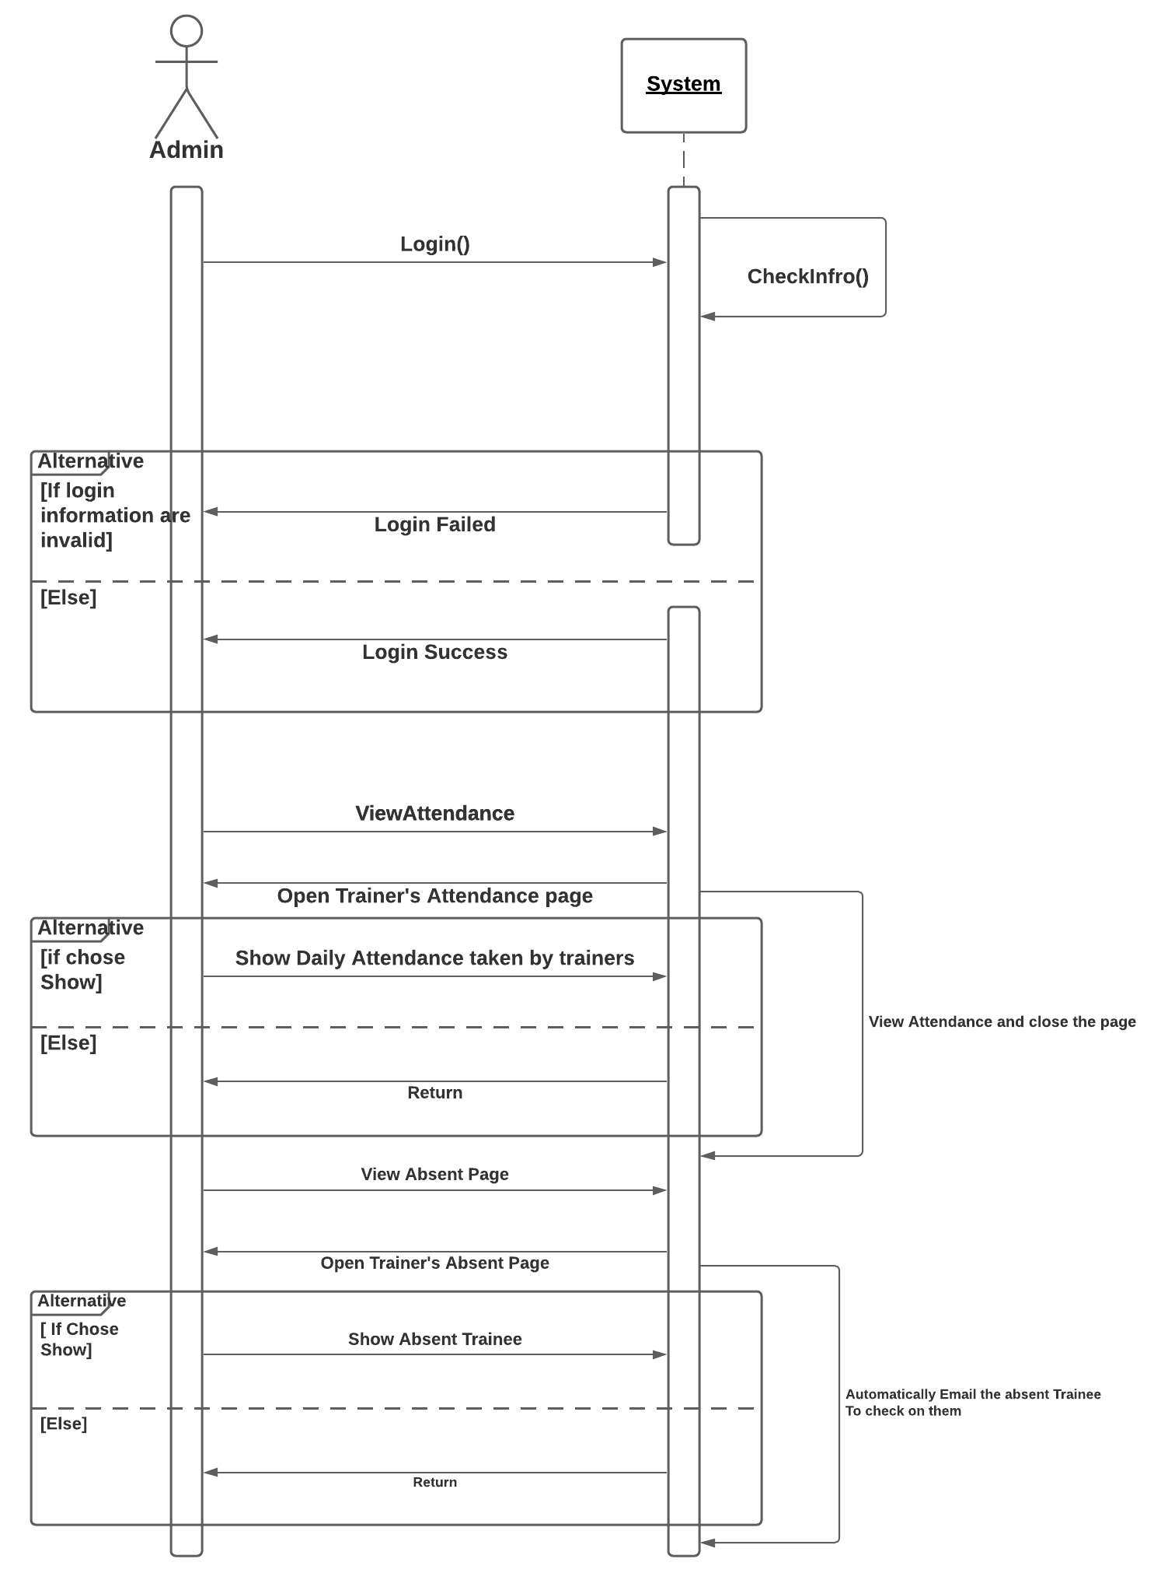

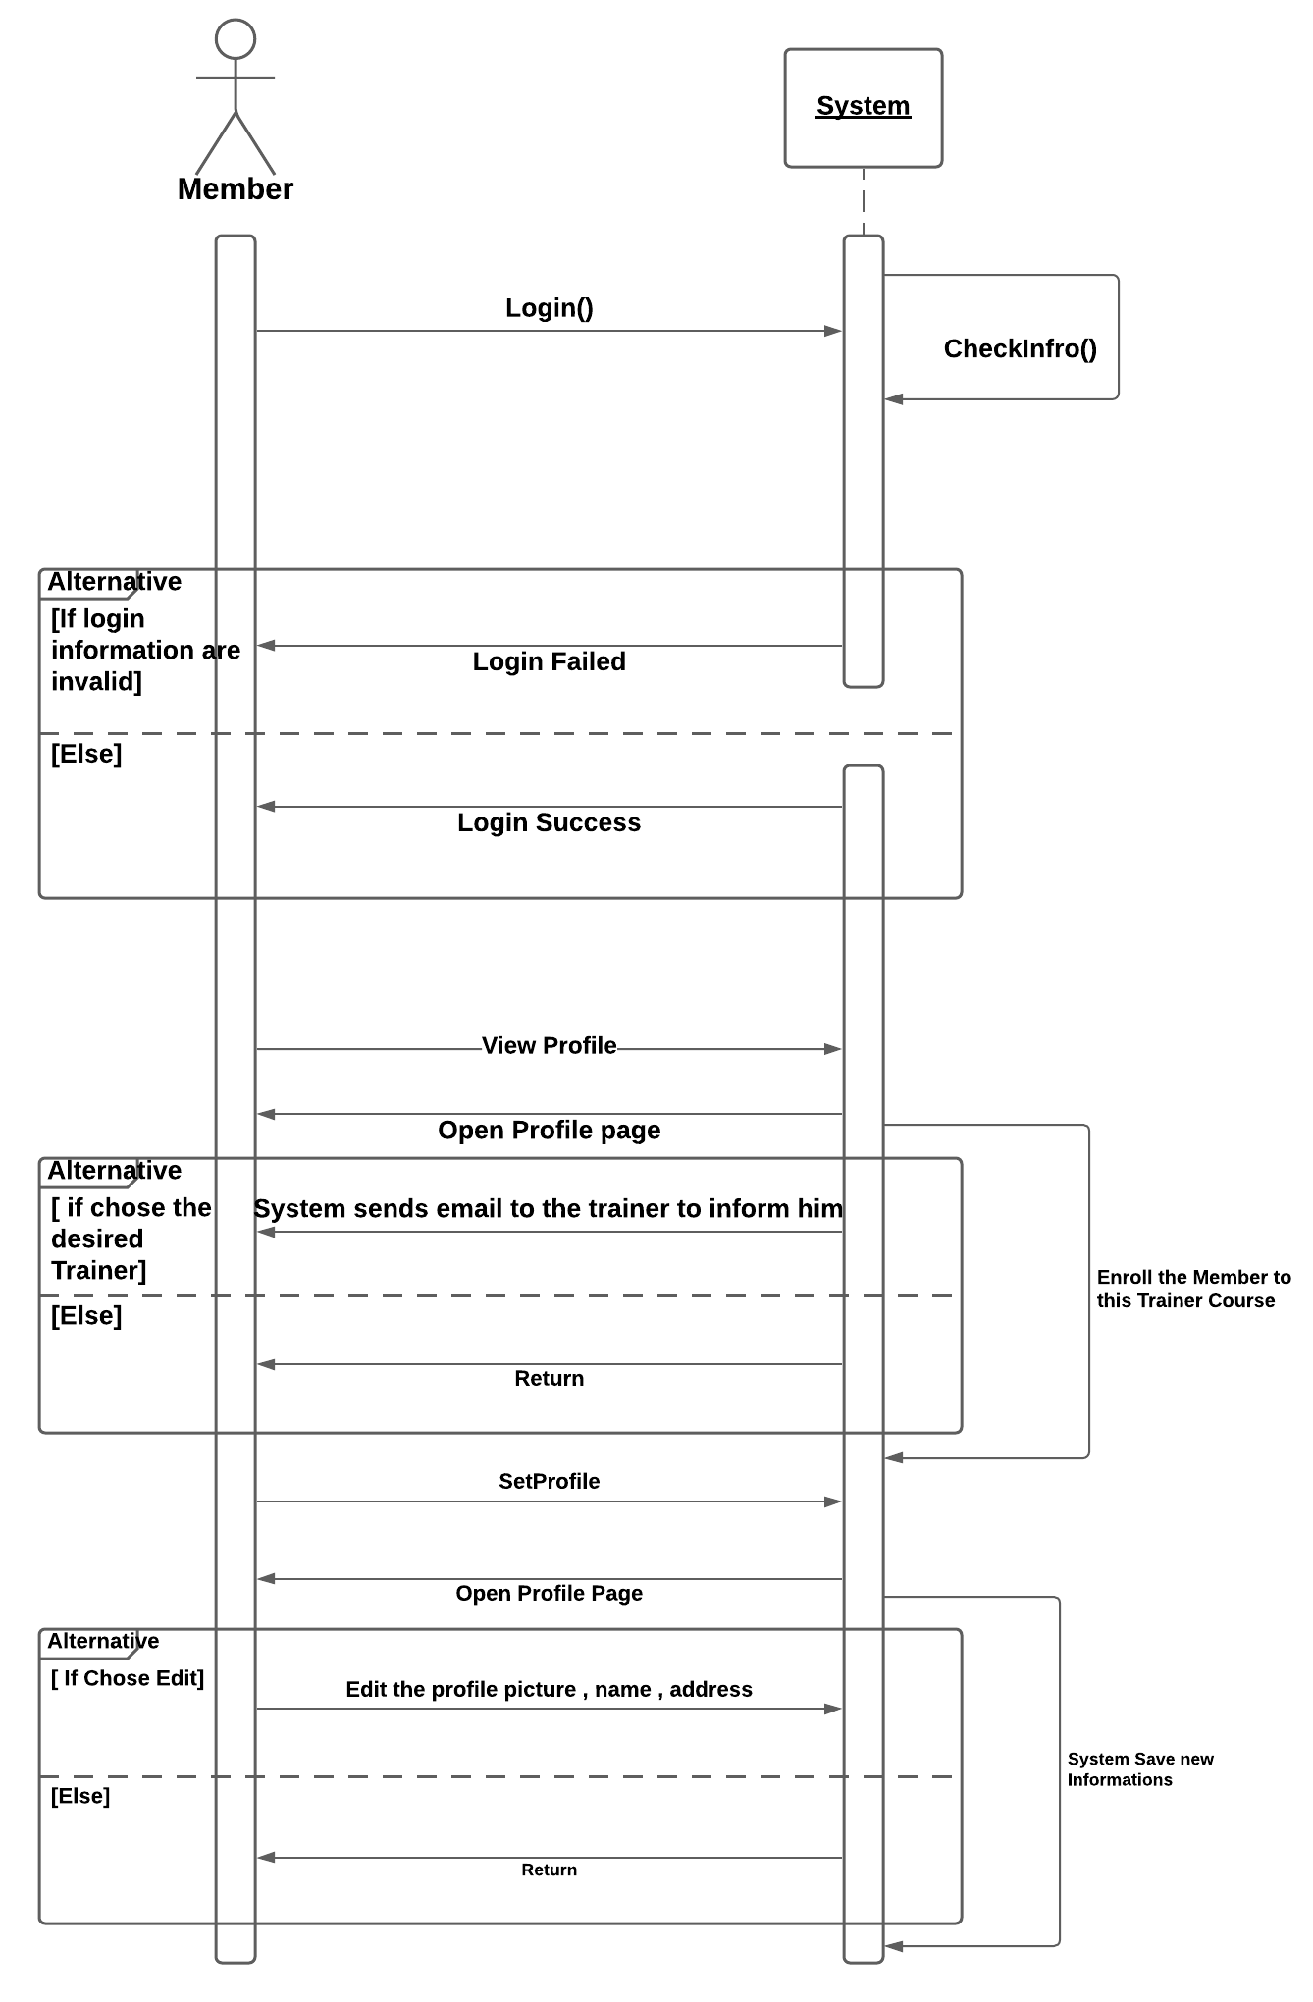

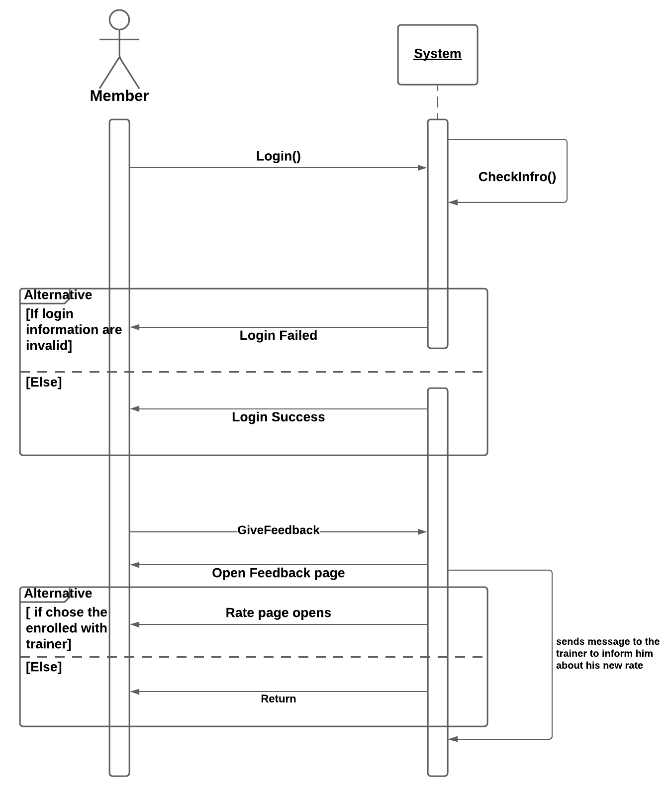

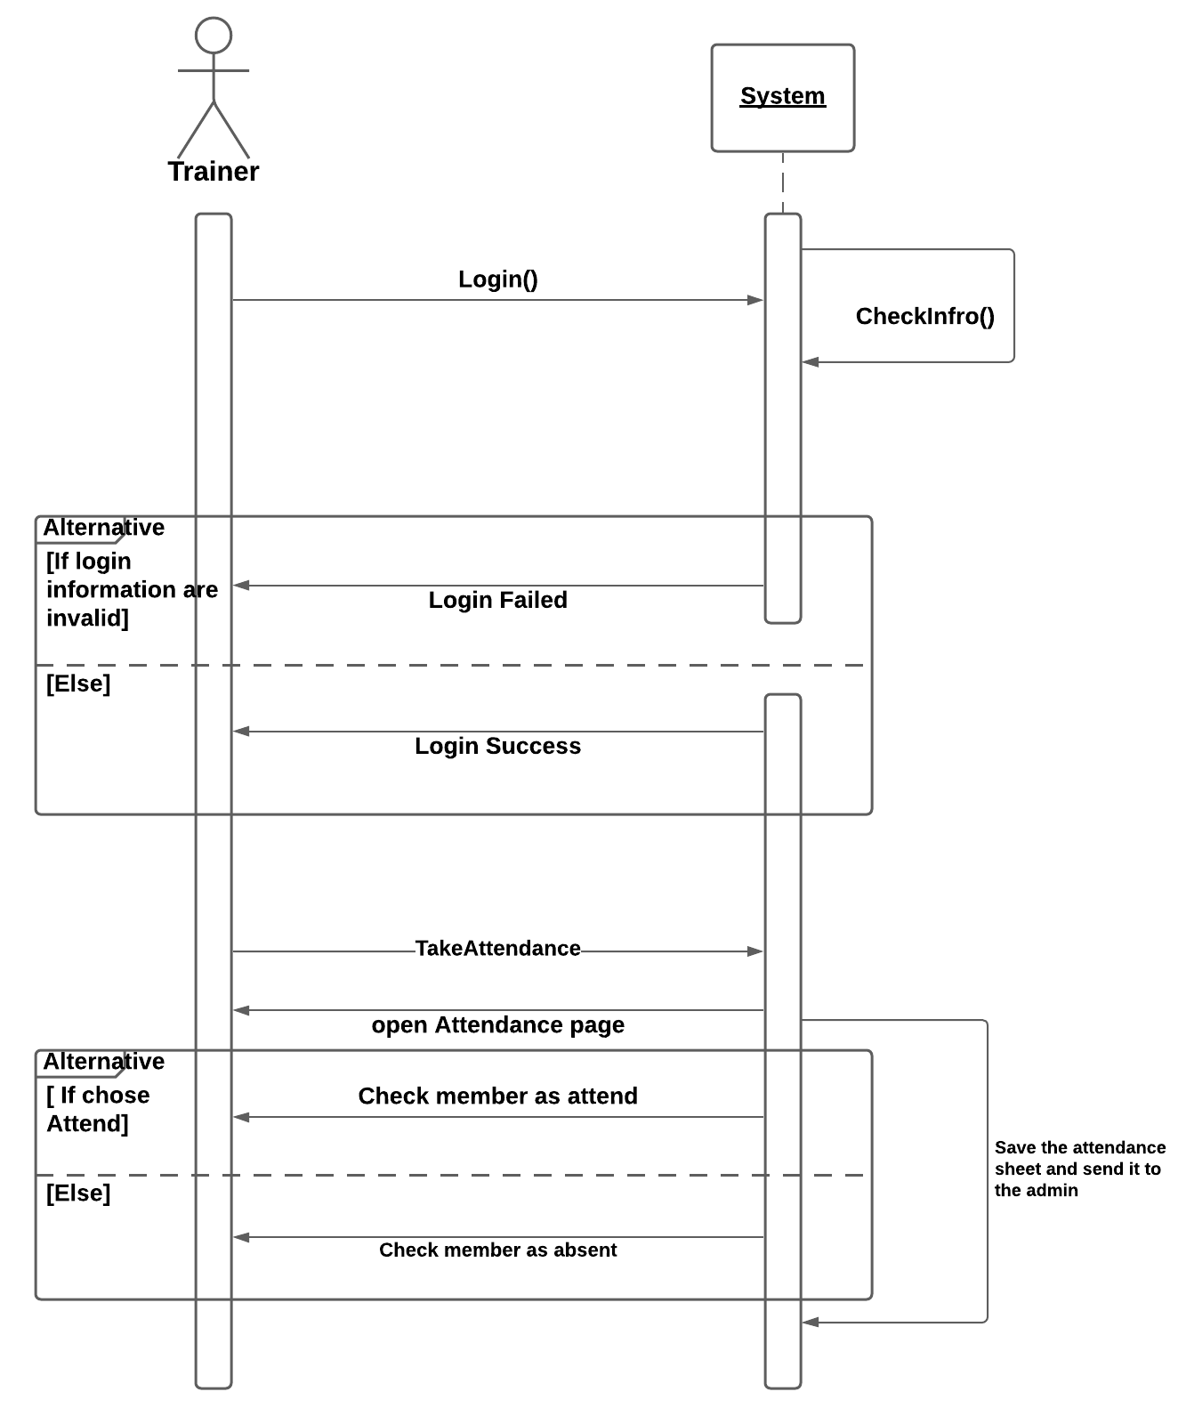

### Class - Sequence Usage Table

|  |  |  |
| --- | --- | --- |
| Class Name | Sequence Diagram | Overall used Methods |
| User | 1 | VerifyLogin() |
| Admin | 2 | VerifyLogin() , ManagePackage() |
| Admin | 3 | VerifyLogin() , ManageMemberDetails() |
| Admin | 4 | VerifyLogin() , ViewAttendance() |
| Member | 5 | VerifyLogin() , ViewProfile() , SetProfile() |
| Member | 6 | VerifyLogin() , GiveFeedback() |
| Trainer | 7 | VerifyLogin() , TakeAttendance() |

## III. Physical Entity-Relationship Diagram

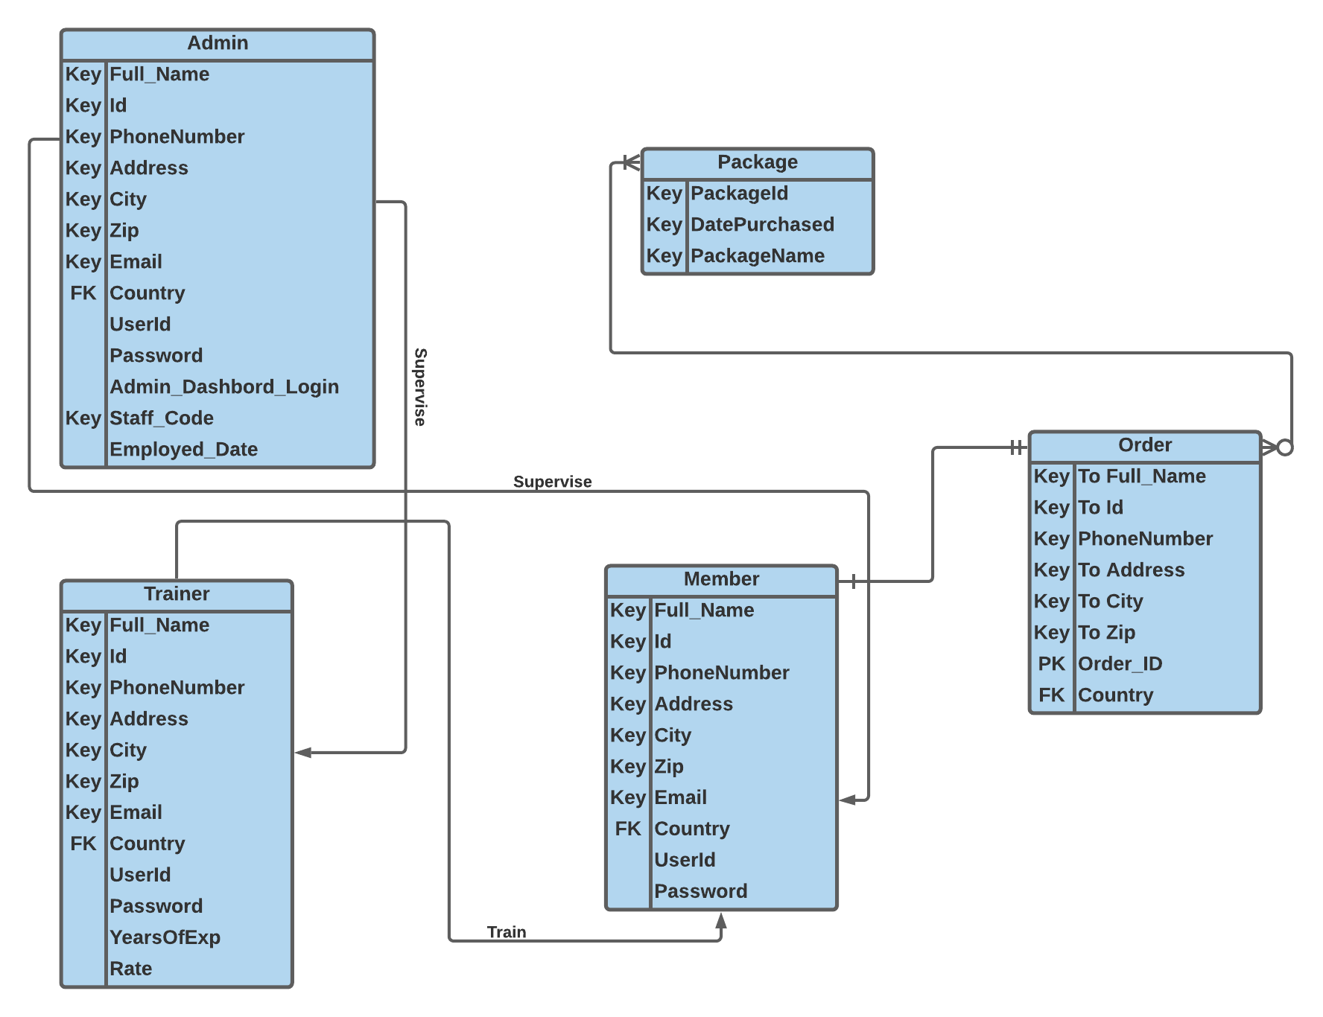

## IV. User Interface Design

## V. Dataflow diagram (DFD)

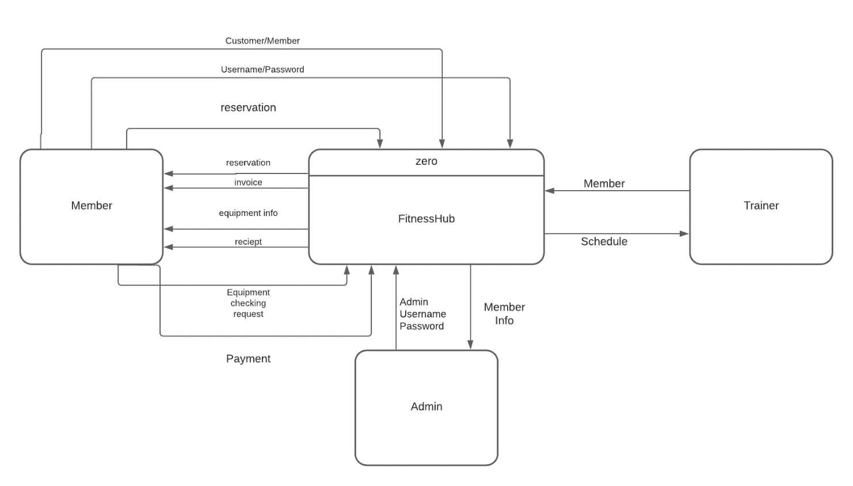

## VI. Algorithms and Data Structures

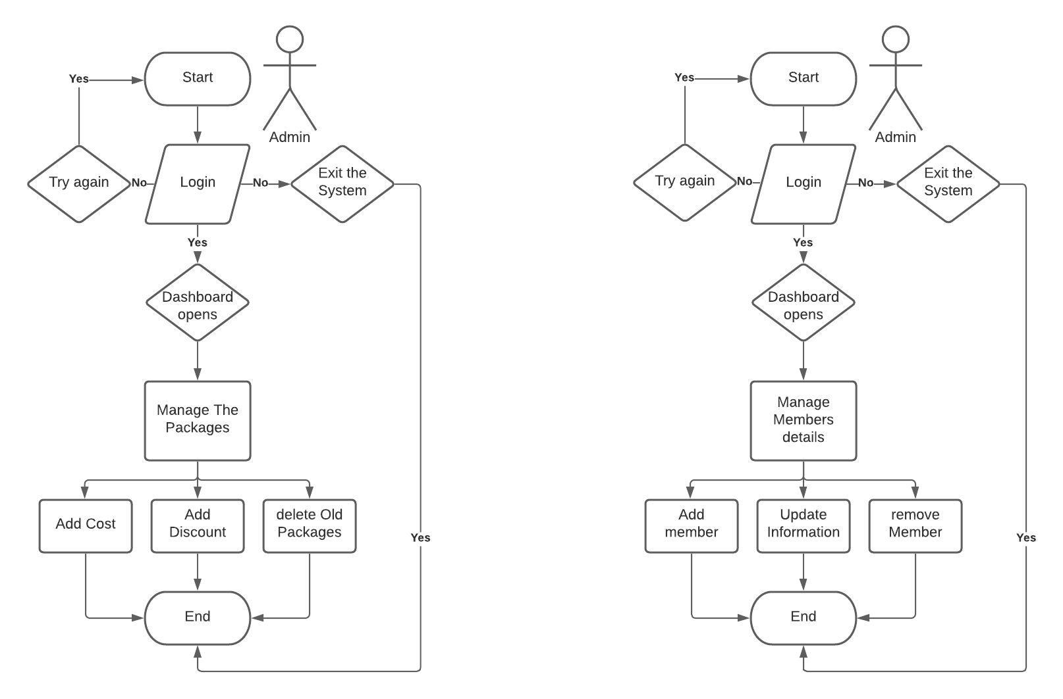

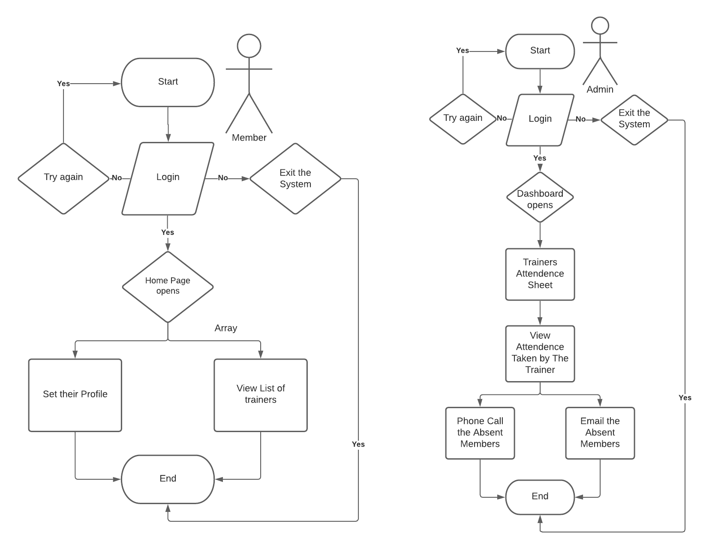

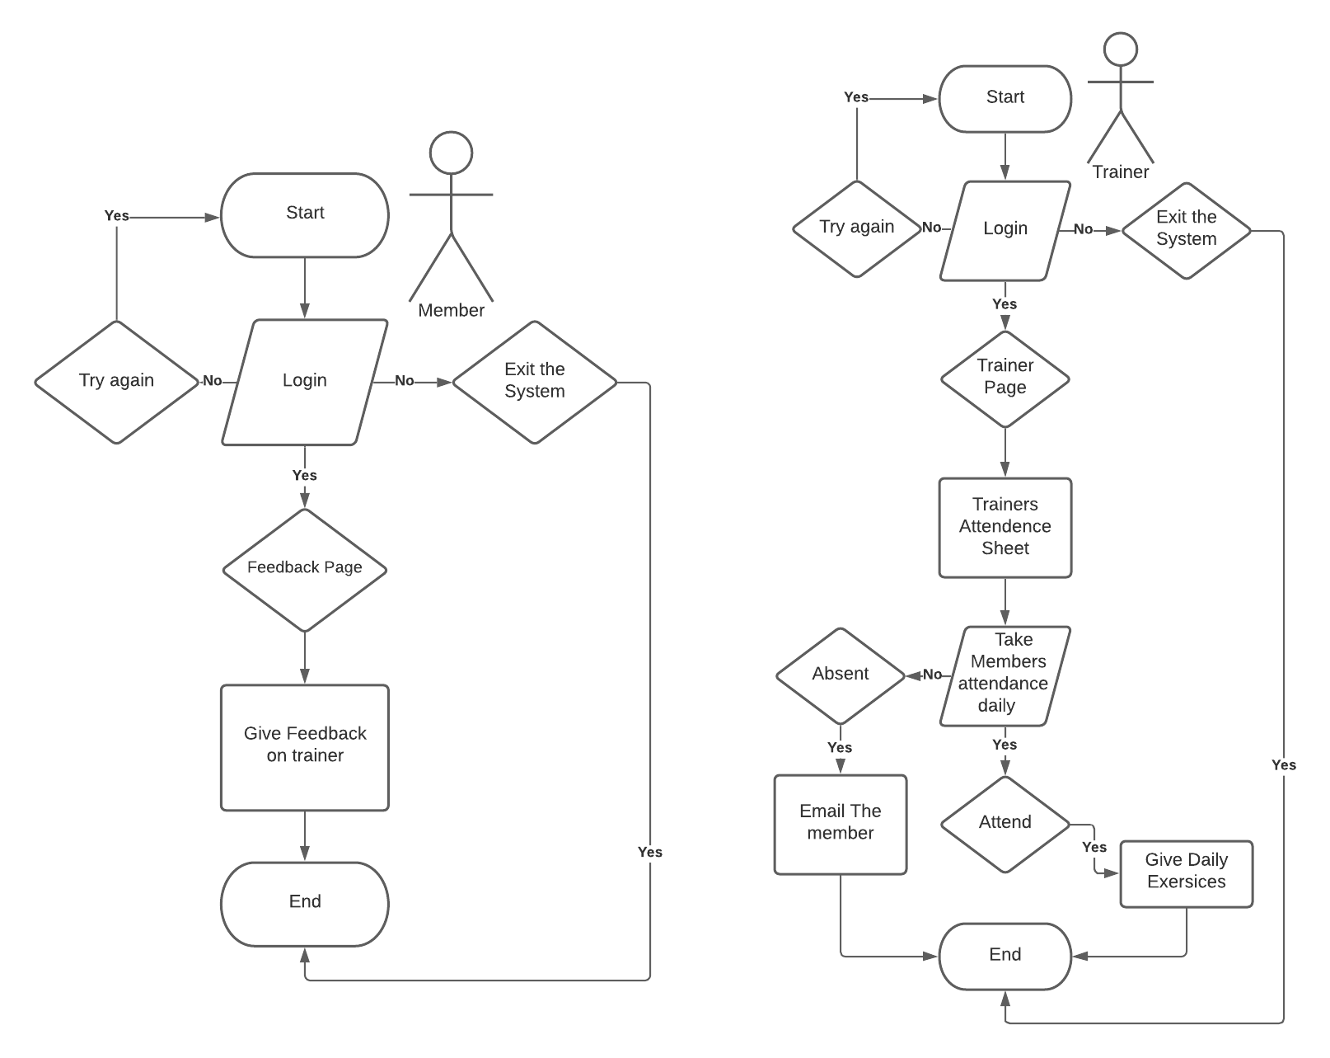

Non-Sure about this system Flowchart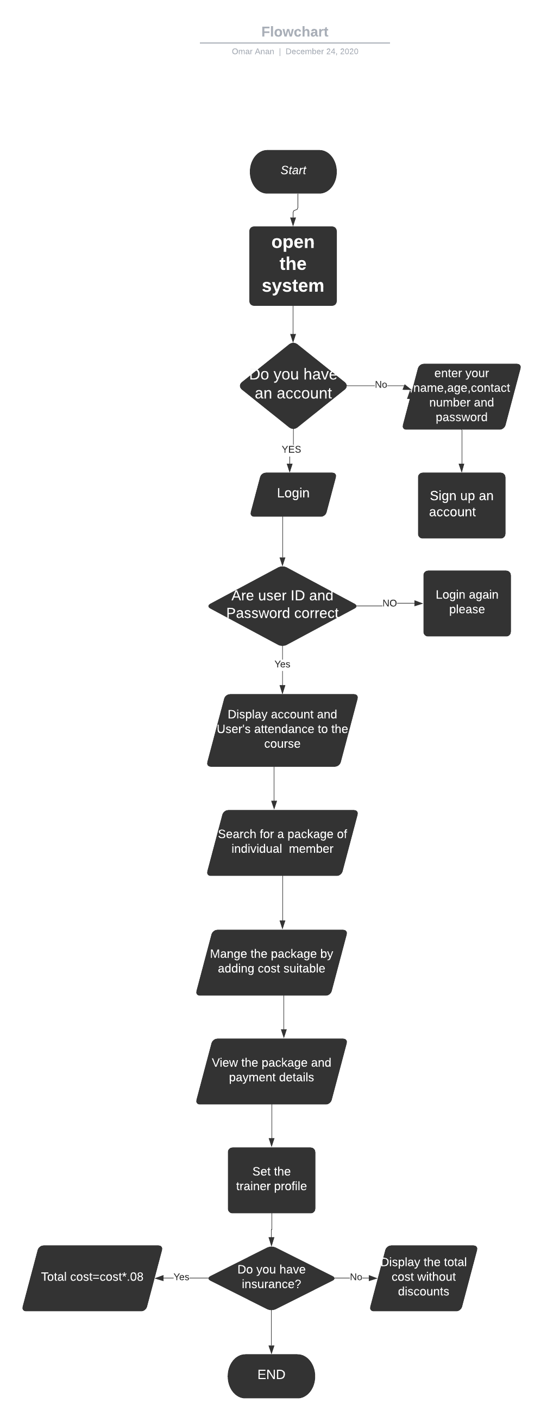

# Ownership Report

|  |  |
| --- | --- |
| Item | Owners |
| None |  |
| None |  |

# Policy Regarding Plagiarism:

Students have collective ownership and responsibility of their project. Any violation of academic honesty will have severe consequences and punishment for ALL team members.

* We Agree.