­­

Course code 206

Course Name Software engineering Theory

Phase 2: Software Design Document Team Name : Sickurity

Dec 2020

12 /2020

Contents

Instructions [To be removed] ............................................................................................................................. 3

Team ................................................................................................................................................................... 3

Document Purpose and Audience ...................................................................................................................... 3

System Models ................................................................................................................................................... 4 I. System Decomposition ................................................................................ Error! Bookmark not defined.

1. Class diagrams ............................................................................................................................................ 4
2. Sequence diagrams .................................................................................................................................... 5

Class - Sequence Usage Table ..................................................................................................................... 7 IV. Physical Entity-Relationship Diagram ........................................................................................................ 8

1. User Interface Design ................................................................................................................................. 8
2. Algorithms and Data Structures .............................................................................................................. 10

Ownership Report ............................................................................................................................................ 10

Policy Regarding Plagiarism: ............................................................................................................................. 10

References ........................................................................................................... Error! Bookmark not defined. Authors ................................................................................................................ Error! Bookmark not defined.

# Team

|  |  |  |  |
| --- | --- | --- | --- |
| ID | Name | Email | Mobile |
| 203130 | Mahmoud Hussienn Mahmoud | [Mahmoudh.buss@gmail.com](mailto:Mahmoudh.buss@gmail.com) | 01092879689 |
| 203133 | Mahmoud Elsayed |  |  |
| 203081 | Omar Anan |  |  |

# Document Purpose and Audience

* This provided document shows how the software designing model is being processed
* Targeted audience : fitness club owner , online stores owners , project managers , CEO’s of company

# System Models

## I. Class diagrams

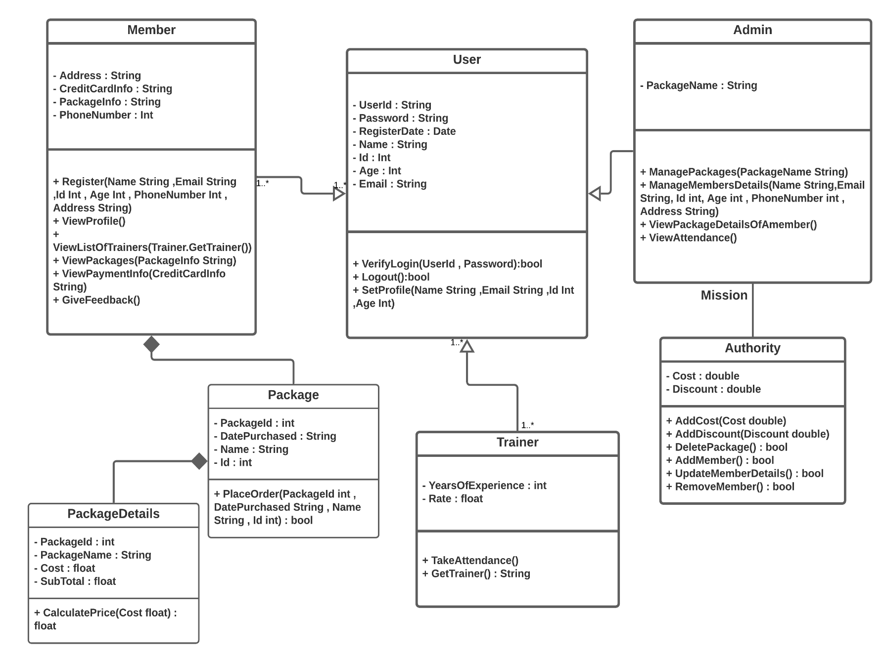

|  |  |  |  |
| --- | --- | --- | --- |
| Class ID | Class Name | Subsystem ID | Description & Responsibility |
|  |  |  |  |

* In the above table make sure that each class belongs to a subsystem.
* In the above table ALL classes should belong to subsystems. And each subsystem should at least contain one class.

## I. Sequence diagrams

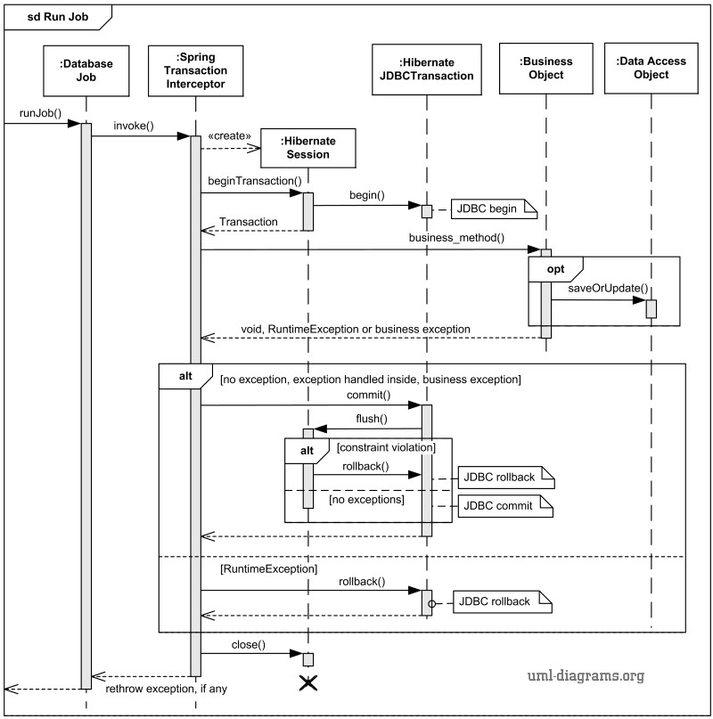

### Class - Sequence Usage Table

• In this table, we will list EVERY class in class diagram and which sequences used this class diagram. This helps in avoiding either unused classes or extra classes appears in sequence diagrams. In "Overall used methods" section, put all functions appeared in all sequences.

|  |  |  |
| --- | --- | --- |
| Class Name | Sequence Diagrams | Overall used methods |
| E.g. Employee | 1, 3, 5 (means Seq Ids 1, 3, 5 used Employee class) | Save, GetData |
|  |  |  |

## III. Physical Entity-Relationship Diagram

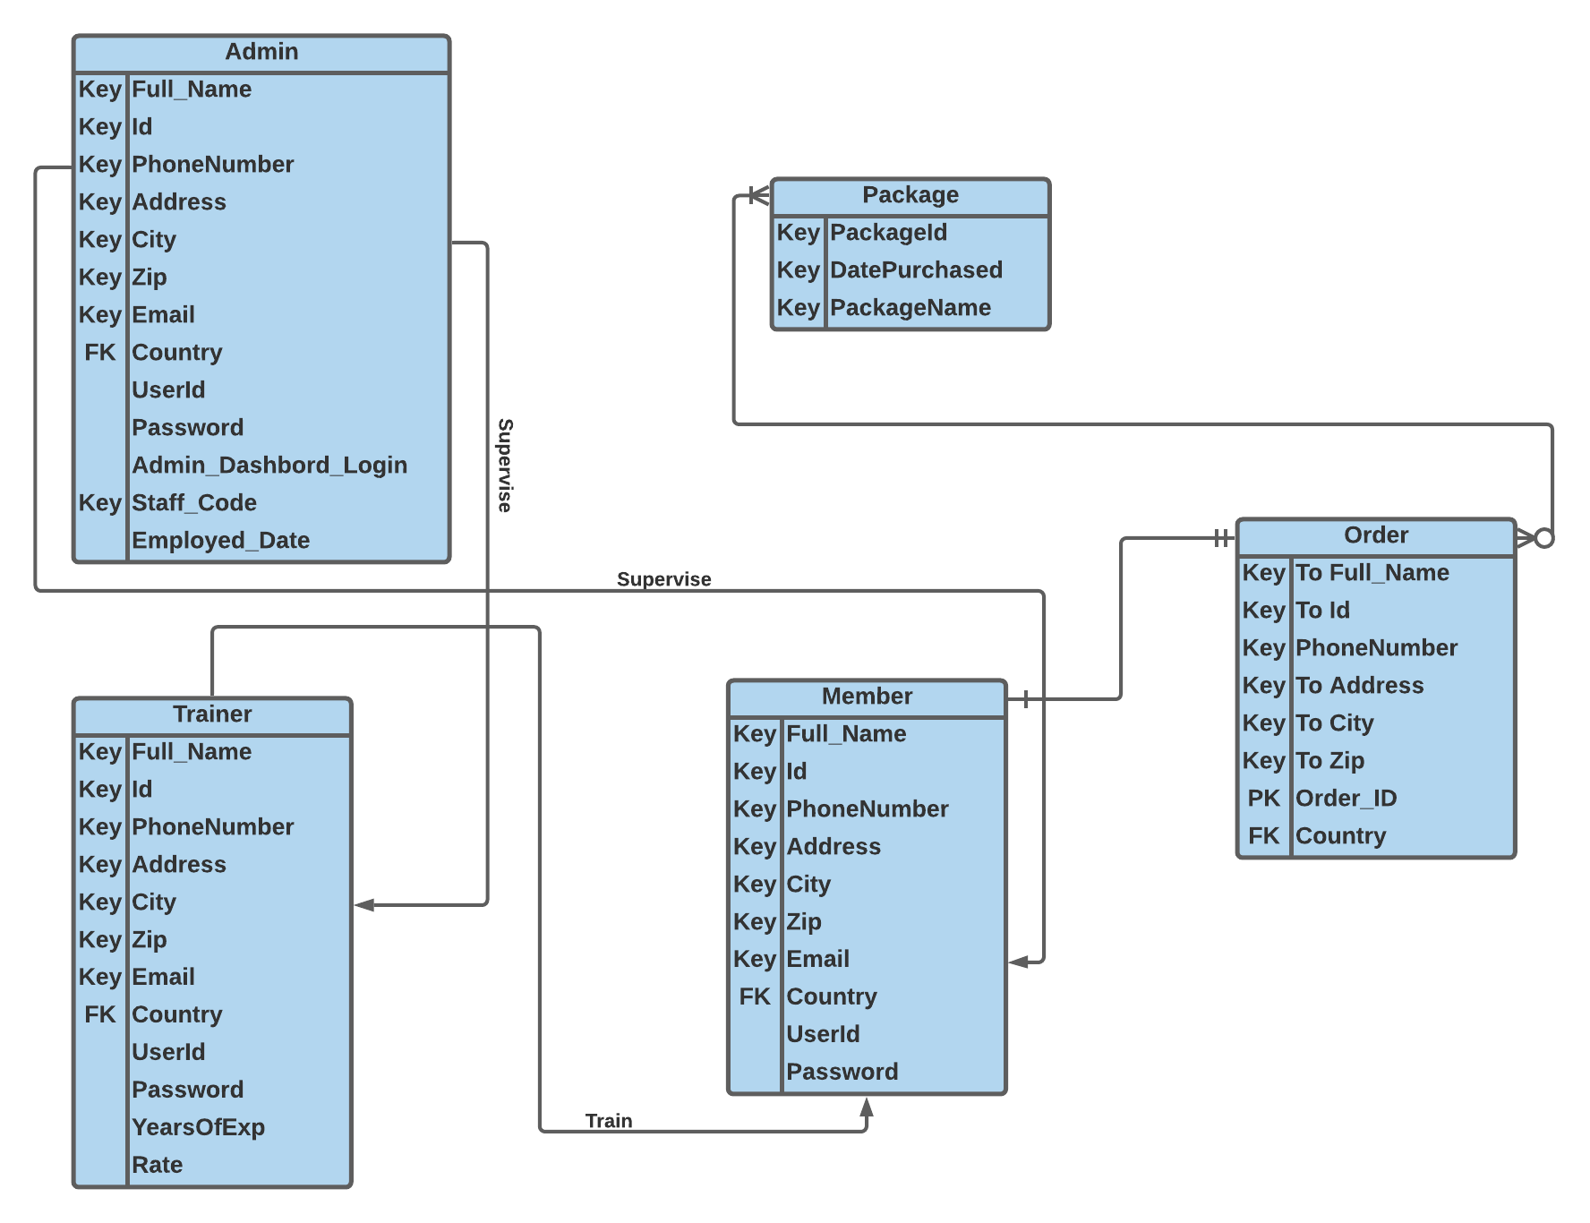

## IV. User Interface Design

V. Dataflow diagram (DFD)

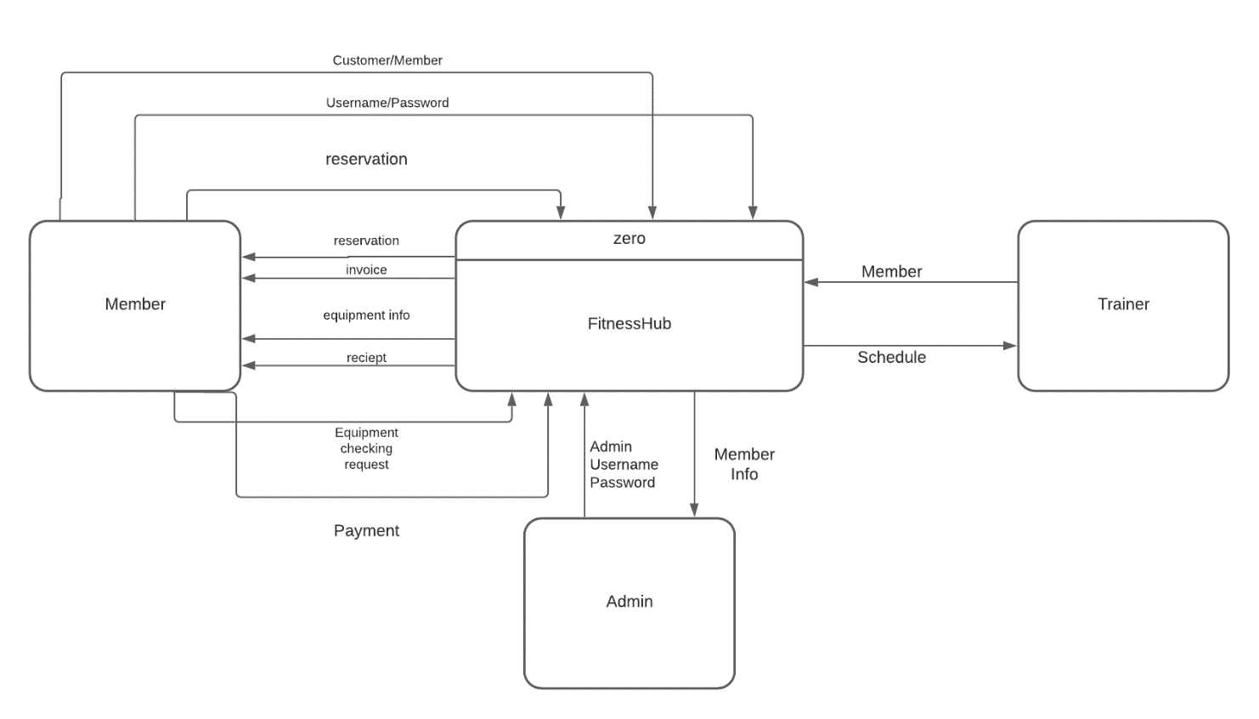

## VI. Algorithms and Data Structures

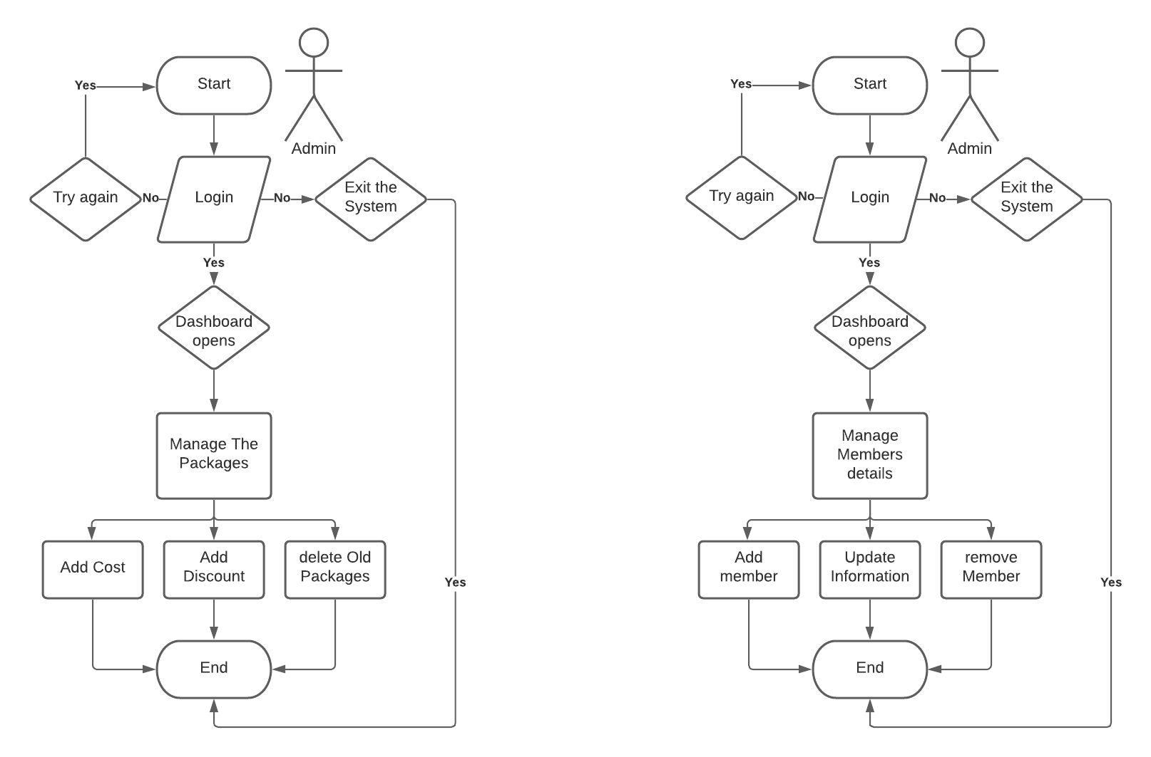

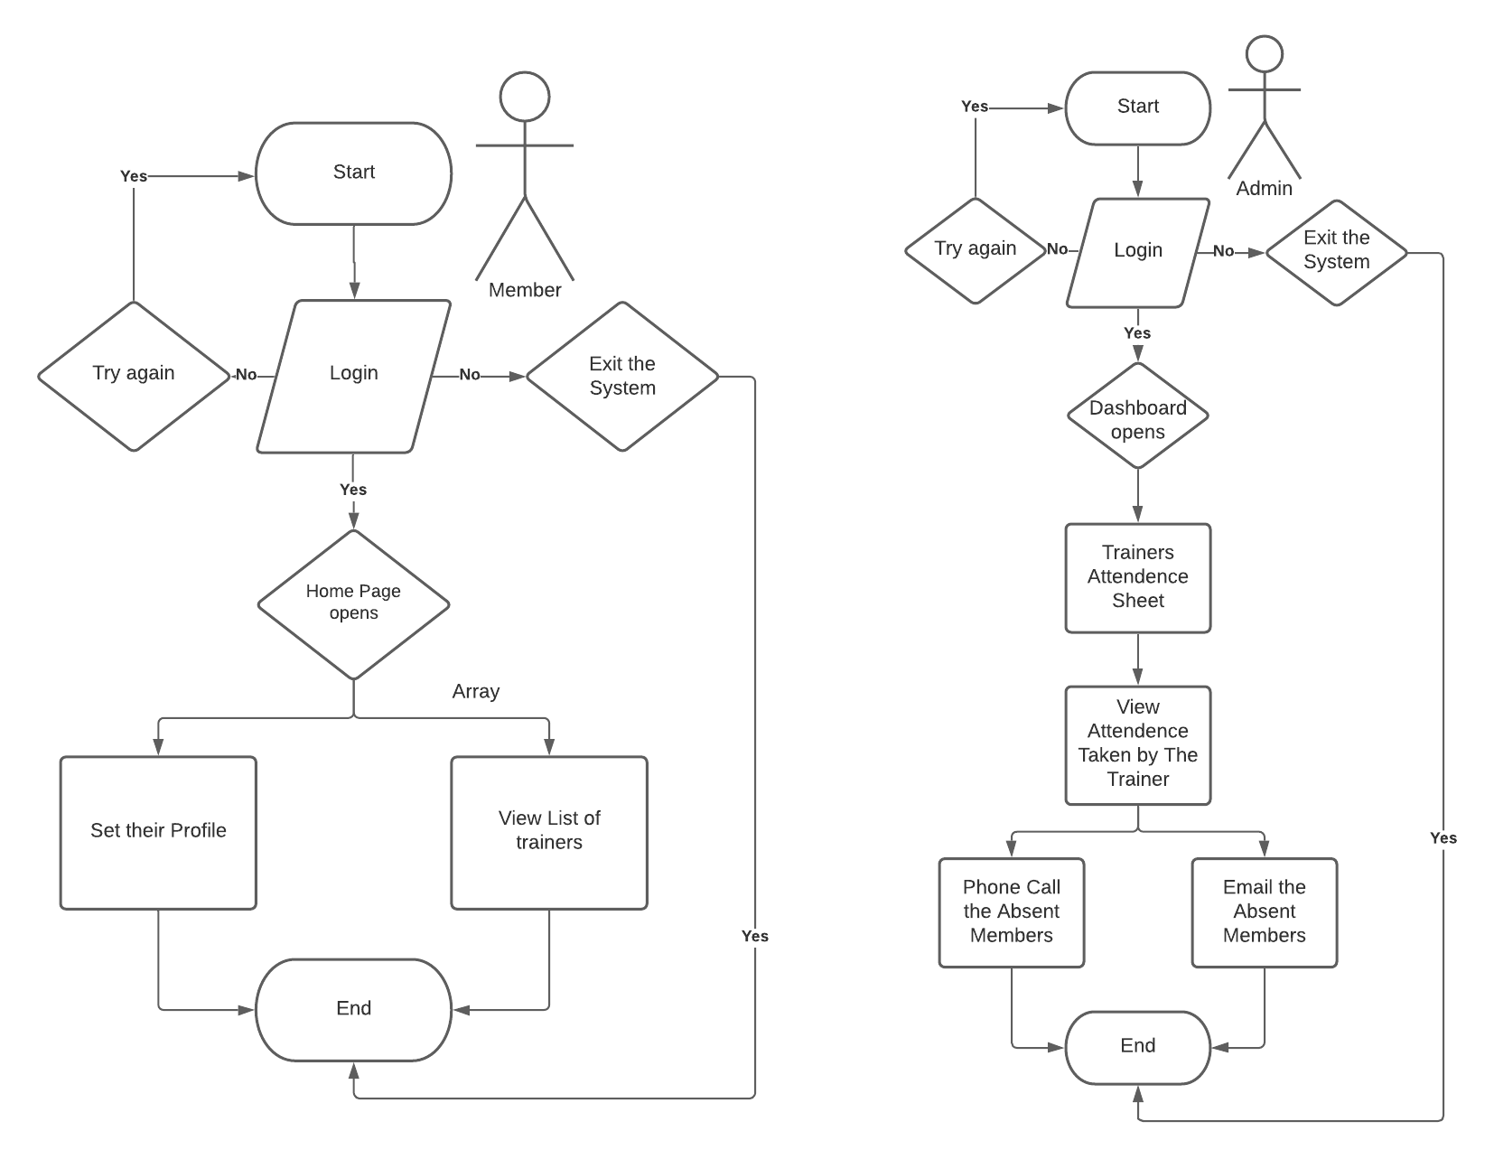

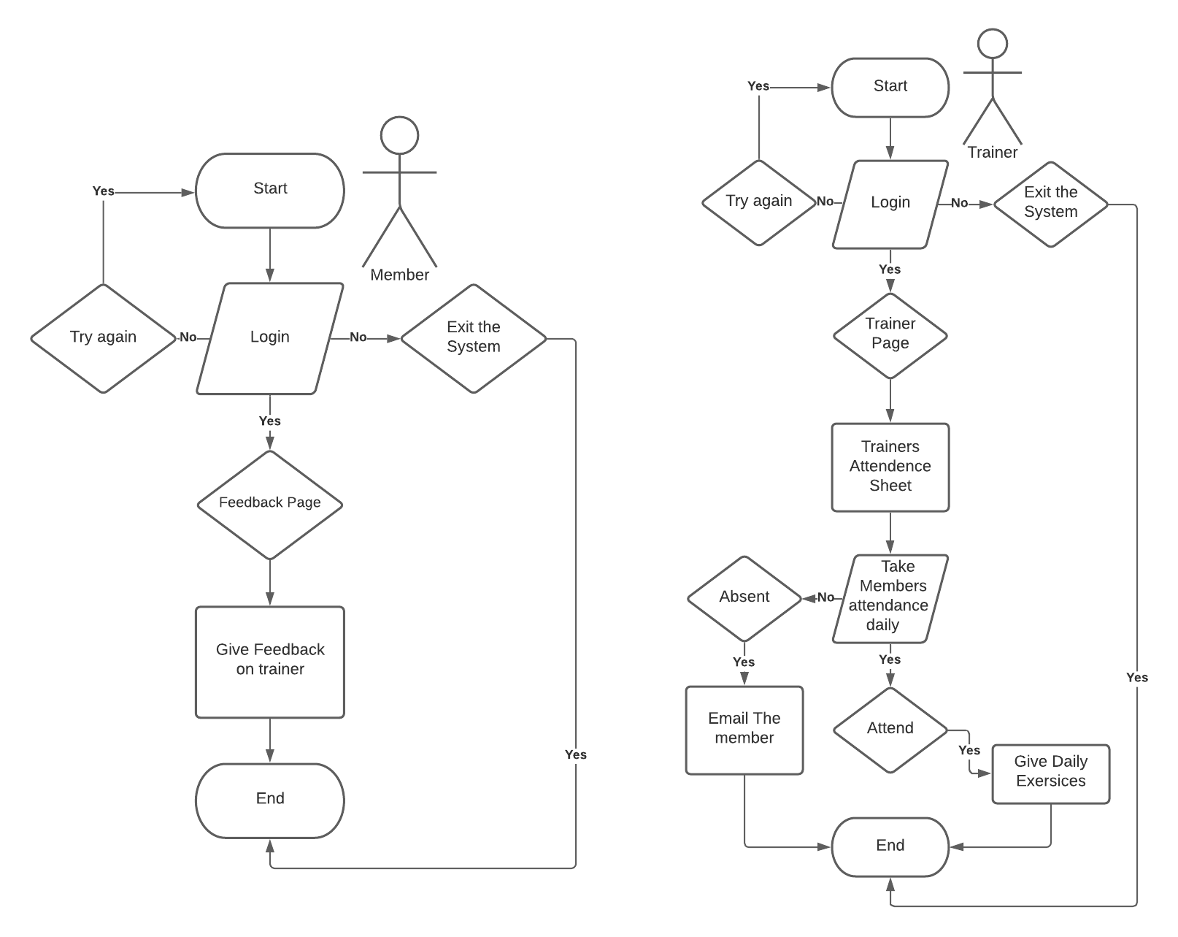

Non-Sure about this system Flowchart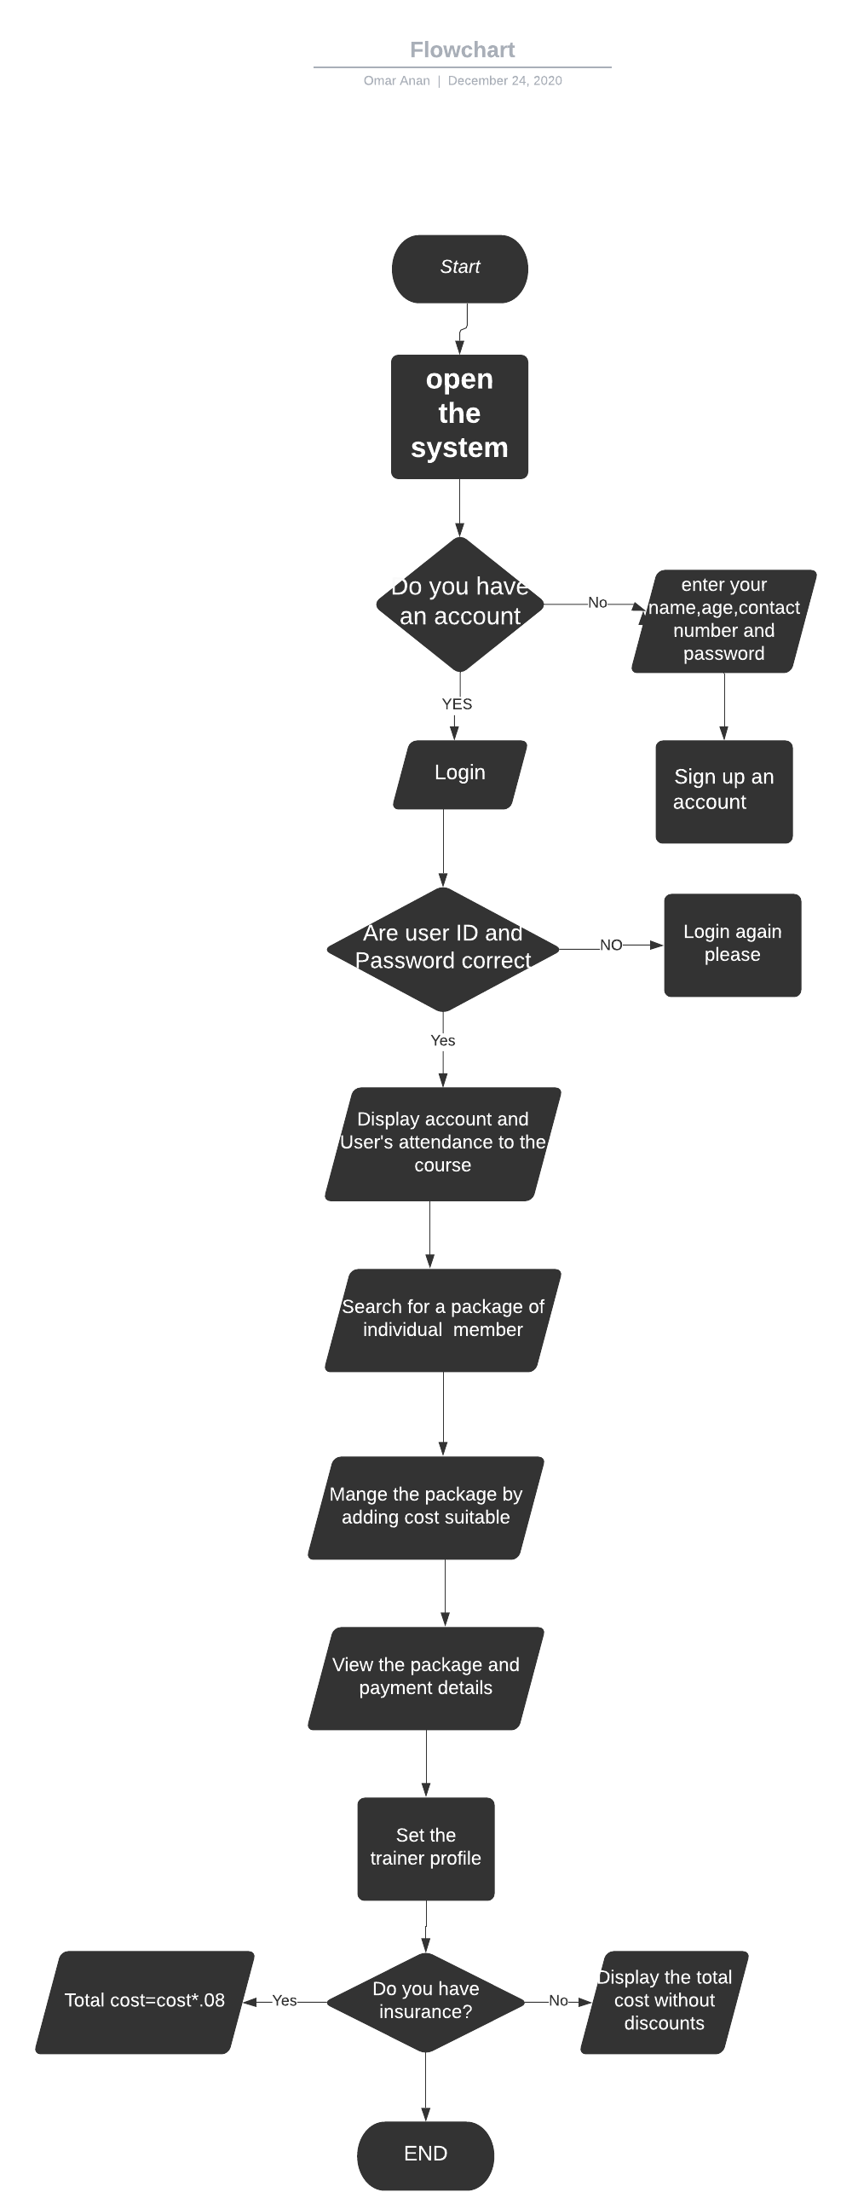

# Ownership Report



|  |  |
| --- | --- |
| Item | Owners |
| None |  |
| None |  |

# Policy Regarding Plagiarism:

Students have collective ownership and responsibility of their project. Any violation of academic honesty will have severe consequences and punishment for ALL team members.

* We Agree.