DropBot self test (2017-09-12T19:19:36)

Control board (UUID: 012345678-abcd-ef01-234-56789abcdef0)

Properties
- display_name: DropBot
- package_name: dropbot
- software_version: 1.30
- url: http://gitlab.com/sci-bots/dropbot.py.git
- base_node_software_version: 0.29
- manufacturer: Sci-Bots Inc.

Config
- max_voltage: 150.0
- R7: 10984.2734375
- min_frequency: 100.0
- switching_board_i2c_address: 32
- max_frequency: 10000.0
- pot_max: 49657.4570312
- i2c_address: 10
- id: ``
soft i2c scan: [44]
number of channels: 120

I2C scan:
- 32: HV Switching Board v3.1, firmware: v0.5, uuid: 012345678-abcd-ef01-234-56789abcdef1
- 33: HV Switching Board v3.1, firmware: v0.5, uuid: 012345678-abcd-ef01-234-56789abcdef2
- 34: HV Switching Board v3.1, firmware: v0.5, uuid: 012345678-abcd-ef01-234-56789abcdef3
- 80: 120-channel-pogo-pin-board v3.3, uuid: 012345678-abcd-ef01-234-56789abcdef4

Test voltage results:
- Output voltages:
- 0 1 2 3 4
target 46.2 V 67.0 V 87.7 V 108.5 V 129.2 V
measured 46.2 V 66.7 V 87.4 V 109.5 V 131.3 V
- Root-mean-squared (RMS) error: 0.9% 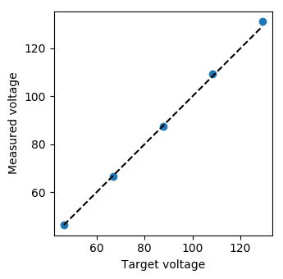

Test shorts results:
- No shorts.

Test on-board feedback calibration results:
- Measured capacitance:
- 0 1 2 3
nominal 0.0 F 10.0 pF 100.0 pF 470.0 pF
measured 2.0 pF 10.4 pF 111.2 pF 494.7 pF
- 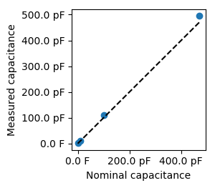
- On-board feedback calibration capacitors

Test channels results:
All 120 channels passed.
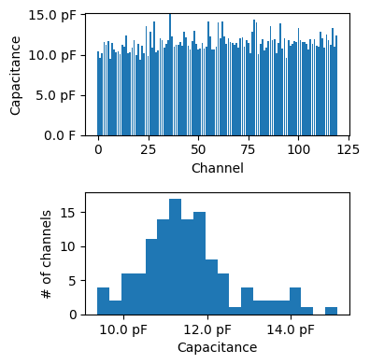
Channel capacitance summary

