dataCluster1

Autogenerated data summary from dataMaid

2022-12-08 18:10:41

# Data report overview

The dataset examined has the following dimensions:

| Feature | Result |
| --- | --- |
| Number of observations | 133 |
| Number of variables | 3 |

### Checks performed

The following variable checks were performed, depending on the data type of each variable:

|  | character | factor | labelled | haven labelled | numeric | integer | logical | Date |
| --- | --- | --- | --- | --- | --- | --- | --- | --- |
| Identify miscoded missing values | × | × | × | × | × | × |  | × |
| Identify prefixed and suffixed whitespace | × | × | × | × |  |  |  |  |
| Identify levels with < 6 obs. | × | × | × | × |  |  |  |  |
| Identify case issues | × | × | × | × |  |  |  |  |
| Identify misclassified numeric or integer variables | × | × | × | × |  |  |  |  |
| Identify outliers |  |  |  |  | × | × |  | × |

Please note that all numerical values in the following have been rounded to 2 decimals.

# Summary table

|  | Variable class | # unique values | Missing observations | Any problems? |
| --- | --- | --- | --- | --- |
| waste | numeric | 74 | 0.00 % | × |
| PIBcapta | numeric | 133 | 0.00 % |  |
| Escolaridade | numeric | 133 | 0.00 % | × |

# Variable list

## waste

| Feature | Result |
| --- | --- |
| Variable type | numeric |
| Number of missing obs. | 0 (0 %) |
| Number of unique values | 74 |
| Median | 78.63 |
| 1st and 3rd quartiles | 72.43; 93.83 |
| Min. and max. | 33.38; 164.36 |

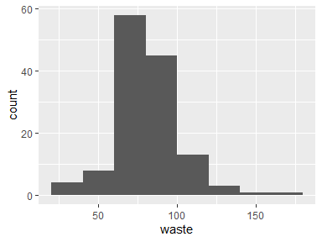

* Note that the following possible outlier values were detected: "33.38", "34.21", "39", "39.78", "49.92", …, "54.7", "55.94", "58.83", "59.6", "61" (3 values omitted).

## PIBcapta

| Feature | Result |
| --- | --- |
| Variable type | numeric |
| Number of missing obs. | 0 (0 %) |
| Number of unique values | 133 |
| Median | 8475.73 |
| 1st and 3rd quartiles | 3318.33; 25777.4 |
| Min. and max. | 285.88; 123944.91 |

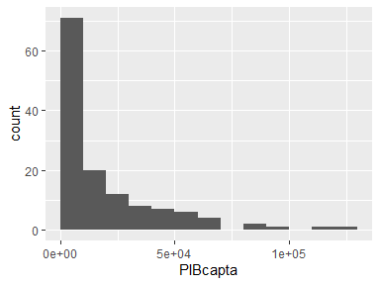

## Escolaridade

| Feature | Result |
| --- | --- |
| Variable type | numeric |
| Number of missing obs. | 0 (0 %) |
| Number of unique values | 133 |
| Median | 10.17 |
| 1st and 3rd quartiles | 7.7; 11.88 |
| Min. and max. | 1.6; 14.01 |

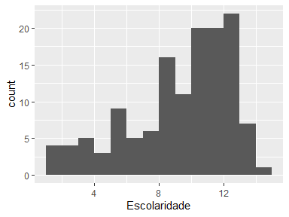

* Note that the following possible outlier values were detected: "14.01".

Report generation information:

* Created by: Douglas Pedroso (username: dgspp).
* Report creation time: qui dez 08 2022 18:10:43
* Report was run from directory: C:/Users/dgspp/Desktop/MBA data science/TCC DSA/TCC_SCRIPT/tcc
* dataMaid v1.4.1 [Pkg: 2021-10-08 from CRAN (R 4.1.3)]
* R version 4.1.3 (2022-03-10).
* Platform: x86_64-w64-mingw32/x64 (64-bit)(Windows 10 x64 (build 19044)).
* Function call: makeDataReport(data = dataCluster1)