HTTP CLIENT AND SERVER
This project deals with implementing an HTTP client and server that run a simplified version of HTTP/1.1 protocol. Before delving into the programming aspect of the project, let us discuss the fundamentals needed to understand the concepts.

- Socket Programming:
This is a widely used concept in networking, which provides communication mechanisms between two computers using HTTP/TCP. A socket is an endpoint of a two-way communication link between two programs running on the network. When the connection is made, the server creates a socket object on its end of the communication. The client and server can then communicate by writing to, and reading from the socket.

- Programming with TCP/IP sockets:
There are a few steps involved in using sockets:
- Create the socket
- Identify the socket
- On the server, wait for an incoming connection
- On the client, connect to the server's socket
- Send and receive messages
- Close the socket
- Create the socket:
A socket, s, is created with the socket system call:
int s = socket(domain, type, protocol)
All the parameters as well as the return value are integers:
domain, or address family —communication domain in which the socket should be created. Some of address families are AF_INET (IP), AF_INET6 (IPv6), AF_UNIX (local channel, similar to pipes).
type—This is selected according to the properties required by the application.
Protocol—indicate a specific protocol to use in supporting the sockets operation.

- Identify a Socket:
When we talk about naming a socket, we are talking about assigning a transport address to the socket (a port number in IP networking). In sockets, this operation is called binding an address and the bind system call is used for this.
int bind(int socket, const struct sockaddr *address, socklen_t address_len);

socket is created with the socket system call.
structure sockaddr is a generic container that just allows the OS to be able to read the first couple of bytes that identify the address family.
Address_len is simply the length of the structure in the second parameter: sizeof(struct sockaddr_in)

- Connect to a server from a client:
If we're a client process, we need to establish a connection to the server. Now that we have a socket that knows where it's coming from, we need to tell it where it's going to. The connect system call accomplishes this.
int connect(int socket, const struct sockaddr *address, socklen_t address_len);

- Accept connections on the server:
Before a client can connect to a server, the server should have a socket that is prepared to accept the connections. The listen system call tells a socket that it should be capable of accepting incoming connections:
int listen(int socket, int backlog);

backlog, defines the maximum number of pending connections that can be queued up before connections are refused.

- Communicate:
We finally have connected sockets between a client and a server! Communication is the easy part. The same read and write system calls that work on files also work on sockets. One important thing to keep in mind is that TCP/IP sockets give us a byte stream, not a packet stream. If we write 20 bytes to a socket, the other side is not guaranteed to read 20 bytes in a read operation. It may read 20. It may read less if there was some packet fragmentation. In that case, we will need to loop back and keep reading. If we write 20 bytes to a socket and then write another 20 bytes to a socket, the other side may read all 40 bytes at once ... or not.

There are some functions pre-defined to make the transfer as seamless as possible.

The send and recv calls are similar to read and write with the addition of the flags parameter.

The sendto and recvfrom system calls are like send and recv but also allow callers to specify or receive addresses of the peer with whom they are communicating. This is most useful for connectionless sockets.

Finally, sendmsg and recvmsg let one use a message header structure to minimize the number of directly supplied arguments and also minimize the number of system calls by using scatter/gather to read/write from/to a number of distinct memory blocks.

- Close the Connection:
When we're done communicating, the easiest thing to do is to close a socket with the close system call — the same close that is used for files.

- HTTP GET and PUT Methods:
Two commonly used methods for a request-response between a client and server are: GET and POST.
- GET - Requests data from a specified resource
- POST - Submits data to be processed to a specified resource
  - GET: In GET method, the clients connect to the server using a TCP connection. After this is done, a filename with filepath is sent as a request to the server, requesting for the contents of the file to be shown. On the server’s side, the server first checks for the availability of the file and sends the content if available along with “200 OK” status message, else a “404 Not Found” message is sent to the client.
  - PUT: In the PUT method, the clients get connected to the server using TCP connection. The client then checks for the availability of the file in the client. If the file exists, the file is sent to the server. The server in turn saves the file and sends “200 OK” message to the client, if saved.

This project, since it uses a multi-client to server model, various instances of command prompt windows are opened. The following screenshots and explanation would provide a complete understanding of our work.

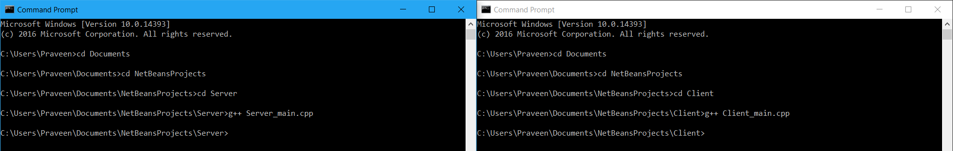
Fig.1) Server and Client program Compilation using g++

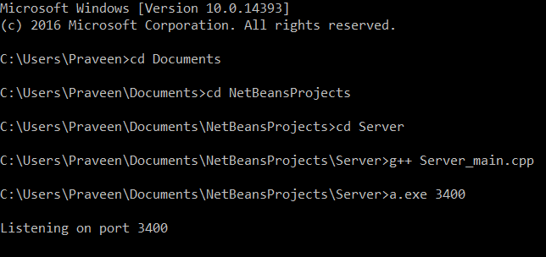
Fig.2) Server execution with Port Number as parameter
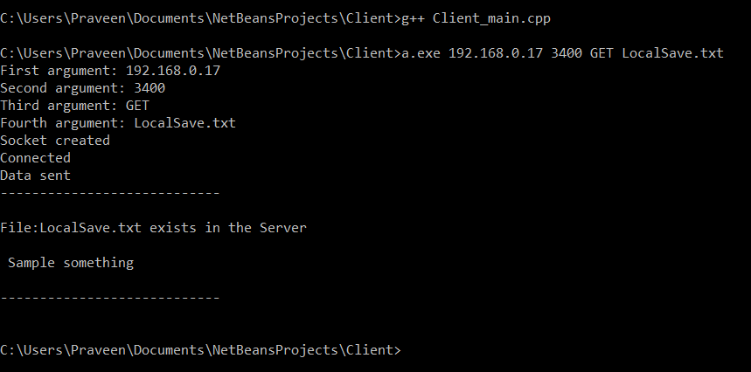
Fig. 3) Client execution with all 4 parameters
Here, the fourth parameter specifies the file to look up in the server, and the server returns whether the file is present at the server location.

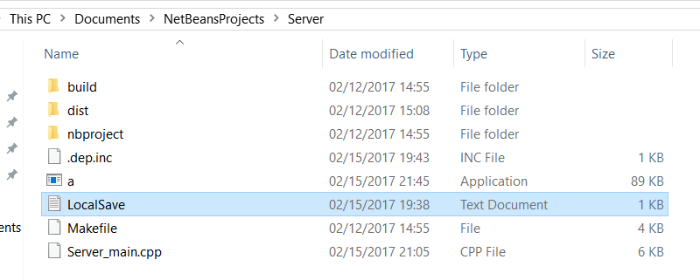
Fig. 4) File present at the server location

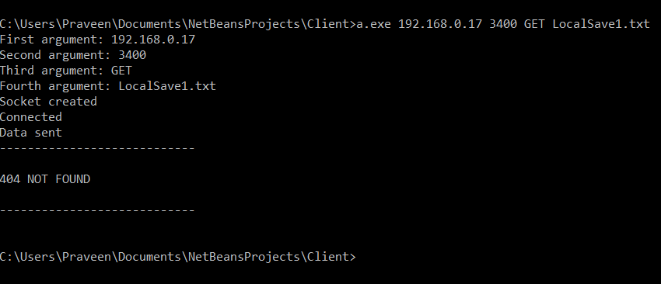
Fig. 5) Client message of File Not Found
Here, in the above screenshot, when the parameter is passed for an unknown file at the server, the response is 404 File not found.

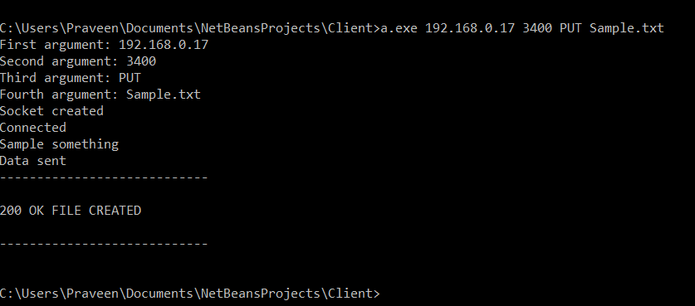
Fig. 6) Client Message for PUT command

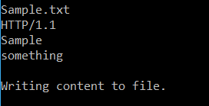
Fig. 7) Server displaying response for creating a file at server side

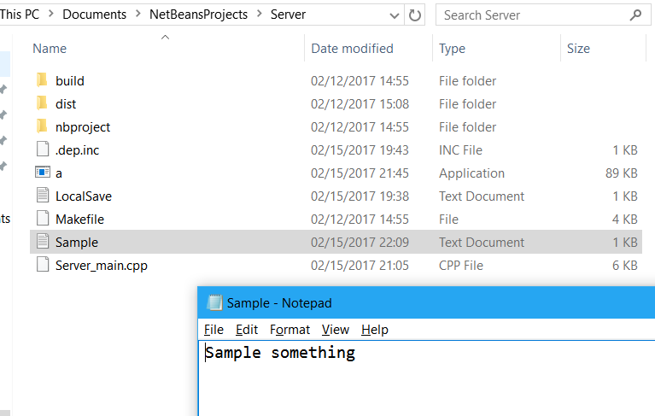
Fig. 8) Server folder and transferred file contents

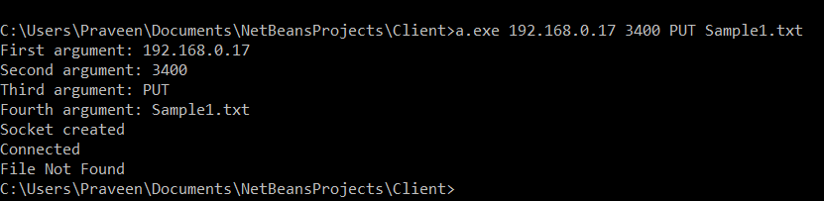
Fig. 9) Client error message when there is an unknown file path given in PUT command.

Now, let us deal with the error handling part of the code, when one of the parameters while execution is not given.

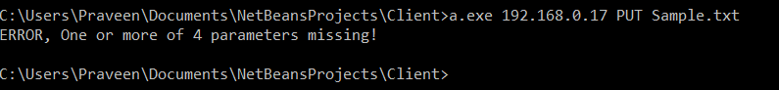
Fig. 10) Client showing error message while missing one of the parameters

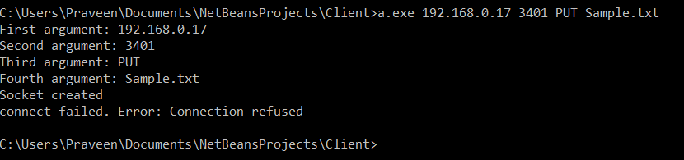
Fig. 11) Client showing error message , when giving an unmatched port—3401 instead of 3400.

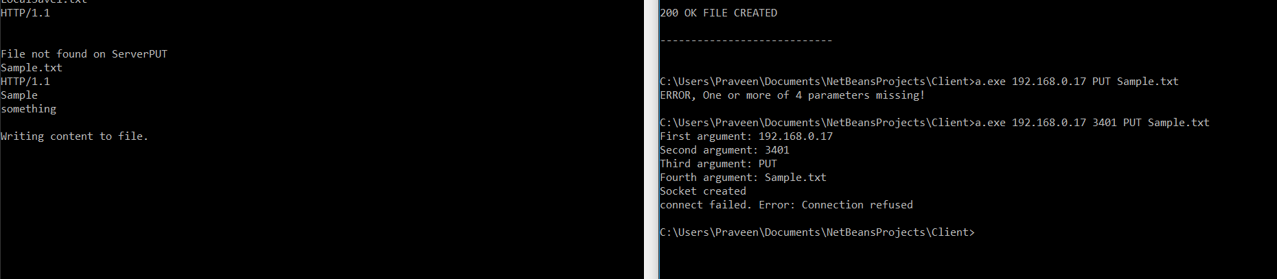
Fig.12) Server and Client windows—showing a multi-threaded Server, waiting for clients.

Now, finally, the below screenshot shows the handling of keyboard press(Ctrl+C) interrupt to terminate the server, after which even the clients get disconnected.

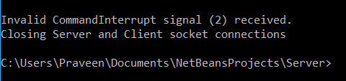
Fig.13) Server showing message indicating signal interrupt SIGINT

