Assignment Report

# Task 1 – FastAPI and MongoDB Setup

GitHub Repository link: https://github.com/sciclunaCynthia/multimedia_api_project

Live API URL: https://multimedia-api-project-cynthia.vercel.app/docs

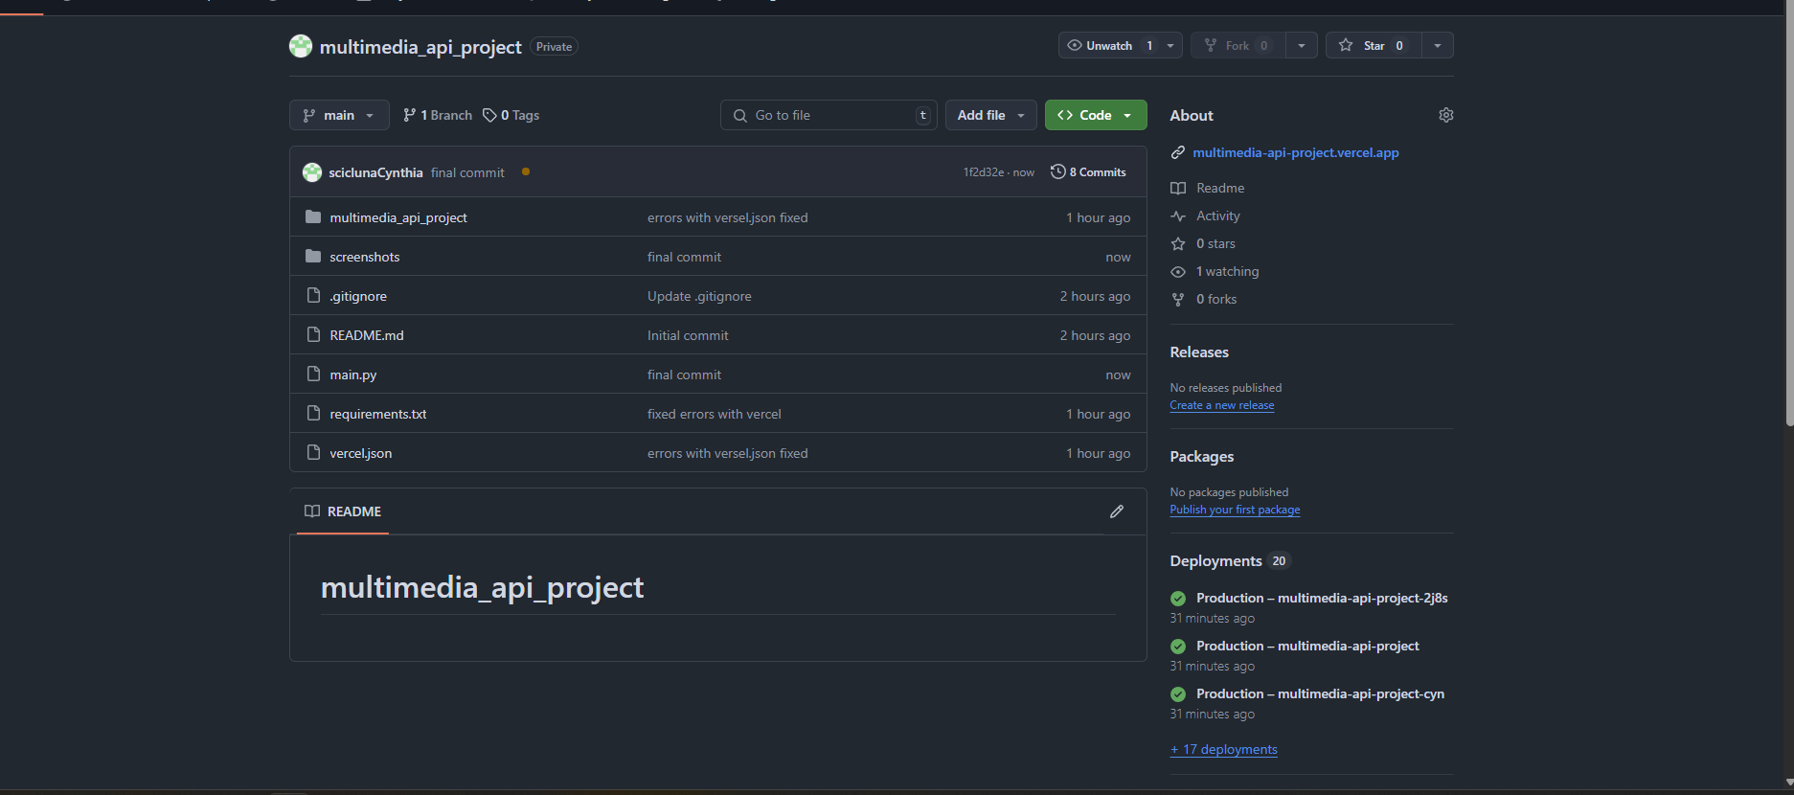

Figure shows github repositry project files

Figure shows MongoDB Atlas cluster dashboard

Figure Successful deployment of vercel app live

# Task 2 – Mock Data Upload to MongoDB

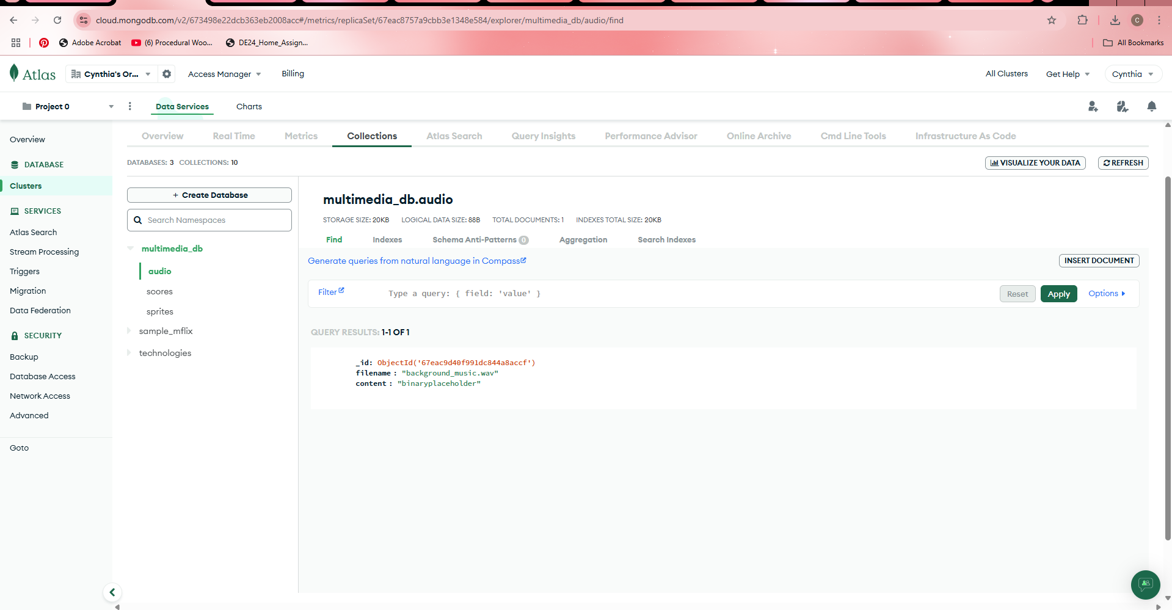

Figure shows audios

Figure shows scores

Figure shows sprites

# Task 3 – API Testing via Swagger UI

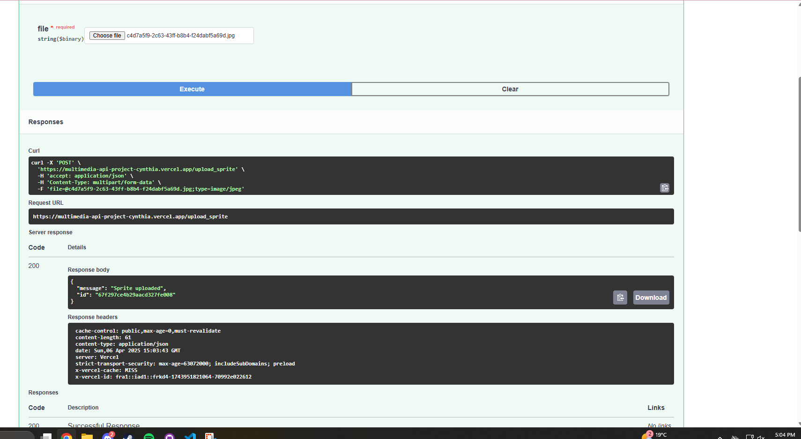

Figure shows successful sprites test

Figure shows successful audios test

Figure shows successful scores test

# Task 4 – Configuring Database Security

## 4a.

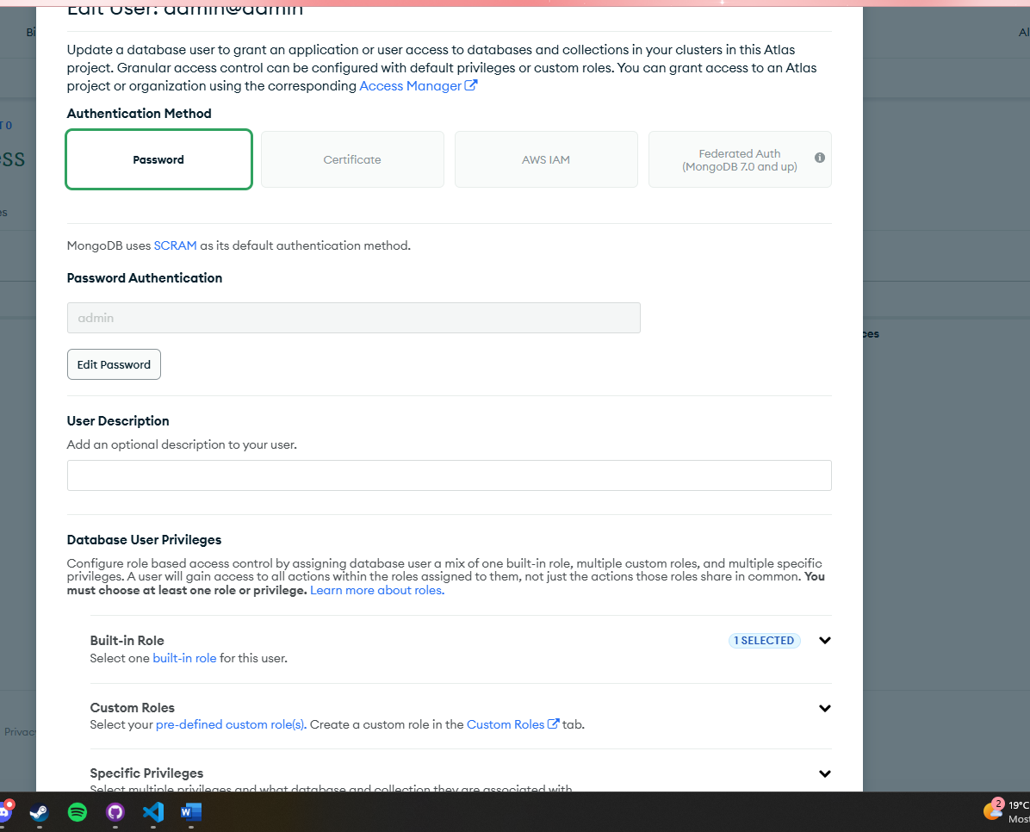

Figure shows MongoDB user credentials setup (admin@admin)

## 4b.

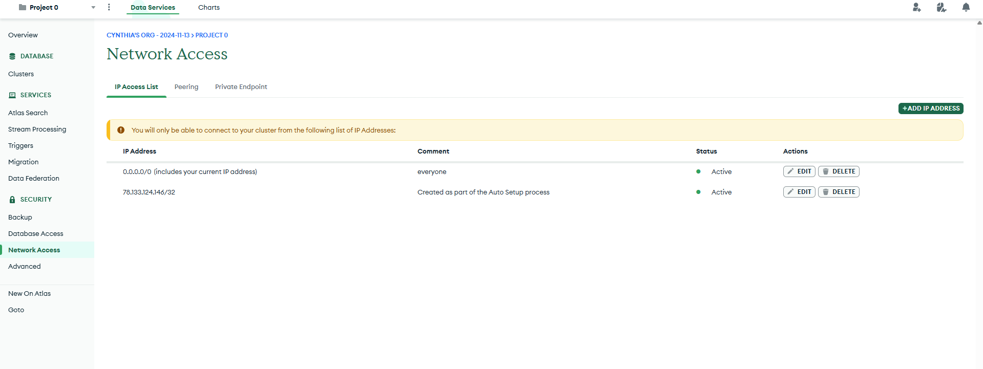

Figure shows IP Whitelist configuration in MongoDB Atlas

## 4c.

Figure shows how I added custom input validation

Figure shows that before inserting the player’s name and score into MongoDB, I validate that the player_name is safe

Figure shows that I ensured that the correct data types are being sent