# Bookmarks and Cross-references Test

## Author

* Smith, John “John Smith, PhD” (NYU)

## Affiliation

* New York University (NYU) – New York, NY, USA

## Abbreviation

* sci.pe: science periodicals

## Introduction

Bookmarked word: testing.

Cross-reference to bookmarked word testing.

Cross-reference section heading: Introduction.

Cross-reference in a footnote[1].

Cross-reference abbreviation sci.pe.

Cross-reference to a footnote1

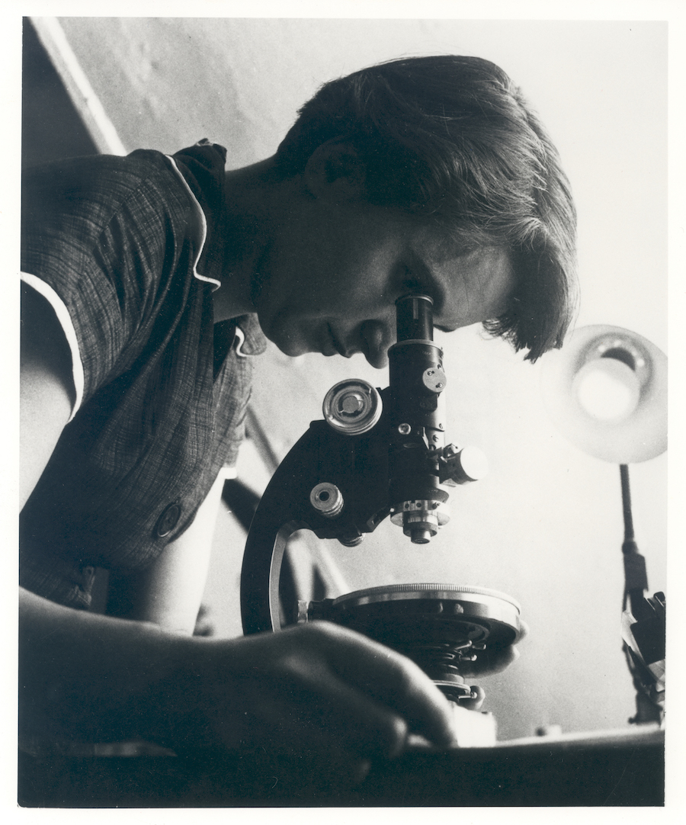

Figure Rosalind Franklin.

Cross-reference to a figure label Figure 1.

Text Box Textbox example with cross-reference.

Cross-reference in a textbox testing.

## Disclosures

John Smith, PhD discloses a conflict of interest.

1. testing