# Were Captions Hop-less Monsters?

Table [table-above]

|  |  |
| --- | --- |
| table-above | XXX |

§

|  |  |
| --- | --- |
| Table-below | XXX |

Table [table-below]

§

Code 1[code-above]

for (let id in ctx.hyperLinkFixes) {

let rel = relsDoc.createElementNS(RELNS, 'Relationship');

rel.setAttribute('Id', id);

rel.setAttribute('Type', `${RELNS}/hyperlink`);

rel.setAttribute('Target', ctx.hyperLinkFixes[id]);

rel.setAttribute('TargetMode', 'External');

el.appendChild(rel);

}

§

for (let id in ctx.hyperLinkFixes) {

let rel = relsDoc.createElementNS(RELNS, 'Relationship');

rel.setAttribute('Id', id);

rel.setAttribute('Type', `${RELNS}/hyperlink`);

rel.setAttribute('Target', ctx.hyperLinkFixes[id]);

rel.setAttribute('TargetMode', 'External');

el.appendChild(rel);

}

Code 2[code-below]

§

§§

Text Box 1[text-box-above]

[text-box 1]

§

§§

[text-box 2]

Text Box 2[text-box-below]

§

Figure Figure 1[figure-above]

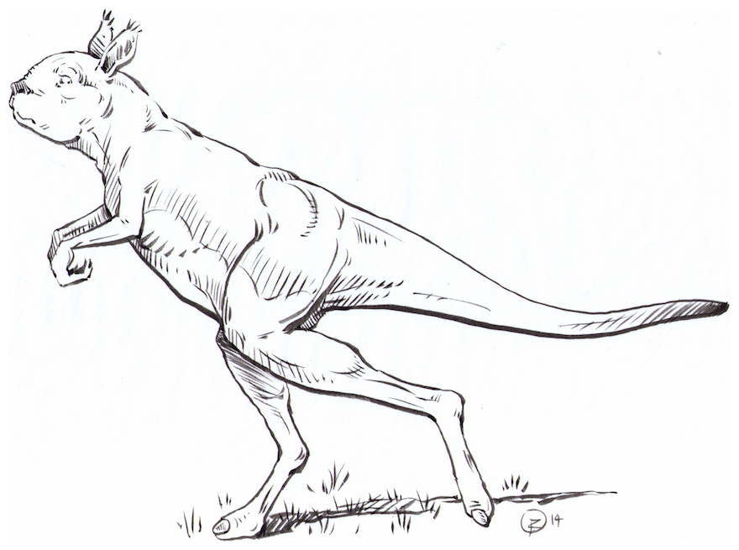

§



Figure [figure-below]

§

Equation [math-above]

§

Table Caption with newlines  
On a new line.  
Another new line.  
[caption-newlines]

|  |  |
| --- | --- |
| caption-newlines | XXX |

§

This caption was made just by applying the Caption style. [style-only-above]

|  |  |
| --- | --- |
| style-only-above | XXX |

§

|  |  |
| --- | --- |
| style-only-below | XXX |

[style-only-below]

§

First caption in a row [lonely-1]

Second caption in a row [lonely-2]

§

Table First caption inserted for this table [table-pile-1]

Table Second caption for this table [table-pile-2]

|  |  |
| --- | --- |
| Table-pile |  |

§

|  |  |
| --- | --- |
| Table-pile-below |  |

Table F[table-pile-below-top]

Table G[table-pile-below-bot]

§

This is a basic caption.Table This is the caption of a caption [caption-caption]

|  |  |
| --- | --- |
| Caption-caption |  |

§

Table This caption was attached to the table, but then a paragraph was inserted.[caption-then-para]

Inserted paragraph.

|  |  |
| --- | --- |
| caption-then-para | XXX |

§

Table [caption-li]

* One
* Two
* Three

|  |  |
| --- | --- |
| Caption-li | XXX |

§

|  |  |
| --- | --- |
| empty-caption | XXX |

Table K

§

[preceded-by-empty-caption]

§

Code 3[hyper-above]

<http://berjon.com/>

§

[Web 2024](http://berjon.com/web-2024/)

Figure 3[hyper-below]

§

This is a reference to the first table (label and number only): Table A.

§

This is a reference to the second table (caption text only): [table-below].

§

This is a reference to the first table (full caption): Table A [table-above].

§

This is a reference to the first table (page number): 1.