# Test that figures are emptied

## Introduction

Code 1. R code for creating Figure 1A.

rm(list=ls())

library(RColorBrewer)

counts<-c(293,88,224)

pc<-c("48%","15%","37%")

labs<-c("No Data","Symptomatic","Asymptomatic")

#piechart of all drivers

postscript("~/12-1042-F1A.eps", width=5, height=4,pointsize=10, onefile=FALSE, horizontal=FALSE, paper="special")

par(mar=c(2,0,1.5,0))

pie(counts, labels=pc, ps=14,edges=400,radius=0.5, col=brewer.pal(9,"Greys")[c(1,3,6)],lty=1,lwd=1, init.angle=-90)

legend(0.6,-0.1, labs,col=brewer.pal(9,"Greys")[c(1,3,6)],fill=brewer.pal(9,"Greys")[c(1,3,6)],bty="n",cex=0.9)

dev.off()

Equation 1.

$$y_{diseaseStatus}\sim x_{virusFamily}+x_{hostOrder}+e$$

## Results

Figure 1.

Table 1.

|  |  |  |  |  |  |  |
| --- | --- | --- | --- | --- | --- | --- |
| Predictor[1] | Coefficient | SE | Test statistic (Z) | p-value | OR | 95% CI |
| Constant | -0.33 | 0.58 | -0.56 | 0.58 | 0.72 | (0.23, 2.26) |
| Virus Family (Reference category: Flaviviridae) | | | | | | |
| Bunyaviridae | -1.74 | 0.64 | -2.71 | 0.01 | 0.18 | (0.05, 0.62) |
| Filoviridae | 3.26 | 1.83 | 1.78 | 0.08 | 26.07 | (0.72, 944.49) |
| Herpesviridae | 0.10 | 0.65 | 0.16 | 0.87 | 1.11 | (0.31, 3.94) |
| Paramyxoviridae | 3.43 | 1.42 | 2.41 | 0.02 | 30.95 | (1.90, 503.52) |
| Picornaviridae | 1.12 | 0.76 | 1.48 | 0.14 | 3.08 | (0.69, 13.68) |
| Poxviridae | 2.29 | 0.81 | 2.82 | <0.001 | 9.90 | (2.01, 48.72) |
| Reoviridae | 2.13 | 1.05 | 2.02 | 0.04 | 8.39 | (1.07, 66.12) |
| Rhabdoviridae | 9.20 | 2.39 | 3.85 | <0.001 | NA[2] | NA2 |
| Togaviridae | -0.36 | 0.63 | -0.58 | 0.56 | 0.70 | (0.20, 2.38) |
| Species Order (Reference category: Artiodactyla) | | | | | | |
| Chiroptera | -6.47 | 1.81 | -3.57 | <0.001 | 0.00 | (0.00, 0.05) |
| Perissodactyla | 0.58 | 0.76 | 0.77 | 0.44 | 1.79 | (0.40, 8.03) |
| Primates | -0.16 | 0.68 | -0.24 | 0.81 | 0.85 | (0.22, 3.24) |
| Rodentia | -1.12 | 0.67 | -1.66 | 0.10 | 0.33 | (0.09, 1.22) |

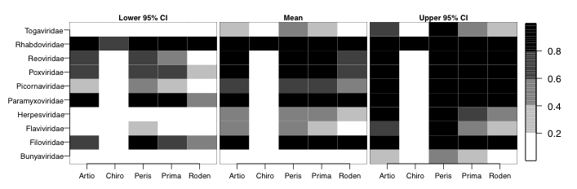

Figure 2.

1. Virus and host reference groups were selected as those for which sample size was sufficiently large and symptomatic infection was moderate .
2. All host–virus pairs were symptomatic.