# Host and viral traits predict zoonotic spillover from mammals (version 0.0.0)

## Authors

* [Olival, Kevin J.](https://science.ai/user/olival) “Kevin J. Olival” (EHA)[1]
* [Hosseini, Parviez (R)](https://science.ai/user/hosseini) “Parviez R. Hosseini” (EHA)
* [Zambrana-Torrelio, Carlos](https://science.ai/user/zambrana) “Carlos Zambrana-Torrelio” (EHA)
* [Ross, Noam](https://science.ai/user/ross) “Noam Ross” (EHA)
* [Bogich, Tiffany (L)](https://science.ai/user/tiffany) “Tiffany L. Bogich” (EHA)
* [Daszak, Peter](https://science.ai/user/daszak) “Peter Daszak” (EHA)[2]

## Affiliation

* [EcoHealth Alliance (EHA)](https://www.ecohealthalliance.org/) - New York, NY, USA

## Abstract

This is the first draft of the abstract.

## Keywords

* [Conservation biology](https://science.ai/subjects/conservation)
* Red fox

## Introduction

This is the body of article version 0.0.0 with a footnote[3] and an endnote[4].

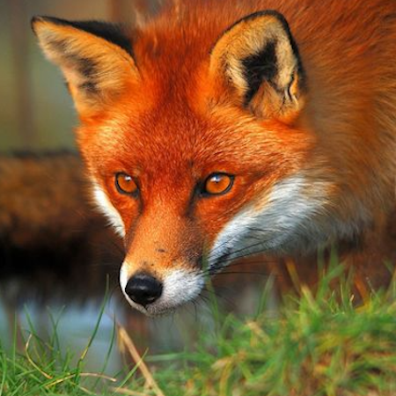

Figure 1 This is the caption for image of article version 0.0.0.

## Funding

| Source | Award | Target | Comment |
| --- | --- | --- | --- |
| Emerging Pandemic Threats PREDICT program (PREDICT) < [United States Agency for International Development (USAID)](https://www.usaid.gov/) – Washington, D.C., USA |  | Dataset 1 | Awarded to Peter Daszak, PhD |

## Supporting Information

data.xlsx

Dataset 1 This is the file of article version 0.0.0.

1. Email: [olival@ecohealthalliance.org](mailto:olival@ecohealthalliance.org).
2. Email: [daszak@ecohealthalliance.org](mailto:daszak@ecohealthalliance.org).
3. Footnote text
4. Endnote text