# Are DS3 Formats Hop-less?

## Authors

* [Berjon, Robin (M) “Robin Berjon”](http://berjon.com/) (Team DocX < Standard Analytics (SA) – New York, NY, USA; Scholarly HTML Community Group (SHCG) < [World Wide Web Consortium (W3C)](https://www.w3.org/) – Boston, MA, USA; Cryptozoology)[1]
* Regal, Brian “Dr. Brian Regal” (Cryptozoology )

## Affiliations

* Cryptozoology < Kean University – Union, New Jersey, USA

## Copyright

© 2017 Robin Berjon; W3C; Overlord, Evil (Lizard) “Britney Spears”; Jersey Devils Inc. – Pine Barrens, NJ, USA

## Introduction

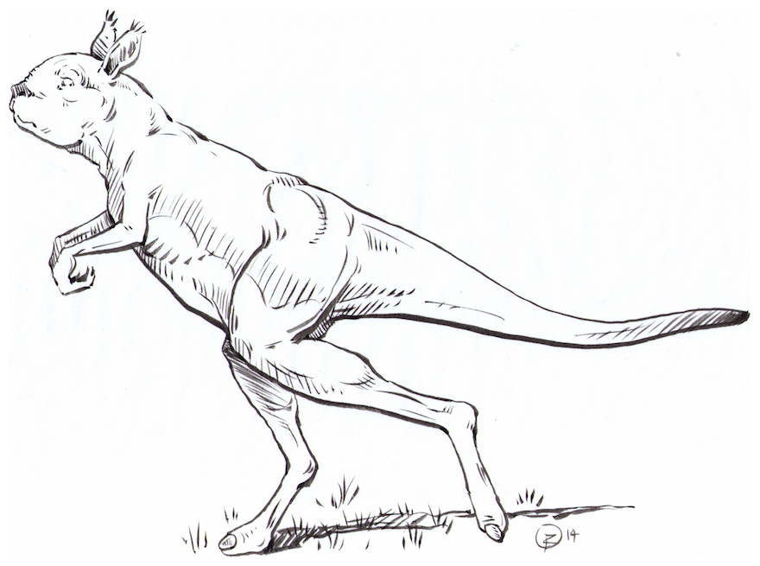

Figure Hop-less kangaroo. Author: Dr. Brian Regal. Contributors: Ballesteros, Sébastien “Sébastien Ballesteros” (Standard Analytics — NYC, NY, USA)[2]; Robin Berjon. License: [CC-BY-4.0](https://creativecommons.org/publicdomain/zero/1.0). Copyright: © 1977 Dr. Brian Regal. Reproduced from: (Regal 1977) © 2010 New York University, with permission. Code from: Figure 2 Painting. Courtesy of: Kardell, Brian “Brian Kardell”.; (Kardell 2015).

§



Figure Painting. Courtesy of: Kardell, Brian “Brian Kardell”.

§

Figure Pretty pictures. Author: Robin Berjon. (A) Lobster eating a sheep. (B) Pretty flowers. Copyright: © 2015 Ville de Montreuil - Montreuil, France. (C) Statue. (D) The best music. Data from: Goldman, Jean-Jacques “JJG”.

§

## Funding

|  |  |  |  |
| --- | --- | --- | --- |
| Funder | Grant | Targets | Notes |
| Collaborative systems < Division of Information & Intelligent Systems (IIS) < National Science Foundation (NSF) | award number 0553202 "SGER: First Stages of Exploratory Development of HyperScope" | The work |  |
| Science and Technology Directorate < Department of Homeland Security (DHS) | contract HSHQDC-12-C-00058 | Figure 2 Painting. Courtesy of: Kardell, Brian “Brian Kardell”. |  |

## Acknowledgements

Unstructured acknowledgements

## Disclosure

Unstructured disclosure

1. Email: [robin@berjon.com](mailto:robin@berjon.com) (personal); [robin@standardanalytics.io](mailto:robin@standardanalytics.io). Twitter: [@robinberjon](https://twitter.com/robinberjon). Skype: robinberjon. Tel: [+33.6.81.75.45.41](tel:+33.6.81.75.45.41) (old).
2. Email: [sebastien@standardanalytics.io](mailto:sebastien@standardanalytics.io). GitHub: [@sballesteros](https://github.com/sballesteros). NPM: [sballesteros](https://www.npmjs.com/~sballesteros).