`These test papers are copyright and must not be reproduced in any way.
This paper should be withdrawn after use in the examination or classroom and retained by the teacher.
Test papers may not be used for private tutoring in the year of publication.


Year 11
Human Biology
2004

Name: __________________________________ Teacher: _________________

TIME ALLOWED FOR THIS PAPER:

Reading time: Ten minutes
Working time: Two and a half hours OR Three hours

MATERIALS REQUIRED / RECOMMENDED FOR THIS PAPER:

TO BE PROVIDED BY THE SUPERVISOR:
This Question / Answer Booklet
Separate Multiple Choice Answer Sheet

TO BE PROVIDED BY THE CANDIDATE:
Standard Items: Pens, pencils, eraser or correction fluid, ruler.
Special items: A 2B, B or HB pencil for the Separate Multiple Choice Answer Sheet and calculators satisfying the conditions set by the Curriculum Council.

IMPORTANT NOTICE TO CANDIDATES

No other items are to be taken into the examination room.
It is your responsibility to ensure that you do not have any unauthorised notes or other items of a non-personal nature in the examination room. Please check carefully, and if you have any unauthorised material with you, hand it to the supervisor BEFORE reading any further.

STRUCTURE OF THIS PAPER

Part | No. of questions available | No. of questions to be attempted | Marks available
I Multiple choice | 40 | ALL | 80
II Short answers | 6 | ALL | 80
III Extended answers: for  2 1/2 Hour Paper Only  Section A  Section B  IV Extended answers: for  3 Hour Paper Only  Section A  Section B | 2  2  2  2 | 1  1  1  1 | 10  10  20  20

INSTRUCTIONS TO CANDIDATES

PART I Write your answers on the separate Multiple Choice Answer Sheet using a 2B, B or HB pencil. DO NOT USE A BALL-POINT OR INK PEN.

PART II Write your answers in the spaces provided in this Question / Answer Booklet. Use a blue or black ball-point or ink pen. Draw any diagrams in pencil.

PART III Write your answers in this Question / Answer Book. Answer on the
and pages following the end of the questions, using a blue or black ball
PART IV point or ink pen. Do not copy the questions when answering, merely
write the number of the question in the margin.

N.B Students doing a TWO AND A HALF HOUR examination, answer PART I, PART II and PART III (NOT PART IV).

Students doing a THREE HOUR examination, answer
PART I, PART II and PART IV (NOT PART III).
PART I [80 marks]

Select the best alternative and mark this on the answer sheet provided.
____________________________________________________________________

1. Compared to prosimians, all the other primates

a) evolved earlier in time.
b) tend to be nocturnal.
c) have large eyes for better vision.
d) show more convolutions on their brain surface.

2. New World monkeys

- have ischial callosities.
- have a prehensile tail.
- are quadrupedal.
- tend to be nocturnal.

The next TWO questions refer to the diagram below showing an upper limb.

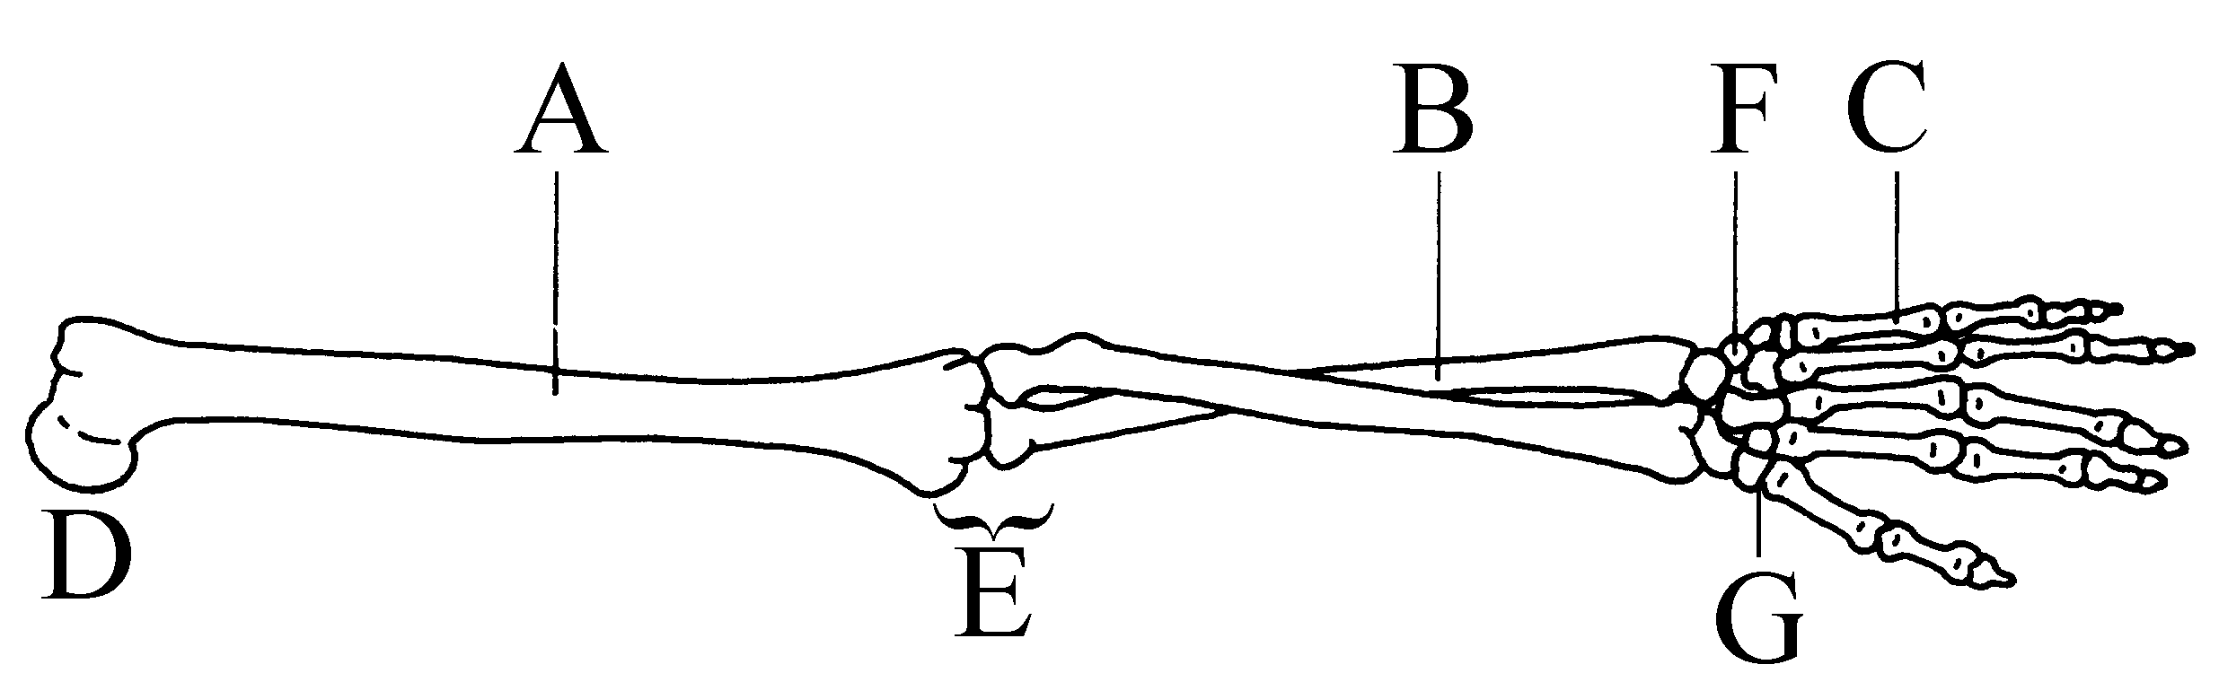

3. The bones labelled A, B and C in the diagram above are, in order, the

- humerus, radius and carpals.
- radius, ulna and metatarsals.
- humerus, ulna and metacarpals.
- ulna, radius and carpals.

4. With regard to the diagram above, which of the following statements is CORRECT?

- The biceps muscle would cross joint D.
- Joint E is a ball and socket joint.
- Joint F is a hinge joint.
- Joint G is the only one of its kind in the human body.
The next THREE questions refer to the diagram below showing a synovial joint.

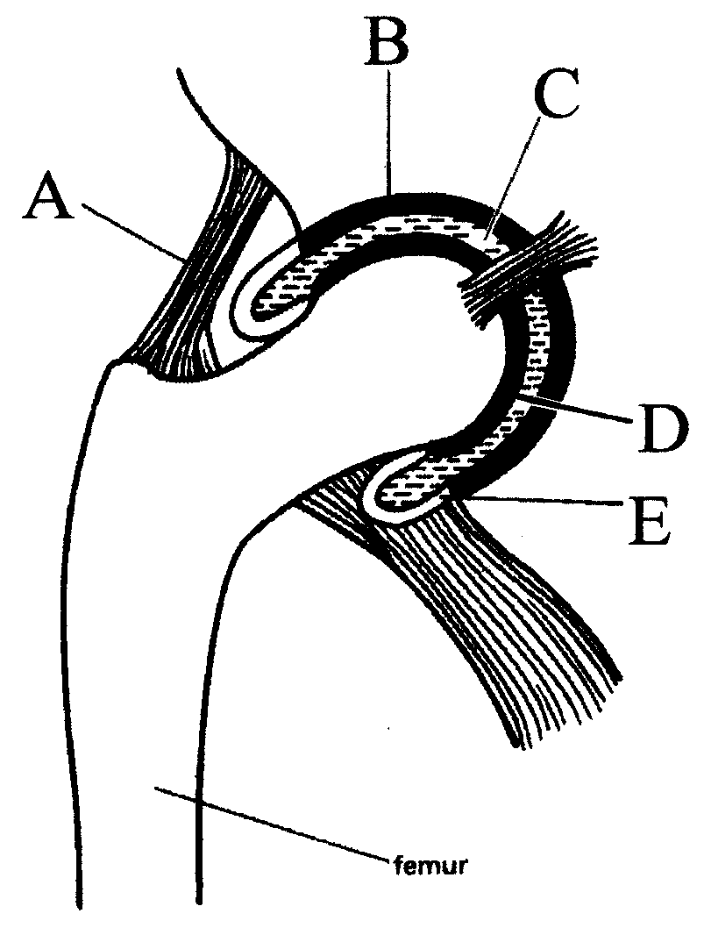

5. The structure labelled A in the diagram above is a

- tendon.
- ligament.
- cartilage.
- muscle.

6. The structure labelled B in the diagram above is

- articular cartilage, a type of connective tissue.
- a tendon, a type of connective tissue.
- a ligament, a type of epithelial tissue.
- squamous epithelium, a type of epithelial tissue.

7. Friction in this joint is reduced by the presence of

- structure B.
- structures B and C.
- structures B, C and D.
- structures B, C, D and E.

8. To be an efficient locomotor in an erect and bipedal manner, humans must have

- a carrying angle.
- an elongated pelvis.
- a foramen magnum placed towards the rear of the skull.
- arms longer than legs.
9. Greenstick fractures

a) always break the skin.
b) break the bone completely in half but don’t break the skin.
c) occur mainly in children.
d) are due to the bone being twisted.

10. The human skeleton has many functions. Which of the following is INCORRECT?

a) It acts to support the body.
b) It protects the major organs.
c) It provides leverage for movement to take place.
d) It is a store for calcium and potassium.

The next TWO questions refer to the diagram of cells below.

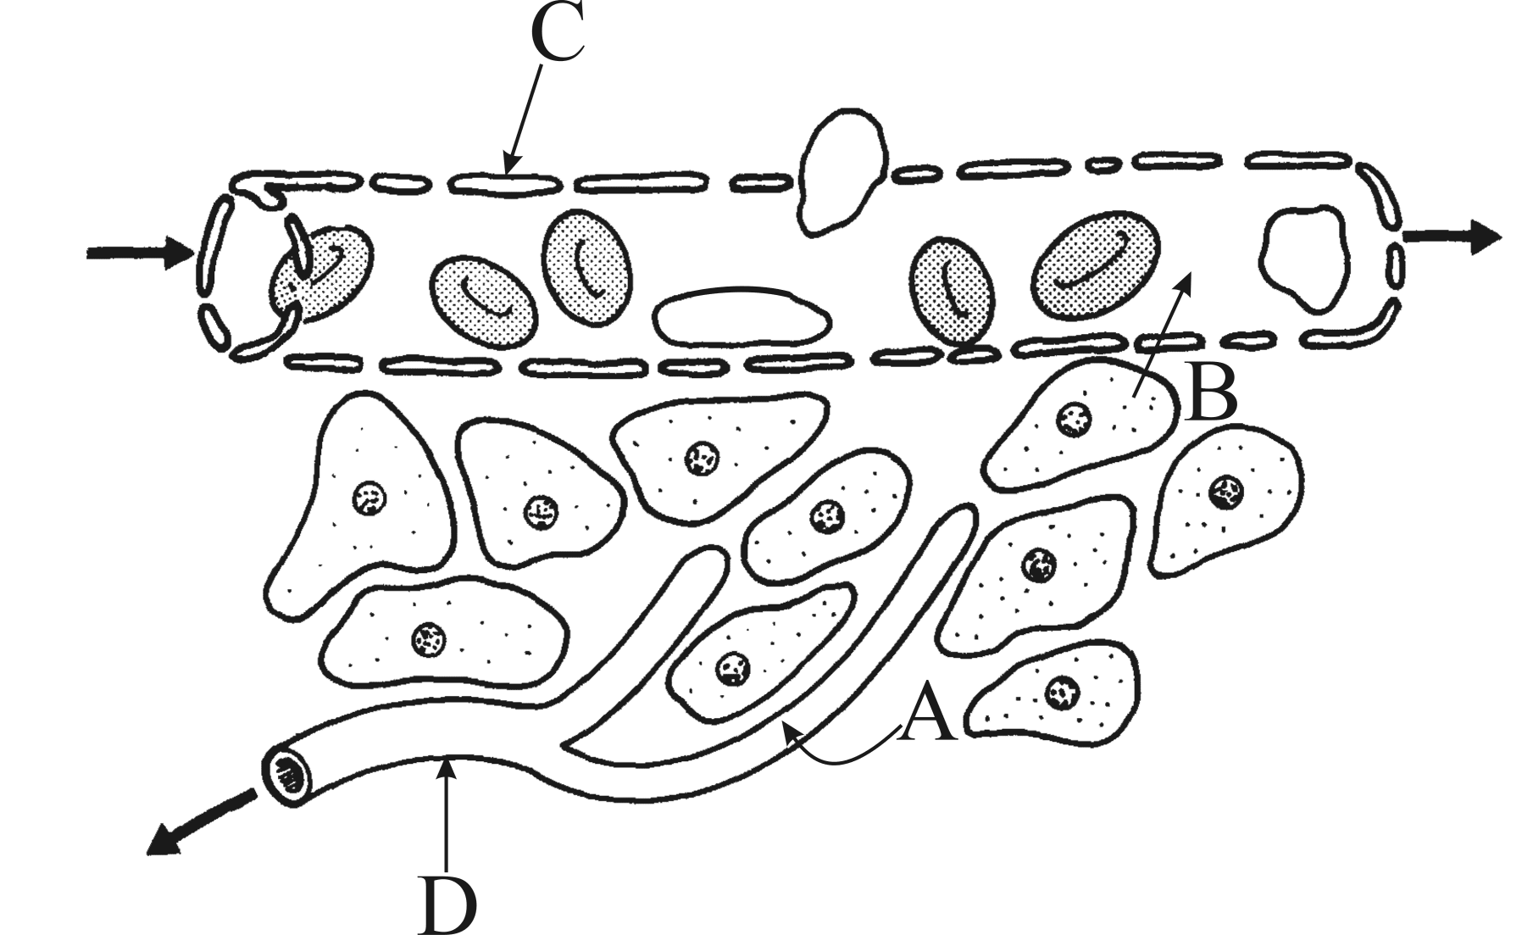

11. The substances referred to by the arrows labelled A and B in the diagram above are most likely to be, in order,

- carbon dioxide and glucose.
- glucose and carbon dioxide.
- water and glucose.
- water and carbon dioxide.

12. In the diagram above,

- C is a lymph vessel because it carries materials away from the cells.
- C is a blood vessel because it has valves.
- D is a lymph vessel because it is blind ended.
- D is a capillary because it contains red blood cells.
The next THREE questions refer to the graphs below which depict the volume of air breathed in and out by a runner before and immediately after starting a race.

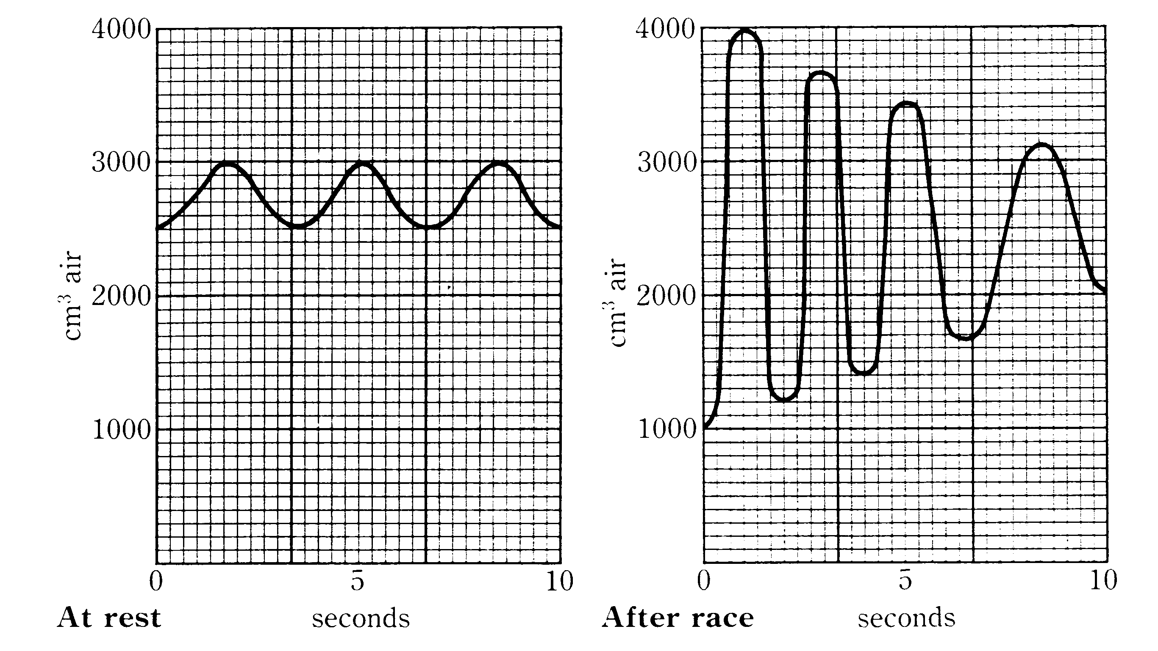

13. According to the graph above, how much air does the runner take in with each breath before the race?

- 100 cm³.
- 300 cm³.
- 500 cm³.
- 3000 cm³.

14. How many breaths does this runner breathe per minute before the race begins?

- 18.
- 16.
- 12.
- 3.

15. After the race, the runner

- only breathes more shallowly.
- only breathes faster.
- only breathes more deeply.
- breathes more deeply and faster.

16. Which of the following pairs of structures would BOTH be considered to be organs?

- Skeletal muscle and neurons.
- Cartilage and the heart.
- The stomach and skin.
- Blood and the pancreas.
The following question refers to the graph below showing a reaction taking place with and without substance X.

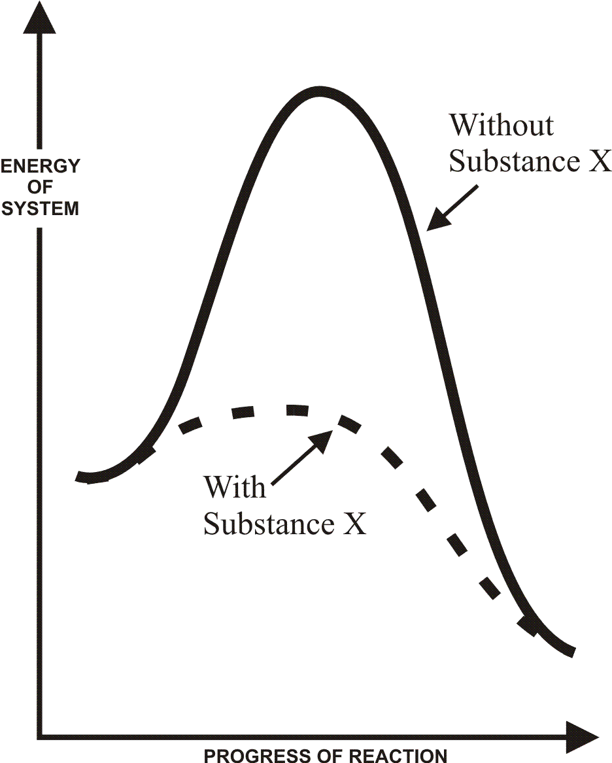

17. Substance X is most likely to be

- a hormone.
- an enzyme.
- glucose.
- oxygen.

The next question refers to the diagram below showing peristalsis taking place in the oesophagus.

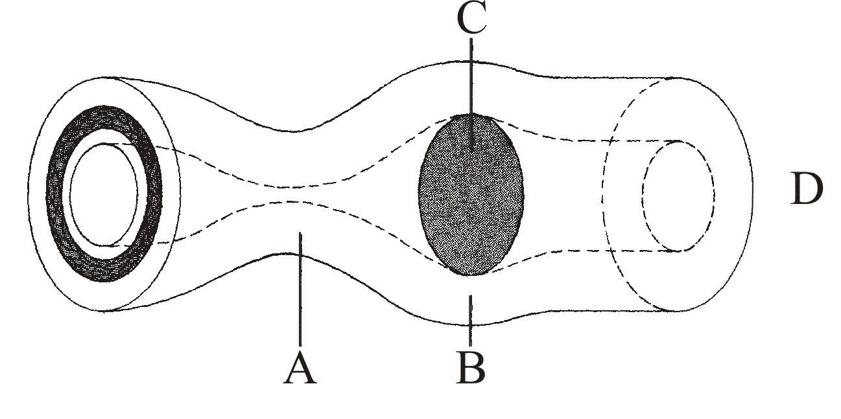

18. With reference to the diagram above, which of the following statements is CORRECT?

- The circular muscles at A are relaxed.
- The circular muscles at B are contracted.
- The structure labelled C is chyme.
- D takes food to the stomach.
The next question refers to the table of information below.

Vitamin | Food sources | Essential for | Deficiency disease
A | Sardines, green vegetables, milk | Growth, protection from infection | i)
B | ii) | Proper working of heart, nerves, muscles | Beri beri
C | Citrus fruits, nuts, tomatoes, onions | iii) | Scurvy
D | Eggs, milk, liver | Healthy bones, teeth | iv)

19. The table needs to be completed. Which of the following statements is INCORRECT?

- i) is night blindness.
- ii) most fruits and vegetables.
- iii) is wound healing, healthy gums and teeth.
- iv) is rickets.

20. Enzymes denature at

- very low temperatures only.
- body temperature.
- very high temperatures only.
- very low and very high temperatures.

21. Glycerol is the basic unit of

a) fats which are broken down by lipases.
b) carbohydrates which are broken down by amylases.
c) fats which are broken down by amylases.
d) carbohydrates which are broken down by lipases.

22. Villi increase the surface area of the

a) large intestine.
b) small intestine.
c) stomach.
d) caecum.
The next THREE questions refer to the diagram below of the male reproductive system.

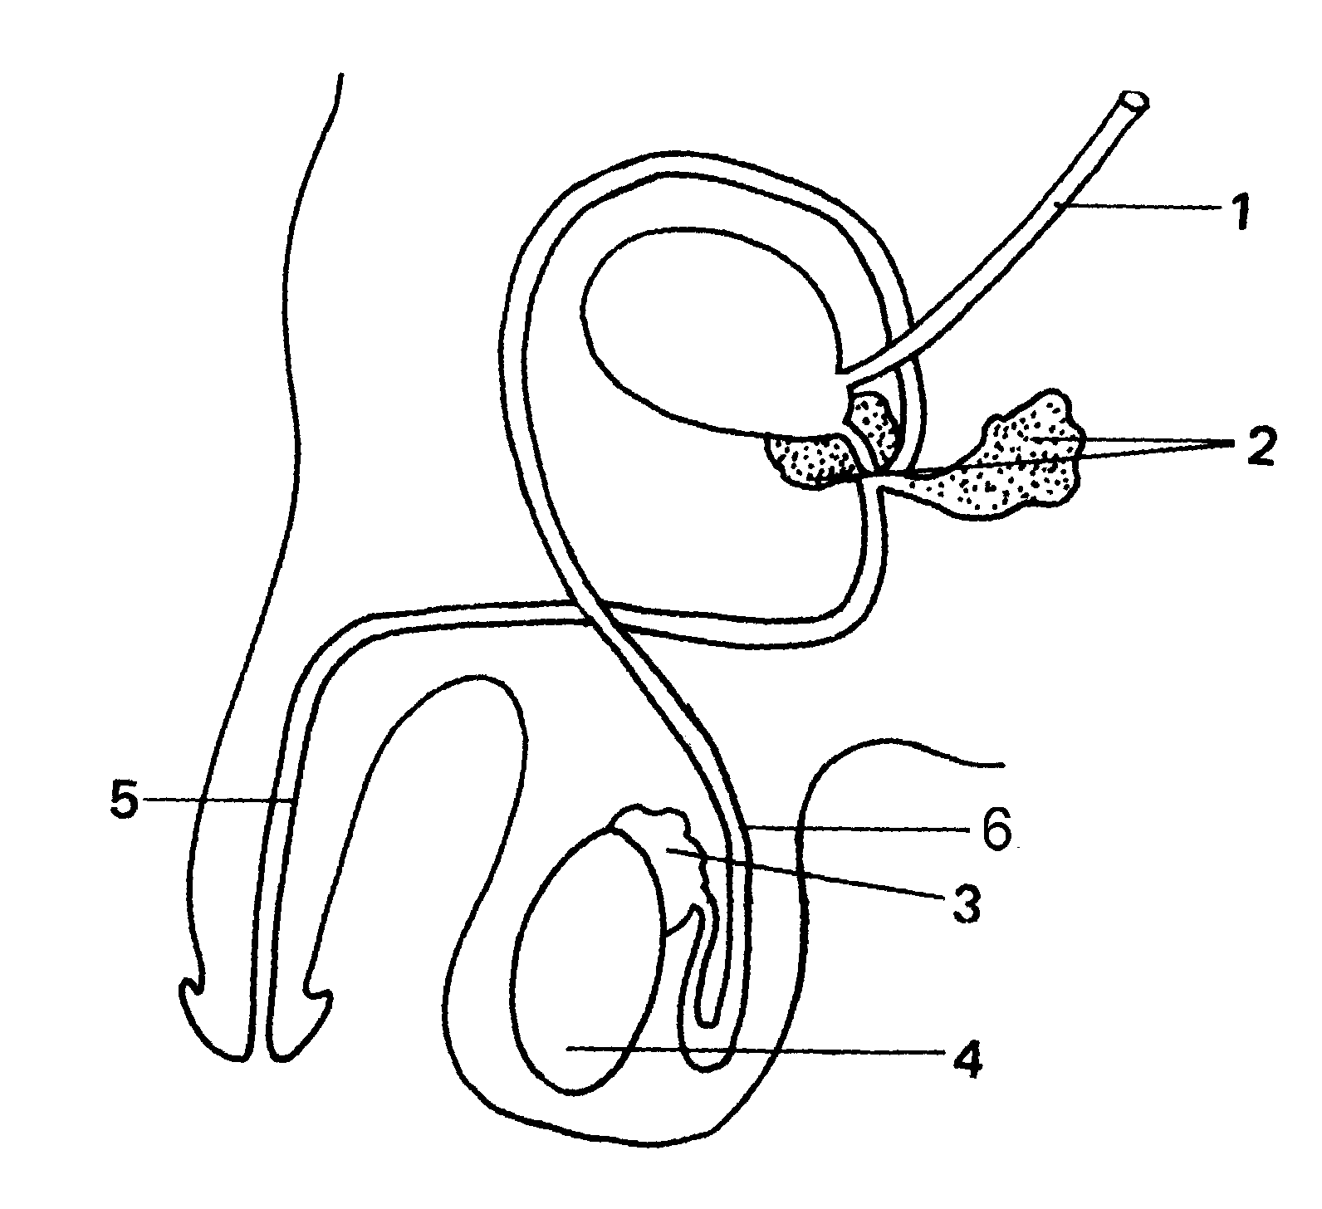

23. Sperm are produced in the structure labelled

- 4 and stored in the structure labelled 3.
- 3 and stored in the structure labelled 4.
- 4 and stored in the structure labelled 4.
- 3 and stored in the structure labelled 2.

24. Which of the statements below is CORRECT?

- Structure 6 carries semen only.
- Structure 6 carries sperm only.
- Structure 5 carries semen only.
- Structure 5 carries sperm only.

25. During a vasectomy,

- Structure 1 would be cut and the ends tied.
- Structure 6 would be cut and the ends tied.
- Structure 4 would be removed.
- Structure 5 would be cut and the ends tied.

26. A student viewed 108 cheek cells across a field of view of 2.7 mm. The
average diameter of each of these cheek cells would be closest to

a) 0.25 um.
b) 2.5 um.
c) 25 um.
d) 250 um.
27. A student observed four cells under a microscope using a 10X ocular and 4X
objective lens. If the student changed the objective to a higher power (8X), how any cells would then be seen?

a) 1.
b) 2.
c) 4
d) 8.

28. Which substance listed below can NOT pass from the mother’s blood to her
unborn baby’s blood across the placenta?

- Erythrocytes.
- Alcohol.
- Oxygen.
- Glucose.

29. The egg is fertilised

- before taking about 7 days to implant in the endometrium.
- whereupon it is now called a blastocyst.
- in the uterus.
- by two sperm if dizygotic twins are formed.

30. Twin studies, where identical siblings have been separated and raised apart, have
been used extensively to determine the nature of various characteristics, such
as intelligence. These studies are trying to determine whether intelligence is
due to

a) genetic factors only.
- environmental factors only.
- genetic and environmental factors.
- factors outside the control of the experiment.

31. The ductus arteriosus in the foetus

- joins the pulmonary artery and the aorta, diverting blood from the lungs.
- connects the right atrium and left atrium, diverting blood from the lungs.
- bypasses the liver of the foetus taking blood to the baby’s heart.
d) joins the left ventricle and right ventricle, diverting blood from the lungs.
The next question refers to the following information:

For fertilisation to occur, the sperm must meet the egg. Below is a list of processes that occur in males and females.

- muscular contractions of the urethra
- muscular contractions of the uterus
- sperm motility
- movement of cilia in the oviducts
- consistency of the cervical mucous

32. The process of fertilisation is aided by

- ii), iii) and iv).
- iii), iv) and v).
- ii), iii), iv) and v).
- i), ii), iii), iv) and v).

The next question refers to the following information:

The following reasons are given as to why mothers feed their baby milk.

- It can be done by either parent
- The milk is sterile
- The milk is at the correct temperature
- Feeding provides immunity against diseases
- The amount of milk consumed is known

33. Breastfeeding is preferred for feeding babies milk because of the reasons labelled

- i) and v).
- ii) and iii).
- iii), iv) and v).
- ii), iii) and iv).

34. Ectoderm gives rise to

- the nervous system.
- the linings of the reproductive system.
- skeletal muscles.
- most internal organs.

35. Which of the statements below associates the hormone with its correct function?

- Prolactin causes milk to be released.
- Oxytocin causes milk to be released.
- Oestrogen causes milk to be produced.
- Progesterone causes milk to be produced.

36. A child shows all of the following characteristics except one. Which one?

a) Sexual immaturity.
b) Slow growth pattern.
c) Requires parental care.
d) Rapid language development.

37. Which ratio shown below would most accurately approximate the length of the
head compared to the total body height for an adult?

a) 1:3.
b) 1:4.
c) 1:6.
d) 1:10.

38. One primate feature that is most developed in humans is the extended period of
infant dependency. This period of time is for all of the following reasons
except one. Which one?

- Ensuring language development can take place.
- Teaching the infant the social customs of the group.
- Education and personal development of the infant.
- The physical development of the infant.

39. Menopause is associated with all of the following symptoms except one. Which
one?

a) Mood swings.
b) Changes in body temperature.
c) Greater fertility.
d) Drying skin.

40. Senescence is

- characterised by a quick growth rate.
- a time of life when independence is achieved.
- when females stop menstruating.
- often associated with a loss of short term memory.

End of Part I
PART II [80 marks]

Answer all the questions in the spaces provided.
____________________________________________________________________

Question 41. [15 marks]

a) The contraceptive pill is widely used due to its low rate of failure. Using your
knowledge of female hormones, discuss how the pill prevents pregnancy from
occurring.

____________________________________________________________________

____________________________________________________________________

____________________________________________________________________

____________________________________________________________________

____________________________________________________________________
(4 marks)

b)
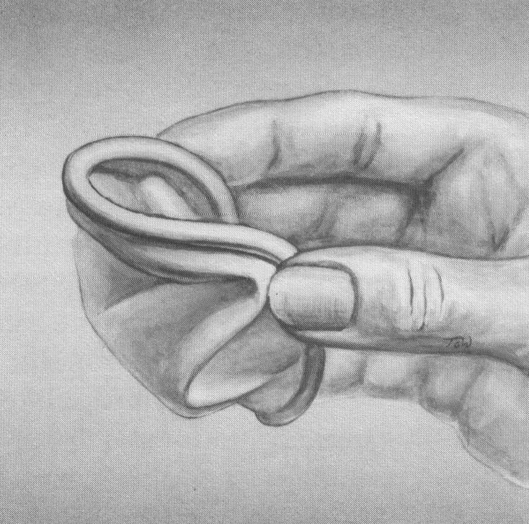

Name the method of contraception shown in the diagram above, and indicate its
mechanism of action.

________________________________________________________________

________________________________________________________________

________________________________________________________________
(2 marks)

c) The table below shows the relative failure rates for different contraceptives.
Complete the table with the appropriate method of contraception from the
following list:
tubal ligation, withdrawal, condom, intra-uterine device.

Method of Contraception | Number of pregnancies /100 women/year
i) | 0
Contraceptive pill | 0.1
ii) | 3
iii) | 5
iv) | 18 – 30
None | 50 – 80
(4 marks)

d) The graph below shows two hormones of the female menstrual cycle.

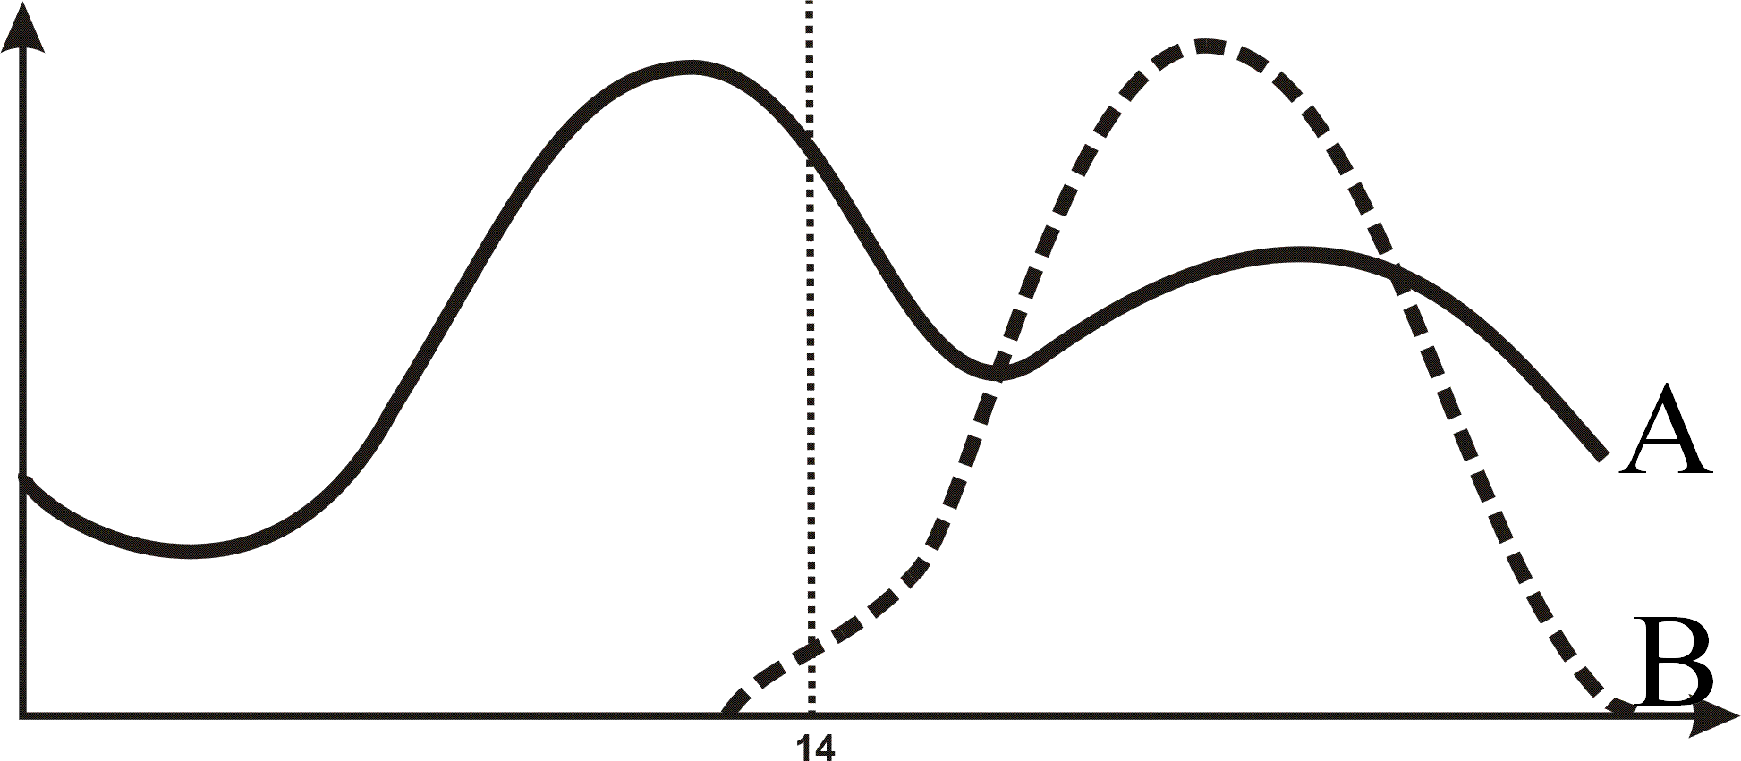

- Name the hormones shown in the graph above:

A _____________________________________________________________

B _____________________________________________________________
(2 marks)
ii) What structure produces both hormones A and B?

______________________________________________________________
(1 mark)

iii) The drop in hormones A and B trigger another hormone to be produced.
Name this other hormone and state the structure that produces it.

______________________________________________________________
(2 marks)

Question 42. [15 marks]

The following hypothetical cells are cuboidal in shape, with the same length, breadth
and height as indicated.

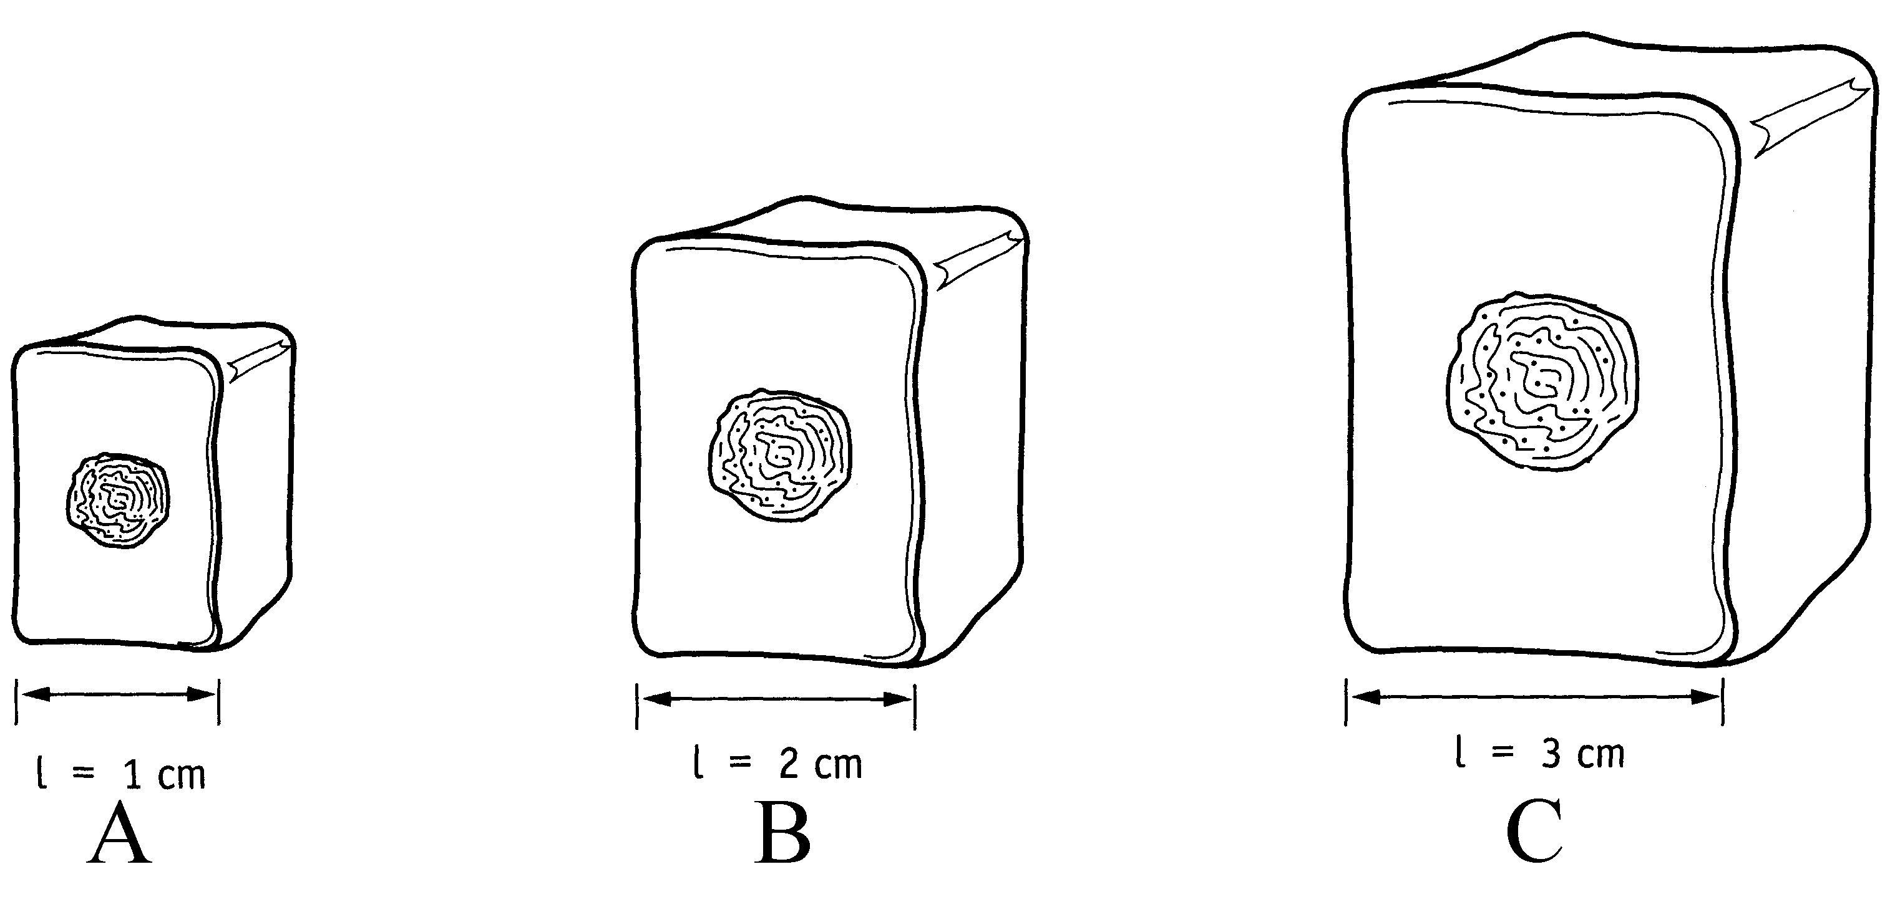

a) Which of the cells in the diagram above (A, B or C) would have the largest surface
area to volume ratio?

____________________________________________________________________
(1 mark)

b) Which of the cells in the diagram above (A, B or C) would supply its organelles
with the substances they require most efficiently?

____________________________________________________________________
(1 mark)

c) Name two inputs and two outputs of typical animal cells.

Inputs ______________________________________________________________

Outputs _____________________________________________________________
(2 marks)

d) Most animals are made up of many specialised cells. What are the advantages of
multi-cellularity and cell specialisation?

____________________________________________________________________

____________________________________________________________________

____________________________________________________________________

____________________________________________________________________
(2 marks)

- Complete the table below showing the various organelles and their functions.

Name of the Organelle | Diagram of the Organelle | Function of the Organelle
 | 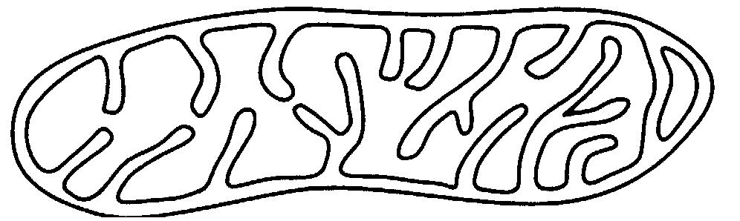
 | 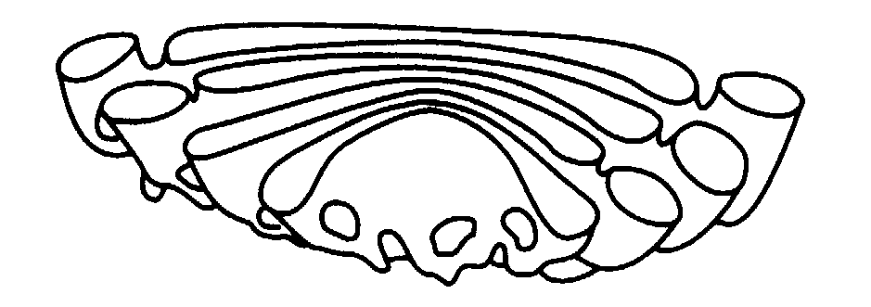
 |  | Transports protein around the cell
(3 marks)

f) Mitosis and meiosis are two cellular processes that are vital in animal cells.
Complete the table below showing the differences between these two
processes.

Feature | Mitosis | Meiosis
Number of daughter cells produced
Number of chromosomes in each daughter cell
What this process is used for

(6 marks)

Question 43. [14 marks]

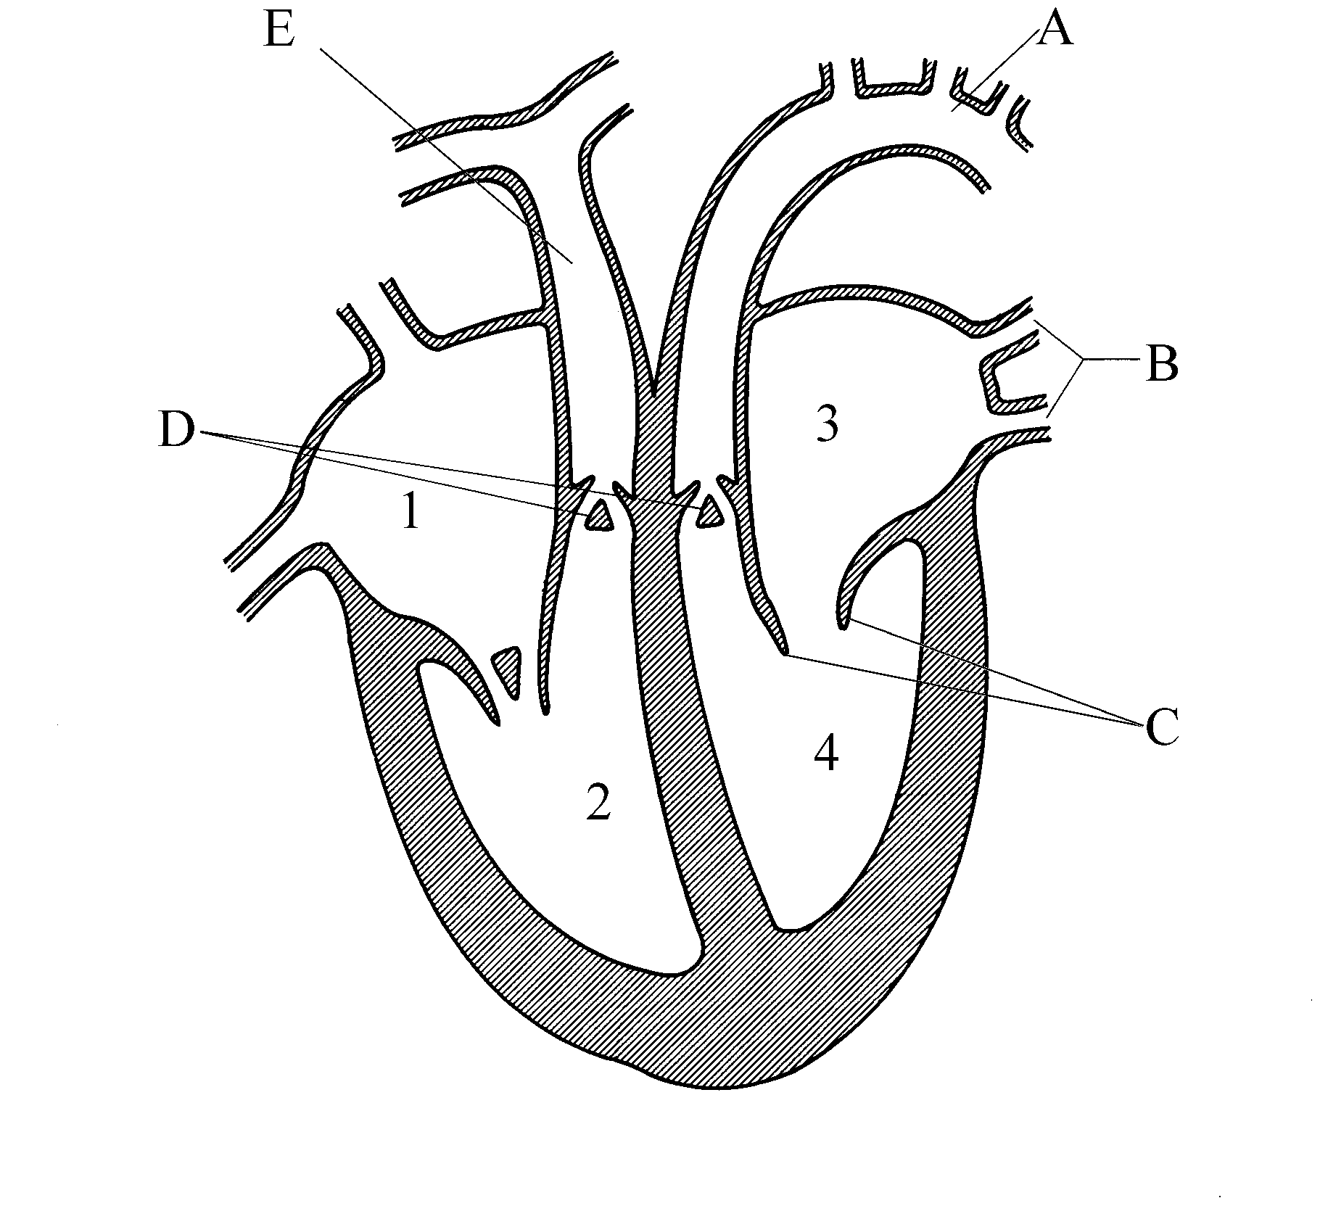

a) Compare the structure and function of the vessels labelled A and B in the diagram
above.

____________________________________________________________________

____________________________________________________________________

____________________________________________________________________

____________________________________________________________________
(4 marks)

b) Label the structures of the heart in the spaces below:

C _____________________________________________________________

D _____________________________________________________________

E _____________________________________________________________
(3 marks)

c) Describe how the heart muscle itself is supplied with blood.

____________________________________________________________________

____________________________________________________________________
(1 mark)

d) Which chamber (1, 2, 3 or 4) contains the most muscle tissue? Explain why this is
the case.

____________________________________________________________________

____________________________________________________________________

____________________________________________________________________
(2 marks)

e)
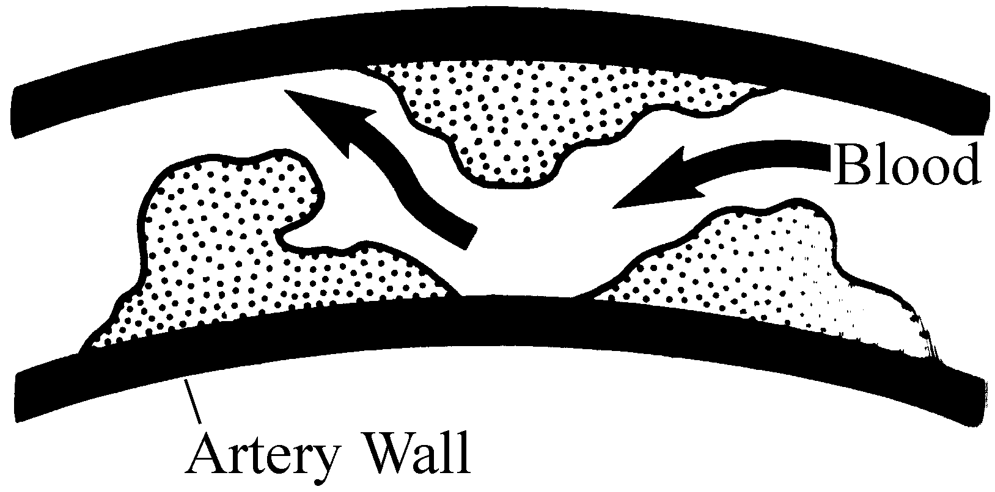

i) What condition is depicted in the diagram above?

______________________________________________________________
(1 mark)

ii) Name two factors that could contribute to making this condition worse.

______________________________________________________________

______________________________________________________________
(1 mark)
f) Describe two benefits of regular exercise.

____________________________________________________________________

____________________________________________________________________
(2 marks)

Question 44. [6 marks]

Enzymes play a major role in the process of cellular respiration, a process carried out
by all living cells.

a) Define the term enzyme.

____________________________________________________________________

____________________________________________________________________
(1 mark)

b) Write the word equation for the process of cellular respiration.

____________________________________________________________________
(1 mark)

c) Which body system would supply the requirements of cellular respiration to the
body’s cells?

____________________________________________________________________
(1 mark)

d) The process of cellular respiration contributes to a person’s metabolic rate.
Describe in general terms how a person’s metabolic rate would vary between
pregnant, breastfeeding and non pregnant women.

____________________________________________________________________

____________________________________________________________________
(1 mark)

e) State two factors that could occur during a typical day that could cause a person’s
metabolic rate to increase.

____________________________________________________________________

____________________________________________________________________
(2 marks)

Question 45. [13 marks]

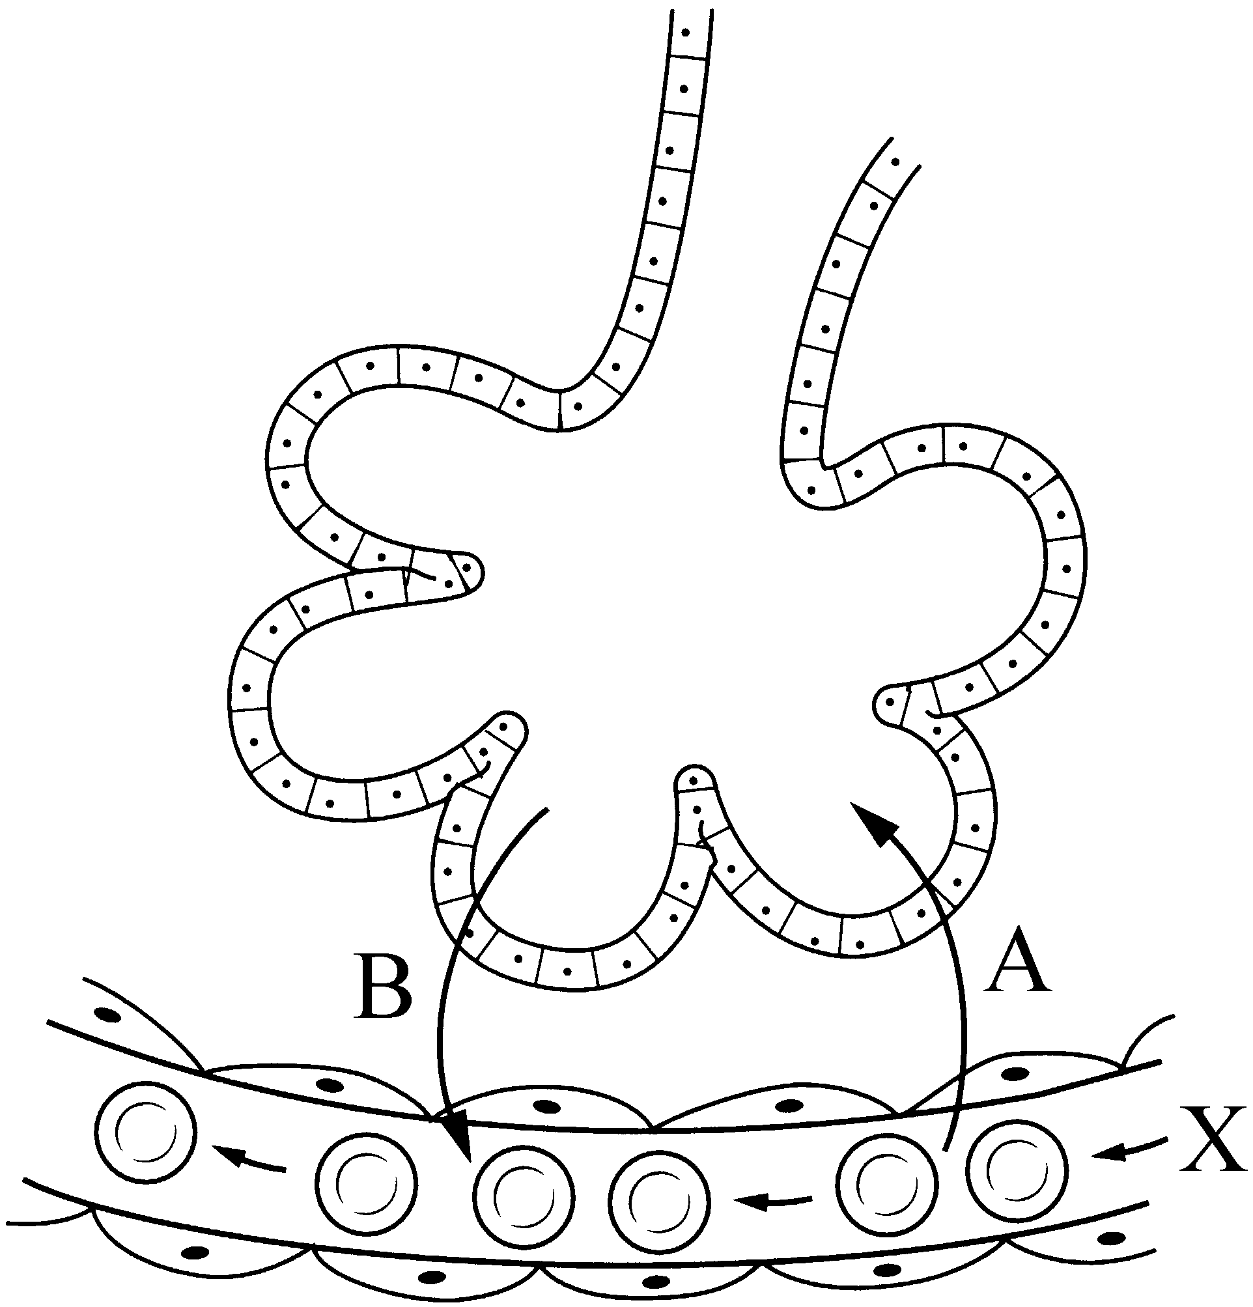

a) Name the substances indicated by the arrows labelled A and B.

A _____________________________________________________________

B _____________________________________________________________
(2 marks)

b) i) Name and define the process by which these substances, A and B, move.

____________________________________________________________________

____________________________________________________________________

____________________________________________________________________
(2 marks)

ii) State four features of the system shown in the diagram above that increases the
efficiency of the process just named.

____________________________________________________________________

____________________________________________________________________
(4 marks)

c) What term would be used to describe the type of blood found at the position
labelled X in the diagram?

____________________________________________________________________
(1 mark)

d) State the chemical stimulus that initiates breathing, and explain the process
whereby inhalation occurs.

____________________________________________________________________

____________________________________________________________________

____________________________________________________________________

____________________________________________________________________

____________________________________________________________________
(4 marks)

Question 46. [17 marks]

Recent studies have suggested a relationship between the incidence of asthma in
children and the degree of cleanliness of the house in which they lived as a child.

a) Discuss the condition, asthma, and indicate how it can be treated.

____________________________________________________________________

____________________________________________________________________

____________________________________________________________________

____________________________________________________________________
(3 marks)

b) Based on the information given above, write a possible hypothesis that the
scientists could be testing.

____________________________________________________________________

____________________________________________________________________
(1 mark)

c) Identify the dependent variable.

___________________________________________________________________
(1 mark)

A group of scientists followed 20 couples for 10 years. Ten of these couples formed Group A, and they were instructed to only wash floors and other surfaces with the cleaner provided, which was, in fact, scented water. The others, Group B, were also given a cleaner to use, with the same instructions, except their cleaning liquid had antibacterial properties.

During the course of the study, all couples had 1, 2 or 3 children. Both groups had either a dog, cat or both animals for the duration of the study, and they all lived in the metropolitan area.

Every year the scientists met each family and discussed the respiratory health of the children. Any diagnosis of asthma was confirmed by one specialist in the field who the scientists employed.

d) Write down two controlled variables.

____________________________________________________________________
(2 marks)

e) What is the scientific term given to the treatment Group A received?

____________________________________________________________________
(1 mark)

f) Give one reason, besides ease of access, why it would have been advantageous for
all the couples to live in the metropolitan area.

____________________________________________________________________

____________________________________________________________________
(1 mark)

The following data was collected by the scientists after the 10 years had elapsed.

 | Group A  (Water only) | Group B  (Antibacterial agent)
Number of children diagnosed with asthma | 5 | 18
Number of children  free from asthma | 13 | 4
TOTALS | 18 | 22

g) i) What percentage of each group developed asthma?

A _____________________________________________________________

B _____________________________________________________________
(2 marks)

ii) Graph the percentages of children with asthma on the graph paper below.
(5 marks)

h) What conclusion can be drawn from the data and graph above?

____________________________________________________________________

____________________________________________________________________

____________________________________________________________________
(1 mark)

End of Part II
PART III [20 marks]

Complete this section if you are doing a TWO AND A HALF HOUR EXAM.

Answer ONE question from Section A and ONE question from Section B. Write your answers on the lined paper at the end of this booklet. You may illustrate your answers with diagrams where appropriate. Up to two marks may be deducted for poorly structured answers such as answers in point form or diagrams not explained or discussed in the text of the answer. Do not write your answers in pencil.
____________________________________________________________________

SECTION A

ANSWER EITHER QUESTION 47 OR QUESTION 48 – NOT BOTH

47. The liver is the second largest organ in humans and it plays a major role in the
efficient functioning of our body. Discuss the various functions the liver
performs and identify how the organisation of the circulatory system assists in
this. (10 marks)

OR

48. The order primates is a diverse group of organisms who are classified together
because they share specific characteristics. Within the primate group are the
prosimians and the anthropoids. Using one example from each of these two
groups, discuss the primate features they have in common. (10 marks)

SECTION B

ANSWER EITHER QUESTION 49 OR QUESTION 50 – NOT BOTH

49. Gametogenesis produces cells very different to the typical human somatic or body cell. Compare the two forms of gametogenesis in regard to their process
and the products formed. (10 marks)

OR

50. Every year in Western Australia, hundreds of people die from conditions such as lung cancer and heart disease, often after a long period of suffering. Discuss the needs of the dying person, the stages they go through, and, ultimately, the signs of their death. (10 marks)

End of 2 1/2 Hour Examination

PART IV [40 marks]

Complete this section if you are doing a THREE HOUR EXAM.

Answer ONE question from Section A and ONE question from Section B. Write your answers on the lined paper at the end of this booklet. You may illustrate your answers with diagrams where appropriate. Up to two marks may be deducted for poorly structured answers such as answers in point form or diagrams not explained or discussed in the text of the answer. Do not write your answers in pencil.
____________________________________________________________________

SECTION A

ANSWER EITHER QUESTION 47 OR QUESTION 48 – NOT BOTH

47.
a) The order primates is a diverse group of organisms who are classified together because they share specific characteristics. Within the primate group are the prosimians and the anthropoids. Using one example from each of these two groups, discuss the primate features they have in common. (10 marks)

b) The BBQ is an Australian icon. Discuss the chemical digestion of a piece of steak as it moves through your digestive system. Include in your answer the sites, chemicals and products formed at each step. (10 marks)

OR

48.
a) The liver is the second largest organ in humans and it plays a major role in the efficient functioning of our body. Discuss the various functions the liver performs and identify how the organisation of the circulatory system assists in this.
(10 marks)

b) In one hot spell at Perth metropolitan beaches this year, there were 126 rescues and one spinal injury in one weekend alone. In one incident, a teenager was pulled unconscious from the water.

- Although his heart was beating, he was not breathing. Indicate the steps you would take to assist this person. (5 marks)

- During your treatment of this person, you determine that his heart has stopped beating. Discuss the steps you would take to treat this person now. (5 marks)

SECTION B

ANSWER EITHER QUESTION 49 OR QUESTION 50 – NOT BOTH

49.
a) Gametogenesis produces cells very different to the typical human somatic or body cell. Compare the two forms of gametogenesis in regard to their process and the products formed. (10 marks)

b) Every year in Western Australia, hundreds of people die from conditions such as lung cancer and heart disease, often after a long period of suffering. Discuss the needs of the dying person, the stages they go through, and, ultimately, the signs of their death. (10 marks)

OR

50.
a) Puberty tends to be a difficult time for the person involved and the rest of their family, particularly their parents! Discuss the role puberty plays in the physical, social and sexual development of the individual. (10 marks)

b) Certain sexually transmitted diseases, such as chlamydia and AIDS have become more common in teenagers in recent years, especially in western societies. Discuss the cause, effect, possible treatment and mechanisms of control for each of these two diseases in young people today. (10 marks)

End of 3 Hour Examination

____________________________________________________________________
____________________________________________________________________
____________________________________________________________________
____________________________________________________________________
____________________________________________________________________
____________________________________________________________________
____________________________________________________________________
____________________________________________________________________
____________________________________________________________________
____________________________________________________________________
____________________________________________________________________
____________________________________________________________________
____________________________________________________________________
____________________________________________________________________
____________________________________________________________________
____________________________________________________________________
____________________________________________________________________
____________________________________________________________________
____________________________________________________________________
____________________________________________________________________
____________________________________________________________________
____________________________________________________________________
____________________________________________________________________
____________________________________________________________________
____________________________________________________________________
____________________________________________________________________
____________________________________________________________________
____________________________________________________________________
____________________________________________________________________
____________________________________________________________________
____________________________________________________________________
____________________________________________________________________
____________________________________________________________________
____________________________________________________________________
____________________________________________________________________
____________________________________________________________________
____________________________________________________________________
____________________________________________________________________
____________________________________________________________________
____________________________________________________________________
____________________________________________________________________
____________________________________________________________________
____________________________________________________________________
____________________________________________________________________
____________________________________________________________________
____________________________________________________________________
____________________________________________________________________
____________________________________________________________________
____________________________________________________________________
____________________________________________________________________
____________________________________________________________________
____________________________________________________________________
____________________________________________________________________
____________________________________________________________________
____________________________________________________________________
____________________________________________________________________
____________________________________________________________________
____________________________________________________________________
____________________________________________________________________
____________________________________________________________________
____________________________________________________________________
____________________________________________________________________
____________________________________________________________________
____________________________________________________________________
____________________________________________________________________
____________________________________________________________________
____________________________________________________________________
____________________________________________________________________
____________________________________________________________________
____________________________________________________________________
____________________________________________________________________
____________________________________________________________________
____________________________________________________________________
____________________________________________________________________
____________________________________________________________________
____________________________________________________________________
____________________________________________________________________
____________________________________________________________________
____________________________________________________________________
____________________________________________________________________
____________________________________________________________________
____________________________________________________________________
____________________________________________________________________
____________________________________________________________________
____________________________________________________________________
____________________________________________________________________
____________________________________________________________________
____________________________________________________________________
____________________________________________________________________
____________________________________________________________________
____________________________________________________________________
____________________________________________________________________
____________________________________________________________________
____________________________________________________________________
____________________________________________________________________
____________________________________________________________________
____________________________________________________________________
____________________________________________________________________
____________________________________________________________________
____________________________________________________________________
____________________________________________________________________
____________________________________________________________________
____________________________________________________________________
____________________________________________________________________
____________________________________________________________________
____________________________________________________________________
____________________________________________________________________
____________________________________________________________________
____________________________________________________________________
____________________________________________________________________
____________________________________________________________________
____________________________________________________________________
____________________________________________________________________
____________________________________________________________________
____________________________________________________________________
____________________________________________________________________
____________________________________________________________________
____________________________________________________________________
____________________________________________________________________
____________________________________________________________________
____________________________________________________________________
____________________________________________________________________
____________________________________________________________________
____________________________________________________________________
____________________________________________________________________
____________________________________________________________________
____________________________________________________________________
____________________________________________________________________
____________________________________________________________________
____________________________________________________________________
____________________________________________________________________
____________________________________________________________________
____________________________________________________________________
____________________________________________________________________
____________________________________________________________________
____________________________________________________________________
____________________________________________________________________
____________________________________________________________________
____________________________________________________________________
____________________________________________________________________
____________________________________________________________________
____________________________________________________________________
____________________________________________________________________
____________________________________________________________________
____________________________________________________________________
Spare Graph paper if required:

ACKNOWLEDGEMENTS

Question 42 (diagram) Instant Lessons in Biology – Book 1 by
Question 42 (e) (diagram) Allan Burns. Reproduced by permission of Question 45 (diagram) Learning Essentials, Leichhardt, NSW.
Question 43 (diagram) Biology Today – A Course For First Examinations, by M D Robson and A G Morgan. Reproduced by permission of Macmillan Education Ltd.
Question 17 (diagram) AS and A Level Biology Through Diagrams,
Question 41 (d) (diagram) By W R Pickering. Reprinted by permission of Oxford University Press.
Questions 23 – 25 (diagram) Multiple Choice in Human Biology, by
Tse Kwok Wing. Reproduced by permission of Greenwood Press, Hong Kong.
Questions 3, 4 (diagram) Human Biology and Health, by Dorothy
Questions 11, 12 (diagram) Baldwin. Reproduced by permission of
Questions 13 – 15 (diagram) Pearson Education, UK.
Question 43 (e) (diagram)
Question 18 (diagram)
Question 41 (b) (diagram) What About Birth Control, by Jennifer
Angyal. Reproduced by permission of
Carolina Biological Supply Company, USA.

