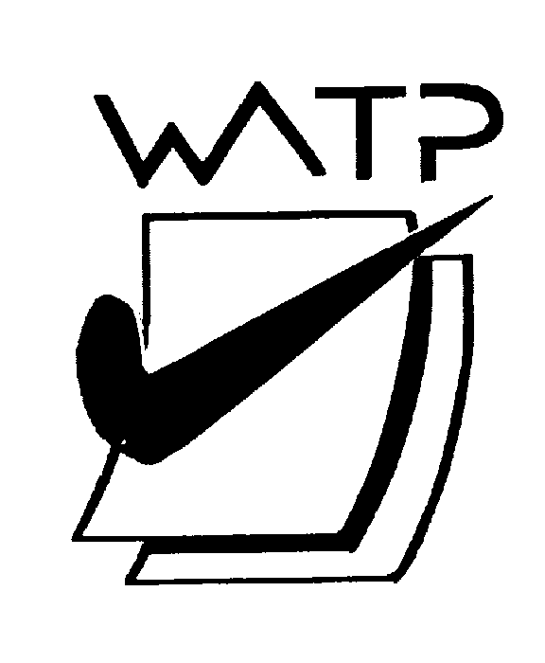

Multiple-choice Answer Sheet

Name:

INSTRUCTIONS

For each question shade the box to indicate your answer.
Use only a blue or black pen to shade the boxes.

For example, if b is your answer: a □ b ■ c □ d □

If you make a mistake, place a cross through that square and shade your new answer. Do not erase or use correction fluid/tape.

For example, if b is a mistake and d is your answer: a □ b ■ c □ d ■

If you then want to use your first answer b, cross out d and then circle b.
a □ b ■ c □ d ■
Marks will not be deducted for incorrect answers.
No marks will be given if more than one answer is completed for any question.

1 | a □ b □ c □ d □ |  | 11 | a □ b □ c □ d □ |  | 21 | a □ b □ c □ d □
2 | a □ b □ c □ d □ |  | 12 | a □ b □ c □ d □ |  | 22 | a □ b □ c □ d □
3 | a □ b □ c □ d □ |  | 13 | a □ b □ c □ d □ |  | 23 | a □ b □ c □ d □
4 | a □ b □ c □ d □ |  | 14 | a □ b □ c □ d □ |  | 24 | a □ b □ c □ d □
5 | a □ b □ c □ d □ |  | 15 | a □ b □ c □ d □ |  | 25 | a □ b □ c □ d □

6 | a □ b □ c □ d □ |  | 16 | a □ b □ c □ d □
7 | a □ b □ c □ d □ |  | 17 | a □ b □ c □ d □
8 | a □ b □ c □ d □ |  | 18 | a □ b □ c □ d □
9 | a □ b □ c □ d □ |  | 19 | a □ b □ c □ d □
10 | a □ b □ c □ d □ |  | 20 | a □ b □ c □ d □

