ARANMORE CATHOLIC COLLEGE

YEAR 11 PHYSICS 2A2B

PRACTICAL TEST – ELECTRICITY

NAME: _____________________________ Marks:
/25

Resistivity

Aim
To determine the resistivity of a conducting wire.

Background

The resistivity of a conductor of resistance, R (Ω), length, L (m), and cross-sectional area, A (m²), is:
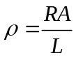.
Resistivity is a characteristic of the type of material that the conductor is made.

Equipment Required

1 m nichrome wire, ammeter, voltmeter, rheostat (you will use a 22 Ω resistor instead), leads, power supply, metre rule, micrometer, globe.
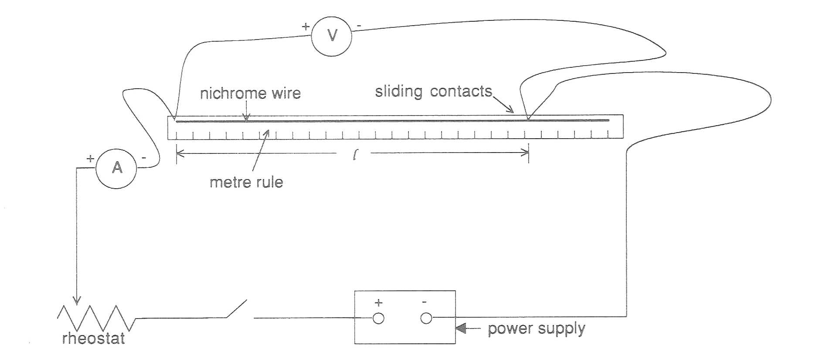
Circuit Diagram

Procedure
- Set up the apparatus as shown in the diagram.

- Use the micrometer screw gauge to determine the diameter (and hence the area) of the nichrome wire. (Hint: consider ways to reduce random error.)

- Set the power supply to 6 V.

- Attach the alligator clips so that 0.80 m of wire is used.

- Record the potential across the length of wire and the current through the wire.

- Repeat this for different lengths of wire, 5 measurements are ideal.

Results:

Diameter: [3 marks]

Area Calculation: [2 marks]

Table 1: Measurements and calculations:

L (m) | P.D. (V) | Current (A) | R of wire (Ω)

Analysis:

- Complete the table above. [7 marks]

Analysis (Continued):

- Draw a graph using appropriate values from your Table. [5 marks]
- Using information from your graph determine the value of ρ. [4 marks]

- Compare your value with the accepted value of 1.0 x 10⁻⁶ Ω m. [2 marks]

- Describe the relationship shown by your graph. [2 marks]

***********************

END OF TEST

