YEAR 11 – PHYSICS 2A2B

ASSIGNMENT 3: NUCLEAR PHYSICS

NAME: DUE DATE: 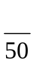

1. Which one of the following best describes the part of an atom from which beta particles (β⁻) originate? [2]
A the electron cloud
B a decayed neutron
C a decayed proton
D none of the above

2. Which one of the following best describes the relative speeds at which alpha, beta and gamma particles travel after being emitted from radioisotopes? [2]
A Alpha is the fastest, followed by beta and then gamma.
B Beta is the fastest, followed by gamma and then alpha.
C Gamma is the fastest, followed by alpha and then beta.
D Gamma is the fastest, followed by beta and then alpha.

3. The activity of a sample of iodine -131 is initially 8.0 x 10¹¹ Bq. Given that ¹³¹I has a half-life of 8.0 days, which one of the following best describes its activity after 28 days? [2]
A 1.0 x 10¹¹ Bq
B less than 1.0 x 10¹¹ Bq
C less than 0.5 x 10¹¹ Bq
D 0.5 x 10¹¹ Bq

4. Determine the atomic and mass numbers for particle X in this decay equation. [2]

5. Write an equation for the beta (β⁻) decay of thorium-218. [4]

6. Carbon-14 is a radioisotope and a β⁻ emitter. By discussing the composition of the nucleus, explain why this isotope is unstable. [2]

7. The following diagram is of a thermal nuclear power plant.

a) Explain the function of the concrete shield around the reactor core. [2]

b) Explain the function of the control rods. [2]

c) Explain the function of the coolant. [2]

d) What would happen if the coolant in the reactor stopped flowing through the reactor core? [3]

8. A sample of the radioisotope arsenic-33 has a half-life of 26 hours and an activity of 4.00x10¹⁰ Bq. The sample is divided into two equal portions.

a) What would the half-life of each portion be? Explain briefly. [2]

b) What would the activity of each portion be? [2]

9. A 70 kg male who died from radiation exposure received a dose equivalent of 12 Sv from an alpha emitting radioactive source.

a) Calculate the total amount of energy that was absorbed from the radioactive source. [2]

b) Calculate the dose equivalent if the radioactive source was a beta emitter. [2]

c) What would have been the likely effect on this person if it had been a beta emitter? [1]

10. One particular fission reaction of uranium-235 is:
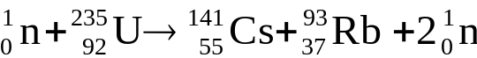

mass(uranium-235) = 3.90305 x 10^{–25} kg; mass(caesium-140) = 2.33979 x 10^{–25} kg;
mass(rubidium-93) = 1.54152 x 10^{–25} kg; mass(neutron) = 1.67495 x 10^{–27} kg

a) Calculate the mass that has been transformed into energy during this process. [3]

b) How much energy (in joules) is released by this fission reaction? [2]

c) Determine the percentage of the initial mass of uranium that is lost. [2]

d) If a 15 kg lump of pure uranium-235 completely underwent fission, how much energy would be released? Give your answer in J and MeV. [4]

11. a) Add to the diagram below and use it to help describe the type of chain reaction that is needed to produce an explosion in a nuclear fission bomb. Label the main parts of the diagram. [4]

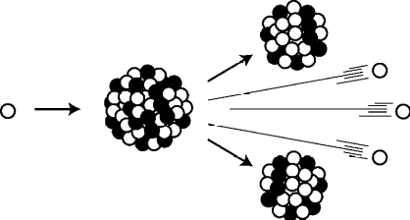

Explanation:

b) Explain why a 4 kg spherical piece of uranium-235 will spontaneously explode, but a 4 kg piece in the shape of a long cylindrical rod will not. Refer to diagram in your explanation.
[3]

