ARANMORE CATHOLIC COLLEGE
YEAR 11 ATAR PHYSICS - 2015
TEST 1: MOTION

/50
NAME: ___________________________ MARK:

Instructions:
- Answer all questions in the spaces provided.
- Show full working out to get marks as shown in brackets after each question.
- Answers should show correct use of significant figures.

Note: Acceleration due to gravity is 9.80 m s⁻²

Questions:

- The position - versus - time graph, which is shown below, describes the motion of five different objects which are labelled A to E.
[4 Marks]
a) Which two objects start from the same position, but at different times?
b) Which two objects start at the same position and at the same time?
c) Which two objects have the same speed, but different velocities?
d) Which of the five objects has the lowest speed?

A
B
C
D
Time
Position

E

- Two bus stops, X and Y, are 2.10 km apart. A bus starts moving from bus stop X towards Y. The bus accelerates at a constant rate over the first 56.0 m to reach a speed of 14.0 ms⁻¹ and then travels at a constant speed for most of the trip. As the bus nears bus stop Y, it begins to decelerate at an average rate of 1.4 ms⁻² until it comes to rest at the bus stop.
The line shown below represents the three stages of the bus's motion.
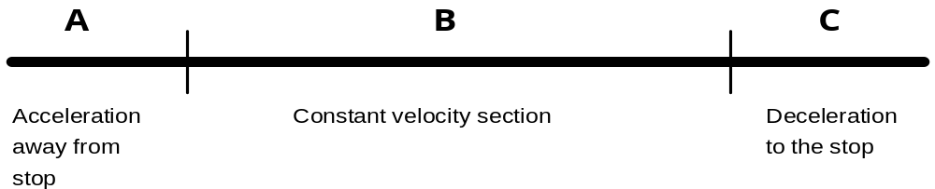
a) What was the acceleration during section A? [3 marks]

- What distance and time did the bus take to stop after braking (section C)?
[5 marks]

c) What is the distance of section B? [2 mark]

d) What was the total time for the trip (X to Y)? [3 marks]

- A hot air balloon is rising vertically at 5.1 ms⁻¹ when an apple is accidentally dropped overboard. The balloon was 102 m above the ground when the apple was dropped.

(a) Does the apple start to fall towards the ground immediately after it is dropped, or does it continue to move upwards initially? Explain your answer briefly.
[2 marks]

(b) Calculate the velocity of the apple at impact with the ground.
[3 marks]

(c) How long does it take for the apple to reach the ground?
[3 marks]

4. A bush walker covers 6.50 km northeast in 60.0 minutes, then moves 4.50 km northwest in 45.0 minutes.

(a) Calculate the distance covered by the walker during this time.
[1 mark]

(b) What is the displacement of the person for this movement?
[3 marks]

(c) Determine the average speed of the walker.
[3 marks]

(d) What is the average velocity of the person?
[2 marks]

5. A motorbike, travelling at 10.0 ms⁻¹ along a straight road, accelerates at 2.00 ms⁻² for 10.0 s. It then maintains this velocity for 15.0 s before braking uniformly for a further 5.00 s to reduce its speed to 15.0 ms⁻¹. The motorbike then continues at this velocity along the road.

(a) Draw a velocity-time graph for the motion described. The time scale needs to run to at least 40.0 s. The scales need to be drawn accurately.
[4 marks]

(b) Determine the deceleration experienced by the rider whilst reducing speed.
[3 marks]

(c) How far has the rider travelled after 40.0 s?
[4 marks]

6. Determine: (i) the change in speed and (ii) the change in velocity of each of the following situations.

a) The driver of a car heading north along a freeway at 95 km h⁻¹ slows down to 45 km h⁻¹ as the traffic gets heavier. [2 Marks]

b) A car moving east at a speed of 20 ms⁻¹ turns right and heads south at 15 ms⁻¹.
[3 Marks]

***************************************

END OF TEST

