ARANMORE CATHOLIC COLLEGE

YEAR 12 PHYSICS 3A3B

ASSIGNMENT 4 - SOUND

NAME: __________________________________ MARK:
/40

- The diagram below shows how the sound level varied with time when a note was played on a particular musical instrument.

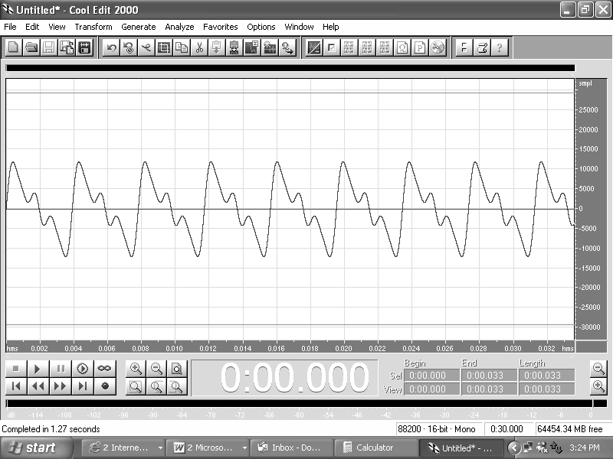
TIME AXIS
(s)
  - Is the note a “fundamental note” or are there other harmonics present? Explain. [3]

  - Given that the time axis units are seconds. Estimate the frequency of the note. [3]

  - When a section of an orchestra comprising 15 musicians is playing the same instrument as above, the sound level recorded approximately 10 metres away is 86.0 dB. Assuming that each musician is playing at about the same amplitude, what would the sound level be during a duet of these musicians? [5]

  - Estimate the acoustic power output of just one of the above musicians. [4]

  - Although music is a subjective phenomena, in physics there is a clear distinction between music and noise. Explain this distinction and use it to decide if the above output is music or noise. [4]

- Bats emit ultrasonic waves. The shortest wavelength emitted in air by a bat is about 3.3mm.

  - What is the highest frequency that this bat can emit? [3]

  - Would humans be able to hear these sounds? Explain your answer. [3]

  - Dolphins use similarly high frequency sounds to navigate, however, they are unable to detect similar sized objects as bats. If they both use the diffraction of sound to do this, explain, with a calculation, this difference. [6]

- The effective length of the ‘A’ string on a guitar is 74.0 cm.

a) When sounded, the ‘A’ string produces at least the first three harmonics. On the axes below sketch the standing waves (one on top of the other), for all three harmonics (label them). [4]

b) If the speed of propagation of a wave along the ‘A’ string is 296 ms⁻¹, calculate the frequencies of these harmonics. [5]

