ARANMORE CATHOLIC COLLEGE

YEAR 12 PHYSICS 3A3B - 2012

PRACTICAL TEST: TORQUES AND EQUILIBRIUM

NAME: ____________________ MARK:
/25

Static Equilibrium

Aim:
To study the turning effect of a force (the moment of a force or the torque), and to investigate the equilibrium of a beam under the action of a number of forces.

Materials:

Slotted masses Retort stand Nail Metre rule

Method:

- Attach the ruler to the retort stand with the nail, so that the ruler is free to rotate. Check if the ruler balances on its own, if not, put some blue-tac on one side until it balances.

- Suspend weights on either side of the ruler; adjust the amount and distance of the weights to balance the ruler.

- Repeat these steps to obtain 3 sets of data suitable for calculating torques and record them in an appropriate table (leave room for 5 additional columns for analysis).
[5 marks]
Accuracy [3 marks]
Error [1 mark]

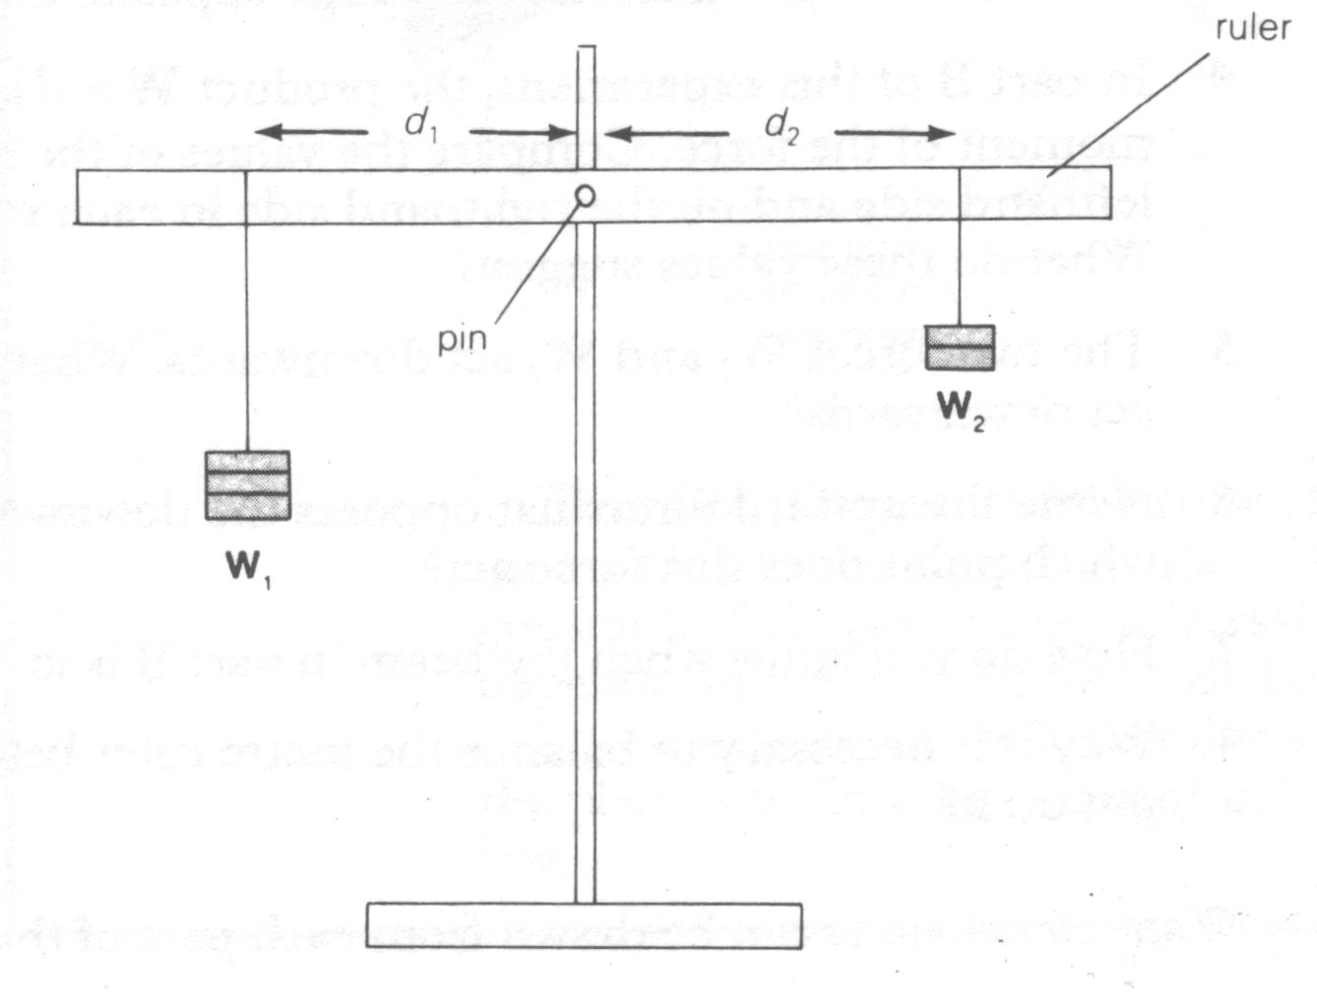
Figure 1: Apparatus
for measuring
F₂
torques
F₁

Analysis:

- In your table include values for clockwise and anticlockwise torques and sum of forces up and down.
[4 marks]

- Compare your forces, do your results reflect Translational Equilibrium?
[2 marks]

- Compare your torques, do your results reflect Rotational Equilibrium?
[3 marks]

- How did you know the ruler was ‘in equilibrium’?
[1 marks]

Conclusion:

Write an appropriate conclusion/discussion for this experiment.
[6 marks]

