ARANMORE CATHOLIC COLLEGE

YEAR 12 PHYSICS 3A3B - 2012

TEST 3: - ELECTROMAGNETISM

NAME: _______________________________________ MARK:
/50

Instructions:

- Answer all questions in the spaces provided.
- Show all working out to get full marks as shown in brackets after each question.
- Answers should be in decimal form and show correct use of significant figures.
- Scientific calculators as per Curriculum Council guidelines are permitted.
- Where practical, answers must be in blue or black ink.

QUESTIONS:

- On the diagram of the earth below, draw the Earth’s magnetic field. (3 marks)

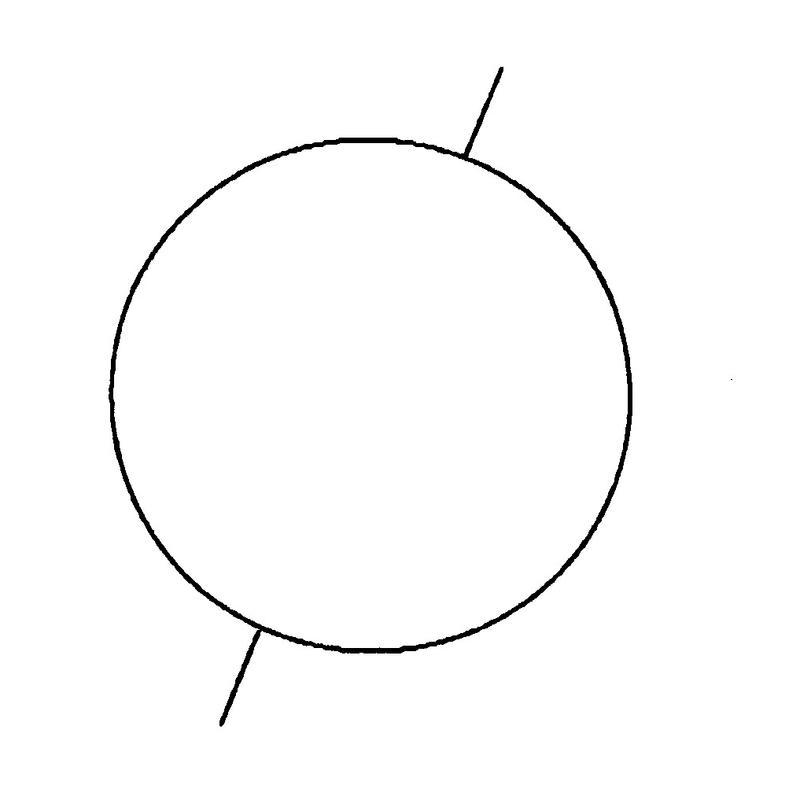

- Estimate the magnitude of the force acting on the 10 A wires in your place of residence, if they are perpendicular to the field of the earth (B_{e} = 6.0 x 10⁻⁵ T). How will the force on the actual wires in your residence differ from this value and give two reasons why they will differ?
(4 marks)

- (a) A magnetized needle is placed on a piece of polystyrene and floated in the middle of a container of water. Describe the motion of the needle until it comes to rest and explain your answer.
(3 marks)

- Explain why the needle of a cheap compass in Perth is not quite in the horizontal plane. In which way does it dip – does the north or south end of the compass dip downwards? Is there anywhere on the earth that the needle of this compass would be horizontal?
(3 marks)

- Determine the direction of the resultant magnetic field due to the following identical bar magnets or the current-carrying conductors, at each of the points A, B, C and D.
(4 marks)

CONDUCTORS:

(a)
A

(b)
B

BAR MAGNETS:

(c) N S • S N
C

(d) D • N S

N

S

- A simple transformer is illustrated below:

240 V

12 V

A

0.10 A
1000 turns

(a) Determine the reading on the ammeter and the number of secondary coils, assuming 100% efficiency.
(4 marks)

(b) What are eddy currents? Explain their effect on a transformer.
(3 marks)

- Lucas was required to build a simple DC motor as part of a laboratory investigation. He wound a rectangular coil of 20 turns to make a coil with a length of 0.05 m and a width of 0.04 m. The coil was pivoted in the centre so that it could rotate around the axis as shown by the dotted line in the diagram below. A current of 2.00 A (from P to S through the coil) was used and the field in the region of the coil had a uniform strength of 6.00 x 10⁻¹ T.

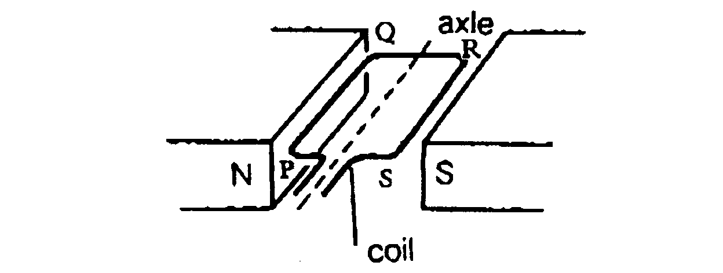

(a) On the side marked RS of the coil, indicate the direction of the force by drawing an arrow on the diagram. Calculate the magnitude of the force. (Show all working.)
(4 marks)

(b) The coil is stationary in the position shown on the diagram, but begins to rotate when the current is turned on. Explain how this happens when the total force acting on the coil is 0 N.
(3 marks)

(c) Explain three ways that Lucas could increase the speed of the coil.
(3 marks)

(d) Explain how this arrangement could be modified by Lucas to make a generator.
(3 marks)

(e) Explain the role of Faraday’s law and Lenz’s law in the generator.
(4 marks)

- An electrical power station produces electricity at 16 kV, but steps up the voltage to 330 kV before transmitting it to a small city 120 km away. The station uses a 200 MW generator to provide the city’s power supply.

(a) Calculate the percentage power loss from the power station to the city if the average resistance in the transmission cables is 1.2x10⁻⁴ Ω m⁻¹.
(4 marks)

(b) Explain why the power station steps up the voltage to 330 kV before transmitting electricity to the city.
(2 marks)

(c) Why do the transmission cables from the power station have a much larger diameter than the cables which supply electric power direct to our homes?
(3 marks)

******************************************************************

END OF TEST

