NAME: _________________________________
/50

ARANMORE CATHOLIC COLLEGE

YEAR 12 PHYSICS - 2012

TOPIC TEST - SOUND

Instructions:

- Answer all questions in the spaces provided.

- Show all working out to get full marks, shown in brackets after each question.

- Data/Formulae: (At 25°C) Speed of sound in air = 346 ms⁻¹, Speed of sound in water = 1500 ms⁻¹
f_{beat} = ǀf₂-f₁ǀ ; L = 10log(I/I_{o}) ; P = IA.

QUESTIONS:

- Steven and Travis are at the swimming pool to conduct an experiment on sound. Steven hits the metal pool ladder at one end of the pool with a hammer, while Travis records his observations at the other end of the pool. The sound travels through both the air and the water. Estimate the difference in the times of arrival of the two sounds as recorded by Travis. [4 marks]

- While studying physics one evening with some music playing, Maddie notices that a small vase begins to rattle and vibrate. However, it only does this when a certain part of the music plays. Explain why the vase vibrates and why it only occurs at particular points in the music.
[3 marks]

- A guitar string is plucked at the same time as a tuning fork of frequency 435.0 Hz is struck and 25 beats are heard every 10 seconds. The same guitar string is then sounded at the same time as a second tuning fork of frequency 436.5 Hz and 20 beats are heard every 5 seconds. What is the frequency of this guitar string? [4 marks]

- Explain why different musical instruments, for example a violin and a recorder, sound different even if they are both played at the same pitch. [2 marks]

- The fundamental frequency of a closed tube instrument is found to coincide with that of another instrument, which is an open tube. Explain how this is possible, using a diagram to illustrate your answer. [3 marks]

- Draw a neat sketch below of a transverse wave and on it show the following:
[1 mark]
- The amplitude of the wave (label with an A)
- The wavelength of this wave (label with a B)
- Clearly show two points that are in phase (label both C)
- Indicate a point that is momentarily stationary (label D)
- Label a particle that is moving up (label E)
- Label a particle that is moving down (label F) [6 marks]

- A violin, guitar, piano and cello are all stringed instruments; assume one of the strings on such an instrument has a length of 62.5 cm. The speed of the waves in the string is about 375 ms⁻¹.

a) Explain using this situation, the conditions necessary for the formation of standing waves in strings. [3 marks]

b) Sketch the standing waves for, and determine the frequencies of the first two harmonics of the string. [4 marks]

- Mahdi measures the sound level at the side of a busy road to be 91 dB when eight trucks are passing him at the same time. If the trucks are each contributing about the same level of sound, what would the sound level be if only one truck passed at one time? [3 marks]

- 10 m from the space shuttle the sound level is 180 dB. Ignoring the effects of reflection and absorption of the sound find the sound intensity at a distance of 1 km? [3 marks]

- The music at an outdoor concert is being played in phase from two speakers which are 12 m apart. A sound engineer determines that, for a particular frequency, there are 40 points of minimum intensity (destructive interference) along the middle row of seats, with maxima at each end. If the middle row is also 12 m long and situated directly in front of the two speakers at a distance of 16 m, calculate the frequency that the sound engineer used to test the acoustics.
(Assume the speed of sound in air is 340 ms⁻¹).
[5 marks]

SECTION B. COMPREHENSION 9 MARKS
“Hearing aid hives off howl with antisound”
Profoundly deaf people often endure howling and whistling from their hearing aids because they are turned up so high, but an aid launched in Britain last week attacks this problem using antisound. The technique is similar to that used in satellite telephone links: echoes are cancelled out with an identical sound 180° out of phase: the peaks of one sound wave meet troughs of the other, cancelling each other out. (Para. 1)

People who are profoundly deaf have to amplify sound to a degree which would be painful to normal ears. Some of the sound generated by traditional hearing aids is echoed back out of the ear and picked up again by the aid’s microphone. This feedback effect quickly builds up the echo into an intolerable howl or whistle. (Para. 2)

The noise can be reduced in a hearing aid by cutting out all sounds with frequencies over about 1 kilohertz. But this cuts out many useful every day noises. The hearing range for normal ears is between 20 hertz and 20 kilohertz. (Para. 3)

Last week, GN Danavox, a Danish telecommunications company, and British consultancy Scientific Generics launched a hearing aid that cuts out the echo without cutting out high frequency sounds. GN Danavox says the aid, called DFS Genius, can amplify sounds up to about 4 kilohertz. It will be available in Britain next month. By cutting out the echo with antisound, the aid stops feedback before it can begin. But detecting the echo and generating the antisound quickly enough is difficult. The aid does this by generating a test signal in the form of white noise that is too quiet to be heard. It emits the test signal into the user's ear along with the amplified sound. The test signal is echoed along with the rest of the sound and re-enters the aid through the microphone. (Para. 4)

The aid analyses the incoming sound and compares it with the original test signal to identify how much echo there is and what the time delay is. With this information, it can predict what antisound it will need to generate to cancel out the echo of the ambient sound a thousandth of a second later. (Para. 5)
The analyser passes its predicted antisound to a filter which adjusts the amplified sound signal sent to the loudspeaker. The speaker emits all the required sounds together; the ambient sound, the antisound and the test signal. (Para. 6)
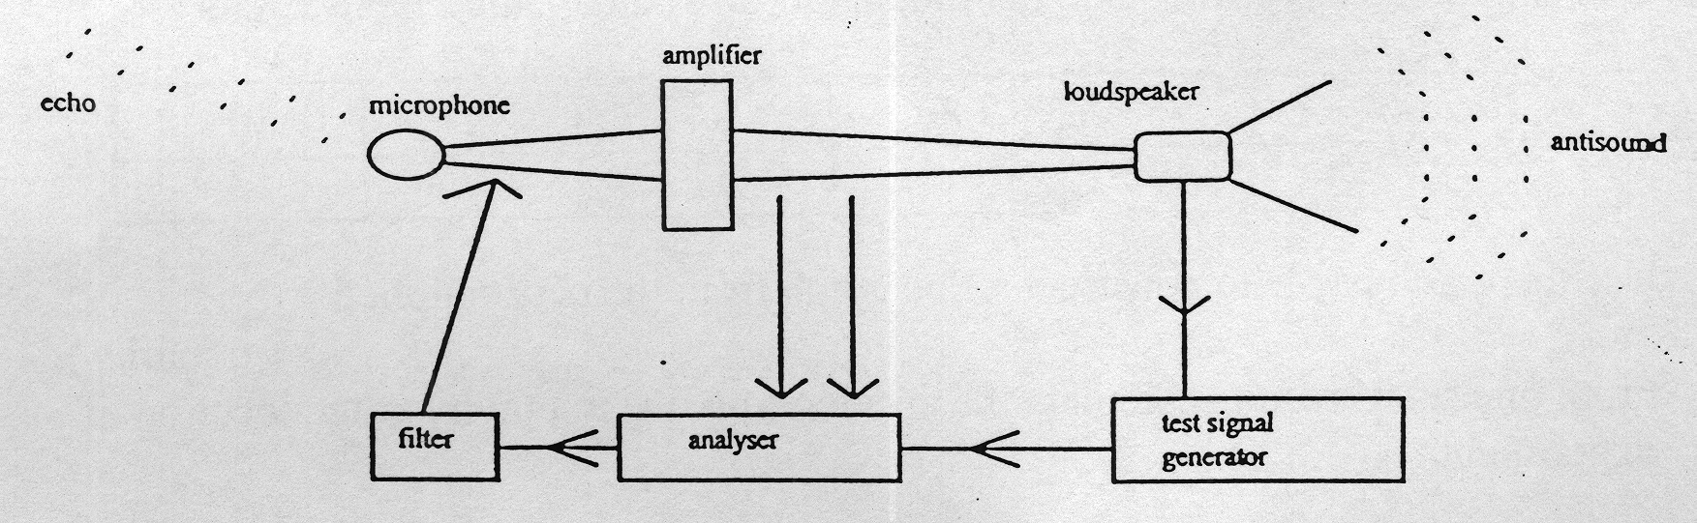
The aid analyses the echo nearly 10 000 times a second to respond to changes in the ambient sound and movements by the user that can affect the echoes, such as jaw movement. (Para. 7)

Clinical trials in Denmark showed that the hearing improved in 9 out of 10 children and 14 out of 20 adults who tried the device. According to Lise Rasmussen, an audiologist with GN Danavox, one woman made the discovery that cats meow when they open their mouths - these high frequency sounds had been cut out by her previous aid. Some of those in the trial were able to hear their own voices more clearly, which improved their diction. (Para. 8)
The electronic chip in the aid had to be designed from scratch, to make them small enough and to allow them to run from a single 1.1 volt battery, as opposed to the more usual 3.3 or 5 volts. (Para. 9)

Questions:

1. Why do profoundly deaf people endure howling and whistling from their hearing aids?
[2 marks]

2. Explain how this problem is reduced or cancelled.
[2 marks]

3. What wave principle is the technique used in question 2 above?
[1 mark]

4 Should people without hearing problems use hearing aids to preserve their hearing?
[1 mark]

5. What is the hearing range for the average human?
[1 mark]

6. How does the range vary with age?
[1 mark]

7. What is the % success rate of the new hearing aid in adults for the trials conducted in Denmark?
[1 mark]

*************************************************

END OF TEST

