ARANMORE CATHOLIC COLLEGE

PHYSICS 3A3B

ASSIGNMENT #1

NAME: ___________________________ MARK:
/40

- Edoardo, an archer, aims an arrow at a 25° angle at an apple across a field. Edoardo fires the arrow from a height of 1.0 m with an initial speed of 33.0 ms⁻¹ and hits the apple, which is 4.0 m above the ground. How far away (horizontal distance, X) is Edoardo from the apple.
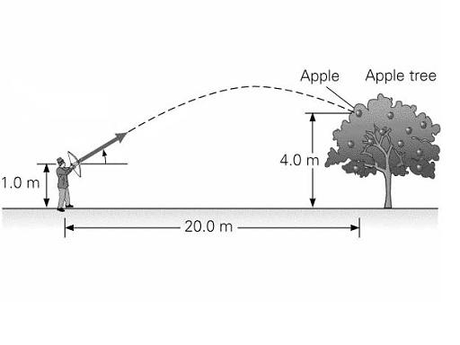
[6 marks]
X
25° º



- Dion is attempting a clever trick. His toy car is travelling at 8.0 m s⁻¹ on a small ramp inclined to the horizontal, which he placed on top of a table. Under the table on the floor, his toy truck is travelling at 4.5 m s⁻¹. At the position shown, the car is directly above the back of the truck. Dion is trying to get the toy car to land in the back of the toy truck. The top of the ramp is 65 cm above the back of the truck.

  - At what angle should the ramp be inclined to the horizontal for the trick to work?
[3 marks]

  - How far from the table do the toys travel before the car lands on the truck?
(ie: what horizontal distance is covered by the toys after the car leaves the ramp?)
[5 marks]

  - Calculate the speed and direction of the car when it lands on the back of the truck.
[4 marks]

- Sunny flies a space shuttle from the surface of Mars into a vertical loop of radius 536 m. If her mass is 55 kg and her speed is 270 km h⁻¹ at the top of the vertical loop, then what is Sunny’s apparent weight at the top of this loop? (g at surface of Mars = 3.68 N kg⁻¹)
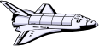
[6 marks]
536 m

- Tore was driving his car on a level road, in a 70 kmh⁻¹ zone at a constant speed, when he accidentally hit a low rock wall. Fortunately, Tore was wearing his seatbelt and was unhurt in the accident. Unfortunately, Nic was car-surfing at the time and, on impact, came off the roof, striking the ground 12 m in front of the point where he was standing on the car’s roof.

.

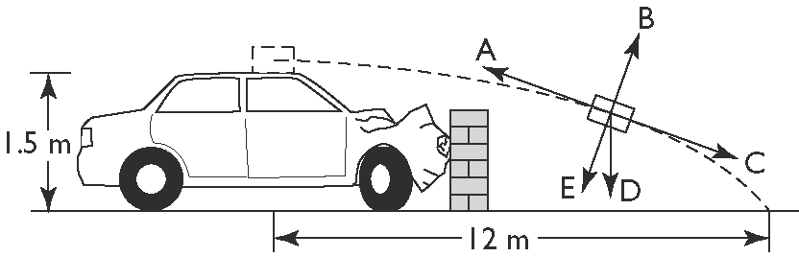

- Mario and his friend witnessed the accident, and Mario’s friend yelled out: “Wow – it’s amazing how Nic was thrown forward like that!” Mario disagreed with what his friend said and offered a more correct physics-based explanation. What was Mario’s explanation for Nic’s demise?
[2 marks]

- If the effects of air resistance were to be considered, which of the arrows A, B, C, D or E correctly indicates the net force on Nic in the position shown? [2 marks]

- Ebtesam, the investigating police officer, was called to the scene and, after taking some measurements (as shown on the diagram above), and making certain assumptions, came up with an estimate of the speed of Tore’s car when it collided with the wall. List her assumptions and determine the estimated speed. [5 marks]

- Using your result from part (c) above, and assuming that Tore and Nic have similar masses, estimate the impulse for each of them arising from the accident and compare the two results. [3 marks]

- Unlike Nic, Tore was unhurt in this accident. Account for this by describing two major safety mechanisms that applied to Tore, but not to Nic. Explain, with reference to your results from part (d) above, how these two mechanisms minimised any injury to Tore.
[4 marks]

