ARANMORE CATHOLIC COLLEGE

PHYSICS 3A3B

ASSIGNMENT #2

NAME: ___________________________ MARK:
/50

1. Rubi visits a space station which is in a circular orbit at a distance of one-half an earth radius above the earth’s surface.
a) What will be the acceleration due to gravity on Rubi in the station?
[4 marks]

b) Find the speed of the station and Rubi in their circular orbit. [3 marks]

c) How long will it take Rubi to make one complete revolution? [2 marks]

- Modern values for the mass of the Earth and other planets have been determined by observing the motion of artificial satellites that have been launched in recent years.

- Derive an expression for the mass of a central body, for example the Earth, in terms of the orbital radius (R) and orbital period (T) of an artificial satellite. Show steps clearly.
[3 marks]

- One of Mars’ moons, Phobos, revolves around Mars with an orbital radius of
9.35 x 10³ km and with a period of 7 hours and 35 minutes. Use your expression from part (a) above to determine the mass of Mars.
[4 marks]

- What is the value for the acceleration due to gravity, ‘g’, on the surface of Mars,
given that Mars has a radius of 3430 km?
[4 marks]

- What is the orbital speed of Phobos (in ms⁻¹)?
[3 marks]

- Is Phobos accelerating? Explain.
[2 marks]

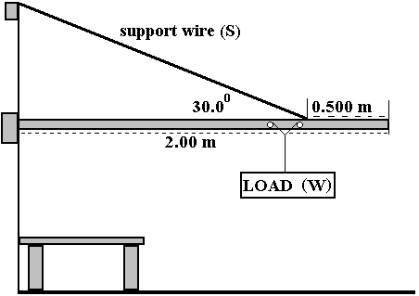3. Derek has a wall crane illustrated below. It is designed to lift motors from cars and transfer them to a workbench using rollers. This allows Derek to shift the load from one end of the beam to the other, as shown in the diagram.

a) If the uniform beam has a mass of 30.0 kg and the load (W) is 3.00 x 10² kg, find the force in the support wire (S) when the load is at the outer end. [5 marks]

b) Sketch a graph to show how the force in the wire varies as Derek moves the load in towards the wall. [3 marks]

4. Jamaul, a painter, rests a 12.0 kg wooden extension ladder of length 3.25 m against a smooth window surface at an angle of 22.6 º to the glass.
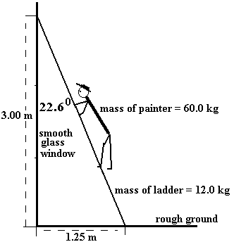
a) What force is the ladder exerting on the glass? (Since the glass is smooth, the force will be perpendicular to the window.) [5 marks]

b) The glass will break if subjected to a force greater than 170 N at the point where the ladder is resting on it. How far up the ladder can Jamaul climb before disaster strikes? [5 marks]

5. Rahul’s mobile hangs in static equilibrium above his bed, as shown in the diagram below. The mass of the horse is 180.0 g and the mass of the anchor is 80.0 g.
[7 marks]
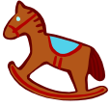


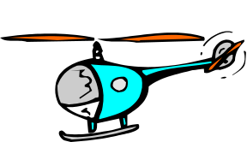
10.0 cm
10.0 cm
10.0 cm
7.50 cm
2.50 cm

  - What is the mass of Rahul’s hanging teddy bear?

  - What is the mass of Rahul’s toy helicopter?

