ARANMORE CATHOLIC COLLEGE

YEAR 12 PHYSICS 3A3B

ASSIGNMENT 3 - ELECTROMAGNETISM

NAME: __________________________________ MARK:
/50

1. When a direct current is switched on and flows through this power line the wire sags more. Indicate on the diagram which direction the current is flowing in the wire.
(2 marks)

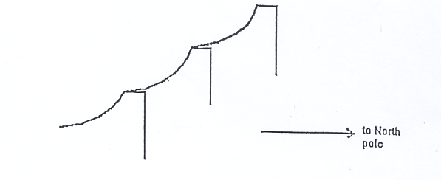

2. A 125 m span of electrical transmission cable that is suspended between two power poles, casts a shadow that lies to the south throughout the day. The cable is located in an area where the horizontal component of the Earth’s magnetic field is 4.8 x 10⁻⁵ T. If a DC current of 6.00 A flows through the cable towards the east, what is the magnitude and direction of the force experienced by the cable due to this current? (4 marks)

3. For each situation shown below, draw the associated magnetic field. (6 marks)

(a)

(b)

(c) 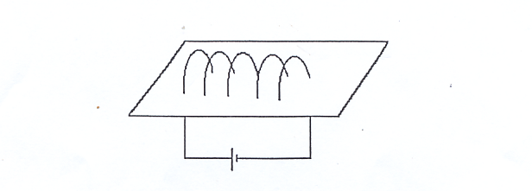

4. Consider the transformer below.
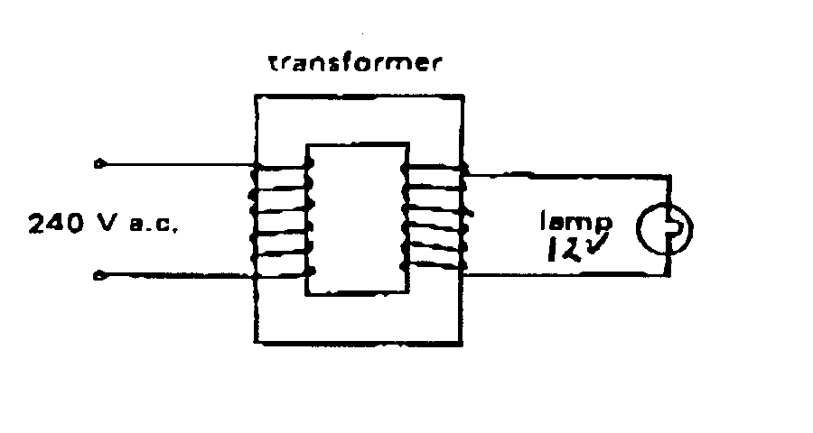
(a) If the primary winding was connected to 240V AC and draws a current of 250 mA, what is the power delivered to the lamp? The transformer is 95% efficient.
(3 marks)

(c) What type of transformer is it? (1 mark)

(d) If the secondary winding had 40 turns and delivered 12.0 V, how many turns has the primary winding? (2 marks)

(e) What would happen if the primary winding was connected to 240V D.C.?
(1 mark)

- A windmill drives a 100 V generator that produces 4000 W of electrical power. This energy is supplied to a distant house through cables that have a total resistance of 2.00 Ω.
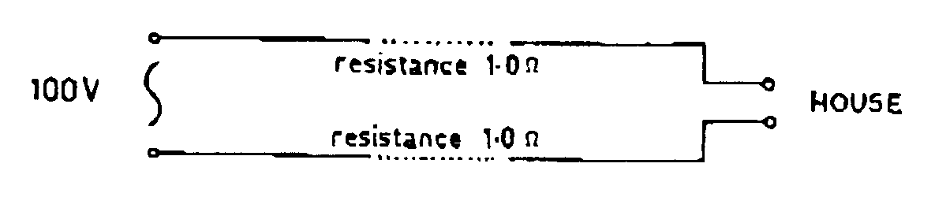
(a) What is the voltage drop over the length of the cables and how much power is dissipated in the cables? (4 marks)

- Two transformers (T1 and T2) of 100% efficiency are used to step-up the voltage at the windmill and step-down the voltage at the house to reduce the above power loss as shown below.

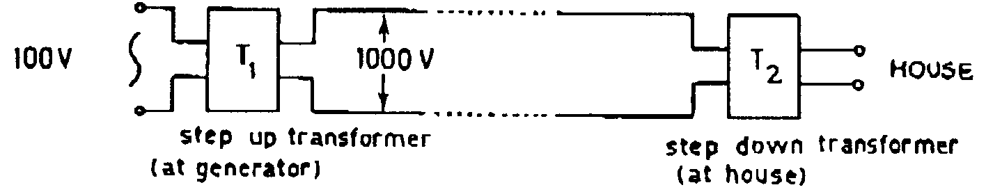

Calculate the voltage drop over the length of the cables between the two transformers and the power dissipated in the cables now? (4 marks)

6. A computer data logger is used by a group of students to analyse the current produced when a magnet is dropped through a coil of copper wire wound on a hollow cardboard cylinder. The graph of current versus time, produced on the screen of the computer is similar in shape to the one shown below. Explain why the shape of the graph is not symmetrical above and below the time axis. (3 marks)
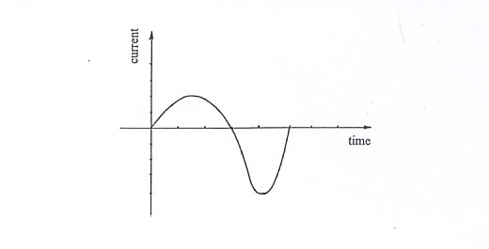

- Tore was attempting to measure the emf induced in a car antennae as the car was being driven in an easterly direction. The value of the horizontal component of the Earth’s magnetic field, in this region, was 48.0 µT and the antennae measured 1.25 m in length. Tore had used a protractor to determine that the antennae was bending at an angle of 15° to the vertical and the car was travelling at a speed of 82 km h⁻¹. Determine the emf that Tore would have measured under these conditions.
(4 marks)

- A coil in a simple motor has 350 turns and measures 15 cm x 12.0 cm. A current
of 0.22 A is flowing through the coil which is situated between permanent magnets that produce a steady field of 0.60 T.

(a) Find the maximum torque acting on the coil.
(4 marks)

- Give a brief description (or draw a diagram) of a 'dynamic' microphone and explain how it works.
(4 marks)

- A radioactive source is used to fire alpha particles (He²⁺ ions) into a magnetic field. The experimental setup is shown below.
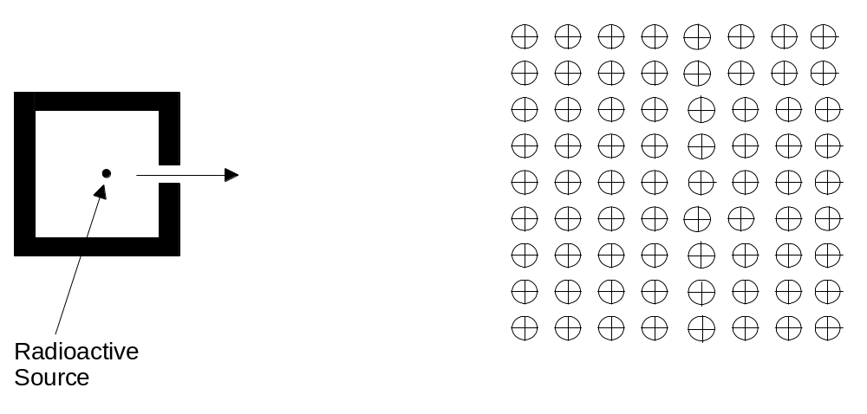

a) On the diagram carefully indicate a possible path for the alpha particles when they enter the magnetic field. Label the path (A).
(2 marks)

b) If the alpha particles are moving at a speed of 8.20 x 10⁴ ms⁻¹ when they enter a uniform 1.60 T magnetic field, calculate their predicted radius in the magnetic field.
(4 marks)

c) If an electron was fired into the magnetic field, carefully indicate a possible path for that particle when it enters the magnetic field. Label the path (B). Describe the two main differences in the path of the electron as compared to that of the alpha particle.
(2 marks)

