ASSIGNMENT 5 - EMR

NAME: ___________________________ MARK: ______/50_

- An industrial process uses a large commercial CO₂ laser for cutting steel plate. The laser has a power of 6.0 x 10² W and produces infra-red radiation of wavelength 10.6 µm.

  - What is the photon energy at that wavelength?
[3 marks]

  - How many photons are released each second?
[1 mark]

- Nickel sulfate-6-water (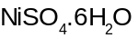) is soluble in water and forms a green solution.
Cobalt sulphate-7-water (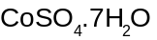) is also water soluble forming a red solution.
  - Explain the physics behind how the green colour is produced from the nickel sulfate-6-water.
[2 marks]

  - If a solution of nickel sulfate and cobalt sulphate is prepared, what colour would it have? Explain. (No chemical reaction takes place)
[2 marks]

- Mario and Rey repeated the photoelectric effect experiment, by shining a light on a clean metal surface, and measuring the maximum kinetic energy of the photoelectrons. They obtained the following results:

Frequency ( 10¹⁴ Hz) | Max Kinetic Energy (eV)
8.24 | 1.90
7.81 | 1.61
7.16 | 1.17
6.45 | 0.69
5.96 | 0.35

- Plot an appropriate graph of this data on graph paper. [6 marks]

- What is the threshold frequency of the metal? [1 mark]

- What is the work function of this metal? [2 marks]

- The diagram below shows the energy levels for a hydrogen atom.
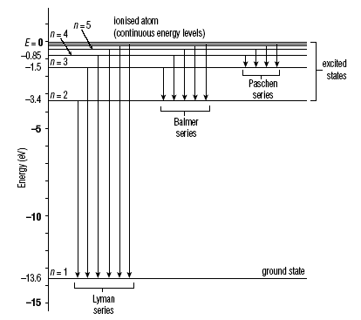

  - The Balmer series of emission lines occurs mainly in the visible spectrum. Would the Lyman series be found in the infra-red or ultra-violet region of the spectrum? Explain your answer. [2 marks]

  - The longest wavelength in the Paschen series would be produced by hydrogen atoms changing from the n=a level to the n=b level.
What are the values for a and b? [2 marks]

  - What is the energy of the photons giving rise to the second longest wavelength of the Balmer series?
[3 marks]

  - A line in the spectrum of hydrogen has a wavelength of 1.88 µm. Is it a member of the Lyman, Balmer or Paschen series? Explain your answer. [4 marks]

- Electrons fired at the screen of a colour television cause it to emit light of different colours.

- Explain how the electrons can cause light to be emitted. [3 marks]

- What determines the different colours of the light? [2 marks]

- Explain the phenomena called fluorescence and phosphorescence and the differences between them. [3 marks]

- In a certain X-ray generator, a voltage of 52000 V is used.

- Explain how a simplified X-ray generator works (a diagram will be necessary).
[6 marks]

- What is the highest energy that the X-rays have in this situation? [1 mark]

- Sketch a graph showing the intensity of X-rays versus wavelength and label all the relevant features. [4 marks]

- Determine the minimum wavelength of X-rays that will be observed.
[3 marks]

