ARANMORE CATHOLIC COLLEGE
YEAR 12 PHYSICS
INVESTIGATION
ELECTROMAGNETISM

NAME: _____________________________________

The Electric Motor

PART A: DESIGN

Design a simple electric motor using household items/parts such as pieces of wood, copper wiring, magnets, needles, corks, etc. Explain the operation of your motor, highlighting the main physics principles of each component that you used in the design of your motor. One or more diagrams may be necessary to illustrate the principles of your design or assist in your explanation of these principles.
(25 marks)
PART B: ASSEMBLY AND TESTING OF A KIT MOTOR

Connect the motor as illustrated by the diagram below. Identify the main parts of the motor on the diagram below.
(15 marks)
Note: The bolts go through the base and the nut is fastened underneath to hold the entire assembly to the base.

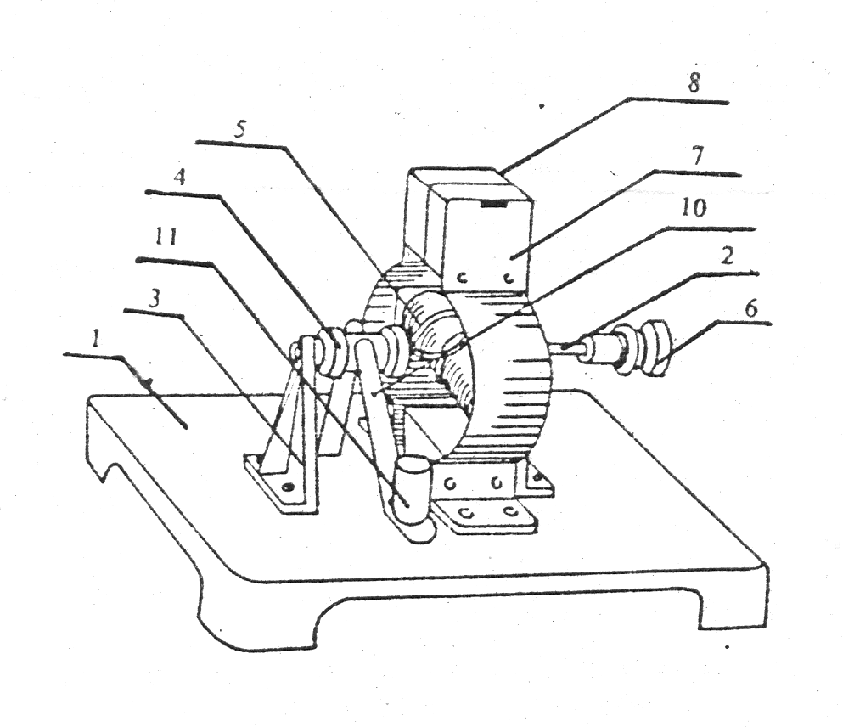
Figure 1: Electric motor kit assembly diagram.

Now connect the terminals to the power supply, using 4-6 V DC, and check that the motor works. It is now time to show the teacher your working motor for checking.

PART C: DISCUSSION

Write a concise (1 page) explanation of the process or principles of an electric motor.
(10 marks)

NAME: _____________________________________

Marking Key – Electric Motor Investigation

Part A: DESIGN + EXPLANATION | MARK | OUT OF
Equipment |  | 5
Design |  | 5
Procedure |  | 5
Operational Explanation |  | 10
Part B: CONNECTION | MARK | OUT OF
Connection time <15 mins (2); 15-25 mins (1) |  | 2
Terminal placement |  | 2
Diagram followed – motor assembly |  | 2
Connection to power supply |  | 2
Operational |  | 2
Part B: IDENTIFICATION OF PARTS
Brushes/terminals |  | 1
Commutator and split |  | 1
Armature/coils |  | 1
Shaft/axle/pulley |  | 1
Magnet/magnetic field |  | 1
Part C: EXPLANATION
Current and Magnetic field |  | 3
Force/torque |  | 2
Turns due to torque |  | 2
Brushes and commutator |  | 3
TOTAL |  | 50

