ARANMORE CATHOLIC COLLEGE

YEAR 12 PHYSICS 3A3B

PRACTICAL TEST: TORQUES AND EQUILIBRIUM

NAME: ____________________ MARK:
/25

Static Equilibrium

Aim:
To study the turning effect of a force (the moment of a force or the torque), and to investigate the equilibrium of a beam under the action of a number of forces.

Materials:
Slotted masses Retort stand Nail Metre rule

Method:
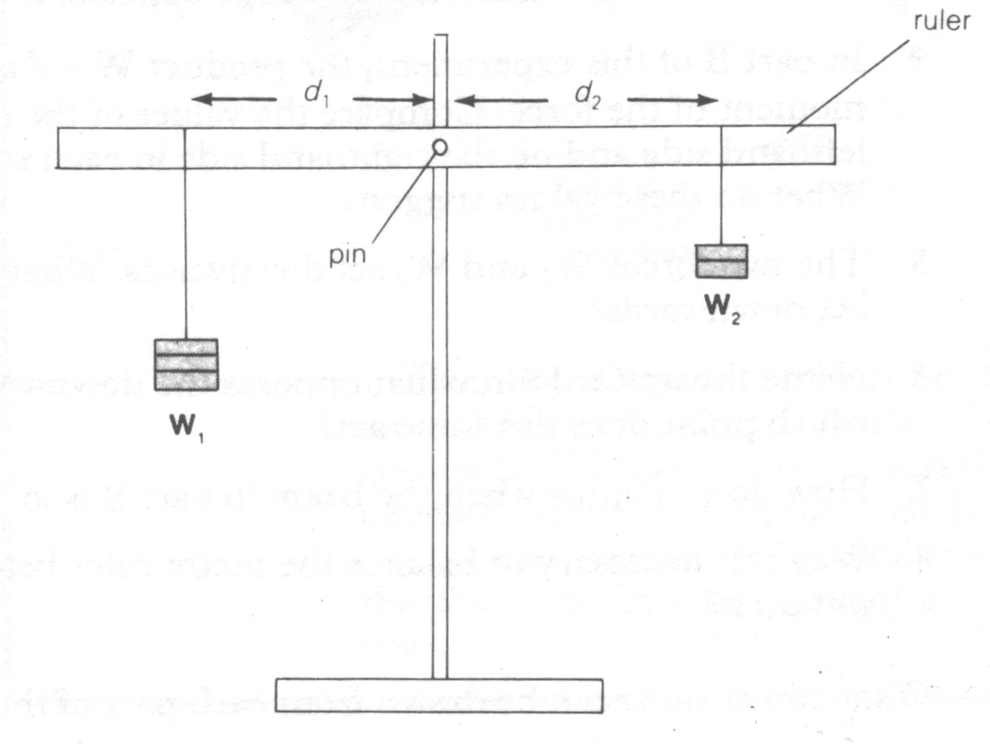
Figure 1: Apparatus
for measuring
F₂
torques
F₁

- A group of students attached a ruler to a retort stand with a nail, so that the ruler was free to rotate. They had to place some blue-tac on one side for it to balance.

- They then suspended weights on either side of the ruler, adjusted the amount and distance of the weights to balance the ruler as shown in the diagram (Figure 1) above, and then recorded the data in the table below. This process was repeated 4 more times.

Mass 1  (g) | Mass 2  (g) | Distance 1 (cm) | Distance 2 (cm) | Force  F 1  (N) | Force  F 2  (N) | Torque (c) | Torque (anti-c) | Δτ  (τ_{c}-τ_{ac}) | Sum of Forces (down) | Sum of Forces (up)
100 | 150 | 40.0 | 26.9 | 0.98 | 1.47 | 0.392 | 0.395 | -0.003 | 2.45 | 2.45
100 | 200 | 40.0 | 19.8 | 0.98 | 1.96 | 0.392 | 0.388 | 0.004 | 2.94 | 2.94
150 | 250 | 40.0 | 23.9 | 1.47 | 2.45 | 0.588 | 0.586 | 0.002 | 3.92 | 3.92
200 | 150 | 35.0 | 46.1 | 1.96 | 1.47 | 0.686 | 0.678 | 0.008 | 3.43 | 3.43
200 | 250 | 35.0 | 28.2 | 1.96 | 2.45 | 0.686 | 0.691 | -0.005 | 4.41 | 4.41
Analysis:

- In the table calculate the forces, F₁ and F₂, the clockwise and anticlockwise torques and the sum of the forces up and down.
[9 marks]
- Compare your forces, do your results reflect Translational Equilibrium?
[2 marks]

- Calculate the difference in the torques, Δτ, - do your results reflect Rotational Equilibrium?
[3 marks]

- Calculate the average percentage difference in the torques and comment on this difference.
[2 marks]

- How did you know the ruler was ‘in equilibrium’?
[1 marks]

- Why can you ignore the mass of the ruler in this experiment?
[1 marks]

Conclusion:

Write an appropriate conclusion/discussion for this experiment.
[7 marks]

