MORLEY SENIOR HIGH SCHOOL

YEAR 12

PHYSICS (STAGE 3)

GRAVITATION TEST

Student’s Name: Tutorial Group:

Teacher’s Name: Date:

_____________________________________________________________________________________

- The force of gravity is that part of the Earth’s total gravitational force, as given by Newton’s Law of Universal Gravitation, which acts on any given object located inside the Earth’s gravitational force field.

- According to Newton’s Law of Universal Gravitation, every object attracts every other object with a force F that for any two objects is directly proportional to the product of their masses m ₁ × m ₂ and inversely proportional to the square of the distance r ² separating them. The size of the gravitational force can be written as: F = G × (m ₁ × m ₂) / r ².
- A force field is a scientific model for representing the way in which a force can exist between objects not in contact. Examples of force fields include: an electric field, a magnetic field, and a gravitational field.

Newton’s Apple and Gravitational Field Strength

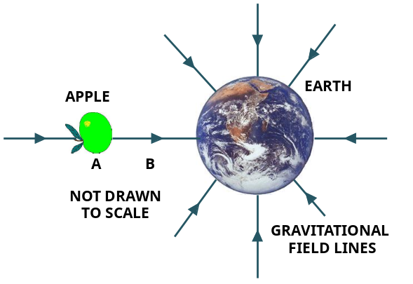
- The force of gravitational attraction exerted on the apple has a definite direction and magnitude at each point in space.
- The direction is radially in toward the centre of the Earth, and the magnitude is mg.
- We can, therefore associate with each point near the Earth, a vector g which is the acceleration that an object would experience if it were released at that point.
- g = F/m is the gravitational field strength in N kg ^{– 1} at the point under consideration.

- Would the gravitational field strength g at Point B be higher or lower than that at Point A? Explain.

[3 marks]
Weight

Weight can be defined in two ways. Definition 2 can be used to explain the concept of weightlessness.

- Definition 1: The weight of an object (F _{W}) = m × g can be defined as the force of gravitational attraction that the Earth exerts on the object.

- Definition 2: The weight of a body is the contact force exerted by a body on any object which supports it, e.g., a table or weighing scales like bathroom scales. Weight of a body is equal to the force of gravity acting on the body.

- Isaac Newton’s Third Law of Motion: The Law of Action-Reaction: If object B exerts a force (F) on object A, object A exerts an equal but oppositely directed force (– F) on object B.

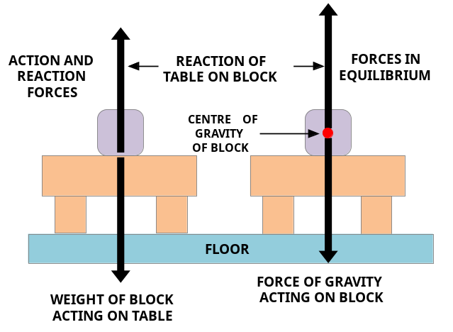
An analysis of the Free-body diagram

- Why can’t an action – reaction pair of forces be in equilibrium?

[2 marks]

Measuring Weight with Bathroom Scales

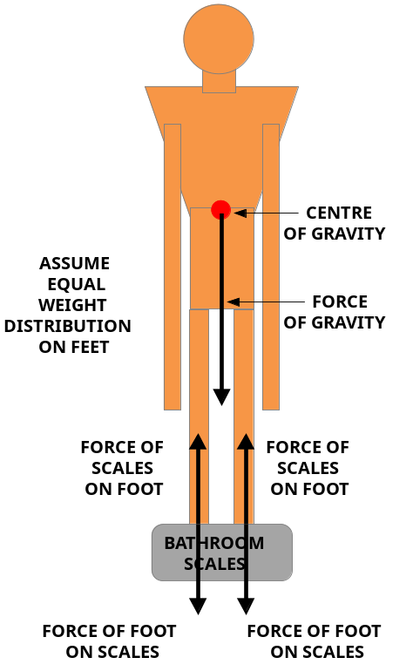
Suppose the man standing on the scales has a weight of 980 N.

- What is his mass?

[2 marks]

Now suppose the man and the bathroom scales were in space and freely falling toward Earth with acceleration – g = – 9.8 m s ^{– 2}.

- What would be the reading on the bathroom scales? Explain.

[2 marks]
- Given upward direction as positive (+), what force do the scales exert on each of the man’s feet?

[2 marks]

- When sitting on a science stool doing this test, do we feel our own weight (the force of gravity acting on us), or do we only feel the upward reaction force of the stool acting on our bottoms? Explain.

[2 marks]

Gravity and the Inverse Square Law

- Newton’s law of universal gravitation is an example of an inverse-square law. The inverse-square law is any physical law, which states that the magnitude of a certain physical quantity, like for example, the force of gravity at any given point, is inversely proportional to the square of the distance from the source of that physical quantity to the given point.

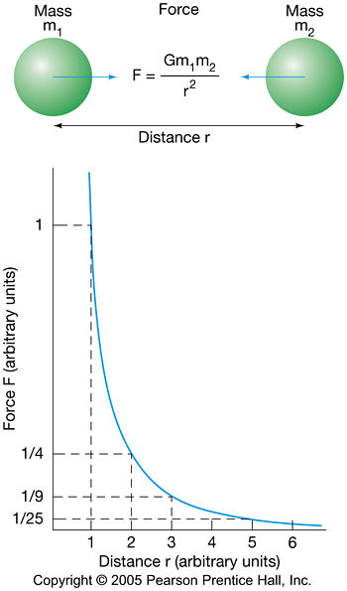
- Given that a standard 5.0 kg mass has a weight of 49 N at the Earth’s surface, what is its weight when located 2 × as far from the Earth’s centre?

[2 marks]

- Given that a standard 5.0 kg mass has a weight of 49 N at the Earth’s surface, what is its weight when located 3 × as far from the Earth’s centre?

[2 marks]
Source of Image URL: <http://physics.uoregon.edu/~jimbrau/BrauImNew/Chap02/FG02_23.jpg>

Gravity near the Earth’s Surface

How can g be calculated at the surface of a celestial object?

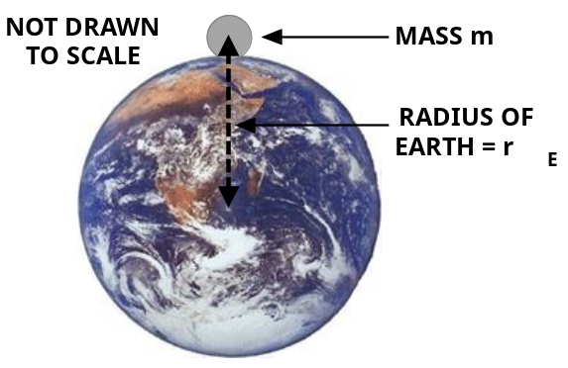
The gravitational force of attraction F is given both by:
F = m × g and F = G × (m × m _{E}) / r _{E} ².
Combining both equations m × g = G × (m × m _{E}) / r _{E} ² gives this equation: g = G × (m _{E} / r _{E} ²).
- Where – g = acceleration due to gravity at the Earth’s surface = – 9.8 m s ^{– 2}
- G = 6.67 × 10 ^{– 11} N m ² kg ^{– 1} (universal gravitational constant)
- m _{E} = mass of Earth = 5.98 × 10 ²⁴ kg
- r _{E} = average radius of Earth = 6.38 × 10 ⁶ m

- What is the value of g at an altitude of one earth radius above the Earth’s surface?

[3 marks]

Gravity on the Moon

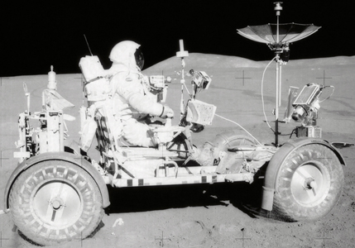
- What would be the value of g at the surface of the Moon, given that the mass of the Moon is 7.20 × 10 ²² kg and its average radius is 1.74 × 10 ⁶ m?

Apollo 15 Lunar Rover [2 marks]

- Given that the mass of the Apollo Lunar 15 rover is 210 kg, what would be its weight on the Moon?

[2 marks]
Gravitational Potential Energy

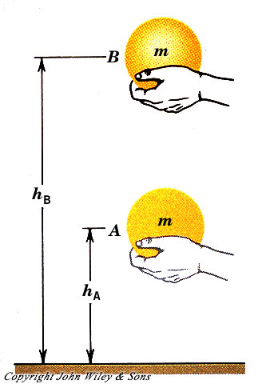
- Potential energy (E_{P}) is the energy an object possesses because of the relative position of its parts, or because of its position inside a force field, e.g., Earth’s gravitational force field.
- Gravitational potential energy (GPE) is the energy an object possesses because of its position inside the Earth’s gravitational force field.

- Gravitational potential energy (E _{P}) = m × g × h; where h = height above a reference level of zero E _{P} (m)

- When an object or a system of objects has work done on it, its energy content is increased; while a system that does work has its energy content decreased.

- The energy of a system can also be changed by either adding or removing heat from the system.

- The adjacent Image shows a bowling ball being raised a distance (Δ h = h _{B} – h _{A}) by a person doing work (W) against the force of gravity (F _{W} = m × g).

Source of Image URL: <http://www.physics.brocku.ca/courses/1p93/Electrostatics/>

- Where does the bowling ball possess the greater amount of gravitational potential energy E _{P}, at Position A or at Position B? Explain in terms of the height h of the bowling ball above the ground.

[3 marks]

- Where does the bowling ball possess the greater amount of gravitational potential energy E _{P}, at Position A or at Position B? Explain in terms of the work done against the force of gravity W = F × s.

[3 marks]
_____________________________________________________________________________________

[Total marks = 30] Percent score =

