MORLEY SENIOR HIGH SCHOOL

YEAR 12

PHYSICS (STAGE 3)

MAGNETIC FIELDS TEST

Student’s Name: Tutorial Group:

Teacher’s Name: Date:

_____________________________________________________________________________________

- A magnetic field is the force field around the poles of a magnet or around a wire carrying a current.

  - A force field is a scientific model for representing the way in which a force can exist between objects not in contact. Examples of force fields include: a magnetic field, an electric field, and a gravitational field.

- Magnetic fields can be visualized using magnetic field lines or lines of magnetic flux. Magnetic field lines form closed loops that never begin or end; and they can never cut across each other.

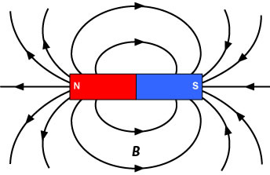
- Do magnetic field lines exist in physical reality, (i.e., are magnetic field lines real, or are they imaginary)? Why are they used?

[3 marks]

Lines of Magnetic Flux and Magnetic Field Strength

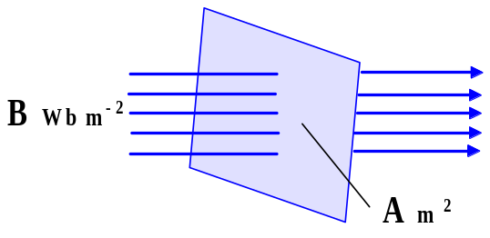
Total Magnetic Flux (Φ) is the total number of lines of magnetic flux threading through a surface, and for a flux density that is both uniform and normal to a surface of area of (A) m ², the Magnetic Flux Φ is given by this physics equation: Φ = B × A (weber).

Where Φ = magnetic flux (Wb)
Φ = B × A
B = magnetic flux density or field strength (Wb m ⁻²) or tesla (T)
A = area through which the flux acts (m ²)
Upon rearranging Φ = B × A, we obtain the formula for magnetic field strength: B = Φ / A, which defines magnetic field strength as the amount of magnetic flux in a unit area perpendicular to the direction of magnetic flow

- Given that the magnetic field strength at the poles of an Alnico bar magnet can be as high as 0.15 T, and that the strength of the Earth’s magnetic field is about 5.0 × 10 ^{– 5} T, how many times stronger is the field of the bar magnet compared with the strength of Earth’s magnetic field?

[2 marks]

- Referring to the bar magnet image given on Page 1, in what two locations is the field strength (or flux density) of the bar magnet’s field, the strongest? Explain.

[3 marks]

Showing Magnetic Fields using a Plotting Compass
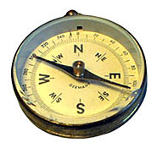

- A compass is a magnet that can align itself within the Earth’s magnetic field.

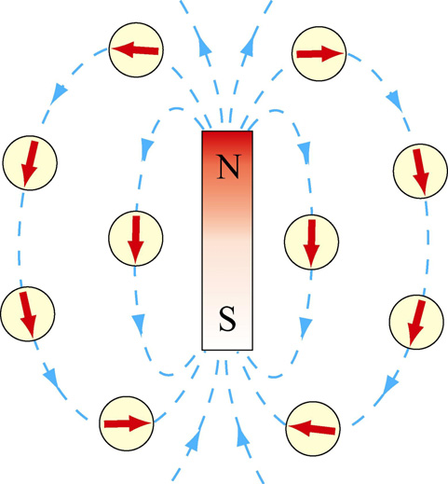
- Why does the compass align itself to the bar magnet’s field and not to the Earth’s magnetic field?

[2 marks]

Source of Image URL: <http://web.mit.edu/8.02t/www/802TEAL3D/visualizations/coursenotes/index.htm>
  - The direction of the magnetic field at any point is taken as the direction of the magnetic force exerted on a north pole placed at that point.

- Referring to the bar magnet image given on Page 1, what does the arrow head on each magnetic field line show? Explain.

[2 marks]
- Why can’t magnetic field lines cut across each other? Explain.

[4 marks]

The Earth’s Magnetic Field

- The Earth’s magnetic field is similar to that of a bar magnet with its S-pole near the geographic North Pole, and its N-pole near the geographic South Pole.

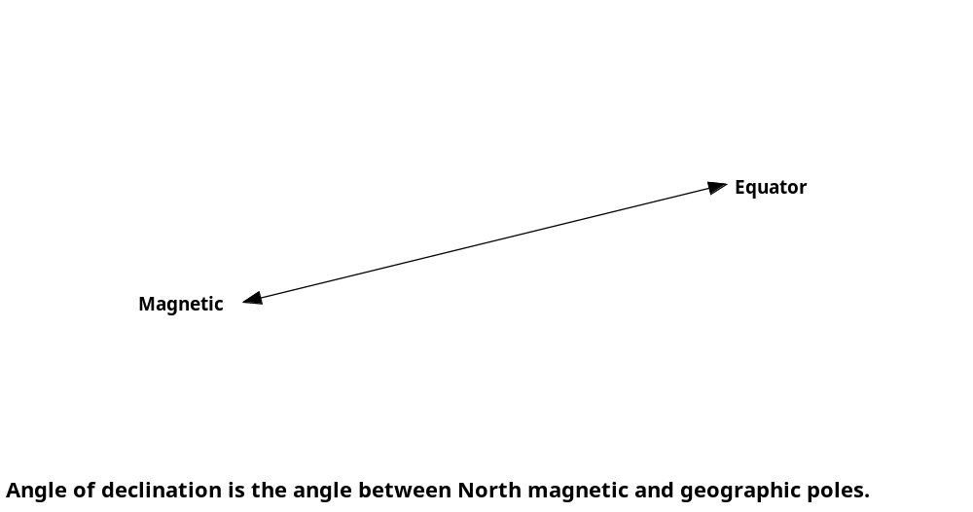
Source of Image URL: <http://www.geo.arizona.edu/xtal/nats101/5_3.jpg>

Carefully study the diagram, given on Page 3, in order to answer Questions 7 through 12.

- At what location are the magnetic field lines horizontal to the Earth’s surface?

[2 marks]

- A compass needle pivoted on its horizontal axis will come to rest at an angle that indicates the dipping of the magnetic field at that location. This angle is referred to as the angle of dip or inclination.

- Why is the angle of dip or inclination zero at the Earth’s magnetic equator?

[2 marks]

- At what locations are the magnetic field lines vertical to the Earth’s surface?

[2 marks]

- Why can’t a compass be used for navigation when travelling near the Earth’s north and south poles?

[2 marks]

- A compass needle lines up with the horizontal component of the Earth’s magnetic field in a direction referred to as magnetic north.
- For all locations on the Earth’s surface does a compass needle always point directly toward the North Magnetic Pole? Explain.

[2 marks]

- Why must the angle of declination, sometimes called magnetic variation, be taken into account when navigating using a compass?

[2 marks]

- The angle of declination is the angle between true north and the direction indicated by a compass needle. The declination varies from place to place over the Earth’s surface and from time to time as typically shown on a published World Magnetic Chart -- Epoch 2000: Declination -- Main Field (D).
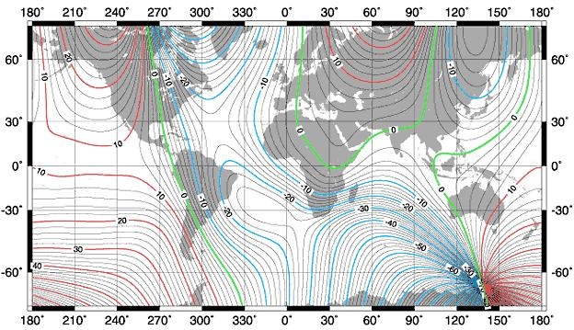

- Study the world map of magnetic variation – Epoch 2000, given on Page 5. What declination is shown for Melbourne in Victoria, Australia?

[2 marks]
Magnetic Interaction between two Magnets

- When two magnets are brought near one another, each exerts a force on the other. The force can be either repulsive or attractive. Magnetic Pole law: Like poles of a magnet repel; unlike poles attract.
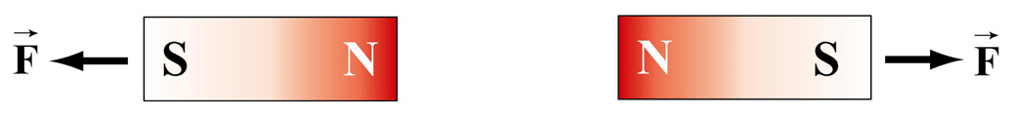
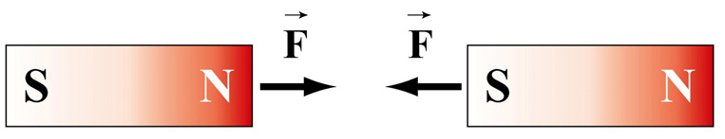
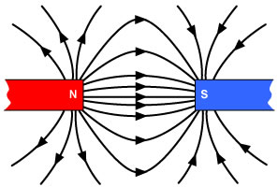
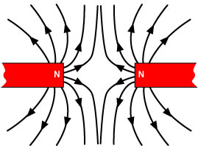

- How do scientists explain magnetic repulsion in terms of the behaviour of the magnetic field lines?

[3 marks]

- How do scientists explain magnetic attraction in terms of the behaviour of the magnetic field lines?

[3 marks]
Electric currents produce Magnetic fields

In 1820, H C Oersted (1777 – 1851) discovered that a magnetic field is established in the region around a current-carrying wire. The direction of the concentric magnetic field lines, around a current-carrying wire, is dependent upon the direction of current flow through that wire.

An electric current is a flow of charge carriers (electrons or holes) through a conducting wire or crystal.
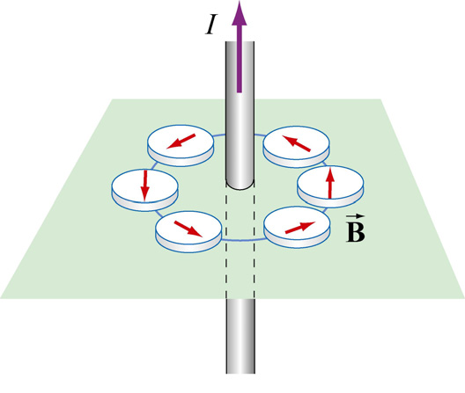
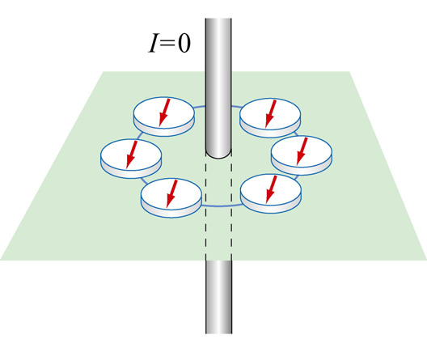

Source of Images URL: <http://web.mit.edu/8.02t/www/802TEAL3D/visualizations/coursenotes/index.htm>

- What type of current is shown in right-hand side diagram? [1 mark]

- To determine the direction of the magnetic field established around a current-carrying wire, we used Right-Hand rules for a conventional current flow (I), and Left-Hand rules for an electron flow (e –).

- Ampere’s Rule: If a current-carrying wire is grasped with the right hand in such a way that the right thumb points in the direction of conventional current flow, the fingers wrap around the conductor in the direction of the magnetic field.

- Why are the field lines shown spaced further apart at increasing distance from the wire conductor?

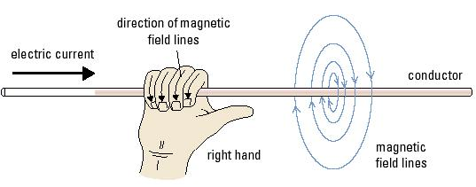

[3 marks]

_____________________________________________________________________________________

[Total marks = 40] Percent score =

