MORLEY SENIOR HIGH SCHOOL

YEAR 12

PHYSICS (STAGE 3)

CIRCULAR MOTION TEST

Student’s Name: Tutorial Group:

Teacher’s Name: Date:

_____________________________________________________________________________________

- Motion is a continuous change in position.

- Uniform circular motion is motion in a circle at constant speed v.

- When any object undergoes uniform circular motion, the magnitude of its velocity (or speed v) remains constant, and the direction of its velocity changes continuously.

- As acceleration is defined as the rate of change of velocity, a continuous change in direction constitutes acceleration, just as a change in the magnitude of the velocity (or speed v) does.

Swinging a Child in a Horizontal Circle


- Why is a child being swung, at constant speed, in a horizontal circle undergoing uniform acceleration?

[4 marks]

Source of Image URL: <http://www.healthofchildren.com/N-O/Nursemaid-s-Elbow.html>

We can draw a free-body diagram to illustrate some selected forces acting as the man swings the child.

- Free-body diagrams are diagrams used to show the relative magnitude and direction of all forces acting upon an object in a given situation, like a child swung in a horizontal circle at constant speed v.

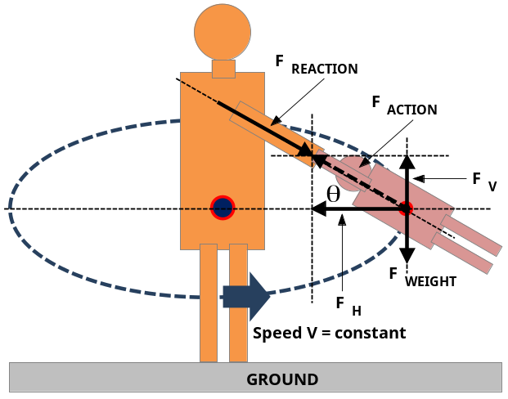
An analysis of the Free-body diagram

- The action force is the force exerted by the man on the child.

- The reaction force is the force exerted by the child on the man.

- The action force has been resolved into two rectangular components at 90 ⁰ to each other.

- The child’s weight force acts through his/her centre of gravity.

Any air resistance acting on the child would be negligible, i.e., it would be so small, it can be ignored.

- Newton’s Third of Motion can be stated as follows: If object B exerts a force (F) on object A, object A exerts an equal but oppositely directed force (– F) on object B.

- In what way is the reaction force F _{REACTION} the same as the action force F _{ACTION}?

[1 mark]

- In what way is the reaction force F _{REACTION} different from the action force F _{ACTION}?

[1 mark]

Resolution of action Force

The free-body diagram shows that the action force has been resolved into two rectangular component vectors: vertical F _{V} and horizontal F _{H}, which when added together have the same effect as the action force, which they have replaced.

- How does the free-body diagram show that the action force F _{ACTION} has been replaced?

[1 mark]
- There are only two original forces acting on the child being swung in a horizontal circle at constant speed v. What are names of these two forces?

[2 marks]

- What mathematical equation can be used to calculate the size of the vertical component F _{V}?

[2 marks]

- What does the vertical component of the action force F _{V} do for the child? What is the effect of F _{V}?

[3 marks]

- What mathematical equation can be used to calculate the size of the horizontal component F _{H}?

[2 marks]

- What does the horizontal component of the action force F _{H} do to the child? What is the effect of F _{H}?

[3 marks]
- Why is the child swung in a horizontal circle, at constant speed, undergoing constant acceleration?

[4 marks]

Centripetal Force

- According to Newton’s second law of motion Σ F = ma, an object that is accelerating must have a resultant force acting on it. Any object moving in a circular path must therefore have a force applied to it to keep it moving in that circular path.

- The resultant force Σ F _{C} giving centripetal acceleration a _{C}, to the object, can be calculated using this physics formula: Σ F _{C} = m × a _{C} = m × (v ² / r)

- Is the child swung at constant speed v, in a horizontal circle, being acted upon by a resultant force F? If so, can you name the force?

[2 marks]
Mechanical Equilibrium

- An object in mechanical equilibrium is either at rest, or moving with a constant velocity.

- Is the child swung at constant speed, in a horizontal circle, in a state of mechanical equilibrium? You must answer either yes or no, and then fully explain your answer.

[4 marks]
Circular Motion and a Common Misconception

A common misconception in physics is that an object moving in a circle has an outward force acting on it, referred to as the centrifugal or (“centre-fleeing”) force. This is incorrect as there is no outward force on a revolving object.

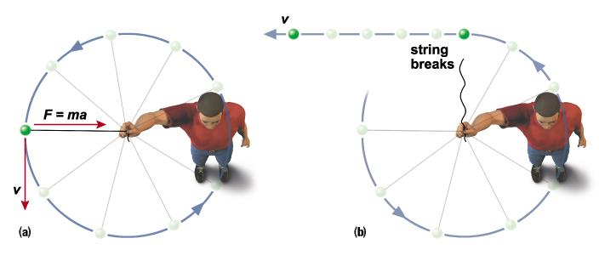
- How does Image (b) show that there is no outward force acting on the (green) ball?

[2 marks]

Numerical Problem Solving

- The moon of mass of 7.30 × 10 ²² kg orbits the Earth in a circular orbit of radius 1.74 × 10 ⁶ m, once every 29.5 days. Can you calculate the: (a) orbital speed (m s ^{– 1}); (b) centripetal acceleration (m s ^{– 2}), and centripetal force (N) needed to keep the moon in its orbit?

Q14 (a) [3 marks]: (b) [3 marks], and (c) [3 marks]
_____________________________________________________________________________________

[Total marks = 40] Percent score =

