MORLEY SENIOR HIGH SCHOOL

YEAR 12

PHYSICS (STAGE 3)

PROJECTILE MOTION TEST

Student’s Name: Tutorial Group:

Teacher’s Name: Date:

_____________________________________________________________________________________

- Motion is a continuous change in position. Rectilinear motion is motion in a straight line.

- The equations of rectilinear motion: v = u + at; v ² = u ² + 2as, and s = ut + ½ a t ²

- Projectile motion is the motion of an object in a parabolic path near the Earth’s surface under the action of gravity alone.

URL: http://galileoandeinstein.physics.virginia.edu/more_stuff/Applets/ProjectileMotion/jarapplet.html

The Principles of Projectile motion

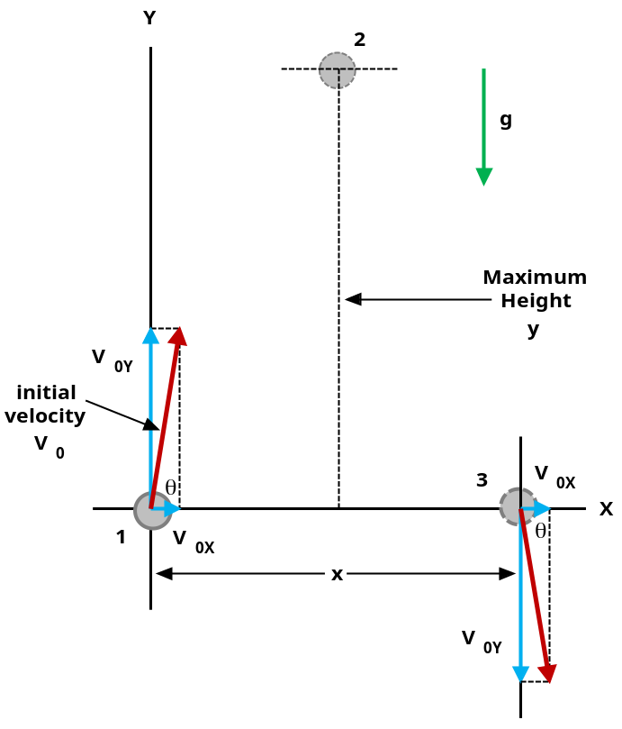
Galileo Galilei (1564 – 1642) argued that projectile motion was a compound motion made up of a horizontal and a vertical motion.

The adjacent diagram shows a projectile launched with an initial velocity of V₀ at an angle of θ ⁰ to the horizontal.

The three principles of projectile motion can be stated as follows. The projectile:

- Has a horizontal velocity, which is constant.
- Has a vertical velocity, which is increasing downwards at g = 9.8 m s ^{– 2}.
- Follows a parabolic path (trajectory).

If air resistance can be ignored, the projectile motion can be analysed as two separate motions.

In a rectangular coordinate system, velocity V₀ can be resolved into two vector components V_{0Y} and V_{0X} at 90 ⁰ to each other.

When answering Questions 1 through 16, assume that air resistance is negligible, i.e., it can be neglected.

- Can you draw an arrow, on the Diagram on Page 1, to show the velocity (magnitude and direction) of the projectile when it is located at Position 2 (at the top of its flight)? [2 marks]

- During the projectile’s flight, what is the magnitude of its acceleration in the negative Y direction shown in the Diagram given on Page 1?

[1 mark]

- During the projectile’s flight, what is the magnitude of its acceleration in the X direction shown in the Diagram given on Page 1?

[1 mark]

- If it takes t seconds for the projectile to travel from Position 1 to Position 3, shown in the Diagram on Page 1, how many seconds will it take to travel from Position1 to Position 2?

[1 mark]

- What is the mathematical equation for the vertical component V_{0Y} of the initial velocity V₀?

[2 marks]

- What is the mathematical equation for the horizontal component V_{0X} of the initial velocity V₀?

[2 marks]

- In the absence of air resistance, what single force acts on the projectile during its flight?

[1 mark]
- In the absence of air resistance, why does the horizontal component V_{0X} remain constant during the flight of the projectile? To correctly answer this Question, you must apply this formula: F = m × a.

[3 marks]

- What is the acceleration of the projectile when it is located at the top of its flight path (Position 2)?

[1 mark]

- Why does the vertical component of V₀: V_{0Y} = 0, at the top of the projectile’s flight path?

[3 marks]

The horizontal Range of a Projectile

- The horizontal range R of a projectile is the horizontal distance a projectile travels before it returns to its original height, which is typically the ground, i.e., y (final) = y ₀.

- The horizontal range R is the distance between what two positions in the Diagram given on Page 1?

[2 marks]

- By referring back to, and analysing the Diagram on Page 1, what mathematical equation can be used to calculate the constant horizontal speed V_{0X} of the projectile during its motion?

[2 marks]
- If it takes t seconds for the projectile to reach its horizontal range R, while travelling at a constant horizontal speed V_{0X}, what mathematical equation can be used to calculate the magnitude of R?

[2 marks]

TABLE 1: KINEMATIC EQUATIONS FOR PROJECTILE MOTION

(y is taken as positive upward: a _{x} = 0; a _{y} = – g = – 9.80 m s ^{– 2})

HORIZONTAL MOTION | VERTICAL MOTION *
(a _{x} = 0; v _{x} = constant) | (a _{y} = – g = constant)
v _{x} = v _{0x} | v _{y} = v _{0y} – g × t
x = x ₀ + v _{0x} × t | y = y ₀ + v _{0y} × t – ½ g × t ²
 | v _{y} ² = v _{0y} ² – 2g (y – y ₀)
* If y is taken as positive downward, the minus (–) signs in front of g become plus (+) signs.

You must answer Questions 14 and 15 in terms of the launch angle θ as given in the Diagram on Page 1.

- What is the mathematical equation for the vertical component V_{0Y} of the initial velocity V₀?

[2 marks]

- What is the mathematical equation for the horizontal component V_{0X} of the initial velocity V₀?

[2 marks]
Numerical Problem Solving
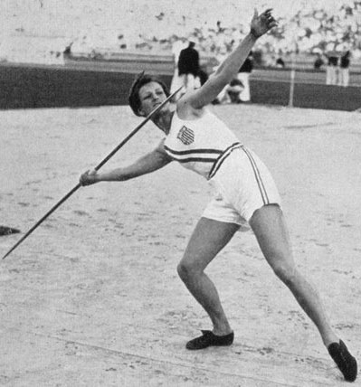
Let’s assume that Babe Didrikson’s 43.68 m gold wining javelin throw, at the Olympics held in Los Angeles in 1932, had the following physical characteristics:

- Launch speed = 25.0 m s ^{– 1}
- Launch angle = 40.0 ⁰ to the ground
- Launch height = 2.00 m above the ground
- Air resistance was negligible

Quadratic formulae:

a x ² + b x + c = 0

x = – b ± √ (b ² – 4 ac)
2a
Babe Didrikson wins gold in 1932

- Can you calculate the (a) size of the horizontal component; (b) size of the vertical component; (c) flight time; (d) height reached above the javelin’s release point; (e) maximum height reached above the ground, and (f) horizontal range of the javelin?

Q16 (a) [2 marks]: (b) [2 marks]: (c) [4 marks]: (d) [2 marks]: (e) [1 mark], and (f) [2 marks]
_____________________________________________________________________________________

[Total marks = 40] Percent score =

