MORLEY SENIOR HIGH SCHOOL

YEAR 12

PHYSICS (STAGE 3)

SATELLITE MOTION TEST

Student’s Name: Tutorial Group:

Teacher’s Name: Date:

_____________________________________________________________________________________

- Satellites may be natural (moons) or artificial (man-made), and may have circular or elliptical orbits.

Satellite Orbits

- For the orbits of satellites to be stable, the plane of the orbit must pass through the centre of the Earth.

- Satellites placed in Earth orbit may orbit around equatorial areas, from pole to pole, or in-between.

- A geosynchronous satellite is one that stays above the same point on the Earth’s surface, which is possible only if it is above a point on the equator (latitude = 0 ⁰). Such satellites are used for TV and radio transmission, for weather forecasting, and for communication relays.
- To remain above the same point on the Earth’s surface, as the Earth rotates, geosynchronous satellites must have a period of revolution of one day. The orbital speed of a geosynchronous earth satellite is given by: v = 2 π r / T; where the period T = 1 day = 24 hours = 86 400 s.

- 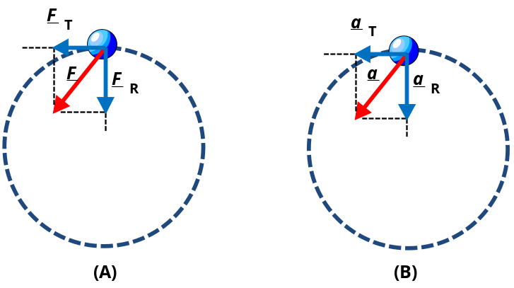In diagrams (A) and (B), imagine that the Earth is located at the centre of the circular motion of the satellite.

- In diagram (A), the centripetal force F is not directed toward the centre of the circle of revolution (or imagined Earth’s centre).

- For a satellite to remain in a stable orbit, why must the plane of a satellite’s orbit pass through the centre of the Earth?

[3 marks]
- A polar satellite is one that passes above or nearly above both poles of the planet (or other celestial body) on each revolution. It therefore has an inclination of (or very close to) 90 degrees to the equator. During a 12-hour day, a polar satellite can observe all points on Earth.

- Why can a polar satellite take observations at all points on the Earth’s surface during a 12-hour day?

[2 marks]

Newton’s Law of Universal Gravitation

- According to Isaac Newton’s Law of Universal Gravitation, every object attracts every other object with a force F that for any two objects is directly proportional to the product of their masses m ₁ × m ₂ and inversely proportional to the square of the distance 1 / r ² separating them. The size of the gravitational force can be written as: F = G × (m ₁ × m ₂) / r ²; where G = 6.67 × 10 ^{– 11} N m ² kg ^{– 1} (universal gravitational constant).

Geosynchronous Satellite Motion

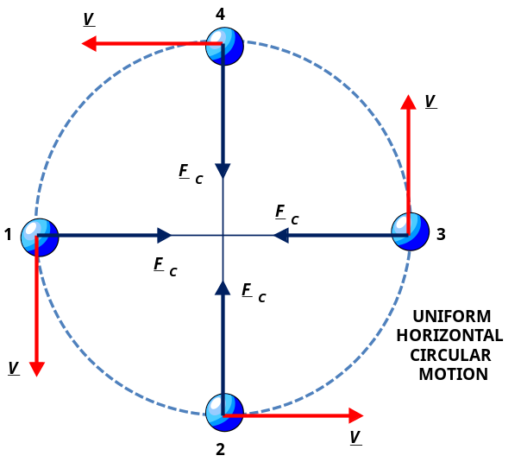Consider a geosynchronous satellite, undergoing uniform circular motion from Position 1 through to Position 4.
- According to Newton’s second law of motion Σ F = ma, an object that is accelerating must have a nett or resultant force acting on it.

- Any object moving in a circular path, like a satellite, must therefore have a force applied to it to keep it moving in that circular path.

- The resultant force Σ F _{C}, giving centripetal acceleration a _{C} to the satellite can be calculated using this equation: Σ F _{C} = m × a _{C} = m × (v ² / r).

- In the above diagram, again imagine that the Earth is located at the centre of the circle of revolution.

- What force provides the centripetal force necessary to keep an Earth satellite in a stable circular orbit?

[1 mark]
- For a satellite in stable circular orbit around the Earth, the centripetal force necessary for its circular motion is supplied entirely by the force of gravitational attraction exerted on the satellite by the Earth.

- By equating gravitational force with centripetal force, can you now show mathematically that the speed of a geosynchronous satellite, orbiting Earth, is given by this equation: v = √ (G × m _{E} / r)?

[3 marks]

- Mass of the Earth m _{E} = 5.98 × 10 ²⁴ kg, and its equatorial radius r _{E} = 6.38 × 10 ⁶ m. π = 3.142

- What is the surface speed (m s ^{– 1}) of the Earth, at the equator, as given by this equation: v = 2 π r / T?

[2 marks]

TABLE 1: A Comparison of Rocket Launch Facilities
Launch Facility | Country | Location | Longitude | Latitude | Rotational Speed of Earth
Cape Kennedy | USA | Florida | 80.5610 W | 28.5218 N | 410 m s ^{– 1} West to East
Kourou | French Guiana | Kourou | 52.7317 W | 05.2080 N | ~ 464 m s ^{– 1} West to East

- Is it more energy efficient to put a satellite into orbit from Kourou or from Florida? Explain.

[3 marks]

- Is it more energy efficient to launch a rocket, from Earth, West to East or East to West? Explain

[3 marks]
- How would you define the escape velocity of a rocket?

[2 marks]

- How would you define the orbital velocity of a satellite?

[2 marks]
Space Stations with Simulated Gravity

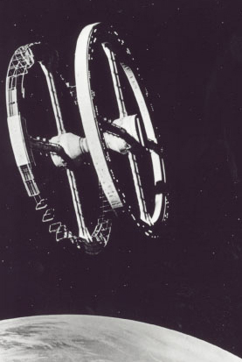
- Scientists have proposed space stations to be placed in Earth orbit that will rotate or spin to provide stimulated (or artificial) gravity comparable to that at the Earth’s surface.

- Most of the proposed space stations are designed like a very large wheel, with the living quarters inside the hollow ‘tyre’ of the wheel. Astronauts would enter and leave the structure at the centre or hub of the wheel, which could be designed, with suitable engineering, to be non-rotating.

- If such a wheel did not spin, the occupants inside would be weightless, but when spun, they will feel themselves pressed to the outer wall of the ‘tyre’. With the correct speed of spin, the push against the outer wall will match the surface gravity of the Earth.

- What is the required diameter d = 2 r of a space station, which is designed to spin at 1.0 rpm with a centripetal acceleration a _{C} = g (9.80 m s ^{– 2}) so that its gravity artificially approximates the Earth’s surface gravity?

[4 marks]
_____________________________________________________________________________________

[Total marks = 25] Percent score =

