MORLEY SENIOR HIGH SCHOOL

YEAR 12

PHYSICS (STAGE 3)

STATICS AND EQUILIBRIUM TEST

Student’s Name: Tutorial Group:

Teacher’s Name: Date:

_____________________________________________________________________________________

- Statics is the branch of mechanics concerned with forces in equilibrium.

- An object in mechanical equilibrium is either at rest or moving at constant speed in a straight line, i.e., it is moving with a constant velocity.

- Velocity is speed in a given direction. Velocity is constant only when speed and direction are both constant.

- A special case of mechanical equilibrium is static equilibrium where the object has zero velocity, i.e., the object is not undergoing translational and / or rotational motion.

- Three types of static equilibrium may be identified dependent upon what happens to the centre of gravity of the object, when the object is displaced:
- Stable Equilibrium: Work must be done to raise its centre of gravity.
- Unstable Equilibrium: Displacement lowers its centre of gravity.
- Neutral Equilibrium: Displacement neither raises nor lowers its centre of gravity.

- The centre of gravity of an object is a point at the centre of an object’s weight distribution where the force of gravity can be considered to act.
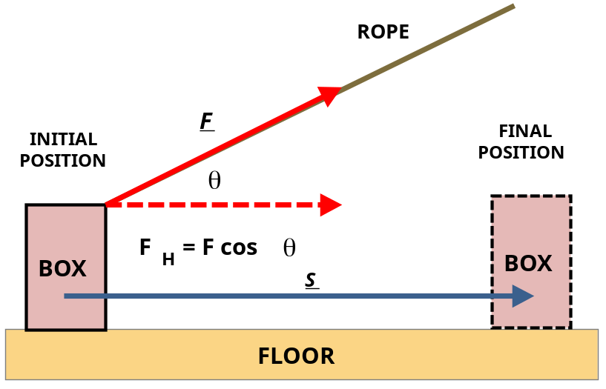
The Work done by a constant Force

The work done on an object by a constant force (both in magnitude and direction) can be found by multiplying the magnitude of the displacement by the component of the force parallel to the displacement, as given by this equation: W = F_{H} × s, where F_{H} is the component of the constant force F parallel to the displacement s. We can also write: W = F cos θ × s, where θ is the angle between the directions of the force and the displacement.

- Can you show mathematically why F_{V} = F sin θ, by resolving the constant force F into its rectangular vector components? Your answer must include a labelled vector components diagram.

[2 marks]

Some examples of Static equilibrium
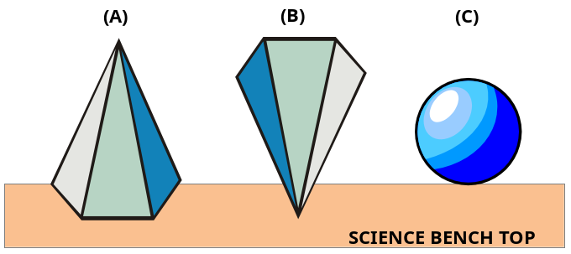

To correctly answer Questions 2 through 4, you must logically apply the concepts of displacement, centre of gravity, and work done, all of which are explained on Page 1.

- In which state of static equilibrium is the pentagonal pyramid shown in diagram (A)? Explain.

[3 marks]

- In which state of static equilibrium is the pentagonal pyramid shown in diagram (B)? Explain.

[3 marks]
- In which state of static equilibrium is the sphere at rest on the bench top in diagram (C)? Explain.

[3 marks]
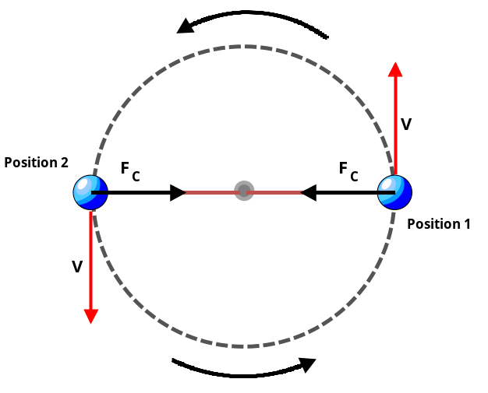
- Why is a sphere being swung at constant speed in a horizontal circle not undergoing constant velocity?

[2 marks]

- Is a sphere being swung at constant speed in a horizontal circle in a state of mechanical equilibrium? You must fully explain your answer.

[3 marks]

Torque about Couples in Physics

- A couple is a pair of forces of equal magnitude acting in parallel but in opposite directions, capable of causing rotational but not translation motion.

- Torque or moment of a force about a point is a measure of its turning effect about that point. Torque is the product of the magnitude (size) of the force and the perpendicular distance from the point to the line of action of the force, as shown by this equation: τ = M = r ┴ × F.

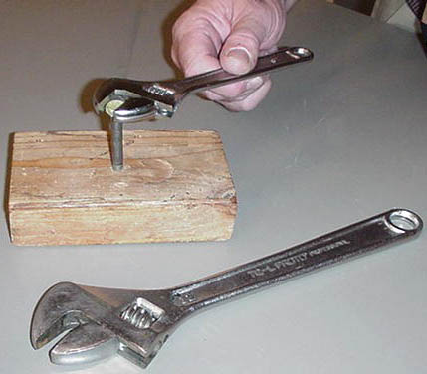
In the adjacent photograph, we see that the small crescent spanner is held about half way down the shaft toward the head of the spanner.

This results in a lever arm that is only about half of its maximum value.

- The lever arm can be defined as the perpendicular distance from the axis of rotation (turning point or fulcrum) to the line of action of the force.

This yields a torque that is only about half of its maximum value. Therefore, in this situation, we have an inefficient use of the crescent spanner.

- Can you correctly apply the physics equation τ = r ┴ × F to explain why, you obtain much more torque by using a large spanner, rather than a small spanner, when screwing a steel bolt into soft pine wood?

[3 marks]
Balanced Torques

- The seesaw system, shown below, is in translation equilibrium and in rotational equilibrium.
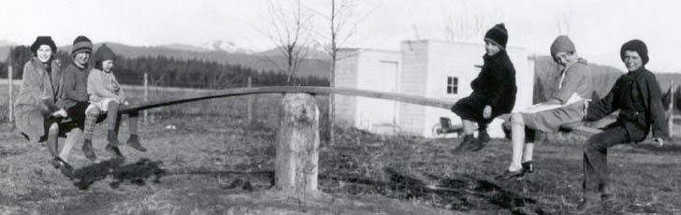

- As the seesaw has no linear acceleration a = 0, then according to Newton’s second law Σ F = m × a, the resultant force Σ F acting on the seesaw must also be zero, i.e., Σ F = 0. Also, as the seesaw is in rotational equilibrium, the sum of the torques Σ τ about any point in the seesaw system must also be zero, i.e., Σ τ = 0.

Conditions for Static Equilibrium

- Equilibrium condition 1: The resultant of all forces acting on an object must be zero, i.e., Σ F = 0.

- Therefore, the sum of all horizontal forces = 0, i.e., Σ F _{H} = 0, and the sum of all vertical forces = 0, i.e., Σ F _{V} = 0.

- Equilibrium condition 2: (or The Principle of Moments): The algebraic sum of torques about any point in the plane, in which the forces act, is zero, i.e., Σ τ = 0. Therefore, Σ Anti-clockwise Moments = Σ Clockwise Moments.

A Free-body Diagram of the Seesaw
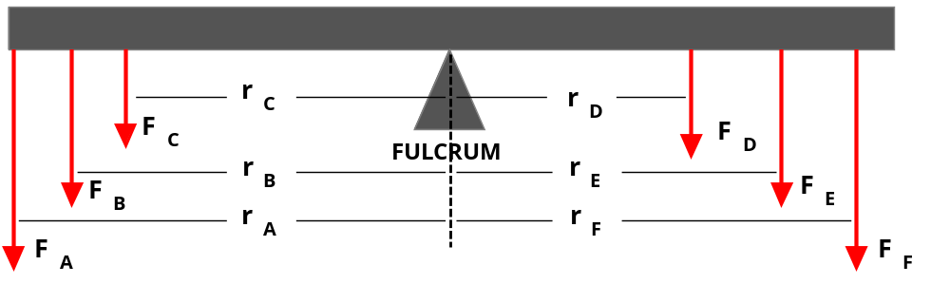

- The weight forces of the children, from left to right in the photograph, are F_{A}, F_{B}, F_{C}, F_{D}, F_{E}, and F_{F}.

- Given that the weight force of the seesaw is F _{SEESAW}, what is the magnitude of the upward force, (not shown in the free-body diagram), which the fulcrum exerts on the balanced seesaw, shown on Page 4?

[2 marks]

- Can you show, in a mathematical equation, how the algebraic sum of the torques about the fulcrum of the balanced seesaw, shown on Page 4, must equal zero?

[2 marks]
Numerical Problem Solving

A metre ruler of mass 90 g has masses of 105 g and 180 g hung from its ends as shown in this diagram.

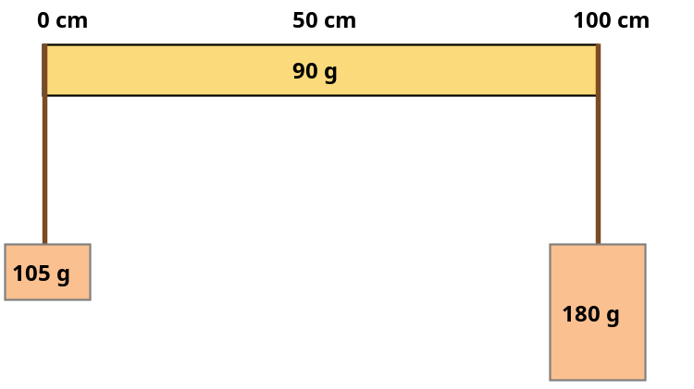

- The Principle of Moments: The algebraic sum of torques about any point in the plane, in which the forces act, is zero, i.e., Σ τ = 0.

- Therefore, Σ Anti-clockwise Moments = Σ Clockwise Moments.

- Can you now draw a free-body diagram to show all the weight forces acting on the metre ruler, including its own weight, and then show with a triangle ∆ the balance point (or fulcrum) of the ruler?

[4 marks]

- At what centimetre mark must the metre ruler (100 cm) be suspended so that it will remain balanced in a horizontal orientation?

[3 marks]
_____________________________________________________________________________________

[Total marks = 30] Percent score =

