MORLEY SENIOR HIGH SCHOOL

YEAR 12

PHYSICS (STAGE 3)

VECTORS TEST

Student’s Name: Tutorial Group:

Teacher’s Name: Date:

_____________________________________________________________________________________

- A scalar quantity has magnitude only.

- A vector quantity has both magnitude and direction.

- For each physical quantity listed in TABLE 1, can you indicate which quantity is a vector, and which is a scalar by printing either V for a vector or S for a scalar in the appropriate cell in the table?

TABLE 1: Which are Scalars? Which are Vectors?
Physical Quantity |  | Scalar | Vector
1 | mass
2 | weight
3 | time
4 | temperature
5 | distance
6 | displacement
7 | speed
8 | velocity
9 | acceleration
10 | force
11 | kinetic energy
12 | potential energy
13 | momentum
14 | impulse

[14 marks]

Suppose that you are a passenger, sitting at rest, on a school bus that is travelling West at 10.0 m s ^{– 1}.

- What is your speed relative to the bus? [1 mark]

- What is your speed relative to the ground? [1 mark]

- What is your velocity relative the ground? [2 marks]

- Graphically a vector is represented by an arrow, whose length gives the magnitude of the vector, and whose arrowhead gives the direction of the vector.

- How would you graphically show the velocity [3 marks]
of a school bus, which is travelling West at 10.0 m s ^{– 1}?

- How would you graphically show the velocity [3 marks]
of a school bus, which is travelling East at 10.0 m s ^{– 1}?

- Can a velocity of 10.0 m s ^{– 1} East be mathematically shown as – 10.0 m s ^{– 1} West? You must fully explain your answer.

[3 marks]

Vector Addition (C = A + B)

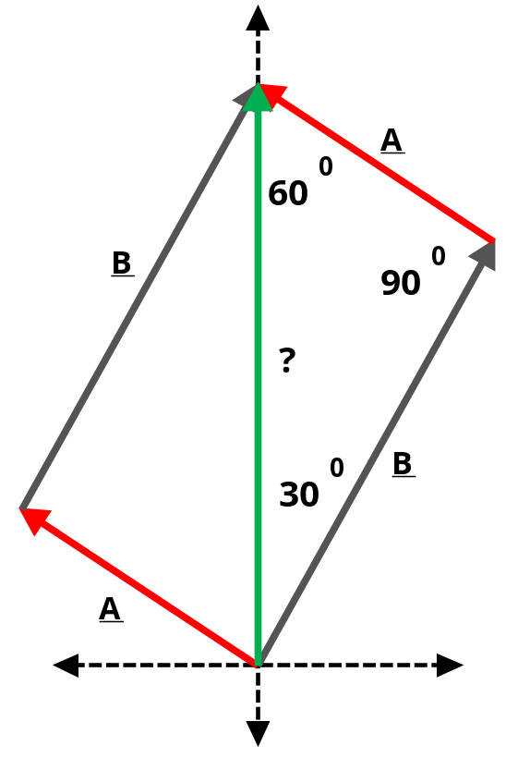
- The resultant or vector sum of vectors A and B is a vector C whose effect on an object is equal to the combined effects of vectors A and B on that object.

- How could you describe in words the unknown vector (?) in terms of vectors A and B?

[1 mark]

- How could you describe mathematically the magnitude of the unknown vector (?) in terms of vectors A and B?

[2 marks]

Does the order of vector addition affect either the magnitude or the direction of the resultant vector?

- If vector B is added to vector A is the resultant obtained the same, as when vector A is added to vector B? You must fully explain your answer? HINT: Refer back to the vector addition diagram on Page 2.

[3 marks]

Trigonometric Formulas

For a right-angled Triangle
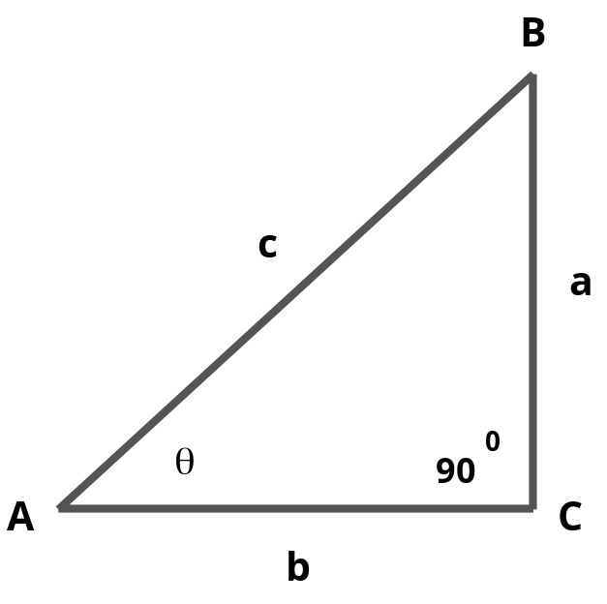

Pythagorean theorem

c ² = a ² + b ²

sin θ = a / c

cos θ = b / c

tan θ = a / b

tan θ = sin θ / cos θ

For any Triangle

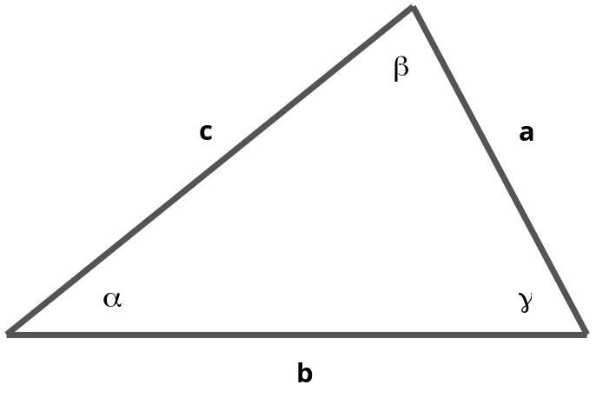

Law of cosines

c ² = a ² + b ² – 2 a b cos γ

Law of sines

sin α / a = sin β / b = sin γ / c

- If a bushwalker walks 6.5 km North East, then 4.5 km North, what is his/her resultant displacement? You must draw a vector addition diagram, with labelled arrows, in your solution to this problem.

[6 marks]

Vector Difference (C = A – B)

- The difference of vectors A and B, represented by A – B is best defined as the sum of A + (– B).

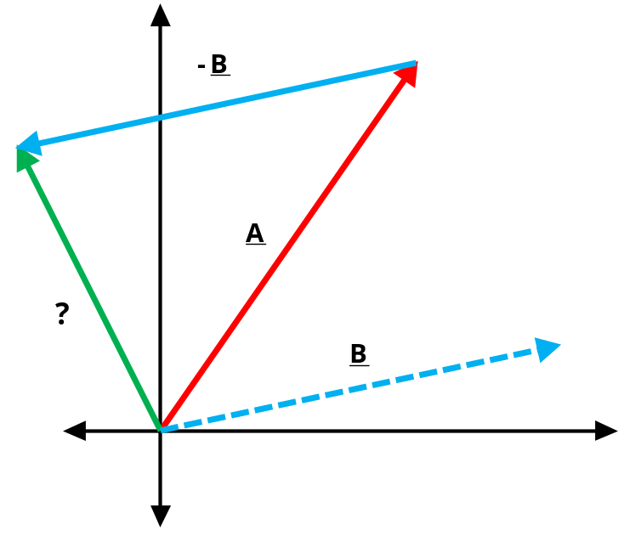
- How is vector – B different from vector B?

[1 mark]

- How could you describe mathematically the unknown vector (?) in terms of vectors A and B?

[1 mark]

- How does reversing the order of subtraction of two vectors affect the vector difference? For example, how would the vector difference of A – B differ from the vector difference of B – A?

[1 mark]
- Change in velocity (∆ v) = (v – u) = v + (– u); where v = final velocity, and u = initial velocity.

In a tennis match at the Kooyong Classic, a player receives a served ball that was travelling at 30 m s ^{– 1} South just before the ball hit his/her racquet. Immediately after leaving his/her racquet, the tennis ball is now travelling at 25 m s ^{– 1} North.

- What change in velocity (magnitude and direction) did the receiving player give to the tennis ball? You must draw a vector difference diagram, with labelled arrows, in your solution to this problem.

[5 marks]

A cyclist travelling at 12 km h ^{– 1} East makes a right-hand turn at an intersection without changing speed.

- What change in velocity (magnitude and direction) did the cyclist experience in making the right-hand turn? You must draw a vector difference diagram, with labelled arrows, in your solution to this problem.

[7 marks]
Resolution of a Vector

- Resolution is the process of splitting or resolving a single vector into its component vectors.

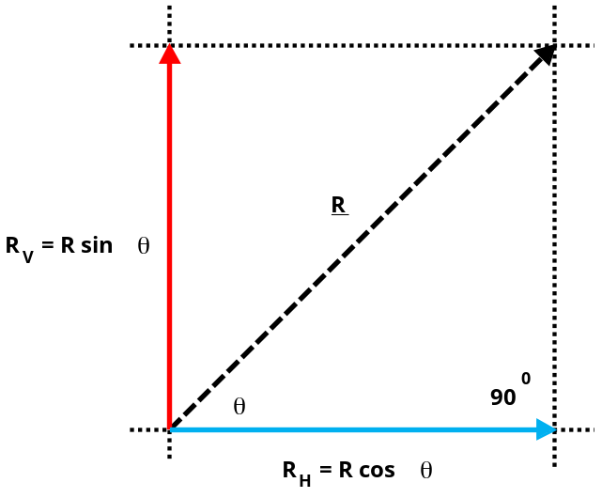
Consider a single vector R making an angle θ ⁰ with the horizontal.

Vector R can be resolved or split into two rectangular (at 90⁰) component vectors:

Vertical component: R _{V} = R sin θ

Horizontal component: R _{H} = R cos θ.

The single vector R has been replaced by its two rectangular (at 90⁰) component vectors R_{V} and R_{H}.

A gardener is pushing with a force of 150 N on the handle of a lawn roller inclined at 40 ⁰ to the ground.

- What vertical downward force is exerted by the gardener on the lawn roller?

[2 marks]

- What horizontal force is moving the lawn roller forward across the lawn?

[2 marks]

- If the lawn roller has a weight of 303.6 N, what is the total force pushing downwards on the lawn?

[2 marks]
_____________________________________________________________________________________

[Total marks = 60] Percent score =

