Physics Stage 2A Practical Examination Marking Guide

Name: __________________________________________________________ (42 marks)

Question One: (10 marks)

A student rolled a toy car down a ramp similar to experiment 2.1 Going Faster. The ramp was 4.0 m long and the student placed the ramp at an angle to the desk. He then marked off sections of the ramp to show when he would record the displacement and time.

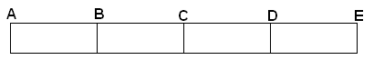

He obtained the results shown below:

Sections of Ramp | A | B | C | D | E
Total displacement from start (m) | 0 | 1.0 | 2.0 | 3.0 | 4.0
Total time (s) | 0 | 3.16 | 5.61 | 8.04 | 10.52

- On the graph below, graph the total distance vs total time and draw a line of best fit. (5 marks)

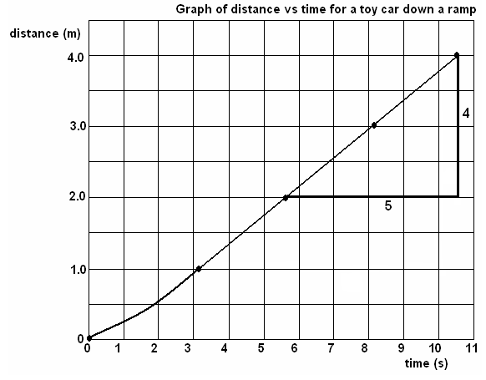

Marks:
title 1 mark
axis correct 1 mark
axis labelled 1 mark
point plotted 1 mark
line of best fit – needs to show curve at start and then straight section 1 mark

- Use the graph to calculate the gradient of the line between 2.0 m and 4.0 m. Show working below. (3 marks)

gradient = 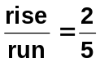 1 mark

gradient = 0.4 m s⁻¹
1 mark 1 mark

NB: only 2 significant figures maximum for graphs (1 is better)

- Using the table and the graph, describe the motion of the car on the ramp. (2 marks)

Initially accelerates 1 mark

by the time it gets to 1.0 m it is travelling with a constant velocity. 1 mark

Question Two (2 marks)

You experimented with both an air track with gliders and with motion trolleys.

One of the experiments was to hit a small glider (A) moving slowly with a large glider (B) moving faster but both moving in the same direction. Describe the motion of each trolley after the collision.
(2 marks)

Larger glider B will slow down 1 mark

Smaller glider A will speed up 1 mark

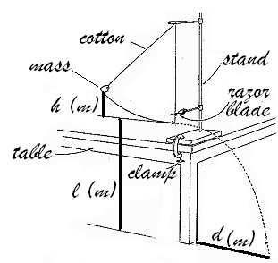
Question Three (6 marks)

Two students were carrying out a similar experiment to the one you did on potential energy transforming to kinetic energy.

In carrying out the experiment, a possible set of data could have been obtained as shown below:

Mass | height mass raised above razor blade | height razor blade above ground | horizontal distance travelled
50.0 g | 26.5 cm | 90.0 cm | 93.4 cm

a. Use this data to calculate the potential energy lost and the kinetic energy gained. (4 marks)

E_{p} = mgh E_{k} = ½ mv²
= 0.05 x 9.8 x 0.265 = ½ x 0.05 x 2.179²
= 0.12985 J 1 mark = 0.1187 J 1 mark

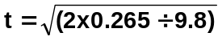
t = 0.4286 s 1 mark

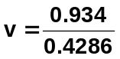
v = 2.179 ms⁻¹ 1 mark

NB: if students use cm instead of m, deduct 1 mark overall

- Write a brief conclusion for the experiment. (2 marks)

Within experimental error, E_{p} lost = E_{k} gained

Would expect E_{k} to be slightly less due to air resistance

Question Four: (5 marks)

The following graph is of the reading on a geiger counter of beta and alpha particles as the distance from the source increases. The sources of each had the same activity.
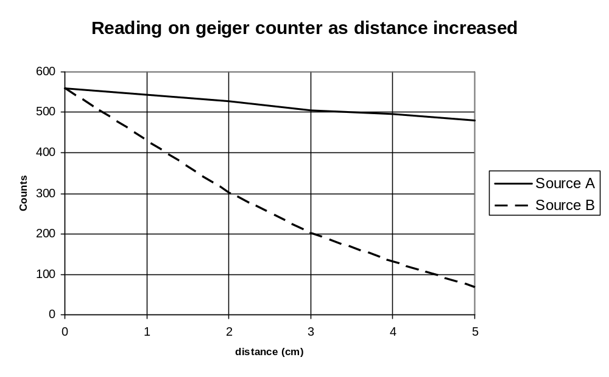

- Which was the beta source, A or B? _____ A____ (1 mark)

- Fully explain, including your understanding of the characteristics of alpha and beta radiation, why you selected this source and why it couldn’t be the other source? (4 marks)

Negative Beta particles are very small and travel at high speeds (1 mark)
Therefore penetrate further than alpha particles in air (1 mark)
Positive Alpha particles are very large and slow moving (1 mark)
Easily stopped by air particles so rapid reduction in count. (1 mark)

Question Five: (9 marks)

Laboratory Skills:
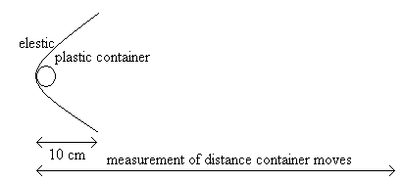
Rachael is conducting an experiment to find out how the weight effects the distance a plastic container can travel.

She clamps a piece of elastic across a desk and pulls it back 20 cm. She places a plastic container weighing 0.1 kg next to the elastic and releases the elastic. The plastic container was shot forward and the distance was measured. The experiment was repeated twice more. See diagram.

She then added 0.1 kg to the plastic container and repeated the experiment. She did this with 0.2 kg, 0.3 kg, 0.4 kg and 0.5 kg.

  - State the independent variable: mass added________________________ [1 mark]
State the dependent variable: distance travelled_____________________ [1 mark]
List the controlled variables: [2 mark]

Same distance container pulled back (10 cm),
same surface container slides on, need at least 2 for 2 marks

  - Write a hypothesis for this experiment. [2 marks]

As the mass is increased, the distance the container travels is decreased. (1 mark)
The relationship will be inversely proportional in that as the mass is doubled the distance travelled is halved. (1 mark)

c. She collected her results and recorded them below. Complete the table. [3 marks]

Total weight (kg) | Distance travelled (cm)
Total weight (kg) | Trial 1 | Trial 2 | Trial 3 | AVERAGE
0.1 | 49 | 43 | 46 | 46
0.2 | 37 | 40 | 42 | 40
0.3 | 32 | 33 | 31 | 32
0.4 | 29 | 32 | 27 | 29
0.5 | 25 | 25 | 27 | 26
0.6 | 19 | 10 | 21 | 20

Marks: calculated averages – 1 mark
use of 2 significant figures only – 1 mark
not using last value trial 2 – 1 mark
Question Six: (10 marks)

A student was carrying out an investigation on half-life and radioactive decay using a normal dice. He counted the dice and found he had been given 200 dice. He decided to let the number 6 represent an atom that had decayed. He mixed them up in an ice-cream container and threw them on the bench, removing all the dice that showed a 6 and counted the dice left. He did this for a total of 12 throws. His results, and the graph of these results, are shown below.

Throws | 0 | 1 | 2 | 3 | 4 | 5 | 6 | 7 | 8 | 9 | 10 | 11 | 12
Dice Left | 200 | 164 | 141 | 114 | 97 | 80 | 70 | 56 | 47 | 39 | 34 | 27 | 23

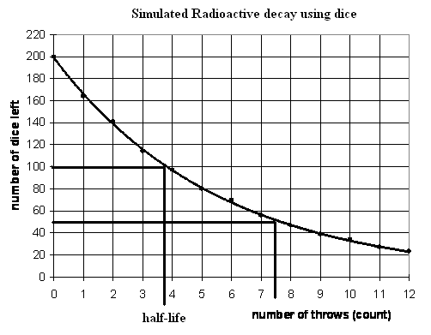

Marks:

title 1 mark
points 1 mark
line of best fit
1 mark

- Plot the data and complete the graph. (3 marks)
- What is the half life of his experiment? 3.7 throws Show this on the graph. (2 marks)
- What is the chance of the dice landing with a 6 facing upwards? One sixth (1 mark)
Is the rate of decay increasing, decreasing or remaining constant. Use values from the graph to justify your answer. (3 marks)
The rate of decay is constant. (1 mark)
The graph shows that the first half-life is about 3.7 counts and the second about 7.4 counts. That is, about 3.7 each time so constant. (2 marks for a suitable justification)

- Describe how the student could have made the experiment more accurate? (1 marks)
Use a larger number of dice (1 mark)

