Section B

Question 26

(a) Define ‘inflation rate’ and demonstrate its calculation for 2002/03. (2)

Inflation rate measures the percentage change in the general level of prices from one year to the next. One method of measurement is the CPI which approximates the extent of increases in the cost of living.
Working must be shown as well as the right answer.

E.g. 120.7 – 120.3 * 100 = 0.33%
120.3

(b) Identify the stage of the business cycle for this economy, in 2003/-4, by reference to two of the indicators shown. (3)

Recovery / upswing.
After two years of negative growth there is a positive change in GDP.
The unemployment rate has fallen, as increased output requires more workers.
Students might also mention a slight rise in inflation but it’s not the clearest indicator to choose.

(c) Describe an appropriate policy response to the economic situation of this country. (5)
Identify the ‘economic situation’.
The recovery appears to be in the early stages: growth is below what might be anacceptable level (3-4%) unemployment is higher than acceptable (5-6%) inflation is below a possible acceptable range (2-3%) and there is in fact a current account surplus.
Identify a possible policy stance: e.g.
Ensure a sustained recovery by stimulating the economy through encouraging expenditure and output and therefore further rises in income.
Existence of a current account surplus gives more freedom to embark on expansionary policy than would a large deficit.
Expansionary monetary policy through lowering or maintaining low official interest rates.
An additional fiscal stimulus might be appropriate depending upon the state of government finances and the medium term goals of fiscal policy. Tax reforms that see a fall in income tax rates could also be appropriate, improving the efficiency of the tax system and boosting disposable income, confidence and household expenditure.

29 a) Describe the components of aggregate expenditure in the Australian economy (6 marks)
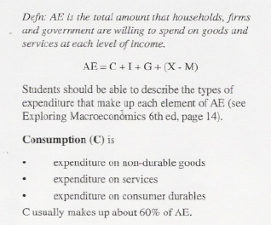
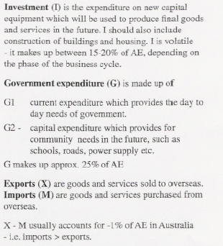

29 b) Discuss the factors which might cause aggregate expenditure to change. (Illustrate your answer by reference to recent Australian experience) (8 marks)

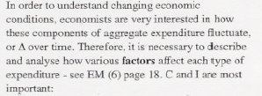
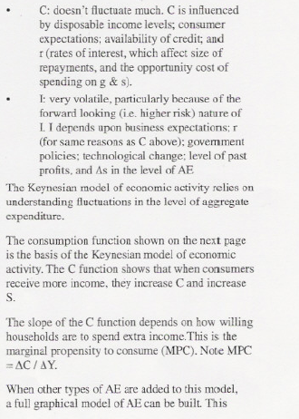
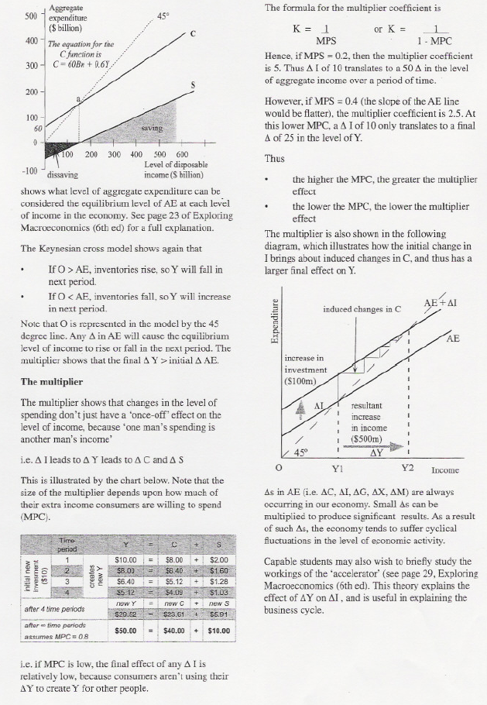

30 a) Use a diagram to illustrate how a tariff raises revenue for the government and protects domestic producers. (7 marks)
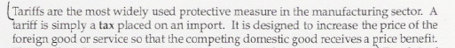
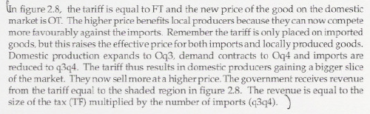
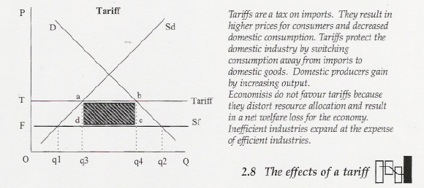
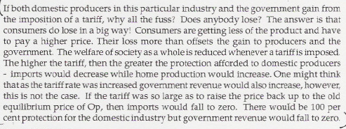

b) Describe the impact of the reduction of trade barriers, both domestic and overseas, on the Australian economy. (8 marks)





31 a) Briefly explain the concept of economic growth (3 marks)

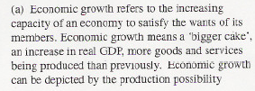
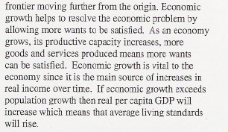

b) Outline the ain cause of economic growth in an advanced economy such as Australia. (6 marks)

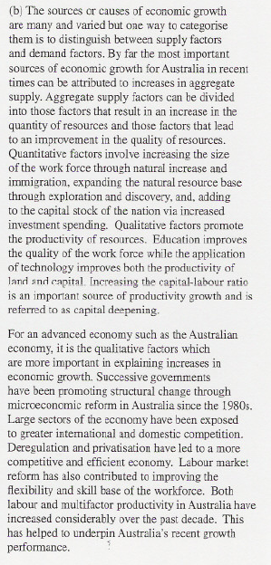
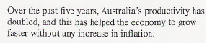

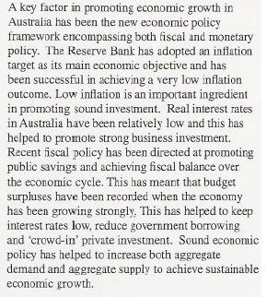

c) Discuss the possible effects of economic growth on unemployment. (6 marks)

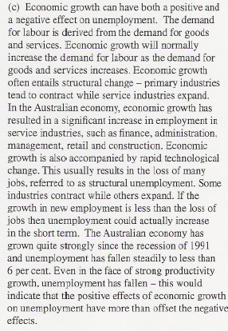
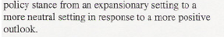

32 a) Define the term foreign debt and explain the link between Australia’ foreign debt and the Balance of payments. (7 marks)

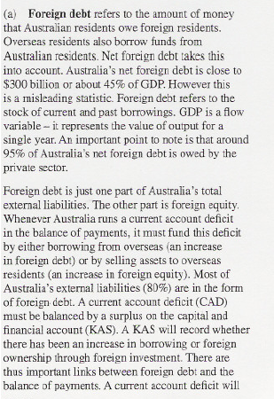
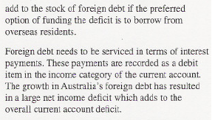

b) Discuss the economic costs and benefits of an increase in the level of foreign debt. (8 marks)
