Narrogin Senior High School

YEAR 12 ECONOMICS

SEMESTER 1 EXAMINATION, 2007

NAME OF CANDIDATE _____________________________________________________

TIME ALLOWED FOR THIS PAPER

Reading Time: Ten Minutes
Working Time: 2 ½ Hours

MATERIAL REQUIRED / RECOMMENDED FOR THIS PAPER

TO BE PROVIDED BY THE SUPERVISOR
This Question/Answer booklet.
Separate Multiple Choice Answer Sheet.

TO BE PROVIDED BY THE CANDIDATE
Standard items: Pens, pencils, eraser, ruler and calculator.
Special items: Calculator satisfying the conditions set by the Curriculum Council

INSTRUCTIONS TO STUDENTS

Section A Answer ALL the questions on the separate Multiple Choice Answer Sheet using a 2B, B or HB pencil. Do not use a ballpoint or ink pen.

Section B Write your answers in the spaces provided in this Question/Answer Booklet.

Section C Write your answers on lined paper.

IMPORTANT NOTE TO CANDIDATES

No other items may be taken into the examination room.

It is your responsibility to ensure that you do not have any unauthorised notes or other items of a non-personal nature in the examination room. If you have any unauthorised material with you, hand it to the supervisor BEFORE reading any further.

ECONOMICS 12 SEMESTER 1 2007

STRUCTURE OF THIS PAPER

Section | Format | No. of questions available | No. of questions to be attempted | Suggested time/minutes | Marks
A | Multiple Choice | 25 | ALL | 30 | 25
B | Data Interpretation | 3 | ALL | 60 | 30
C | Essays/Extended Writing | 4 | 2 | 60 | 30

Total marks 85

SECTION A: MULTIPLE CHOICE
Attempt all questions in this section. Choose the alternative which correctly answers the question or completes the statement. Record your answers on the separate Multiple Choice Answer Sheet using a 2B, B or HB pencil. Read the instructions on this sheet with care.

1. Which of the following are leading indicators of economic activity?

(a) Gross Domestic Product and the rate of change of tax receipts.
(b) Inflation and unemployment.
(c) The All Ordinaries Index and consumer sentiment.
(d) Retail sales and interest rates.

2. GDP (A) is used to measure output. This means that the contribution that a commodity makes to the well being of the community is valued by

(a) its total production costs.
(b) its market price.
(c) the proportion of total spending it occupies.
(d) the extent of need for the good in the community.

Question 3 refers to the diagram below.

S, I S

I

Y/O

Ye Yfe

3. This diagram shows a situation of

(a) disequilibrium.
(b) inflation.
(c) falling inventories.
(d) a deflationary gap.

- The diagram below shows an aggregate demand and aggregate supply curve for an economy.

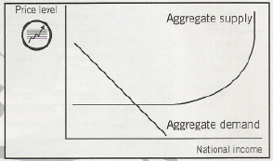

If there is an increase in aggregate demand there will be:

- a rise in prices immediately as firms take advantage of new profitable opportunities.
- a rise in prices if demand increases sufficiently to take up spare capacity.
- a rise in unemployment as workers begin to price themselves out of work.
- immediate inflation as the economy is working at full capacity.

5. The major contribution of Keynes was his development of a model of the economy

(a) that explained the causes of unemployment.
(b) in which full employment is not automatically attained.
(c) that emphasised the importance of equilibrium.
(d) in which investment is the key factor.

6. Which of the following would cause the size of the multiplier to increase?

(a) An increase in investment.
(b) An increase in income that caused expenditure to rise.
(c) A decrease in the marginal propensity to save.
(d) A decline in business expectations.

Question 7 relates to the following data about the economies of two hypothetical nations.

Time Period | Country A  Nominal GDP  ($bn) | CPI | Country B  Nominal GDP ($bn) | CPI
1 | 25 | 114 | 25 | 114
2 | 27 | 114 | 30 | 120
3 | 29 | 115 | 36 | 129
4 | 37 | 116 | 43 | 138
5 | 33 | 116 | 50 | 150
6 | 45 | 116 | 58 | 155

7. According to the data

(a) Country A had the highest rate of economic growth over the period.
(b) Country B had the highest rate of economic growth over the period.
(c) Both countries had the same rate of economic growth over the period.
(d) It is not possible to compare growth rates because they had different inflation rates.

8. Which of the following is most likely to reduce the natural rate of unemployment?

(a) An increase in government spending accompanied by a tax cut to encourage spending, output and therefore the demand for labour.
(b) An increase in government spending accompanied by a reduction in interest rates so that investment and economic growth are encouraged.
(c) An increase in government spending focused on welfare payments and other poverty alleviation schemes.
(d) An increase in government spending focused on education and training accompanied by deregulation of wage setting.

9. According to the idea of inflationary expectations

(a) after several years of inflation decision makers come to anticipate it.
(b) the behaviour of those who have come to expect inflation shifts the Phillip’s curve to the right.
(c) persistent inflation means that people can prepare for inflation and totally avoid its costs.
(d) as people correctly anticipate inflation their behaviour actually stops it from occurring.

Question 10 refers to the following table which shows the cost in terms of labour inputs of producing one unit of rice and one unit of textiles in three countries.

Country | Rice | Textiles
Indonesia | 10 | 8
Thailand | 2 | 2
Japan | 1 | 6

10. If Thailand and Indonesia only trade with Japan which of the following is the combination of exports suggested by the theory of comparative advantage?

(a) Indonesia exports rice to Japan and Thailand exports textiles to Japan.
(b) Both Indonesia and Thailand export rice to Japan.
(c) Both Indonesia and Thailand export textiles to Japan.
(d) Thailand exports rice to Japan and Indonesia exports textiles to Japan.

Question 11 refers to the following data. This data refers to an economy using the same definitions of employment and unemployment as those used by the ABS.

Total population | 18 million
Population of working age | 9 million
Not in the workforce | 3 million
Employed | 5 million
Unemployed | 1 million

11. The rate of unemployment in the economy to the nearest whole number is:

- 20%
- 17%
- 11%
- 6%

The next two questions are based on the following table which shows the production of motor vehicles and tractors in Country A and Country B using one unit of labour.
Commodity Country A Country B
Motor Vehicles (number) 160 200
Tractors (number) 40 100

12. The opportunity cost of one motor vehicle in Country A is
(a) 4 tractors (c) 0.8 tractors
(b) 0.25 tractors (d) 2 tractors

13. A country which is relatively more efficient than other countries in producing a good A must
(a) have an absolute advantage in production of this product
(b) benefit from specialization and trade in that good A
(c) impose restrictions on the import of good A
(d) subsidize exports of good A

Questions 14 to 15 are based on the following hypothetical figures for Australia's balance of payments in the year 2004

Current Account | $ billion
Merchandise exports | 95.5
Merchandise imports | 92.0
Net services | -6.8
Net income | -31.5

14. The balance on goods and services is equal to
(a) - $ 10.3 b (c) - $ 6.8 b
(b) - $ 3.3 b (d) - $ 2.3 b

15. The balance of payments on current account shows a
(a) deficit of $16.4 b
(b) surplus of $3.5 b
(c) deficit of $34.8b
(d) surplus of $28.2 b

16. Stagflation refers to
(a) falling unemployment and rising prices
(b) falling unemployment and falling prices
(c) rising unemployment and rising prices
(d) rising unemployment and falling prices

17. Which of these offers the best explanation for the shape of the Phillips Curve?
(a) There is a positive relationship between inflation and unemployment rates
(b) The closer the economy moves to full employment, the smaller the increase in inflation for a small decrease in unemployment
(c) There is an inverse relationship between inflation and employment growth
(d) The closer the economy moves to full employment, the smaller the increase in inflation for a large decrease in unemployment

18. The depletion of non-renewable resources which can arise from continued economic growth has
(a) led to a requirement for lower economic growth
(b) created a requirement for growth compatible with resource sustainability
(c) reduced the productivity of resources used in growth
(d) created a lower rate of technological change

Question 19 refers to the following information about two countries and their production possibilities.

8

5
CANADA

FRANCE

12
8

19. Which of the following is true?

(a) Canada has a comparative advantage in both wine and wheat.
(b) France has a comparative advantage in the production of wheat.
(c) Canada has nothing to gain from trade with France.
(d) France has a comparative advantage in the production of wine.

20. Which of the following is not a short run cost of reducing tariffs?

(a) Rising structural unemployment.
(b) An increase in the CAD.
(c) Closures of some local firms.
(d) Increased efficiency in the target industry.

Question 21 refers to the following diagram.

Inflation A
Rate
%

B

Unemployment rate %

21. Which one of the following is most likely to cause the economy to move from point A to
point B?

(a) A reduction in interest rates.
(b) Increased government spending.
(c) A decrease in consumer spending.
(d) A decrease in income taxes.

22. Unemployment caused by insufficient aggregate demand for
domestically produced goods and services is called i) ______________
unemployment and short term unemployment caused as people move
from one job to another is called ii) ______________ unemployment.

- i) cyclical; ii) structural
- i) cyclical; ii) frictional
- i) structural; ii) frictional
- i) structural; ii) cyclical

23. Which of the following statements regarding Australia’s pattern of trade is correct?
- Traditionally Australia has been a major importer of manufactured products.
- Traditionally Australia has been a major importer of primary products.
- Traditionally Australia has been a major exporter of manufactured products.
- Traditionally Australia has been a major exporter of services.

24. The main change in Australia’s direction of trade has been from

- the Asian region to the American region
- the Indian Ocean region to the Pacific Ocean region
- Europe to the Asia-Pacific region
- The American region to the Asian region.

25. Which of the following would have least impact in limiting a country’s rate of economic growth?

- a shortage of skilled labour.
- the multiplier effect.
- a high marginal propensity to import.
- automatic fiscal stabilisation.

Section B Data Interpretation 30 marks
3 questions 60 minutes

Write your answers in the spaces provided.

26. The data below relates to a modern industrialised economy with similar economic institutions and objectives as Australia.

YEAR | Real GDP  % change | Unemployment Rate | CPI  (1989-90 = 100) | Current Account  Surplus  % of GDP
1998/99 | 3.8 | 8.2 | 115.8 | 3.0
1999/00 | 3.7 | 8.5 | 117.0 | 2.4
2000/01 | 3.6 | 9.4 | 118.2 | 1.7
2001/02 | -0.7 | 9.9 | 120.3 | 1.7
2002/03 | -1.2 | 8.9 | 120.7 | 2.8
2003/04 | 0.7 | 8.6 | 121.8 | 3.0

(a) Define ‘inflation rate’ and demonstrate its calculation for 2002/03. 2 marks
.

(b) Identify the stage of the business cycle for this economy, in 2003/04, by reference to two of the indicators shown. 3 marks

(c) Describe an appropriate policy response to the economic situation of this country in 2003/4. 5 marks

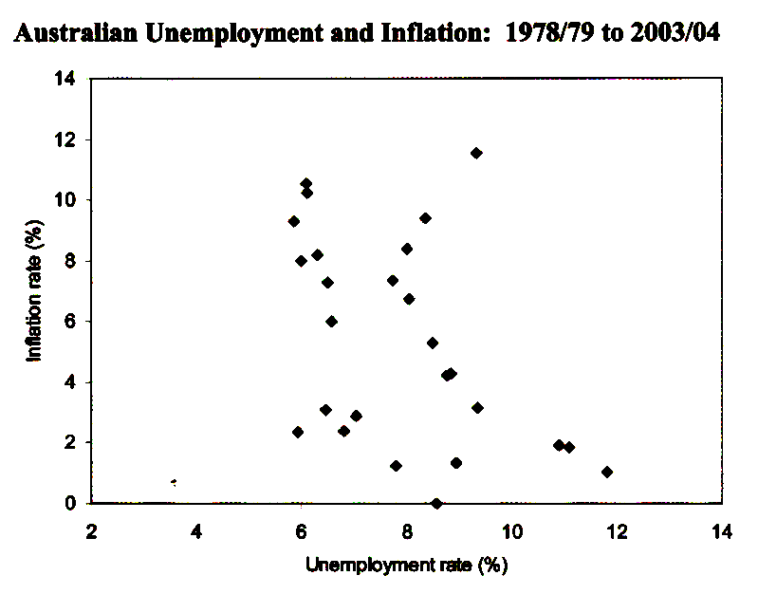
  - i What was the unemployment rate and the inflation rate in the year when stagflation was greatest? 1 mark

ii In 1992/93 the unemployment rate was 11.8 per cent. What was the likely cause of the inflation rate in this year? 1 mark

b) Discuss whether a Phillips Curve relationship is apparent in the graph. 3 marks

- Currently both the unemployment rate and inflation rate are at low levels in Australia. What factors are likely to have contributed to this situation? 5 marks

- Labour force and unemployment
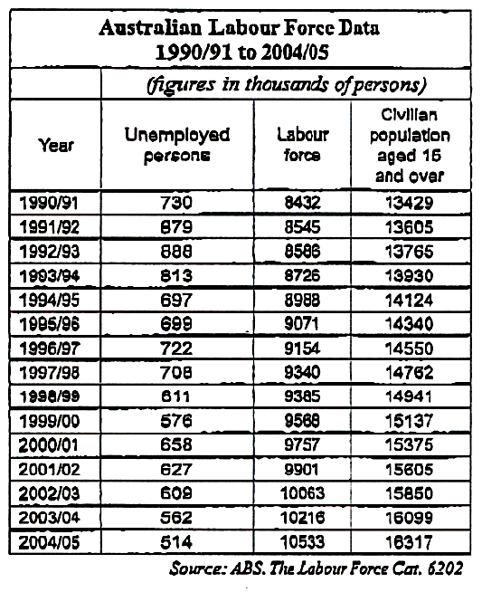

(a) i Calculate the unemployment rate for 2004/05. 1 mark

ii Calculate the participation rate for 2000/01. 1 mark

- Discuss why the number of unemployed persons in Australia has steadily fallen since its peak in 1992/93. 3 marks

- The number of unemployed persons has fallen from 658,000 in 2000/01 to
514,000 in 2004/05. Is this downward trend likely to continue? Discuss why. 5 marks

Section C Essays and Extended answers 30 marks

Answer any TWO questions. Each question is worth 15 marks

29. (a) Demonstrate and explain how a decline in investment expenditure might impact on the level of economic activity in Australia at the present time. (9 marks)

(b) Outline the factors that might change the size of the multiplier in the Australian economy.
(6 marks)

30. (a) Briefly explain the concept of ‘economic growth. (3 marks)

(b) Outline the main causes of economic growth in an advanced economy such as Australia. (6 marks)

(c) Discuss the possible effects of economic growth on unemployment. (6 marks)

31. Discuss the arguments put forward by economists to justify reducing barriers to free trade. (15 marks)

32. (a) Use a diagram to explain the concept of equilibrium within the circular flow of income model. (7 marks)
(b) Discuss the effect that an increase in investment will have on the circular flow, and explain how the economy adjusts back to equilibrium. (8 marks)

END OF PAPER

