Name: _____________________________ Period:____ Date:________________________
Lab: Speed of Moving Blood Source*

Purpose: Analyze the distance between blood drops to determine the speed of the moving blood source. Remember the formula to determine speed is distance/time.

Materials:
Valved-burette filled w/fake blood Butcher paper Calculator
Marker or chalk Tape measure Stopwatch
Procedure:
- Fill a chemistry burette with fake blood  - Go outside on a dry concrete surface and measure off a distance of 15 ft or cut 15 ft of butcher paper. | 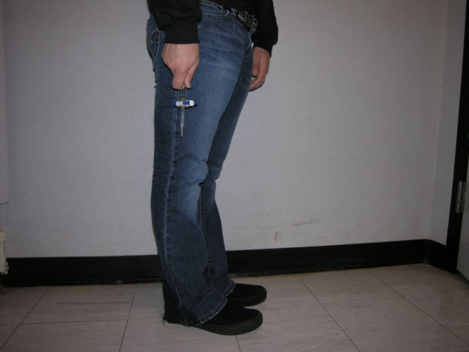
3. Place the burette spigot in your hand proximal to your fingers and hold it in a normal walking motion. | 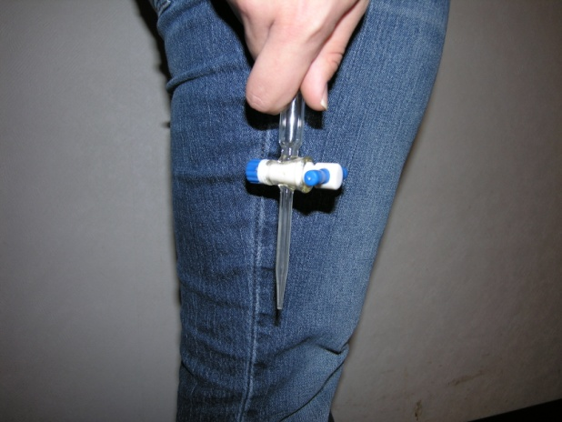
4. Position yourself at the zero mark of the distance you will cover.  5. Have another person in your group be the designated timer.  6. Select another person to mark the drops as they each hit the surface.  7. Adjust valve on the burette so the drip rate is about 1-2 drops per second. | Ending point  Starting point  d  Aerial view of concrete walkway or butcher paper
8. Once you have been given the “GO” command from the timer, walk at a normal pace dripping the burette liquid over the 15 ft. distance; do not swing the burette (i.e., keep it at a 90⁰ angle to horizontal surface).

9. Timer: be sure to stop the time as the person dropping the liquid reaches the 15 ft. mark. Record the total time it took to walk the distance.

10. Calculate the width-to-length ratio for each drop and record this information on your data sheet.

11. Repeat this process but change the pace to a faster walk or run. If you haven’t marked the spots from the 1st trial, do that now so you can tell the 1st trial’s spots from the 2nd trial’s spots. | 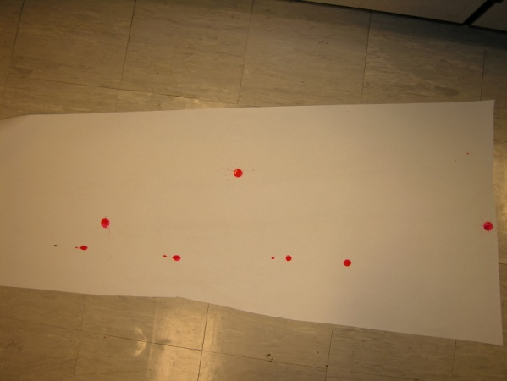
Ask another two groups to share their speed and width-to-length ratios for one of their trials. You will need this for Analysis.

- Lab adapted from Mountain View High School (Mountain View California).

