Name: _____________________________________ Period: _____ Date: __________________________
Blood Spatter Labs
Purpose: You will be creating sample drop patterns using single drops and multiple drops. We will also investigate the effect of motion on blood spatter.

Safety: This can be messy! Be very careful to keep the blood on the paper and not on yourself, the table, or floor. Hold you hand as steady as possible when making the drops. Brace your wrist against the meter stick to help you.

Get your materials from your teacher – paper, black marker, meter stick, goggles, and a bottle of blood.

Procedure & Questions:
Lab 1: Single Droplets
- Label large pieces of papers as 25cm, 50cm, 75cm, and 100cm.
- To do the lab, put on your goggles and hold the dropper/pipet so that the end of it is 25 cm from the paper. GENTLY pipet so that ONE drop of blood is released and lands in the correct location on your paper. It should NOT hit the meter stick.
- Repeat TWO more times at this height for a total of three drops.
- Continue making drops of blood on your paper, but put the drop in a different area of the paper and change the height each time.
- When you are done, analyze your results and answer the questions on your worksheet.

Lab 1 Questions
- What did you notice about the diameter of the parent droplets as you increased the height of the drop?

- How do the spines compare from the different heights?

Lab 2: Multiple Droplets
- Label a long piece of butcher paper (2 -3 meters in length) as 25, 50, 75, and 100cm.
- To do the lab, put on your goggles and hold the pipet so that the end of it is 25 cm from the paper. GENTLY pipet so that ONE drop of blood is released and lands in the correct location on your paper. The drop should NOT hit the meter stick.
- Without moving your hand, release ONE more drop onto the first drop at that height. If you make a mistake, wipe it off with a paper towel and try it again.
- Continue making drops of blood on your paper so you have three sets for each height.
- When you are done, analyze your results and answer the questions on your worksheet. Clean up your area and put away your materials before you leave class.

Lab 2 Questions
Use your results to answer these questions.
What happened when one drop landed on top of another one?

What did you notice about the diameter of the parent droplets as you increased the height of the drop?

What do you notice about the diameter of the satellite spatter as you increased the height of the drop?

Lab 3: Motion Droplets
- During this lab, you will see how motion affects the size and shape of the droplets and spines. You will need a long piece of butcher paper (4-5 meters in length) and tape to secure it to the floor. You will also need safety goggles.
- To do the lab, you will need to hold the pipet so that your hand is out and away from your body (waist level), but is still over the paper.
- Start off walking at a SLOW WALKING RATE along the paper strip from one end to the other and GENTLY squeeze the bottle as you walk so that blood is released ONE DROP at a time. Be sure that all the drops land on your paper strip.
- Repeat this procedure using a NORMAL WALKING RATE and a FAST WALKING RATE.

- When you are done, analyze your results and answer the questions on your worksheet. Clean up your area and put away your materials before you leave class.

Lab 3 Questions
Use your results to answer these questions.
Draw a sketch of the droplets showing the size, shape, and/or distance between them at each speed in the chart below.
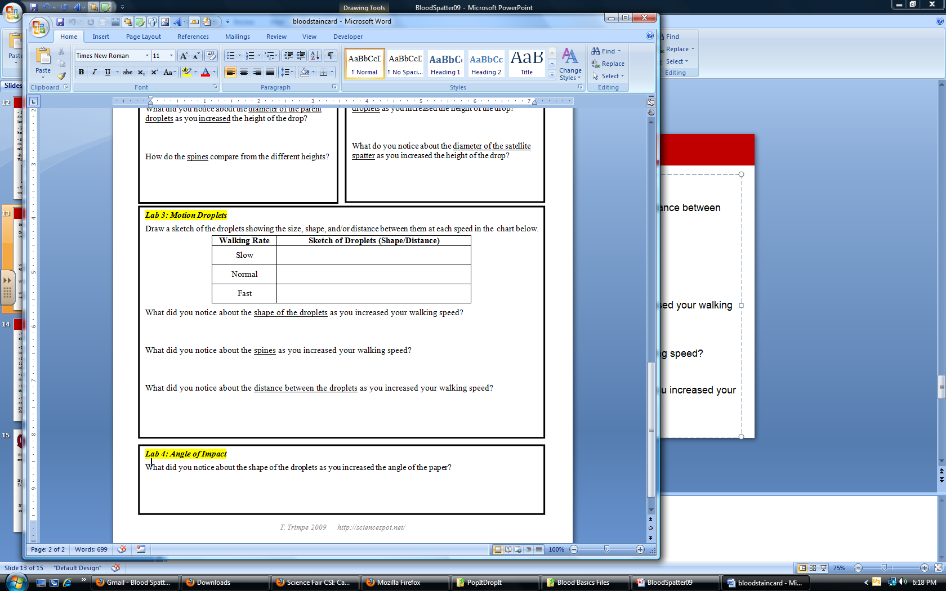
What did you notice about the shape of the droplets as you increased your walking speed?

What did you notice about the spines as you increased your walking speed?

What did you notice about the distance between the droplets as you increased your walking speed?

