Name:__________________________________ P:___ Date:_________________________________

Waves Worksheet 1
1. The illustration below shows a series of transverse waves plotted over distance . Label each part in the space provided.
a

a. e.

b. f.

c. g.

d.

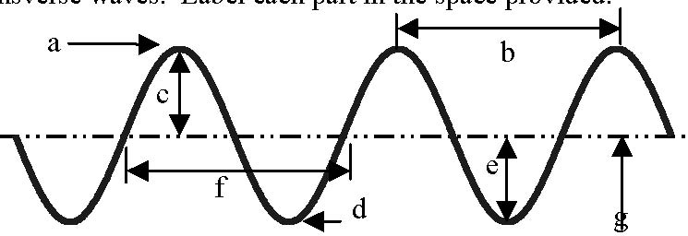
Fill in the blanks:

2. Waves carry ____________________from one place to another.

3. The highest point on a transverse wave is _________________the while the lowest part is the______________ .

4. The ________________ is the height of the wave.

5. The distance from one crest to the next is the_______________________ .

6. Below are a number of series of waves. Underneath each diagram write the numbers of wavelengths in the series.
    - Which of the above has the biggest amplitude?
    - Which of the above has the shortest wavelength?
    - Which of the above has the longest wavelength?

7. Consider a wave generator that produces 10 pulses per second. The speed of the waves is 300. cm/s.
    - a. What is the wavelength of the waves?

    - b. What happens to the wavelength if the frequency of pulses is increased?
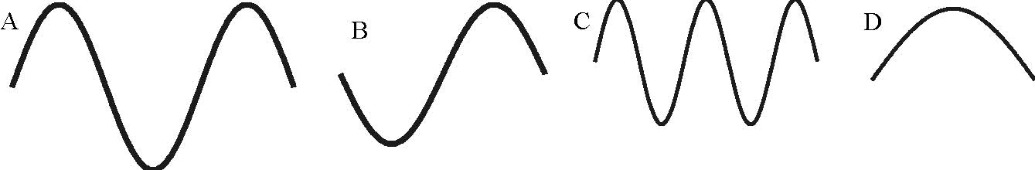
_____________ _____________ _____________ _____________
8.. A wave on Beaver Dam Lake passes by two docks that are 40.0 m apart.

a. If there is a crest at each dock and another three crests between the two docks, determine the wavelength.

b. If 10 waves pass one dock every 16.0 seconds, determine the period and frequency of the wave.

c. What is the speed of the wave?

9. Sally Sue, an enthusiastic physics student enjoyed the opportunity to collect data from standing waves in a spring. She and her partner held the ends of their spring 4.00 meters apart. There were 5 nodes in the standing wave produced. Sally moved her hand from the rest position back and forth along the floor 20 times in 4.00 s. Sketch the situation and determine the following:

a. the wavelength of the wave Sally Sue sent

b. the frequency of the wave produced

c. the speed of the wave

a. What is the speed of the wave in the room?
10. The wavelength of a sound wave in this room is 1.13 m and the frequency is 301 Hz.
- b. If you double the frequency of the sound wave, determine its speed.

  - c. What happens to the wavelength if you cut the frequency in half? How do you know?

