ARANMORE CATHOLIC COLLEGE

YEAR 11 CHEMISTRY - 2014

TEST: ENERGY AND RATES OF REACTIONS

NAME: _____________________________________ DATE: _______

INSTRUCTIONS
TEST SCORE
/50

- Write your answers in blue or black pen in the spaces provided.
- A Chemistry Data Sheet is provided.
- An approved scientific calculator is permitted.
- Time Allowed: 50 minutes.

PART A MULTIPLE CHOICE 10 MARKS

- Which one of the following would be an endothermic process?

- melting of ice
- combustion of petrol
- condensation of water vapour
- two hydrogen atoms forming a molecule

- Which of the following would NOT change the initial rate of reaction between zinc and 1.0 mol L⁻¹ nitric acid?

- The addition of a catalyst
- A change in the temperature of the reactants
- Using double the volume of nitric acid solution
- Breaking down the zinc into smaller pieces

- At room temperature, natural gas does not ignite spontaneously with oxygen gas from air because:

- the reaction is endothermic
- the activation energy is too small
- the collision energy is not usually large enough to overcome the bonding forces of the reactants
- the energy of the reactants is much greater than that of the products

- Rutile (TiO₂) reacts with chlorine and carbon at high temperature according to the
following equation:

TiO₂ _{(s)} + 2 Cl₂ _{(g)} + 2 C (graphite) → TiCl₄ _{(g)} + 2 CO_{(g)} ΔH = -77 kJ

Which of the following can increase the rate of the above reaction?
- Grinding the TiO₂ and C into smaller particles
- Increasing the temperature
- Increasing the pressure

- i only
- i and ii only
- i and iii only
- ii and iii only
- i, ii and iii

- A rise in temperature of gaseous reactants results in an increase in the rate of the reaction. This is mainly due to an increase in the:

- activation energy of the reaction
- proportion of molecules with energies greater than the activation energy
- proportion of molecules which dissociate into their constituent particles
- frequency of collisions between reactant molecules
- pressure inside the reaction vessel

- The following statements refer to the chemical reaction between CaCO₃ _{(s)} and dilute hydrochloric acid solution producing a solution of CaCl₂ and CO₂ gas. Which one of the following statements is FALSE?

- the rate of the reaction decreases with increasing time
- the initial rate of reaction increases with increasing initial temperature
- the initial rate of reaction increases with increasing partial pressure of CO₂ gas
- the initial rate of reaction decreases with decreasing initial concentration of H⁺ ions
- the initial rate of reaction increases with increasing subdivision of CaCO_{3(s)}

- Which of the following reactions are likely to be rapid at room temperature?

i. Ca²⁺_{(aq)} + CO₃²⁻_{(aq)} → CaCO_{3(s)}
ii. C₂H_{6(g)} + Cl_{2(g)} → C₂H₅Cl_{(l)} + HCl_{(g)}
iii. Sn²⁺_{(aq)} + 2Cu⁺_{(aq)} → Sn⁴⁺_{(aq)} + 2Cu²⁺_{(aq)}
iv. CH_{4(g)} + 2O_{2(g)} → CO_{2(g)} + 2H₂O_{(g)}

- i only
- i and ii only
- i and iii only
- ii and iv only
- iii and iv only
- A catalyst increases the rate of a reaction by:

  - increasing the energy of the reactants
  - lowering the energy of the products
  - lowering the activation energy
  - transferring the energy to the activated complex
  - energizing both products and reactants to some extent

Questions 9 and 10 are based on the following graphical representation of the reaction:

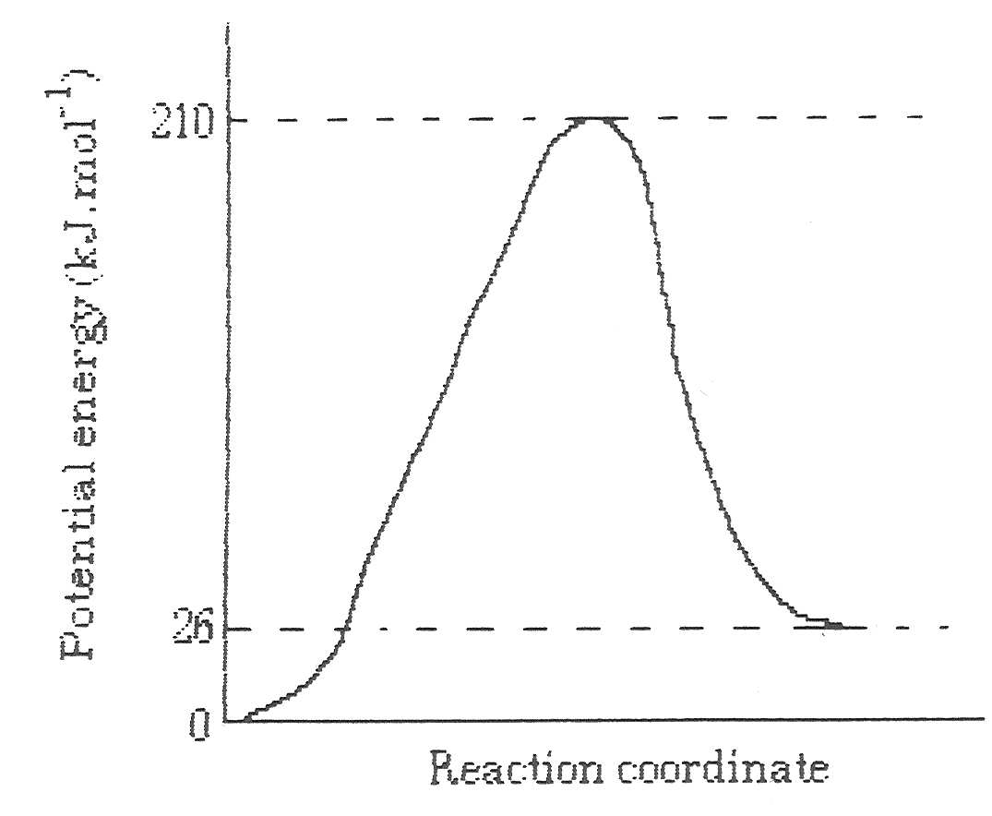
H_{2 (g)} + I_{2 (g)} → 2 HI_{(g)}

- For the reaction above, which of the following is TRUE?

  - it is an endothermic reaction with heat of reaction, ΔH = 26 kJ mol⁻¹
  - it is an exothermic reaction with heat of reaction, ΔH = 26 kJ mol⁻¹
  - it is an exothermic reaction with heat of reaction, ΔH = -26 kJ mol⁻¹
  - it is an endothermic reaction with heat of reaction, ΔH = 184 kJ mol⁻¹
  - it is an exothermic reaction with heat of reaction, ΔH = -184 kJ mol⁻¹

- The activation energy for the reverse reaction would be:

  - 26 kJ mol⁻¹
  - 92 kJ mol⁻¹
  - 184 kJ mol⁻¹
  - 210 kJ mol⁻¹
  - 236 kJ mol⁻¹

PART B SHORT ANSWER 27 MARKS

    - One of the criteria for the choice of fuels is the amount of heat released on combustion per gram of fuel. On this basis, calculate which of the following would be the best fuel.

Heat of combustion (kJ mol⁻¹ of reactant)
H₂ -238
CO -284
CH₃CH₂OH (ethanol) -1371
C₆H₅CH₃ (toluene) -3904
C₈H₁₈ (n-octane) -5447
[4 marks]

    - For each of the following reactions, what property would you measure to indicate the rate of the reaction?
[3 marks]
a) Fe_{(s)} + 2H⁺_{(aq)} → Fe²⁺_{(aq)} + H_{2(g)}

b) 2I⁻_{(aq)} + H₂O_{2(aq)} + 2H⁺_{(aq)} → 2H₂O_{(l)} + I_{2(s)}

c) CaCO_{3(s)} → CaO_{(s)} + CO_{2(g)}

3. Use the collision theory and energy profile diagrams to explain at a molecular level how each of the following factors affect the rate of a chemical reaction.
[6 marks]

a) Increasing the reactant concentrations.

b) Decreasing the temperature.

c) Adding a suitable catalyst.

4. Write full, balanced chemical equations for the following reactions and then write the ionic equation separately:

[4 Marks]

- Sodium hydroxide solution is added to a solution of zinc nitrate.

b) A strip of aluminium is added to an ethanoic acid solution which results in hydrogen gas and a solution of aluminium ethanoate.

5. Ethene can be produced by heating ethane in the presence of a catalyst. The equation can be represented as follows:

C₂H_{6(g)} → C₂H_{4(g)} + H_{2(g)} ΔH = + 120kJ

Sketch an energy profile diagram (Potential Energy / Progress of Reaction) for this reaction. The energy of activation is decreased from 180 kJ mol⁻¹ to 140 kJ mol⁻¹ with the addition of the catalyst. Show each of the following on your graph:
[6 Marks]

a) The energy of the products

b) The energy of the reactants

c) The reaction pathway if the reaction is carried out without a catalyst

d) The reaction pathway if the reaction is carried out with the catalyst.

6. Sketch the enthalpy versus reaction progress diagrams for the following reactions:
[4 Marks]

a) potassium metal reacts violently when added to water producing potassium hydroxide solution and hydrogen gas, which spontaneously ignites.

b) 2H₂O_{(l)} + O_{2(g)} → 2H₂O_{2(aq)} ΔH = 98 kJ

PART C CALCULATIONS 13 MARKS

    - A sample of rock salt is mainly composed of sodium chloride. Calculate the percentage purity of this rock salt if 50.7 mL of 0.180 mol L⁻¹ silver nitrate was required to precipitate all the chloride ions contained in 0.556 g of the sample (of rock salt), according to the following equation.
[6 marks]
AgNO₃ + NaCl → AgCl + NaNO₃

2. Calculate the mass of iron produced when 375 g of iron (III) oxide is reacted with 25.0 g of carbon, according to the following reaction.
[7 marks]
2Fe₂O₃ + 3C → 4Fe + 3CO₂

****************************************
END OF TEST

