Aranmore Catholic College

CHEMISTRY 3A3B - 2012

TEST 1: ATOMIC STRUCTURE AND BONDING

NAME ____________________________________ DATE ___5/3/12____
TEST SCORE
/41

INSTRUCTIONS

1. Time Allowed: 50 minutes
2. Total marks: 41 marks
3. Part 1: Circle your chosen answer
4. Part 2: Write your answers in the spaces provided on the question paper
5. A Chemical Data Sheet is provided
6. A Curriculum Council approved Calculator is permitted

PART 1 MULTIPLE CHOICE 11 MARKS

Circle or cross the best alternative.

1. Which of the following species has a different number of electrons from all the others?

- Al³⁺
- Ar
- Ca²⁺
- Cl⁻

2. Which of the following pairs of atoms would form bonds with the most covalent character?

A. Li and F
B. O and F
C. Na and Ar
D. Cl and Cl

3. The following molecules all have a tetrahedral shape. Which of them would be expected to have a net dipole?

(i) CH₄ (ii) CH₃Cl (iii) CH₂Cl₂ (iv) CHCl₃ (v) CCl₄

- (ii), (iii), (iv) and (v) only
- (ii), (iii) and (iv) only
- (ii) and (iv) only
- (iv) only

4. Choose the element that forms the greatest bond dipole when covalently bonded to fluorine.

- H
- C
- F
- Cl

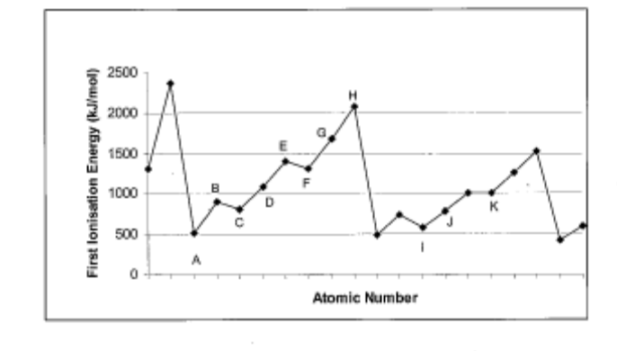

5. Which of the above elements is most likely a noble gas?

- E
- F
- G
- H

6. Which of the following is the shape of a molecule formed between an atom from group 2 and one from group 17 in the periodic table?

A. Pyramidal
B. Tetrahedral
C. Linear
D. Triangular planar

7. Which of the following observations could NOT be explained in terms of hydrogen bonding?

A. Ammonia, NH_{3(g)} is very soluble in H₂O_{(l)}.
B. Water mixes readily with CH₃OH_{(l)}.
C. Salt, NaCl_{(s)} is very soluble in H₂O_{(l)}.
D. Ethanoic acid has a higher density than would be expected from its molecular mass.

8. Which of the following lists correctly shows the order of increasing melting point for the group 16 hydrides?

A. H₂O < H₂S < H₂Se < H₂Te
B. H₂Te < H₂Se < H₂S < H₂O
C. H₂O < H₂Te < H₂Se < H₂S
D. H₂S < H₂Se < H₂Te < H₂O

9. For an element X, the first five successive ionization energies are given in this table.

Ionization energy (kJ/mol)
577
1816
2744
11,600
15, 234

What would be the formula of the compound formed when X reacts with Chlorine?

- XCl
- XCl₂
- XCl₃
- XCl₄

10. The fact that H₂O, NH₃ and HF have higher melting and boiling points than expected can be explained by which intermolecular forces?

- Covalent bonding
- Ionic bonding
- Hydrogen bonding
- Ionic and covalent bonding

11. Carbon tetrachloride (CCl₄) would be a good solvent for:

- Grease (long chain hydrocarbon)
- Silicon dioxide
- Water
- Sodium chloride

END OF PART 1

****************************************************

PART 2 SHORT ANSWERS 30 MARKS

Answer each of the following questions in the spaces provided.

1. Classify with explanations, the following solids as having bonding which is either covalent molecular, metallic, ionic or covalent network.
(4 marks)
- A soft solid that decomposes at 500ºC; the solid does not conduct electricity.

__________________________________________________________________________________________________________________________________________________________________________________________________________________________________________________________________________________________________________________________________________
__________________________________________________________________

- Violet crystals that melt at 114ºC; neither the solid nor the liquid conducts electricity.

______________________________________________________________________________________________________________________________________________________________________________________________________________________________________________________________________________________________________________________________________________________________________________________________________

2. For each molecule listed in the table below

(a) Draw the electron dot diagram, representing ALL electron pairs either as : or as ⎯.
. .
. .
. .
−
−
[For example, water H : O : H or H − O − H or H − O − H and so on]
. .
(b) Name the shape of each molecule. (6 marks)

SPECIES | STRUCTURAL FORMULA  (showing all valence shell electrons) | SHAPE  (name)
Hydrogen cyanide, HCN

Nitrosyl bromide,
NOBr

3. Four unknown elements A, B, C and D have the properties listed below (elements can be used twice).

Element | First ionisation energy (relative) | Number of  valence electrons | Electronegativity
A | medium | 4 | 2.6
B | low | 1 | 1.2
C | high | 7 | 3.5
D | high | 6 | 1.5

Identify an element that fits the description given.
- The element most likely to be a metal ________
- An element most likely to form ions with a -1 charge ________
(c) The element whose atoms could bond by single covalent bonds to form diatomic molecules ________
(d) The element forming a covalent network structure ________
(4 marks)

4. For each of the following groups of three elements, circle the element with the highest first ionisation energy.
(2 marks)

(a) Be, C, F | (b) C, Ge, Pb
(c) O, S, Se | (d) F, Ne, Na

5. Name a substance whose properties match those described.
(2 Marks)

a. Has a very high first ionization energy, a very low boiling point and does not form
bonds with the two elements immediately before or after it in the periodic table.

_________________________________

b. In its pure form it is very malleable and ductile and reacts vigorously with water
(although most other elements of the same group are more reactive), salts containing
this ion are always soluble.

_________________________________

6. Explain the difference in melting point of the following substances:
(6 marks)
Substance | Melting Point (°C)
H₂ | -259
H₂O | 0
CO₂ | -78

7. Explain, using diagram, why water and ethanol (C₂H₅OH) are miscible, whereas water
and carbon tetra chloride (CCl₄) are immiscible.
(6 Marks)

***************************
END OF TEST

