CHEMISTRY 3A3B
ASSIGNMENT #2 – ORGANIC CHEMISTRY
1 /60 0

1. The table below lists seven alkanes. The molecular masses and boiling points of most of them are shown.
[7 marks]
Name | Molecular mass | Boiling point/°C
hexane | 86.2 | 68.7
2-methylpentane | 86.2 | 60.3
2,2-dimethylbutane | 86.2 | 49.7
heptane | 100.2 | 98.4
2-methylhexane | 100.2 | 90.1
octane | 114.2 | 125.8
2-methylheptane | 114.2

(a) Hexane, 2-methylpentane and 2,2-dimethylbutane are structural isomers. Draw the structural formula and give the systematic name of another structural isomer of hexane.

(b) Explain why the boiling points of the straight chain alkanes, hexane, heptane and octane, increase with increasing numbers of carbon atoms in the chain.

(c) Which of the hydrocarbons shown has a boiling point closest to that of water? These two molecules have similar boiling points, but very different molecular masses (the molecular mass of water is 18). Explain why the boiling point of water is so high, despite it being such a small molecule.

(d) Would you expect the boiling point of 2-methylheptane to be higher or lower than its structural isomer octane? Give a reason for your decision.

2. The two amino acids glycine and alanine can join together to form the dipeptide glycylalanine.
[3 marks]
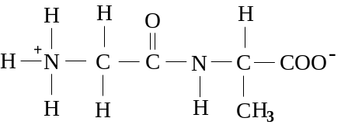
glycylalanine

(a) What is the name given to the bond which joins the two amino acids together to form the dipeptide?

(b) Is glycylalanine the only dipeptide which could be formed by the chemical combination of the two amino acids glycine and alanine? Explain your answer.

(c) Proteins are also composed of amino acids chemically joined together. Why is glycylalanine not classified as a protein?

3. Some of the physical properties of several alcohols and alkanes are shown in the table below:
[9 marks]

Compound | Molecular mass | Boiling point/°C | Solubility in water
ethanol | 46 | 78 | soluble
propane | 44 | -42 | insoluble
propanol | 60 | 97 | soluble
butane | 58 | 0 | insoluble
1,2-ethanediol | 62 | 198 | soluble
pentanol | 88 | 138 | slightly soluble
hexane | 86 | 69 | insoluble
1,2,3-propanetriol | 92 | 290 | soluble

(a) Propanol and butane have very similar molecular masses and yet propanol is a liquid under normal conditions whereas butane is a gas. Explain why this is the case.

(b) Would you expect the boiling point of methanol to be higher or lower than that of ethanol? Why?

(c) What is the general difference between the ability of alkanes and alcohols to dissolve in water? Explain this difference.

(d) (i) Draw a structural formula to represent 1,2-ethane-diol.

(ii) What is 1,2-ethane-diol used for in the automotive industry?

(e) Arrange the following compounds in order of decreasing boiling point:

(i) propane, heptane, pentane

(ii) 2-propanol, 1,2-propane-diol, 1,2,3-propane-triol

4. There are three alkanes which are structural isomers with molecular formula C5H12. All three can be reacted with chlorine gas resulting in the substitution of a chlorine atom for one of the hydrogen atoms. When isomer A reacts in this way a mixture of four different substances results. When isomer B reacts a mixture of three substances are produced. When isomer C reacts there is only one product. From this information work out the structural formulae of isomers A, B and C.
[3 marks]

5. (a) Draw a structural formula for a compound of molecular formula C4H8O which:
[3 marks]
(i) contains a carbon-carbon double bond and is also an alcohol.

(ii) is a ketone.

(iii) is an aldehyde.

(b) What is the relationship between the three molecules you represented in (i), (ii) and (iii) above? [1 mark]

(c) Write an equation, using structural formulae, to represent a reaction which could be used to prepare a sample of the ketone you gave as the answer to (a) part (ii). Include any reagents used. [2 marks]

6. Vitamin A or retinol is a molecule required by humans for the normal production of cells in membranes - particularly those of the eyes. A deficiency of retinol can lead to blindness.

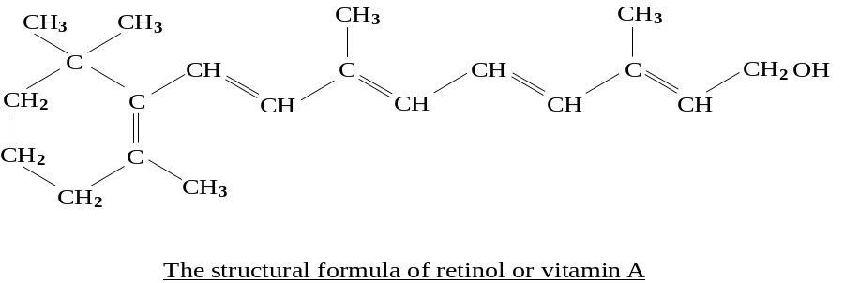
[4 marks]

(a) Retinol is both an alkene and an alcohol. Copy the structural formula for retinol shown above and on it circle, with appropriate labels, the parts of the molecule which make it an: (i) alkene. (ii) alcohol.

(b) What is the molecular formula for retinol?

(c) An important source of vitamin A or retinol in our diet are the carotenes which are found in many green and yellow vegetables. One of these is β-carotene, shown below:
What type of organic compound is β-carotene?

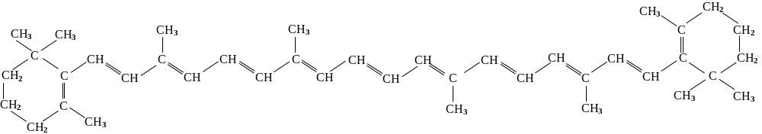
The structural formula of β-carotene

7. In a practical exercise to prepare a sample of an ester, a student heated 60.0 g of acetic acid (ethanoic acid) and 60.0 g of 1-propanol under reflux with a few drops of concentrated sulfuric acid.
[7 marks]

After the ester was formed and isolated, it was weighed. The results are shown below:

Initial mass of acetic acid: | 60.0 g
Initial mass of 1-propanol: | 60.0 g
Final mass of ester: | 68.0 g

(a) Write a balanced equation to represent the reaction which formed the ester.

(b) What is the systematic name of the ester?

(c) (i) If all the acid had reacted, what mass of the ester would have been formed?

(ii) Calculate the percentage yield of the ester using your answer to part (i).

(d) Assuming that the student recovered all the ester which had formed and that leaving the mixture to react longer would have made no difference to the yield of ester, suggest a reason why the yield was not 100%.

8. (a) Draw a structural formula for a compound of molecular formula C3H6O2 which:
[3 marks]
(i) is a carboxylic acid.

(ii) is an ester.

(iii) is an alcohol and a ketone.

(b) Write an equation, using structural formulae, to represent a reaction which could be used to prepare a sample of the ester you gave as the answer to (a) part (ii). Include any reagents used.
[2 marks]

9. The following question refers to the diagram below:
[6 marks]

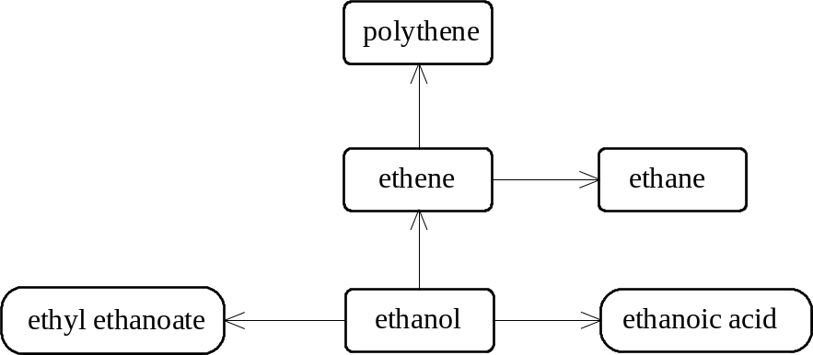

(a) Suggest reagents which could be used to convert ethanol to :

(i) acetic acid (ethanoic acid).

(ii) ethyl ethanoate.

(b) What conditions are required to obtain ethane from ethene? Write an equation for the reaction.

(c) What type of reaction occurs in each of the following changes?

(i) ethene to polythene

(ii) ethanol to acetic acid (ethanoic acid)

10. (a) Is the following reaction an example of addition or condensation polymerisation? Give a reason for your choice. (n is a large number).
[2 marks]
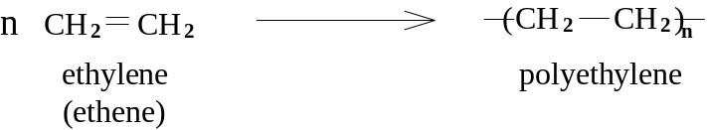

(b) In the mid 1930's the first synthetic rubber, Neoprene, was produced on a commercial basis by the American company du Pont.

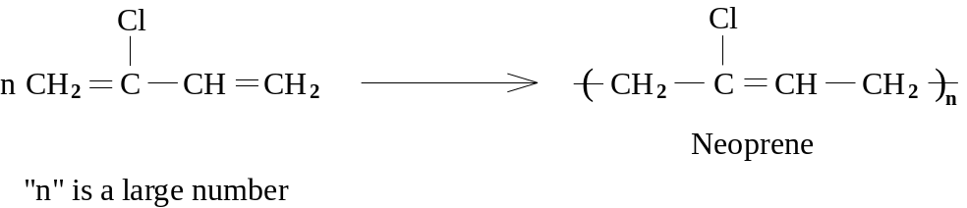

What is the systematic name of the monomer used to produce Neoprene?
[1 mark]

11. The formulae below represent five molecules which are important biochemically:

A | 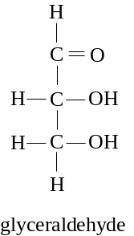 | B | 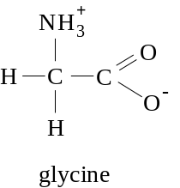
C | EMBED MSDraw \* mergeformat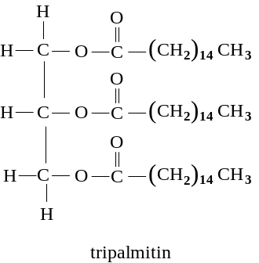 | D | EMBED MSDraw \* mergeformat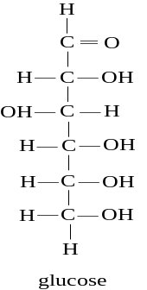
E | 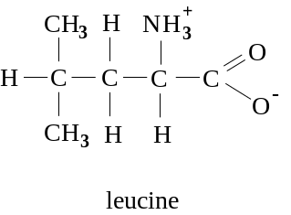

From the above molecules choose one (N.B. - there may be more than one) which:
[7 marks]
(a) is a carbohydrate.

(b) could be joined with other molecules to form a polymer which acts as an enzyme.

(c) is an amino acid.

(d) can exist as either a positive or negative ion, depending on the pH of is surroundings.

(e) could form a peptide bond with another of the molecules shown.

(f) is a triester of glycerol.

(g) is a component of olive oil.

