ORGANIC CHEMISTRY QUIZ

1. Which of the following is the best systematic name for the following compound:

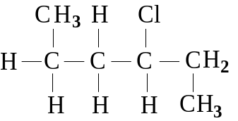
(A) 1,4-dimethyl-2-chlorobutane
(B) 3-chlorohexane
(C) 1,4-dimethyl-3-chlorobutane
(D) 1-methyl-2-chloropentane

2. Chlorine reacts with propene to produce 1,2-dichloropropane. This is an example of:
(A) a condensation reaction.
(B) an addition reaction.
(C) a combustion reaction.
(D) a substitution reaction.

3. If 2-butene and bromine react in an inert solvent such as tetrachloromethane, the product would be:
(A) 2,3-dibromobutene.
(B) 2,2-dibromobutane.
(C) 2-bromo-3-chlorobutene.
(D) 2,3-dibromobutane.

4. Two compounds which have the same molecular formulae, but different structural formulae are:
(A) 1-chloropropane and 3-chloropropane.
(B) butanal and butanone.
(C) propane and propene.
(D) butane and 1-methylpropane.

5. Which of the following molecules is a structural isomer of 3-methyl-1-butene?

(A) | 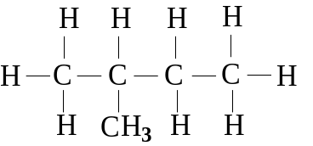 | (B) | 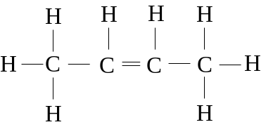
(C) | 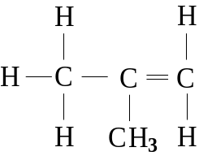 | (D) | 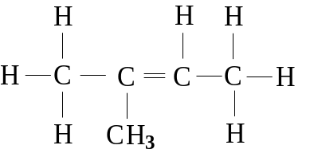

6. Of the following structural formulae for organic compounds, one is not possible. Which one?

(A) | 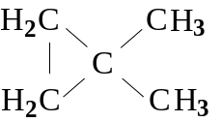 | (B) | 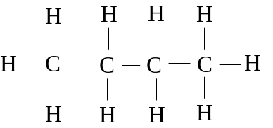
(C) | 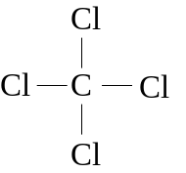 | (D) | 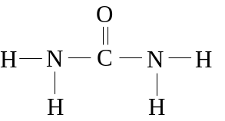

7. Which one of the following names is correct?
(A) 1,3-dimethylbutane
(B) 2-ethyl-3-methylpentane
(C) 2,2-diethylbutane
(D) 2,3-dimethylpentane

8. The structural formula for 2-bromopentane is:

(A) | EMBED MSDraw \* mergeformat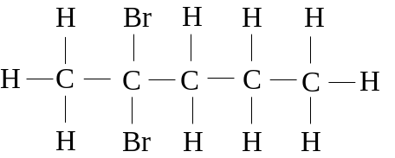 | (B) | EMBED MSDraw \* mergeformat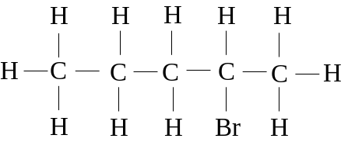
(C) | EMBED MSDraw \* mergeformat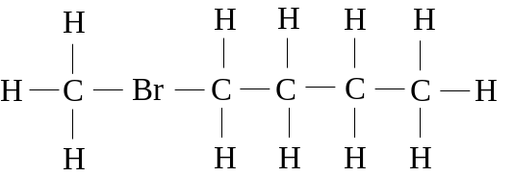 | (D) | EMBED MSDraw \* mergeformat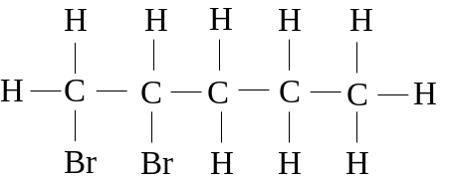

9. In how many different positions can one chlorine atom be substituted in the straight chain C4H10 to give rise to different compounds?
(A) 1
(B) 2
(C) 3
(D) 4

10. Which of the following is the best systematic name for the following compound?

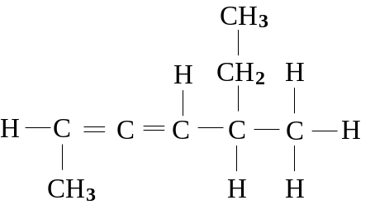

(A) 1-methyl-4-ethyl-1,2-pentadiene
(B) 1,4-dimethyl-1,2-hexadiene
(C) 5-ethyl-2,3-heptadiene
(D) 5-methyl-2,3-heptadiene

11. When propene reacts with bromine, the most likely product is:
(A) 1,1-dibromopropane.
(B) 1,2-dibromopropene.
(C) 1,2-dibromopropane.
(D) 1-bromopropene.

12. Which one of the following names is correct?
(A) 3-propylpentane
(B) 2,2-dimethylpropane
(C) 2,2-diethylheptane
(D) methylbutane

13. Which of the following is a list of substances in order of decreasing boiling point (highest boiling point to lowest boiling point)?
(A) propane, propanol, 1,2-propandiol, 1,2,3-propantriol
(B) propane, 1,2,3-propantriol, 1,2-propandiol, propanol
(C) propanol, 1,2-propandiol, 1,2,3-propantriol, propane
(D) 1,2,3-propantriol, 1,2-propandiol, propanol, propane

14. Which one of the following molecules does not exist as more than one geometrical isomer?
(A) methylbut-2-ene
(B) but-2-ene
(C) 3-methylpent-2-ene
(D) pent-2-ene

15. Of the following equations, which does not represent an addition reaction?
(A) 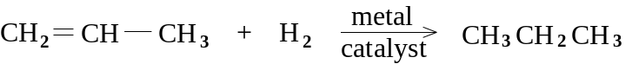
(B)
(C)
(D) 