ARANMORE CATHOLIC COLLEGE

YEAR 12 CHEMISTRY 3A3B

TEST: ORGANIC CHEMISTRY

NAME: ________________________________________ DATE: ___________

Test Score

INSTRUCTIONS

1. Time Allowed: 50 minutes
2. Total marks: 50 marks
3. All questions are to be answered on the question paper.
4. A Chemical data sheet is provided.
5. Approved calculators are permitted.

PART 1 MULTIPLE CHOICE [10 Marks]

- What is the systematic name for the following?

CH₃ ⎯ CH₂⎯ CH₃
│
CH₂ ⎯ CH₂ ⎯ COOH

- 2-ethylbutanoic acid
- 1,1-dimethylbutanoic acid
- 2-methylpentanoic acid
- 4-methylpentanoic acid
- 4,4-dimethylbutanoic acid

- Which of the following would not be expected to decolourise an acidified potassium permanganate solution?

- CH₃OH
- CH₃CH₂OH
- CH₃CH₂CHO
- CH₃COCH₃
- CH₃CHOHCH₃

- The structure drawn here represents one of the isomers of formula C₂H₂Cl₂.
Cl Cl
\ /
C C
/ \
H H
What is the total number of isomers possible for C₂H₂Cl₂?
- 1
- 2
- 3
- 4
- 5

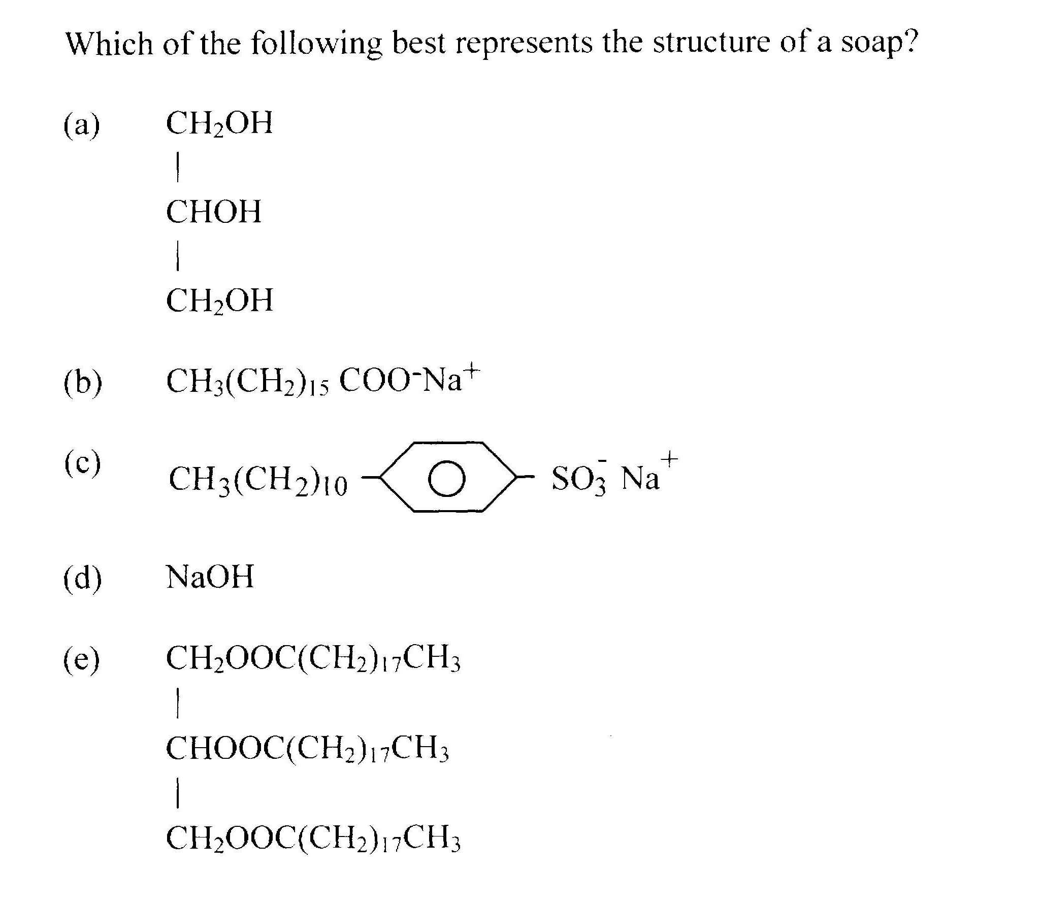
4.
5. Which of the following structures represents a tertiary alcohol?

- (CH₃)₃COH
- CH₃CH₂CHOHCH₃
- CH₃CH₂CH₂CH₂OH
- CH₃CH₂CH₂C(OH)₃
- CH₂OHCHOHCHOHCH₃

6. Which of the following substances is an aldehyde?
(a) CH₃CH₂CH₂OH
(b) CH₃CH₂COOH
(c) CHOCH₂CH₃
(d) CH₃COCH₃
(e) CH₂OHCH₂CH₃
7. Propanone is a ketone which could be prepared by the action of potassium dichromate on:
(a) 1-propanol
(b) 2-propanol
(c) propene
(d) propanoic acid
(e) propanal

8. The molecule represented by the structural formula below is the alarm pheromone produced by honey bees:

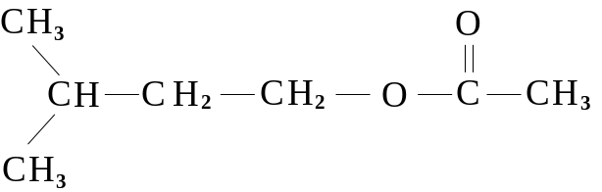

This molecule could be classified as:
(a) an alkane.
(b) an ether.
(c) a ketone.
(d) a carboxylic acid.
(e) an ester.

9. Which of the following is the best systematic name for the compound:

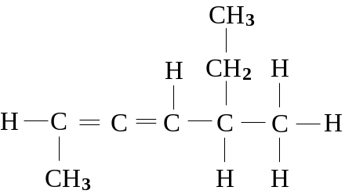

(a) 1-methyl-4-ethyl-1,2-pentadiene
(b) 1,4-dimethyl-1,2-hexadiene
(c) 5-ethyl-2,3-heptadiene
(d) 5-methyl-2,3-heptadiene
(e) 5-ethyl-2,3-hexadiene

10. Which of the following substances is insoluble in water?
(a) hexane
(b) ethanol
(c) formic acid (methanoic acid)
(d) 1,2-propandiol
(e) acetone (propanone)

PART 2: SHORT ANSWER [40 Marks]

1. Write equations showing structural formula for all reactants and product(s) in the following reactions.

a) ethane + chlorine gas in the presence of UV light

b) hydrogen fluoride + 1-butene in the presence of a suitable catalyst

(2 marks)

2. For each of the following reactions draw the structural formula and write the IUPAC name of the major organic product you expect to form.

a) 2-butanol and acidified potassium permanganate

Name:
b) 1-propanol and acidified potassium dichromate

Name:
c) 1-pentanol and propanoic acid with concentrated sulfuric acid

Name:
(6 marks)

3. a) Dicarboxylic acids contain two carboxylic acids on the one hydrocarbon chain. Some dicarboxylic acids can be reacted with dialkanamines to produce polymers. Draw a unit of the polymer that will form when hexanedioic acid reacts with 1,6-hexanediamine.

b) Draw a unit of the addition polymer that will form from the ethene based monomer, ethenyl ethanoate (CH₃COOCHCH₂), in the presence of a suitable catalyst:

(4 marks)

4. Arrange the following compounds (all of similar molecular weight) in order of decreasing boiling point. In the table write “1” for the compound with the highest boiling point, down to “5” for the compound with the lowest boiling point.

COMPOUND | BOILING POINTS IN ORDER  (1 = highest, 5 = lowest)
CH₃CH₂CH₂CH₂CH₂CH₃

CH₃CH₂CH₂COOH

CH₃CH₂CH₂CH(CH₃)₂

CH₃CH₂CH₂CH₂CH₂OH

CH₃CH₂CH₂CH₂CHO

(2 marks)
5. For each of the following pairs of solutions describe a simple chemical test that could be used to distinguish between the two substances. State the observation that you would make with each solution.

Pairs of Solutions Describe the Test Observation for each
2-methyl-2-propanol

and

1-butanol

ethanoic acid

and

ethanal

(4 marks)

6. An organic compound of formula C₃H₈O is found to readily decolourise an acidified potassium permanganate solution to produce a new organic product. The resulting product does not liberate hydrogen when added to sodium metal.

a) Draw the structural formula for the original compound and name it.

b) Draw the structural formula for the product and name it.

(4 marks)
- a) The active ingredients in two common cleaning agents are dodecylbenzene sulfonate ion and octadecanoate ion (stearate ion). Both of these species can ‘dissolve’ grease and oils in a similar way. How do these ions do this? (A diagram will be helpful.)
(2 marks)

b) One of the above ions represents a detergent and the other a soap. What is the main difference between a soap and a detergent and what is the advantage of one over the other?
(2 marks)

d) Ammonia is another common cleaning agent, however, sodium octadecanoate solution is appropriate for cleaning a person’s hands or body, but generally ammonia solution is not. Suggest the main reason for this.
(1 mark)

8. Draw the structure of each of the following:

a) 2,3-dibromocyclopentene

b) 2-methylbutanal

c) 4-ethyl-2-hydroxy-5-methyl-3-hexone

d) ethylmethanoate

e) 2-amino-3-hydroxybutanoic acid (the amino acid, threonine)

(5 marks)

9. A student is asked to identify four organic liquids, contained in four separate flasks.
- 3-Octene
- Hexan-3-ol (3-hexanol)
- Hexan-3-one (3-hexanone)
- Butanoic acid
The student has access to any chemicals and glassware required. Describe the tests that should be carried out, and the observations, that enable the liquids to be identified. Include equations to justify the choice of tests.
(8 marks)

**********************************
END OF TEST

