ARANMORE CATHOLIC COLLEGE

YEAR 12 CHEMISTRY 3A3B

TEST 4: REACTION RATES AND EQUILIBRIUM

NAME: _________________________________________ DATE: __________

Mark
/ 50

INSTRUCTIONS

- Answer ALL questions in the spaces provided.
- A Chemical Data Sheet is provided.
- An approved calculator is permitted.
- Time Allowed: 50 minutes.
- Total marks = 50.

PART 1 MULTIPLE CHOICE 20 MARKS

1. Most collisions between reactant molecules do not result in the formation of products. This is most likely because:

A. the molecules do not collide in the correct ratio.
B. the molecules do not have enough energy.
C. the concentration of reactants is too low.
D. the reaction may already be at equilibrium.

Questions 2 is about a step in the production of nickel at the Kwinana Nickel refinery. The ore is originally treated with ammonia and oxygen, converting the nickel into the tetraaminenickel ion. In the next step, considered here, this complex is treated with hydrogen gas and converted to nickel metal. The equilibrium reaction is represented below:

[Ni(NH₃)₄] ²⁺ _{(aq)} + H_{2(g)} Ni_{(s)} + 2NH₄⁺_{(aq)} + 2NH_{3(g)}

2. Which of the following sets of conditions will bring about the HIGHEST YIELD of nickel metal at equilibrium?

A. High partial pressure of hydrogen and low partial pressure of ammonia.
B. High partial pressure of hydrogen and high partial pressure of ammonia.
C. Low partial pressure of hydrogen and low partial pressure of ammonia.
D. Low partial pressure of hydrogen and high partial pressure of ammonia.
3. In which of the following systems will an increase in pressure cause no change in the relative proportions of reactants and products?

A. CaCO_{3(s)} ⬄ CaO_{(s)} + CO_{2(g)}
B. 2O_{3(g)} ⬄ 3O_{2(g)}
C. 2CO_{2(g)} ⬄ 2CO_{(g)} + O_{2(g)}
D. CO_{(g)} + H₂O_{(g)} ⬄ CO_{2(g)} + H_{2(g)}

- The equilibrium constant for the ionisation of water, as shown below, is 1.0 x 10⁻¹⁴ at 25 ºC and 2.1 x 10⁻¹⁴ at 35 ºC.

2H₂O_{(l)} H₃O⁺_{(aq)} + OH⁻_{(aq)}

Which of the following statements can be concluded from the above information?

A. The ionisation of water is endothermic.
B. Water is a stronger electrolyte at 25 ºC than at 35 ºC.
C. The concentration of H₃O⁺ ions is more than the concentration of OH⁻ ions at 35 ºC.
D. The concentration of H₃O⁺ ions decreases as the temperature is increased.

5. In 50.0 mL of solution, silver metal and mercury (II) ion have reacted and established equilibrium according to the equation:

2Ag(s) + Hg²⁺(aq) 2Ag⁺(aq) + Hg(l)

At equilibrium, the concentration of mercury (II) ion is 0.00020 mol L⁻¹ and the concentration of silver ion is 0.10 mol L⁻¹. Solid silver and liquid mercury are also present. Water is added to the solution so that the volume increases to 100.0 mL, and the mixture is then shaken. What is the new equilibrium concentration of mercury (II) ion?

A. greater than 0.00020 mol L⁻¹
B. between 0.00010 and 0.00020 mol L⁻¹
C. 0.00010 mol L⁻¹
D. less than 0.00010 mol L⁻¹

6. At equilibrium, which of the following statements is TRUE ?
A. The activation energies of the forward and reverse reactions are equal.
B. The rates of the forward and reverse reactions are zero.
C. The concentrations of the reactants equals the concentrations of the products.
D. There are no measurable changes in the system.
E. The addition of a catalyst will change the value of the concentration ratio.

7. An appropriate catalyst can speed up a reaction considerably. Which of the following statements best describes the action of the catalyst:

A. The catalyst does not take part in the reaction, and so is not used up as the reaction proceeds.
B. The catalyst causes the temperature of the reactants to rise, so that more collisions are successful.
C. The catalyst causes the number of collisions to increase by raising the energy of the reactant molecules.
D. The catalyst forms a new intermediate stage in the reaction which requires less energy to produce.
E. The catalyst increases the total surface area available, so that more collisions can take place.

The following three questions (Questions 8, 9, and 10) relate to the reaction, and its associated energy profile diagram, given below.

The energy changes that occur during the reaction,

4C_{(s)} + S_{8(g)} 4CS_{2(g)}

can be represented in the energy profile diagram shown below:

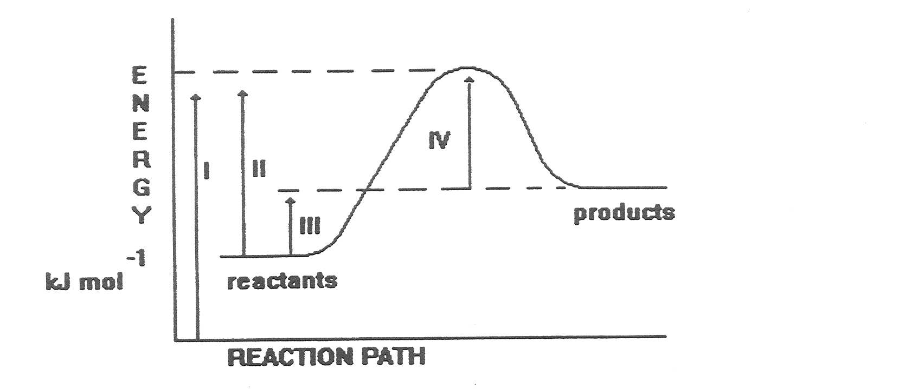

8. The activation energy for the forward reaction is equal to the change:

A. I
B. II
C. I - II
D. III
E. IV

9. The change in enthalpy (heat of reaction) for the reverse reaction is equal to the energy change:

A. II-III
B. II-IV
C. III-II
D. IV-II
E. IV-I

10. This reaction can come to equilibrium in a closed container. What changes would occur to the equilibrium if a small amount of additional carbon was added? Assume that there is no significant change in volume.

A. More sulfur would be produced since the reverse reaction would be favoured
B. The temperature would increase since the reverse reaction would be favoured
C. More carbon disulfide would be produced since the forward reaction would be favoured
D. The temperature would increase since the forward reaction would be favoured
E. No change to the equilibrium would be observed

PART 2 SHORT ANSWER 30 MARKS

1. 7.00 moles of HCl gas and 4.50 moles of O₂ gas are placed in a 5.00 L reaction vessel and the temperature held constant at 700 K until equilibrium is established. The equilibrium system can be represented by the following balanced equation:

4HCl_{(g)} + O_{2(g)} 2H₂O_{(g)} + 2Cl_{2(g)} ΔH = -113 kJ mol⁻¹

Once equilibrium was established, it was determined that 3.00 moles of oxygen gas were present.

a) Calculate the equilibrium concentrations of all the gases.
[6 marks]

b) Write the expression for the equilibrium constant, K_{eq}, in terms of concentrations and determine its value at 700 K.
[3 marks]

c) How would the value of this equilibrium constant change if the volume of the reaction vessel was increased to 10.0 L at 700 K? Explain your answer. (No calculation required.)
[2 marks]

- How will the number of moles of oxygen change if the temperature was raised to 900 K and equilibrium is re-established? What effect will this change have on the equilibrium constant? Explain your answers. (No calculation required.)
[4 marks]

e) Explain how the addition of a catalyst would have influenced this system if added:

(i) at the beginning of the reaction between the hydrogen chloride and oxygen?
[2 marks]

(ii) once equilibrium had been established?
[1 mark]

- Describe what changes are likely to occur in this system if the temperature was slowly reduced to 20ºC.
[2 marks]

2. One of the reactions for the manufacture of sulfuric acid by the Contact process is shown here:
2SO_{2(g)} + O_{2(g)} 2SO_{3(g)} ΔH = -198 kJ mol⁻¹

a) What is the significance of the double arrows?
[2 marks]

b) The equilibrium constant for this reaction has a very small value at room temperature. What does this indicate about the equilibrium yield of SO_{3(g)} at room temperature? Explain your answer.
[2 marks]

c) In the industrial manufacture of sulfuric acid, this reaction is carried out at a temperature of around 450ºC. State the effect on equilibrium yield and speed of formation of SO_{3(g)} at this higher temperature (compared with room temperature). Explain your answer in terms of Le Chatelier’s principle and the Collision theory.

Effect on equilibrium yield of SO_{3(g)}

Explanation in terms of Le Chatelier’s principle
[3 marks]

Effect on speed of formation of SO_{3(g)}

Explanation in terms of Collision Theory
[3 marks]

************************
END OF TEST

