ARANMORE CATHOLIC COLLEGE

YEAR 12 CHEMISTRY 3A3B

TEST: ACIDS AND BASES

NAME _________________________________ DATE ___________
Test Score
INSTRUCTIONS

1. Time allowed: 50 minutes
2. Total marks: 50 marks
3. Part 1 is to be answered on the Multiple Choice Answer Sheet provided
4. Parts 2 and 3 are to be answered in the spaces provided
5. A Chemical Data Sheet is provided
6. Curriculum Council approved calculators are permitted.

PART 1: MULTIPLE CHOICE [20 Marks]

1. Which of the following solutions has the highest pH?

A. 0.010 mol L⁻¹ aluminium nitrate
B. 0.010 mol L⁻¹ ammonium chloride
C. 0.010 mol L⁻¹ barium nitrate
D. 0.010 mol L⁻¹ rubidium chloride
E. 0.010 mol L⁻¹ sodium ethanoate

2. A litre of pure ethanoic acid is slowly added to a few drops of water and the mixture shaken. Which of the following statements BEST describes the resulting solution?

A. It is a concentrated solution of a strong acid
B. It is a dilute solution of a strong acid
C. It is a concentrated solution of a weak acid
D. It is a dilute solution of a weak acid
E. It is a neutral solution of a weak acid

3. Which one of the following pairs would form a buffer solution?

A. HCl and NaCl
B. H₃PO₄ and Na₂HPO₄
C. H₂CO₃ and KHCO₃
D. NaOH and HCl
E. CH₃COOH and NH₃
4. The indicator methyl red changes colour over the pH range 4.4 to 6.2, and the indicator phenolphthalein changes colour over the range 8.3 to 10.0. Which one of the following statements about the titration of a 0.100 mol L⁻¹ ethanoic acid solution with a 0.100 mol L⁻¹ sodium hydroxide solution is true?

A. methyl red is a suitable indicator because the solution is acidic at the equivalence point
B. methyl red is a suitable indicator because the solution is basic at the equivalence point
C. Phenolphthalein is a suitable indicator because the solution is acidic at the equivalence point
D. Phenolphthalein is a suitable indicator because the solution is basic at the equivalence point
E. Either methyl red or phenolphthalein is suitable because the solution is neutral at the equivalence point

5. In which one of the following processes is water acting as a base?

A. HNO_{3(aq)} + H₂O_{(l)} → H₃O⁺_{(aq)} + NO₃⁻_{(aq)}
B. H₂O_{(l)} → H₂O_{(g)}
C. NH_{3(aq)} + H₂O_{(l)} → NH₄⁺_{(aq)} + OH⁻_{(aq)}
D. NaCl_{(s)} {+ H₂O_{(l)}} → Na⁺_{(aq)} + Cl ⁻_{(aq)}
E. O²⁻_{(aq)} + H₂O_{(l)} → 2OH⁻_{(aq)}

6. Which of the following has no reaction with a 6.0 mol L⁻¹ NaOH (aq) solution?

A. CH₃COOH(aq)
B. Zn(OH)₂(s)
C. Mg(OH)₂(s)
D. NH₄Cl
E. HCl

7. A sodium hydroxide solution for use in the Bayer Process was analysed as follows: About 20 mL was transferred from the process tank to a 100 mL bottle. From this, 10.00 mL was transferred by pipette to a 250 mL conical flask and titrated against a standard 0.2083 mol L⁻¹ hydrochloric acid solution from a burette.

All items of glassware were washed, and given a final rinse before use. Which one of the following lists the appropriate liquids for the final rinse?

 | The 100 mL bottle | The 10.00 mL pipette | The 250 mL conical flask | The burette
A. | the NaOH solution | the NaOH soln | the NaOH soln | the 0.2083 mol L⁻¹ HCl
B. | the NaOH solution | the NaOH soln | water | the 0.2083 mol L⁻¹ HCl
C. | the NaOH solution | water | the NaOH soln | the 0.2083 mol L⁻¹ HCl
D. | water | the NaOH soln | water | the 0.2083 mol L⁻¹ HCl
E. | water | water | water | water
8. In the following reaction,
HSO₄⁻_{(aq)} + H₂O ↔ H₃O⁺_{(aq)} + SO₄²⁻_{(aq)}
the conjugate base is:

A. HSO₄⁻_{(aq)}
B. H₂O
C. H₃O⁺_{(aq)}
D. H₂SO_{4(aq)}
E. SO₄²⁻_{(aq)}

9. Which one of the following solutions is the most acidic?

A. Hydrogen chloride in water; concentration of H₃O⁺_{(aq)} = 0.001 mol L⁻¹
B. Sodium hydroxide in water; concentration of OH⁻_{(aq)} = 0.200 mol L⁻¹
C. Ethanoic acid in water; concentration of H₃O⁺_{(aq)} = 0.004 mol L⁻¹
D. Nitric acid in water; concentration of H₃O⁺_{(aq)} = 0.0001 mol L⁻¹
E. Sulfuric acid in water; concentration of H₃O⁺_{(aq)} = 0.003 mol L⁻¹

10. A dilute solution of ammonia (in the conical flask) is titrated with dilute hydrochloric acid (from the burette) and the following graph is obtained:
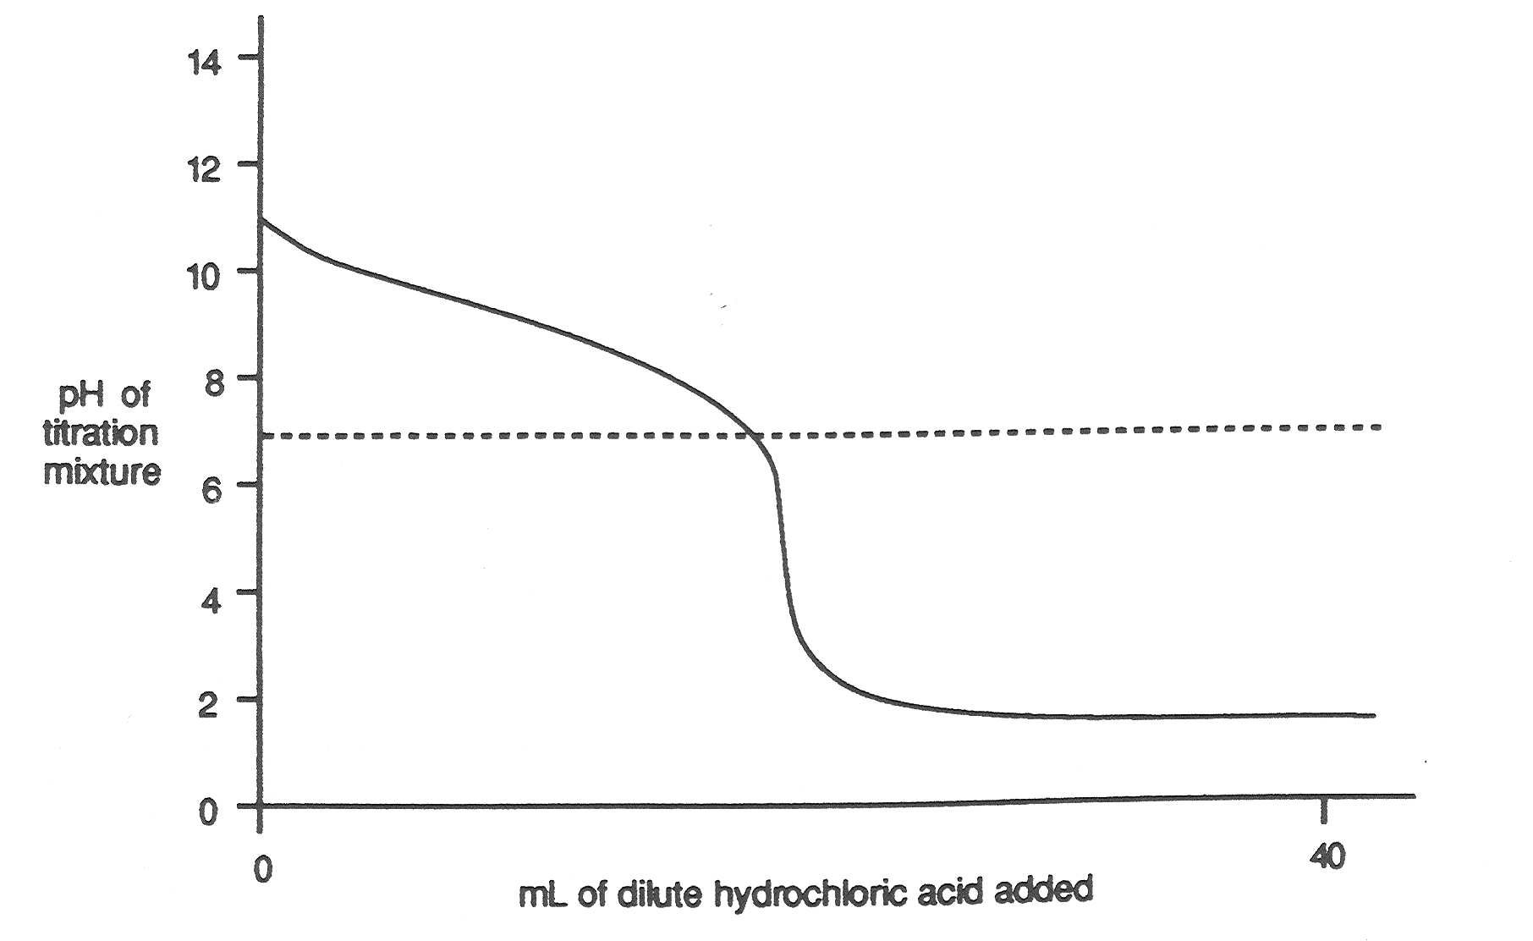

If bromothymol blue, which changes colour around pH = 7 is used as the indicator, which one of the following statements is true?

A. The end point occurs before the equivalence point
B. The end point occurs at the equivalence point
C. The end point occurs after the equivalence point
D. There is no equivalence point because it is the wrong indicator
E. The colour does not change because it is the wrong indicator
PART 2: SHORT ANSWER [20 Marks]

1. Write ionic equations for any reactions that occur in the following procedures. If no reaction occurs write ‘no reaction’.
[9 marks]
In each case describe IN FULL what you would observe, including any
* colours
* odours
* precipitates (give the colour)
* gases evolved (give the colour or describe as colourless)
If a reaction occurs but the change is not visible, you should state this.

a) Dilute hydrochloric acid is added to a potassium sulfite solution.

- A piece of zinc is added to a concentrated sodium hydroxide solution.

- Dilute sulfuric acid is added to copper (II) carbonate.

2. Give one factor on which the buffering capacity of a buffer solution depends.
[1 marks]

3. Identify by name or formula an example of each of the following:
[3 marks]
- A weak inorganic acid.

b) A substance that can be used as a primary standard in a titration against a base.

c) An oxide that reacts with water to produce a basic solution.

- 15.00 mL of 0.100 mol L⁻¹ hydrochloric acid is added to 20.00 mL of 0.100 mol L⁻¹ sodium hydroxide. Calculate the pH of the resulting solution. [4 marks]

5. Distilled water, which has been exposed to air, has a pH of about 5. When it is boiled and then cooled, the pH changes to about 7. The pH of the distilled water prepared in this way then slowly falls back to about 5. Explain with the aid of equations the role of carbon dioxide in these observations.
[3 marks]

PART 3: CALCULATION [10 Marks]

1. Spirits of salts is used in the building industry to clean excess mortar from new brickwork. The active ingredient is hydrochloric acid with a concentration of around 13 mol L⁻¹. In order to precisely determine the concentration of hydrochloric acid in some spirits of salts, a chemist takes a 20.00 mL aliquot and makes this up to 500.0 mL in a volumetric flask. The diluted spirits of salts is analysed by taking 20.00 mL samples of the diluted solution and titrating this with 0.4590 mol L⁻¹ sodium hydroxide solution. An average titre of 21.25 mL of base was obtained for the end point. Use this information to determine the following:

- The moles of sodium hydroxide used in the titration.
[2 marks]

b) The concentration of hydrochloric acid in the diluted solution.
[3 marks]

c) The concentration of the hydrochloric acid in the original spirits of salts.
[2 marks]

d) The percentage of hydrochloric acid by mass in the original undiluted spirits of salts. Assume the original solution has a density of 1.18 g mL⁻¹.
[3 marks]

