ARANMORE CATHOLIC COLLEGE

YEAR 12 CHEMISTRY 3A3B

TOPIC TEST: ELECTROCHEMISTRY

NAME: ________________________________________ MARK:
/50
INSTRUCTIONS:

- Answer ALL questions in the spaces provided.

- Show ALL working clearly to obtain maximum marks, as shown in brackets.

- Use of approved calculators is permitted.

****************************************************************************

- Write a balanced ionic equation for the reaction between the Cr₂O₇²⁻ ion and SO₂ to produce SO₄²⁻ and Cr³⁺.
[2 marks]

- Determine the oxidation number (or state) of the bracketed element in each of the
following:

a) HS₂O₃⁻ (S) d) Mg₃(PO₄)₂ (P)

b) Mn₂O₃ (Mn) e) NaOCl (Cl)

c) IO₃⁻ (I) f) NH₄Cl (N)
[3 marks]

- Write balanced equations for the reactions which occur in the following experiments. Use ionic equations where appropriate. Describe observations such as colours, precipitates, evolution of gases, etc.
[7 marks]
- Chlorine gas is bubbled through a potassium bromide solution.

- A strip of lead metal is added to a zinc nitrate solution.

- A strip of copper metal is added to a concentrated nitric acid solution.

- A 1.0 mol L⁻¹ iron (II) sulfate solution is added to 1.0 mol L⁻¹ hydrogen peroxide solution.

- When potassium iodate (KIO₃) reacts with oxalic acid (H₂C₂O₄), a colourless gas is observed to form and the solution changes from colourless to brown, indicating the presence of iodine. Write down the overall balanced redox equation for this reaction and identify the oxidising and reducing agents.
[3 marks]

- a) Write the overall reaction for the disproportionation of copper (I) ions.
[2 marks]

- Determine the standard potential for the above reaction.
[1 mark]

- Is this reaction spontaneous under standard conditions (why or why not)? Comment on this value with respect to the stability of the copper (I) ion.
[2 marks]

- A demonstration electrochemical cell is made by assembling two half cells consisting of beakers with cobalt metal in contact with cobalt(II) nitrate solution and a layer of pure liquid mercury in contact with mercury(II) nitrate. The half cells are joined as shown in the diagram.
[8 marks]

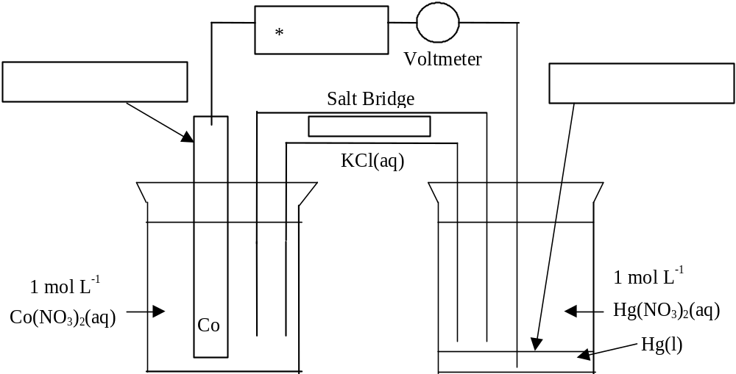

(a) In the boxes provided on the above diagram:

(i) Label the ANODE.
(ii) Label the CATHODE.
(iii) Draw an arrow to indicate the direction of electron flow in the
external circuit. (*)
(iv) Draw an arrow to indicate the direction of flow of the chloride ions
through the salt bridge.

(b) Write balanced equations for the:

(i) ANODE REACTION

- CATHODE REACTION

- OVERALL REACTION

(c) The expected reading on the voltmeter is: .......................................volts.

- Two methods of preventing the rusting of iron are galvanizing and tin plating.

  - What do these two methods have in common with respect to the way in which they protect the iron from corroding?
[1 mark]

  - Describe the main advantage of galvanizing over tin plating with a clear explanation of what happens in each case.
[2 marks]

  - Describe one other method of corrosion protection which is quite different to the above.
[2 marks]

- Write down the following chemical equations involved in the eventual rusting of iron:

  - The initial oxidation and reduction half-equations and associated overall equation.
[2 marks]

  - The formation of iron (II) hydroxide.
[1 mark]

  - The subsequent oxidation to iron (III) hydroxide.
[1 mark]

  - The formation of rust from the iron (III) hydroxide.
[1 mark]

- Fuel cells are starting to be used in vehicles in order to save fossil fuels and to reduce greenhouse gas emissions. In one fuel cell, hydrogen gas and oxygen gas are bubbled across a platinum catalyst in acidic solution to produce the only product, water:

2H_{2(g)} + O_{2(g)} → 2H₂O_{(l)}

  - Write the anode and cathode half reactions by referring to the E° table of values.
[2 marks]

  - What would the output voltage of the cell be under standard conditions?
[1 mark]

- A 1.00 g sample of impure iron wire was dissolved in sulfuric acid to produce an acidified solution of iron (II) sulfate and was made up to 250.0 mL with distilled water. 20.00 mL samples of this solution were then titrated with a 0.0194 mol L⁻¹ solution of KMnO₄ with the following results:

 | Rough trial (mL) | Trial 1 (mL) | Trial 2 (mL) | Trial 3 (mL)
Final | 13.96 | 26.84 | 39.66 | 14.02
Initial | 0.60 | 13.96 | 26.84 | 1.16
Titre

Calculate the (percentage) purity of the iron wire.
[9 marks]

********************************************************

END OF TEST

