These test papers are copyright and must not be reproduced in any way. This paper should be withdrawn after use in the examination or classroom and retained by the teacher. Test papers may not be used for private tutoring in the year of publication.
©



PHYSICS

YEAR 11

2002

INSTRUCTIONS TO CANDIDATES

TIME: 2½ Hour Paper: MARKS: 160

Attempt questions 1 to 14 Section A
Attempt questions 1 to 6 Section B
Attempt question 1 Section C

TIME: 3 Hour Paper: MARKS: 200

Attempt ALL questions

STRUCTURE OF THE PAPER

Section | No. of  Questions | No. of questions  to be attempted | No. of marks  out of 200 | Proportion of  exam total
A: Short Answers | 15 | ALL | 60 | 30%
B: Problem Solving | 7 | ALL | 100 | 50%
C: Comprehension and  Interpretation | 2 | ALL | 40 | 20%

Note: Above refers to 3 hour paper. For less than 3 hours refer to front cover.

INSTRUCTIONS TO CANDIDATES

Write your answers in the spaces provided beneath each question. The value of each question (out of 200) is shown following each question.

The enclosed Physics: Formulae and Constants Sheet may be removed from the booklet and used as required.

Calculators satisfying conditions set by the Curriculum Council may be used to evaluate numerical answers.

Answers to questions involving calculations should be evaluated and given in decimal form. Quote the final answer to not more than four significant figures. Despite an incorrect final result, credit may be obtained for method and working, providing these are clearly and legibly set out.

Questions containing specific instructions to show working should be answered with a complete, logical, clear sequence of reasoning showing how the final answer was arrived at; correct answers which do not show working will not be awarded full marks

Questions containing the instruction "Estimate" may give insufficient numerical data for their solution. Students should provide appropriate figures to enable an approximate solution to be obtained.

Section A: Short Answers

Marks allocated: 60 marks out of a total of 200 (30%)

Attempt ALL 15 questions in this section. Each question is worth 4 marks.
Answers are to be written in the space below or next to each question.

1 A climbing rope hanging from the ceiling in a gymnasium has a mass of 25 kg. A 60 kg gymnast hangs from the bottom of the rope without touching the floor. What is the tension in the rope?

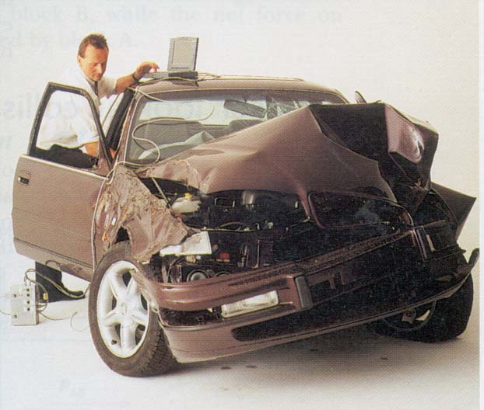
2 The photo opposite shows a typical family car being tested in a “crash laboratory”. If the car had been traveling at 60 km h⁻¹ before the impact, estimate the impulse of the crash.

3 An announcer on a radio station plays a practical joke on her listeners by announcing; ‘The temperature today will reach a maximum of 40 Kelvin. It will therefore be a great day to cool off at the beach”. Why isn’t the statement correct?

4 The photo opposite shows a girl holding on to a Van de Graaff generator which is supplying a very large electrical charge to her body. Explain why her hair is the way it is.
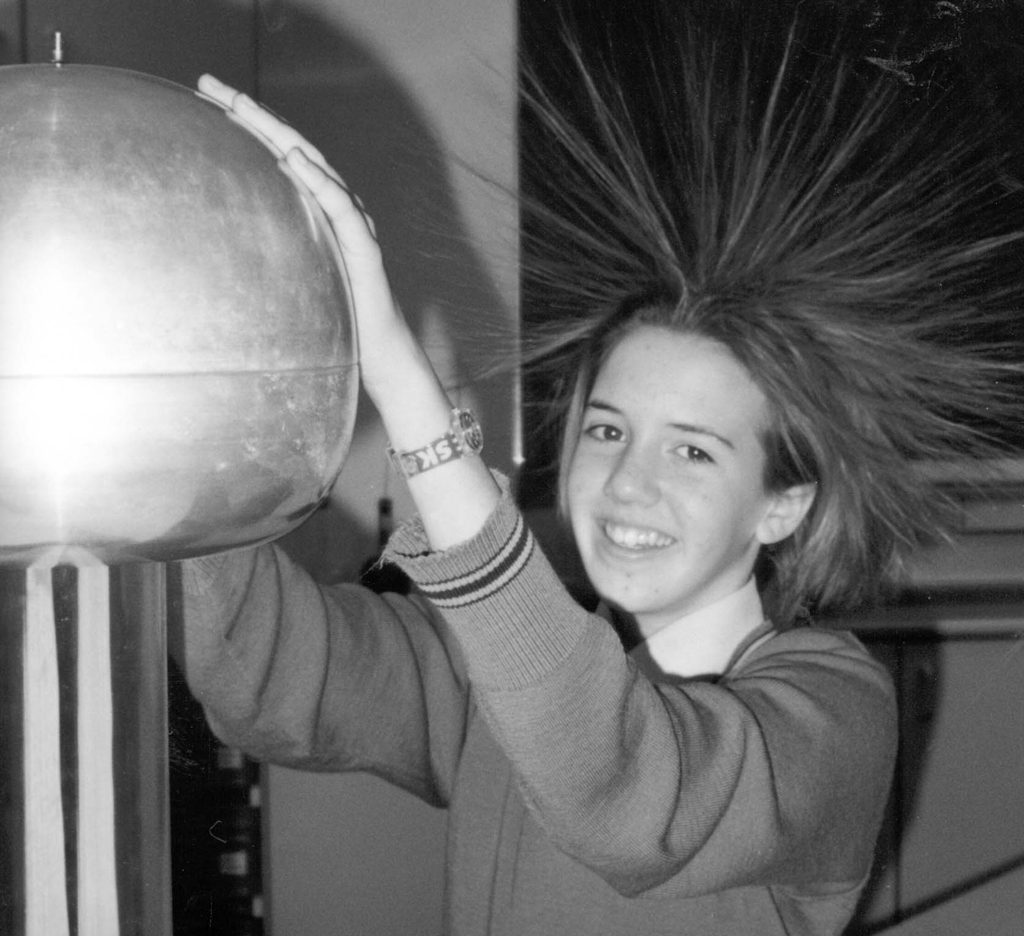

5 A year 11 girl goes for a midday swim in winter and this causes her normal body temperature to drop by 2ºC. She comes out of the water and stands in the sunlight to try and get warm. If the solar radiation which is reaching her is 900 W m⁻² and her average body specific heat is 3.5 kJ K⁻¹ kg⁻¹, estimate how long she needs to stand in the sun until her body temperature becomes normal again.

6 Food can be preserved by irradiating it with nuclear gamma radiation. Meat typically requires an equivalent dose of 1000 Sv to sterilize it.

(a) How much energy does 2.0 kg of meat absorb when it undergoes sterilization?

(b) If meat has a similar specific heat capacity to water, how much would the
2.0 kg of meat’s temperature increase if it didn’t lose heat to the surroundings?

7 A refrigerator freezer can extract thermal energy from the freezer at the rate of
2.59 x 10³ J per minute. If 375 mL of water at 22ºC is placed in the freezer, how
long would it take to convert the water to ice at - 4ºC?
(the specific heat capacity of ice is 2.10 x 10³ J K⁻¹ kg⁻¹)

8 Iodine – 131 is a radioisotope which is used to treat over hyperactive thyroid glands. It
decays into xenon (Xe) by beta emission with a half life of 8.1 days. The xenon then
decays emitting a gamma ray.

(a) Write a nuclear equation for the decay by beta emission of iodine-131.

(b) Write a nuclear equation for the decay of xenon as it emits a gamma ray.

(c) In terms of half life, explain why iodine – 131 is useful in this application.

- A 75.0 kg water- skier is accelerated from rest by being towed behind a powerful boat. The tow rope is horizontal to the water.
  - If the tension in the rope is 1 500 N, what is the horizontal force pulling the
skier along?

(b) If the skier experiences a frictional drag due to the water of 400.0 N, what
is her acceleration?

Below is a diagram of a convex lens. This type of lens is used to focus images in a camera (or the human eye). On the principal axis of the diagram mark the focal length of the lens. Now draw two construction lines from the top of the object to demonstrate how an image of the object is located in a camera or the human eye.

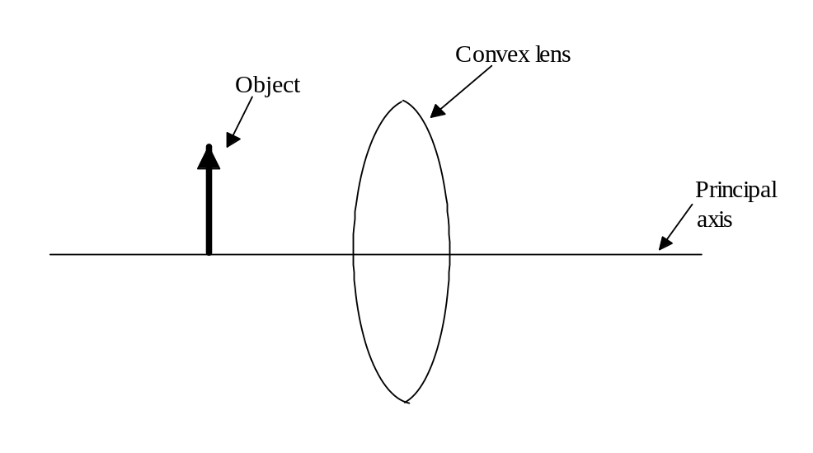

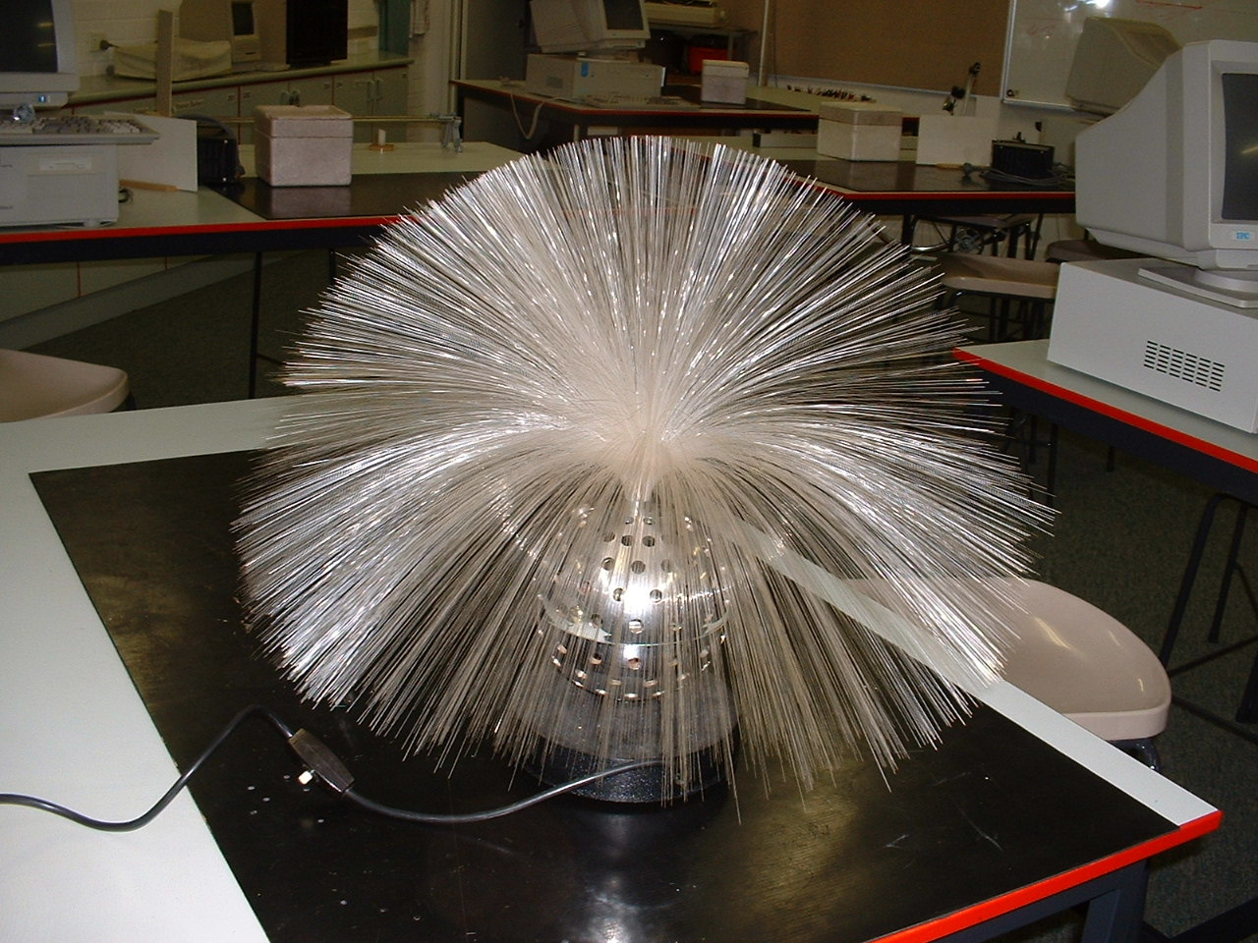
11 The photo opposite is of a lamp which was popular in homes in the 1960s. It consists of hundreds of small diameter optical fibres above a light source in the base of the lamp.

(a) When the lamp is switched on, why does an observer only see light being
emitted from the ends of the fibres and NOT along their entire length?

(b) Complete the diagram below to show the direction of a single ray of light
as it passes through the optic fibre.
Exterior
cladding
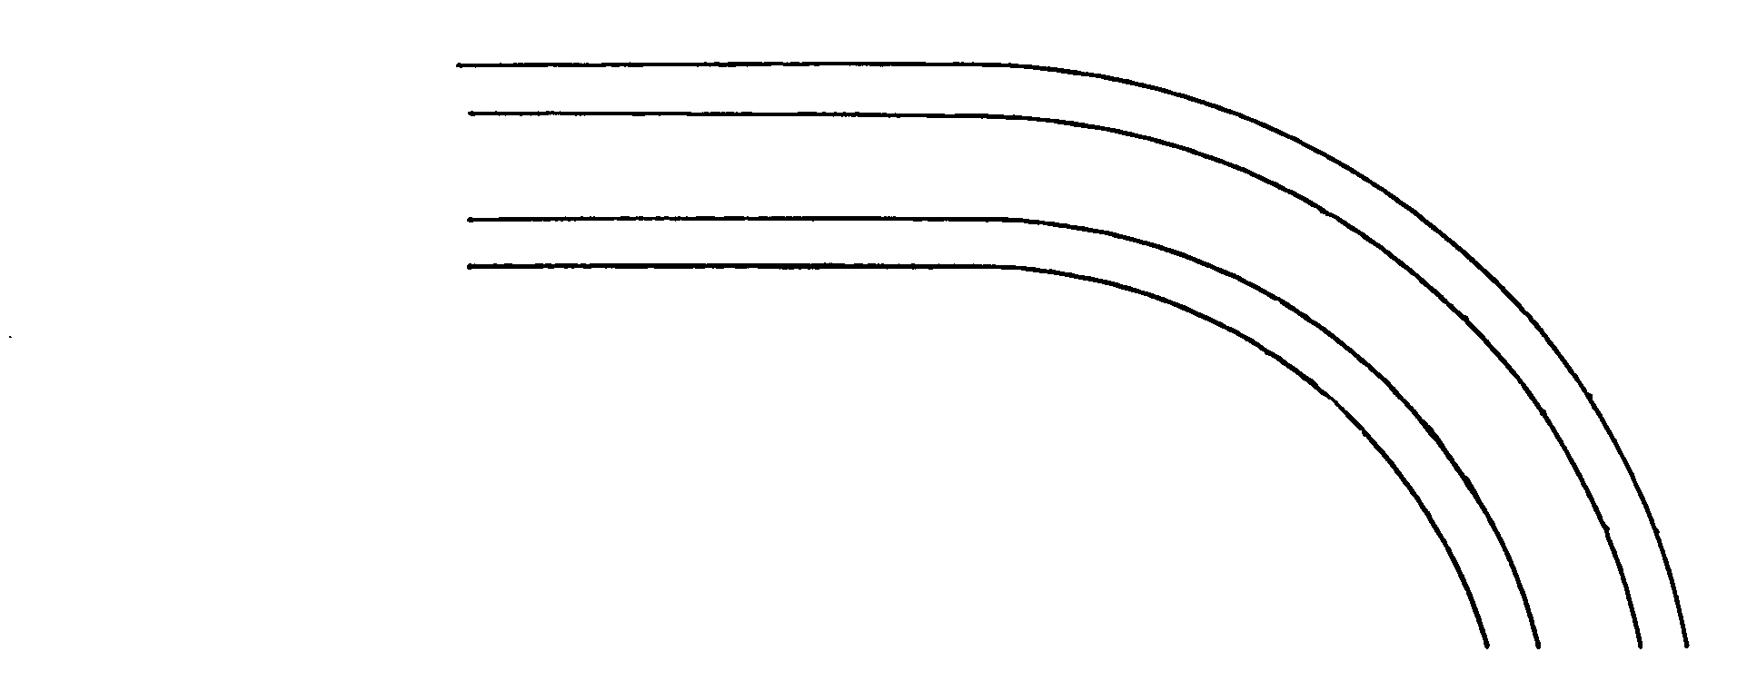
Ray of
light entering
optic fibre

12 A 100 g car in a “loop the loop” toy has 1.50 J of potential energy and 1.20 J of kinetic energy at the top of the loop. If the loop rests on a flat bench, at what height above the bench was the car released if the friction between the car and the track caused 10% of the initial energy given to the car to be lost as heat
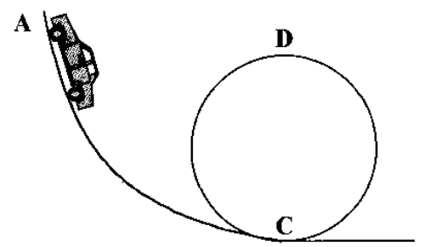

13 (a) Stained glass windows are often seen in churches. The pieces of coloured glass
from which the windows are made only appear coloured when light is shone
through them. Why is this so?

(b) A red coloured opaque object only appears to be red under what type of
illumination.

- Below is a diagram of four empty cooking pots, all made of iron
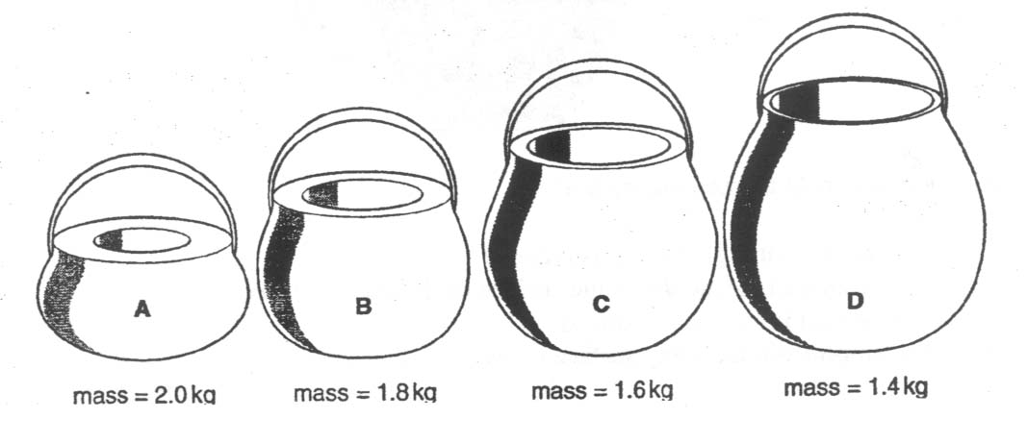

(a) Which pot (A, B, C, D) has the greatest specific heat?

(b) If all the pots were heated so they each had the same heat input, which pot (A, B, C, D) would take least time to heat from 20ºC to 80ºC?

(c) Which pot (A, B, C, D) has the greatest quantity of heat stored in it if all the pots are
at 20ºC?

15 A hair drier is marked 240 V, 1 250 W.

(a) What current does it draw?

(b) If the owner of the hair drier uses it for 2 hours per week, how much would it cost to operate per week if electricity costs 14.1 cents per unit? (1 unit = 1 kWh)

Section B: Problem Solving

Marks allotted: 100 marks out of a total of 200 (50%)

This section contains 7 questions.

You should answer: ALL of the questions 1, 2, 3, 4, 5, 6 and 7

Answer the questions in the spaces provided

(14 marks)
A solar furnace made from a concave mirror has an area of 0.5 m² and is used to cook food.
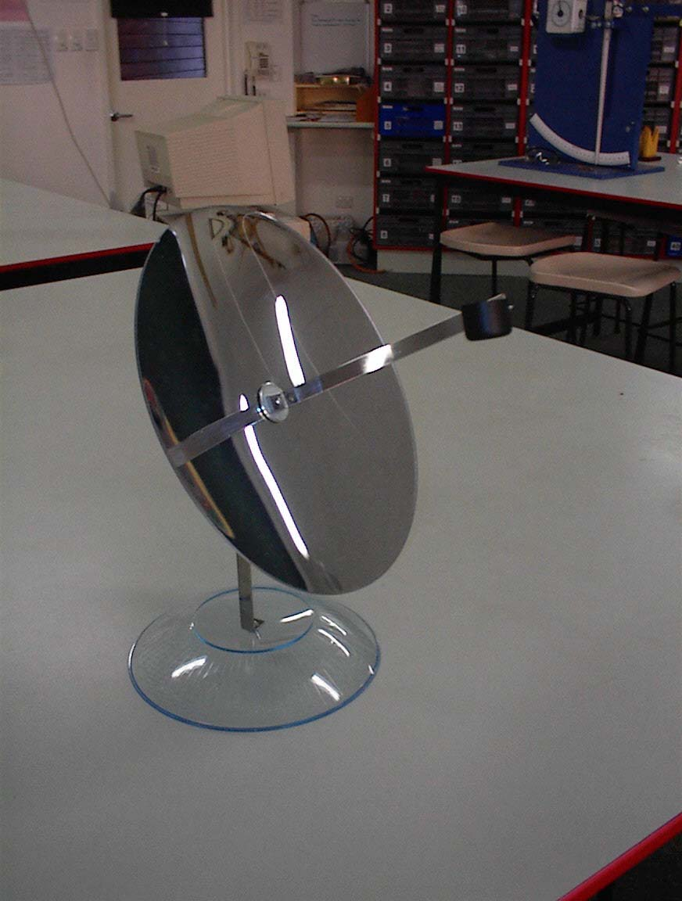

(a) Complete the diagram below to show how radiant
energy from the Sun can be used to efficiently heat
the food.
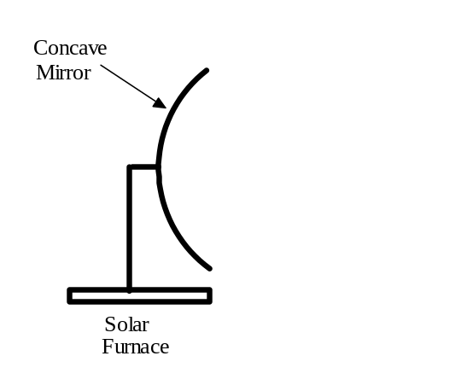
(3 marks)
(b) Why is a concave mirror and NOT a convex mirror used in this situation?
(2 marks)

(c) Using a parabolic mirror in the furnace, instead of a concave mirror, would be more effective in heating the food. Why would this be so? (2 marks)

(d) Would you expect all the radiant energy from the Sun which is incident on the
0.5 m ² mirror to be reflected onto the food? Explain your answer. (2 marks)

(e) If the radiant energy from the Sun is incident on the mirror at a rate of
1 500 W m⁻² and 95 % of the energy reaches the food, how long would
it take to heat 2.0 kg of water from 20º C to 80º C? (5 marks)

2 (16 marks)
(a) In a factory that manufactures plastic food wrap the thickness of the plastic
is monitored by a thickness recorder. The plastic passes between a beta
particle source and a detector as shown in the diagram below. The table
below shows the readings on the detector (in counts per second) during one production run.

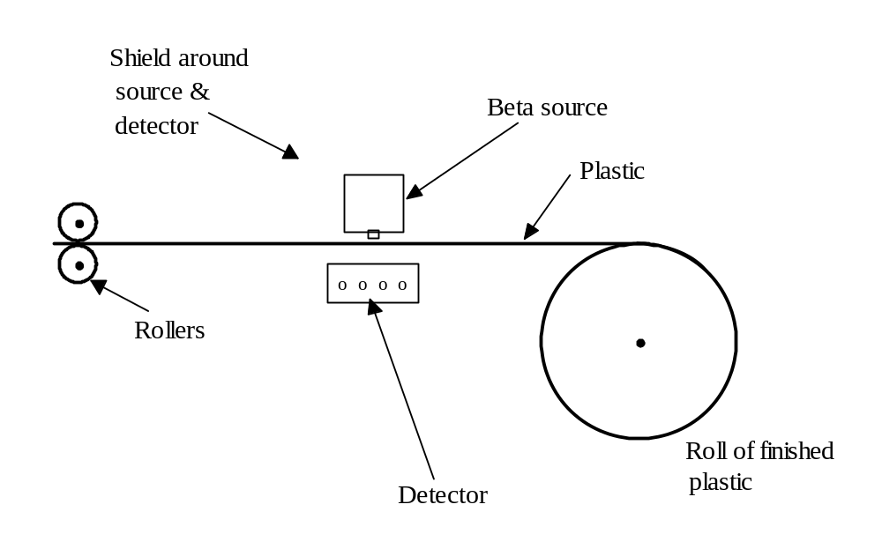
time interval (min) | 0 - 2 | 2 - 4 | 4 - 6 | 6 to 8 | 8 -10 | 10 - 12 | 12 - 14 | 14 - 16 | 16 - 18 | 18 - 20
Counts/ s | 89 | 90 | 88 | 89 | 91 | 170 | 172 | 172 | 168 | 169

(i) What is the probable cause for the reading during the sixth recorded interval to be so different from the fifth recorded interval? (2 marks)

(ii) From what material should the safety housing be made to offer MINIMUM necessary protection for workers working near the beta source? Explain your answer.
(3 marks)

(b) The radioactive decay curve for the beta particle source that was considered to be used in the thickness detector is shown below.
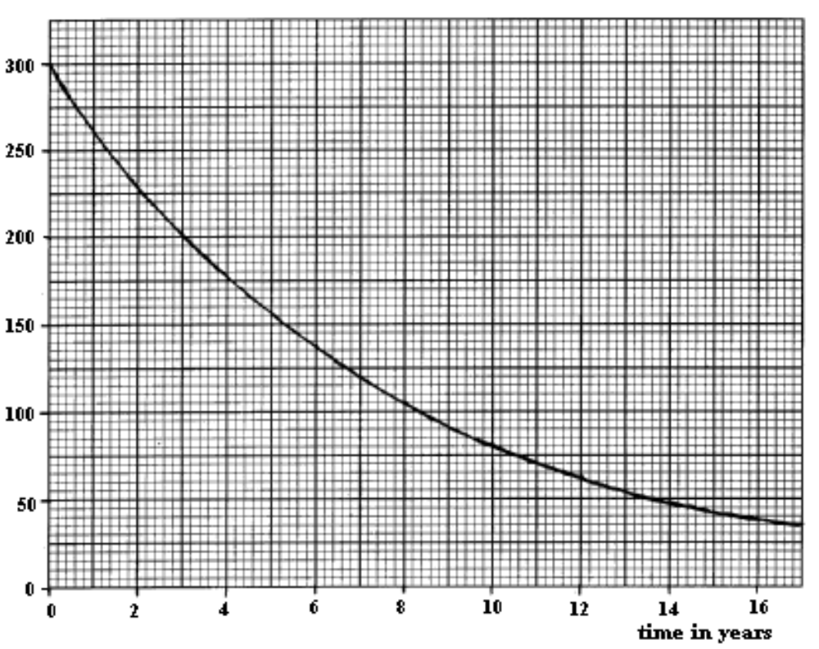
(i) Use the graph to calculate the half life of the source. Show construction lines clearly on the graph. (5 marks)
(ii) Would this source be suitable to use in the thickness detector? Explain your answer. (3 marks)

(iii) Would an alpha source be more suitable to be used in the thickness detector? Explain your answer. (3 marks)

3 (15 marks)
(a) The figure below shows a salt water swimming pool with a spectator looking down
into it.
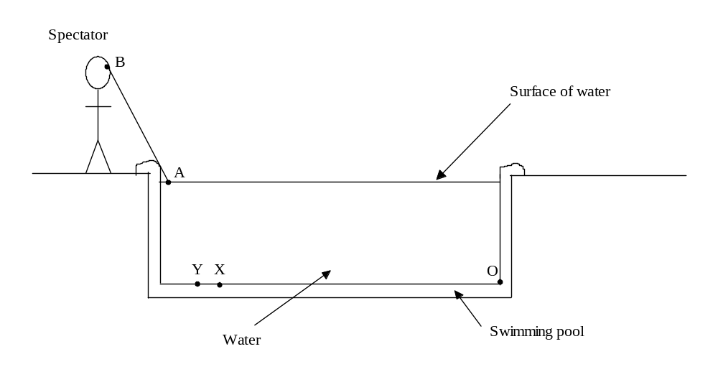
The spectator might be expected to see the bottom over the length OX but can actually see the bottom over the length OY.

AB is a ray of light emerging from the water that just misses the corner of the pool on its direct path to the spectator’s eye when the spectator can see the region OY.

  - On the figure above draw the path of the ray in the water that emerges along AB. Explain with reference to the other rays why the whole of XY can be seen but that the point O may not. (2 marks)

  - The light waves traveling towards A are generally green and have a frequency of 5.77 x 10¹⁴ Hz and a wavelength of 3.82 x 10⁻⁷ m. Calculate the speed of light in the salt water of the pool. (3 marks)

  - Determine the refractive index of the salt water in the pool. (3 marks)

(iv) The spectator also sees a lamp that she knows to be located at point X. On the figure above, draw a dot to mark the position the lamp appears to be and label it L. Show construction lines. (2 marks)

(b) A camera has a convex lens with a focal length of 50 mm. It is 6.6 cm from the
film. At what distance from the lens should the object be so as to produce a clear
image which is focused on the film (3 marks)

- (11 marks)
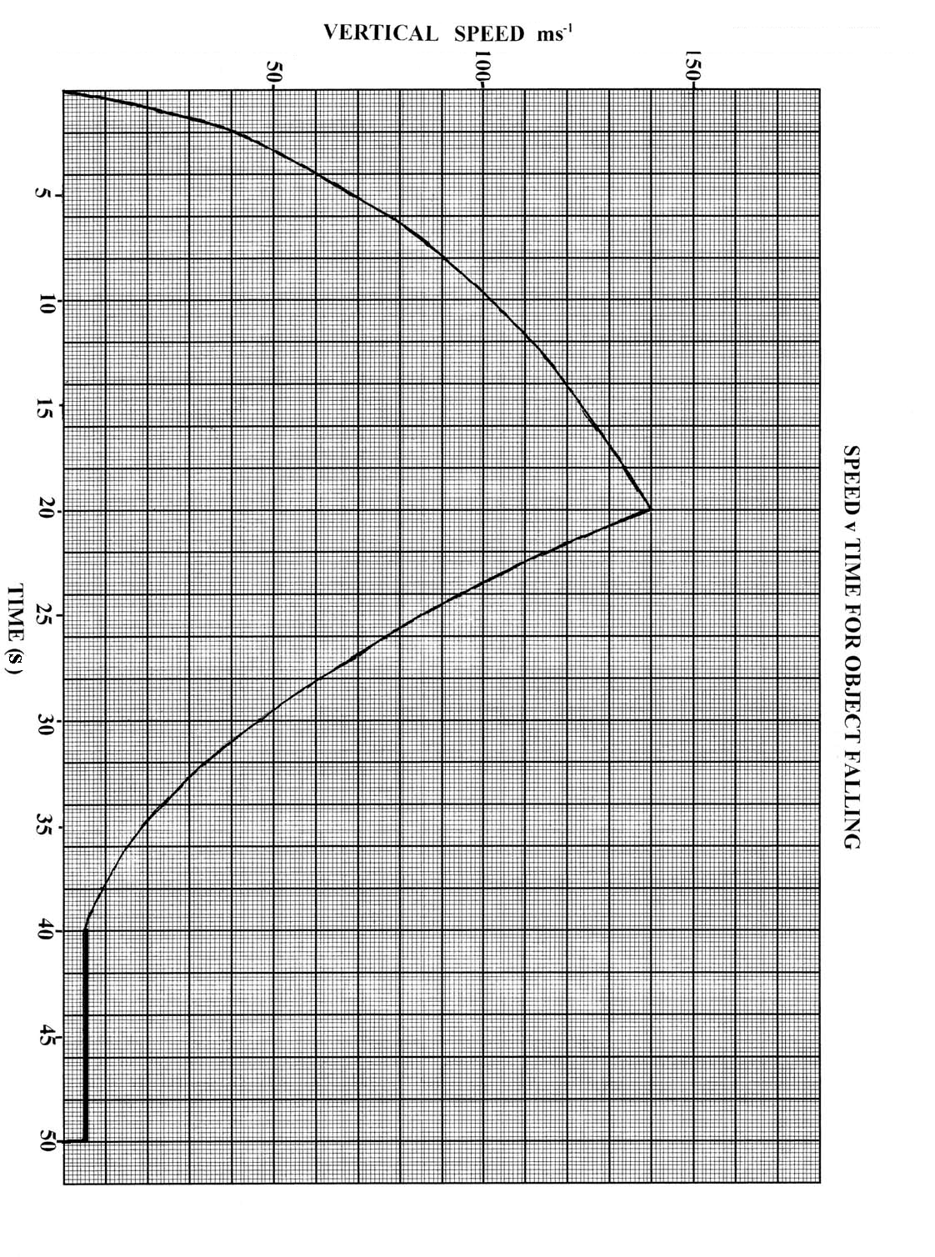
A small, dense object is released from a helicopter which is stationary, hovering some distance above the ground. At some point during the object’s decent a parachute attached to the object opens. The air resistance on the object is negligible for the first 5.0 s of its fall. The graph opposite shows the vertical velocity versus time for the object from the time it is released until it hits the ground.

- What type of motion is the object undergoing between 0 and 4.0 s?
(1 mark)

- What type of motion is the object undergoing between 41.0 and 45.0 s? (1 mark)

- At what time does the parachute open? (1 mark)

- What is the terminal velocity of the parachute? (2 marks)

- What is the average acceleration of the object between 22.0 s and 35.0 s? (4 marks)

(f) What is the distance travelled while the parachute is traveling at its terminal velocity? (2 marks)

- (18 marks)
An electrical circuit is set up by a teacher to test students understanding of current, resistance and potential difference (voltage). The meters used in the circuit do not have any influence on the circuit other than to register current and potential difference. The students could see the readings on five of the meters but the teacher had covered the dials of three of the meters so the students could not see what they registered. A diagram of the circuit is below

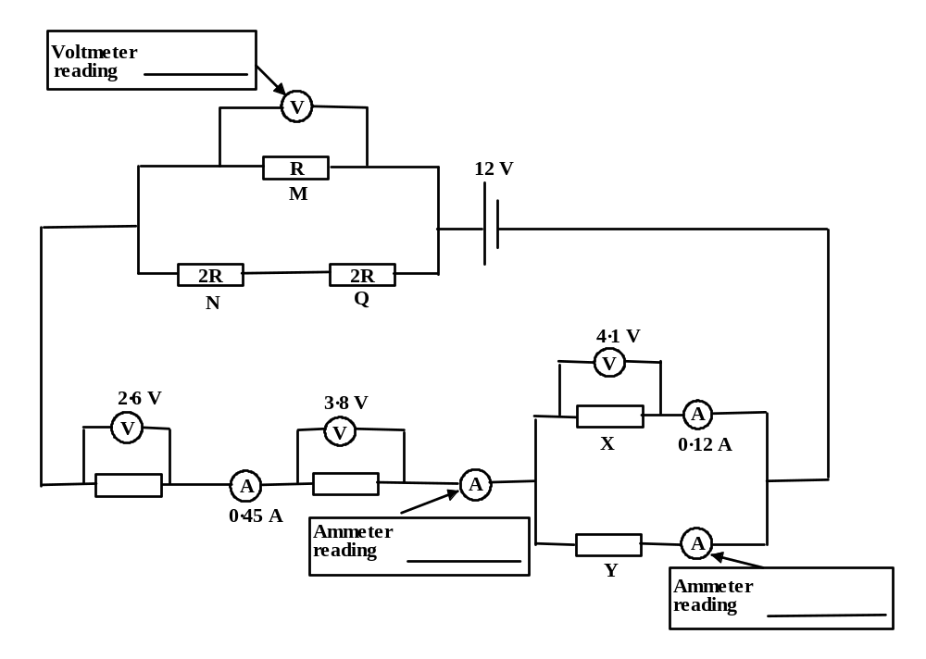
(a) Calculate what the readings on the three meters would be, and write the values next to the meters in the spaces provided. (3 marks)

(b) Calculate the resistance of X. (2 marks)

(c) Calculate the quantity of charge which flows through resistance Y in 5.0 minutes. (2 marks)

(d) Calculate the effective resistance of the combination of resistors M, N and Q. (2 marks)

(e) Calculate the value of resistance R (4 marks)

(f) Calculate the current flowing through resistor N. (2 marks)

(g) The battery can supply1.4 MJ of energy. For how long could this battery operate? (3 marks)

6 (11 marks)
A car traveling along the Freeway (speed limit 100 km h⁻¹) gets out of control and crashes into a bridge pylon but does not rebound. The driver was not hurt in the crash. The mass of the car plus driver is 1.2 tonne. A graph of force versus time for the impact of the car with the pylon can be seen below.

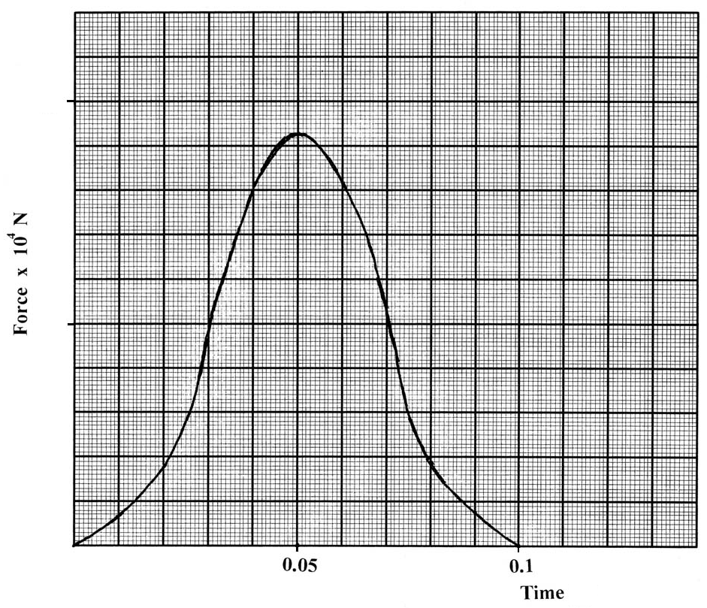
40
80
(s)
- What physics quantity does the area under the graph represent? (2 marks)

(b) List two built in safety devices which the car may have had which could have saved the driver from injury. (2 marks)

(c) Use the information provided by the graph to determine whether the car was exceeding the speed limit. Show all your working to justify your answer.
(4 marks)

(d) A crane is brought to the crash site to lift the car onto the back of a truck.
If the maximum safe working load of the crane is 1.4 x 10 ⁵ N then what is the maximum safe upward acceleration of the car while it is being lifted?
(3 marks)

7 (15 marks)
Although not part of the Physics course a teacher decided to provide some extra work for her students. The task set by the teacher was to find the resistivity (ρ) of graphite which was taken from a ‘lead’ pencil.
The equation which enables the resistivity to be calculated is:

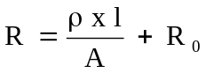

Where R is the resistance of the graphite
l is the length
ρ is the resistivity
A is the cross sectional area
and R_{o} is a constant

Because the resistance per unit of length of the graphite could not be measured directly a circuit was set up to measure the current and the potential difference when different lengths of graphite were in the circuit. In this way the resistance could be measured using:

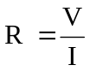
A diagram of the circuit can be seen below.
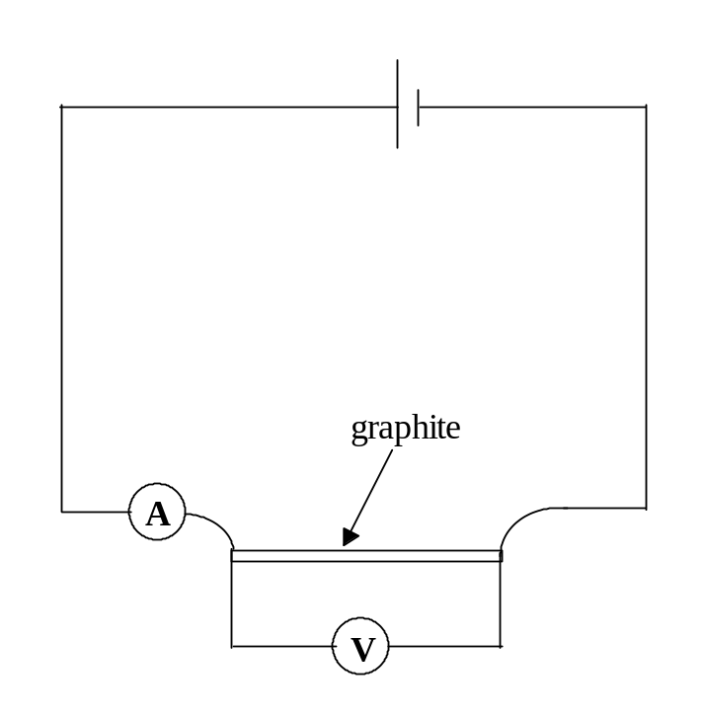

The students went ahead and gathered the data and recorded it in the following table. The diameter of the graphite was 2.00 mm for its entire length.

Length (l) in m  X 10⁻² | Current (I) in A | Potential difference (V) in V | Resistance (R) in Ω
12.0 | 0.27 | 1.78
10.0 | 0.29 | 1.74
8.0 | 0.35 | 1.73
6.0 | 0.41 | 1.67
4.0 | 0.53 | 1.49
2.0 | 0.69 | 1.27

- On the graph paper supplied plot R (y axis) against l (x axis) and draw the best straight line through the points. (4 marks)

Or
Use your graphics calculator to graph the data. If you use this method sketch the shape of the graph on the graph paper and label the axis fully.

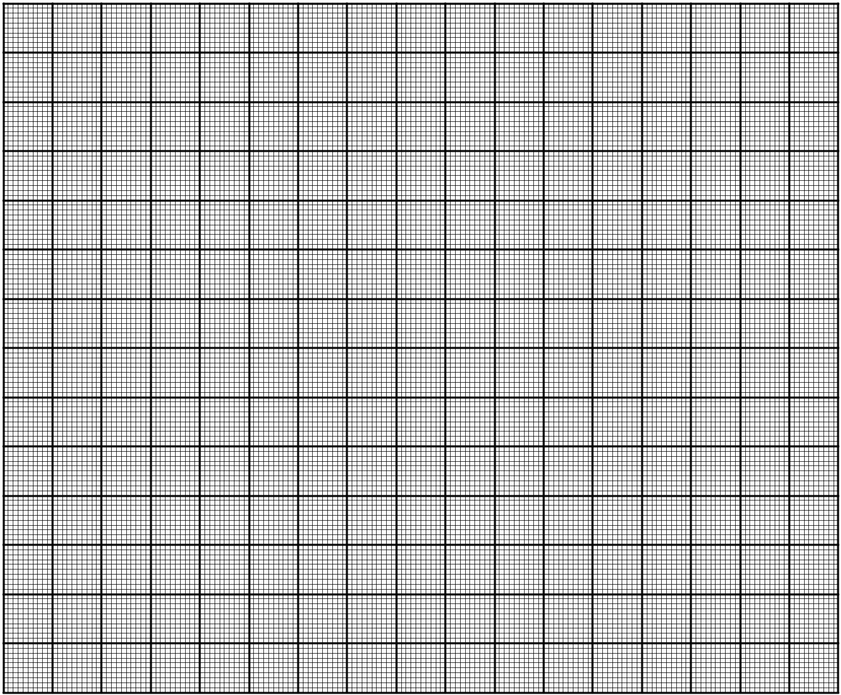

- Write the equation for the line of best fit. (2 marks)

(c) Determine the gradient of the line. (2 marks)

(d) Determine the y intercept. (2 marks)

(e) Use your answers from (b) and the value of A to determine the values for
ρ and R_{o} (5 marks)

THIS PAGE HAS BEEN LEFT BLANK INTENTIONALLY.

Section C: Comprehension and Interpretation

Marks allotted: 40 marks out of 200 (20%)

BOTH questions should be attempted. Each question is worth 20 marks.

Read each passage carefully and answer all of the questions at the end of each passage.
You are reminded of the need for clear and concise presentation of answers. Diagrams (sketches), equations and /or numerical results should be included as appropriate.

Question 1
SMOKE DETECTORS

Householders Ignore Fire Brigade Advice
on Smoke Detectors

Thirty-two people died and 567 were injured in fires in West Yorkshire last year.

However, only 7% of householders in Yorkshire and Humberside have followed fire brigade advice to fit smoke detectors, which give an early warning of fire and allow time to escape.

A recent Government sponsored survey shows the region joint bottom of all areas in England and Wales. Said Assistant Chief Officer Peter Kneale: "Despite our efforts for the past two years, the area is still well below the national average of 10% in its provision of smoke detectors.

"We are disappointed to read the statistics when we look back at the efforts we have made to sell the theme that smoke detectors save lives."

The survey also shows that pensioners are the most poorly provided for, with only 5% having a smoke detector, despite being one of the groups most at risk.
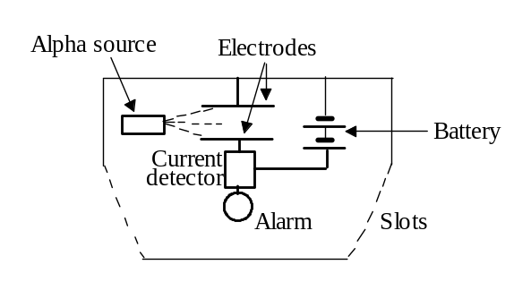

The diagram opposite shows the construction of one kind of smoke detector.

The weak radioactive source has a long half life and gives out alpha particles. (Americium-241 is often used.) The alpha particles ionise air molecules in the detector. The ions are attracted to one or other of the electrodes, so a small current flows.

If smoke enters the detector, fewer ions are produced so less current flows. This decrease in current is detected electronically and the alarm is sounded.
Questions
1 Explain what happens to air molecules when they become 'ionised'. (2 marks)

2 What sort of ions are attracted to the positive electrode? (2 marks)

3 Suggest a reason why fewer ions are produced if smoke enters the detector. (3 marks)

4 Why is a radioactive source which gives out alpha particles used, rather than one which gives out
beta or gamma radiation? (3 marks)

5 What is an alpha particle? (2 marks)

6 What is meant by the 'half life' of a radioactive substance? (3 marks)

7 Why should the radioactive source used in the detector have a long half life? (3 marks)

8 Someone might be worried about the presence of a radioactive source in the detector.
What could you say to convince that person that it is safe? (2 marks)

THIS PAGE HAS BEEN LEFT BLANK INTENTIONALLY.

Question 2
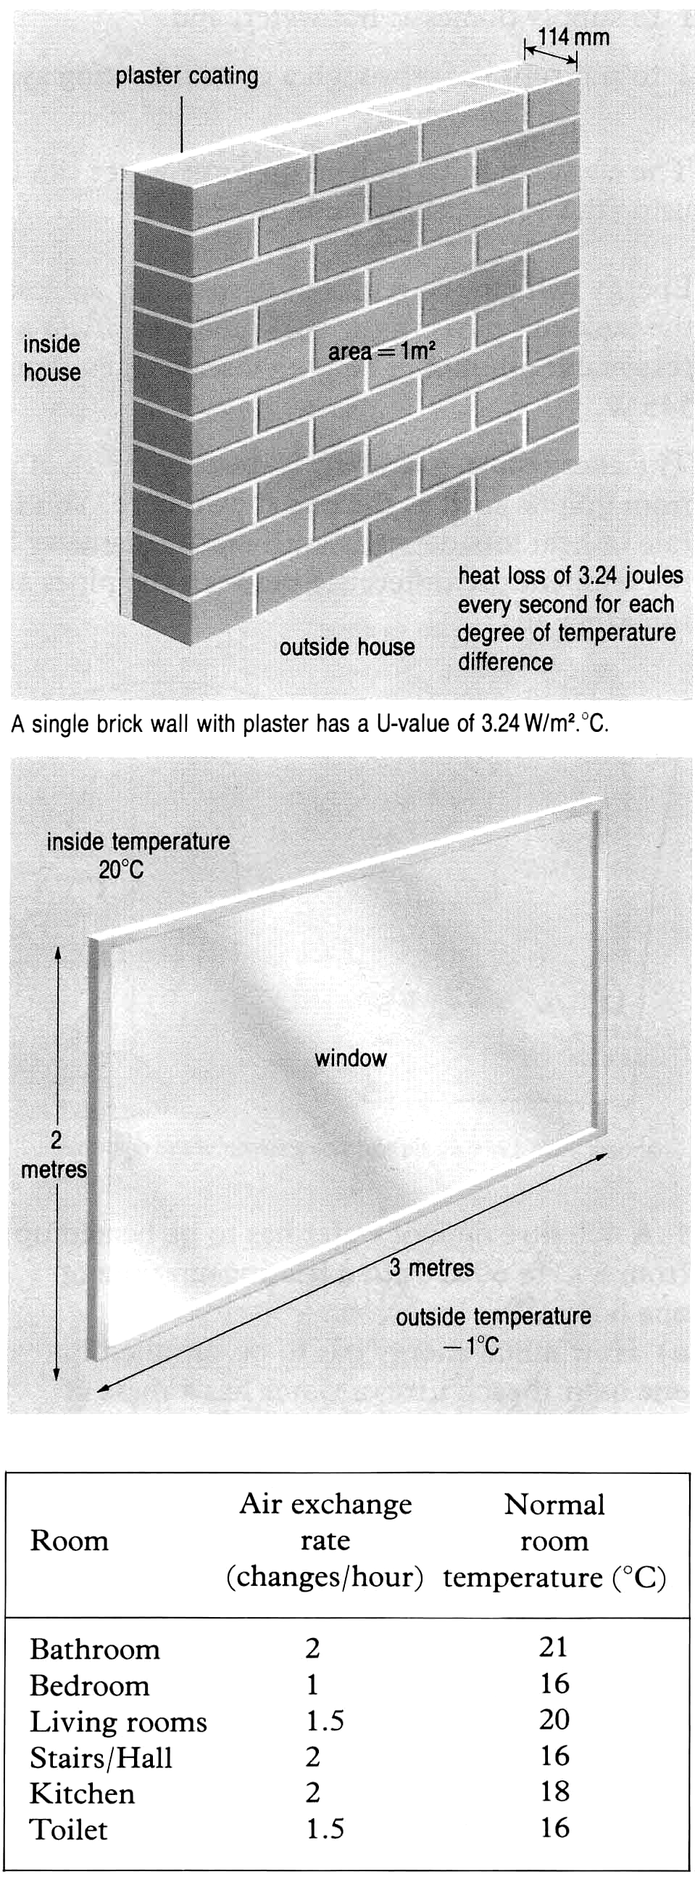
Calculating Heat Loss

Just Passing Through

Even after all steps have been taken to insulate a home some heat will continue to be lost through the fabric of the building. Energy will be required from the heating system to replace this. The rate at which heat escapes from a room depends on three factors:

1 The type of material used.
In construction work special tables are prepared to show how easily different materials allow heat to pass through. These are called U-values and tell us how good a conductor a material is. A good conductor has a high U-value.

2 The surface areas (A) of the different materials making up the room. For example the more windows there are the greater will be the heat loss through glass.

3 The difference in temperature between the room (T2) and outside (T1). The greater the difference, the greater will be the rate of heat loss. So in winter a room loses heat more quickly than it does in summer.

Putting these ideas together leads to a formula for P, the rate of heat loss, i.e. heat loss per second.
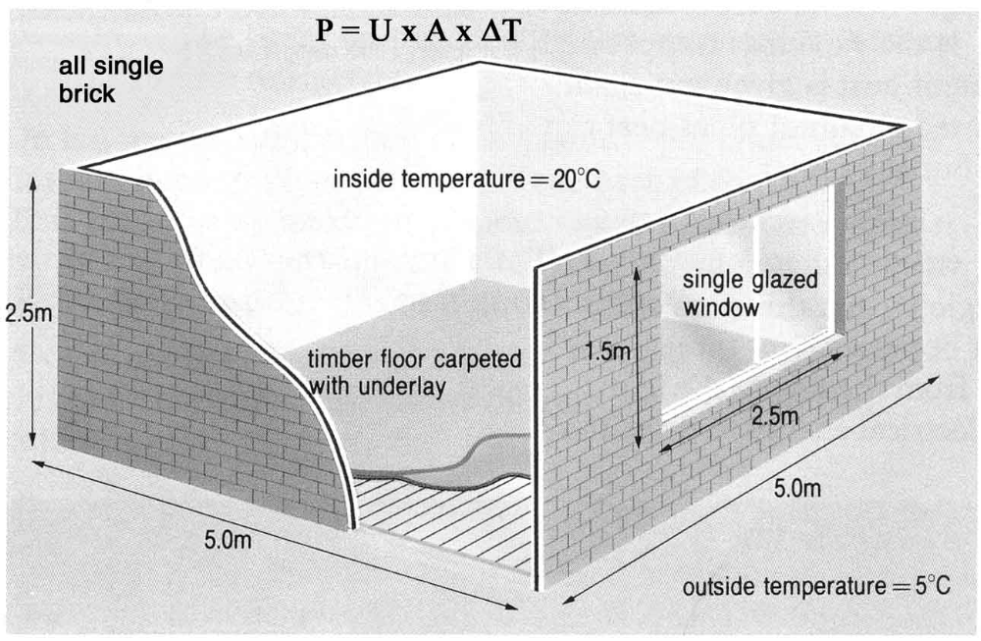

In practice the walls, floor and ceiling of a room are made of different materials. The rate of heat loss (P) must be calculated for each, and then a total found at the end.

Type of Fabric | U - Value
Ceiling | 4.1
Single glazed window with 6 mm glass | 5.6
Double glazed window with 20 mm gap | 2.8
Single brick wall with plaster (114) | 3.24
Double brick wall with 280 mm air cavity / plaster | 1.7
Double brick wall with cavity insulation / plaster | 0.6
Timber floor set on joists | 1.7
Timber floor on joists with carpet and underlay | 0.7

In-out in-out

Energy will also be required to heat the air that has to pass through a house for ventilation. Although we want our houses to be well insulated there has to be a regular change of air. This prevents rooms from becoming stuffy and avoids problems of condensation and dampness. You can see from the table that different rooms require different amounts of ventilation.

Questions

- What are the units for:
(i) Rate of heat loss (P)

(ii) U values. (2 marks)

- From the table of U values find the building arrangement which gives the lowest rate of heat loss. (2 marks)

- Less energy is lost through the walls between rooms inside a house than through outside walls. Suggest a reason for this. (2 marks)

- Calculate the rate of heat loss to the outside from the room shown on page 29.

  - through the walls (3 marks)

  - through the window. (3 marks)

5 List 3 likely sources of condensation and dampness in a room (2 marks)

6 Suggest a reason why the air exchange rate for a kitchen is different to that of a bedroom. (2 marks)

7 Explain why a double glazed window with a 20 mm air gap is a better insulator than a single
glazed window. (2 marks)

8 Suggest a way in which the U value for a ceiling may be reduced from its relatively high
value of 4.1. (2 marks)

END OF PAPER
ACKNOWLEDGEMENTS

SECTION C

Question 1: Smoke Detectors. Extract from Lambert, Andrew (1990). Questions on
Everyday Physics. Published by Blackie & Son Ltd.

Question 2: Calculating Heat Loss Extract from Jardine, Jim (1988). Physics Through
Applications. Published by Oxford University Press.

