

West Australian Test Papers

PHYSICS

Year 11

2002

SOLUTION BOOKLET

&

MARKING GUIDE

Markers should note that the solutions presented here are skeletal answers and
should be used as a guide only.

Alternate answers used by students may be perfectly acceptable and discretion
should be used.
Section A

- Tension = (25 + 60) x 9.8 = 833 N

2 Estimate mass to be about 1 200 kg
initial velocity is 16.7 m s⁻¹
I = m(v - u)
=1 200(0 - 16.7)
= - 2 x 10⁴ kg m s⁻¹

- 40 K is very cold. You would not be wanting to cool off at the beach. The actual celsius temperature would be -233 ºC.

- Charge generated by the Van de Graaff generator is conducted by her body to her hair. Each strand of hair is charged with the same type of charge. As like charges repel, the strands repel each other and stand apart.

- Estimate her body mass to be 60 kg.

Estimate surface area of half her body to be 0.5 m² (half her body is shaded)

Q = 60 x 3.5 x 10³ x 2

= 4.2 x 10⁵ J

Heat absorbed = 900 J s⁻¹ m ^{– 2} , ∴ Heat absorbed = 450 J s ⁻ ¹

T = 930 s = 16 min

6a Dose = 1000 Gy

- = energy absorbed / 2
energy absorbed = 2.0 x 10³ J

6b Q = m x c x ΔT
2.0 x 10³ = 2 x 4.2 x 10³ x ΔT
ΔT = 0.24 ºC

- Q = [m x c x ΔT] + [m x L] + [m x c x Δt]
Q = [0.375 x 4 200 x (22 – 0)] +[0.375 x 3.34 x 10⁵] + [0.375 x 2 100 x 4]
Q = 1.63 x 10⁵ J

Time = 1.63 x 10⁵ / 2.59 x 10³ = 62.9 min

8a ¹³¹I₅₃ ¹³¹Xe₅₄ + ⁰e₋₁

b ¹³¹Xe₅₄ ¹³¹Xe₅₄ + ⁰γ₀

c Iodine -131 has a reasonably short half life so there is only a very small residual amount of it in the body after a few weeks.

9a The tension is equal to the horizontal force = 1 500 N

b F = m x a
(1 500 - 400) = 75 x a
a = 14.7 m s⁻²

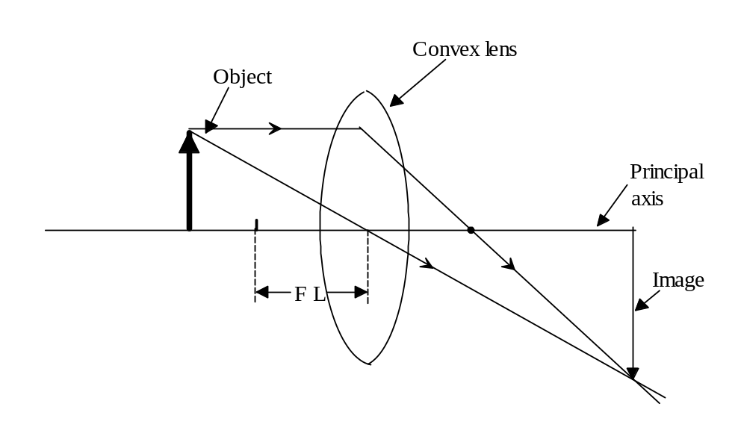
11a The light is totally internally reflected along the length of the optical fibre. The incident ray is always meeting the surface at an angle greater than the critical angle for that medium.

b
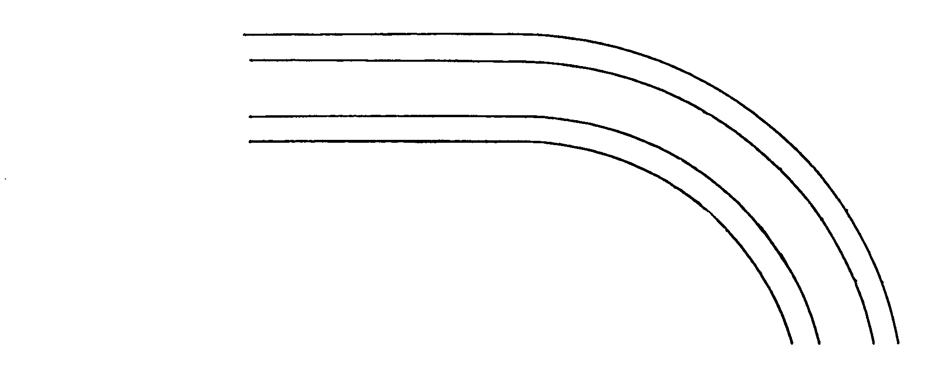
Exterior
cladding
Ray of
light entering
optic fibre

- energy at top of loop = 2.7 J

potential energy required at A is 100 / 90 x 2.7 = 3.00 J

Energy at A = m g h = 3.00 = 0.1 x 9.8 x h

h = 3.00 / 0.1 x 9.8 = 3.06 m

13a Coloured glass will only transmit the colour of light which matches the colour from which it is made. i.e. red glass transmits red light. The appearance of colour relies upon light being transmitted through the glass and reaching our eyes.

b Opaque objects appear the colour they are because of the light they reflect. A red object will appear red only under red light or light which contains red light ie. white light.

14a All the pots have the same heat capacity because they are all made of the same material.

b Pot A because it has the smallest mass.

c Pot D because it has the largest mass.

15a P = I x V
1 250 = I x 240
I = 1 250 / 240
= 5.21 A

b cost = number of kW h x 14.1
= (1.250 x 2) x 14.1
=35.3 cents

Section B

1a
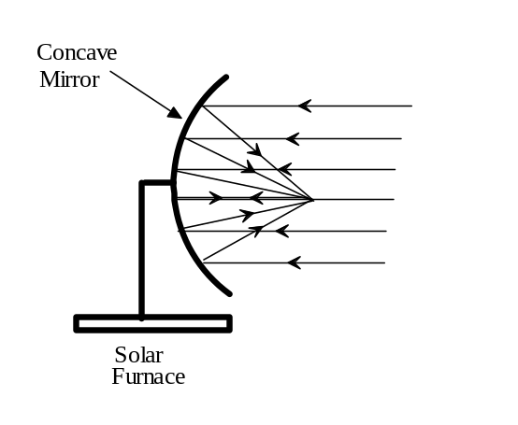
b A concave mirror is used because it is able to focus the light (heat) rays at a point. A convex
mirror is a diverging mirror so it would disperse the rays and not concentrate the heat at a point.

c A parabolic mirror is capable of focusing the rays which are incident on the edges of the mirror
to a point, thus avoiding spherical aberration. A concave mirror would produce spherical
aberration in which not all the incident rays would be focused to a point.

d No. Some of the energy would be absorbed by the mirror and the mirror would become hot. The heat absorbed by the mirror may be re-radiated through the back of the mirror.
Spherical aberration also means that not all rays would be focused at a single point on the food.
e Q = m x c x ΔT
Q = 2 x 4 200 x (80 - 20)
Q = 5.04 x 10⁵ J

1 500 x T x 0.5 = 5.04 x 10⁵
T = 672 s if it is 100% efficient.

If it is only 95% efficient then 672 x (100/95) = 707 s

It would take 11.8 min

2a(i) The thickness of the plastic sheet has changed so the detector is receiving more radiation due to the sheet becoming thinner.

- Aluminium sheeting would offer minimum necessary protection as beta radiation cannot usually penetrate aluminium.

b(i) The half life is 5 years (Students would need to take several half lives from the graph and find the average to be awarded full marks for this question.)

- Yes the source would be suitable because there is a considerable difference in count rate for different thicknesses and the half life is long enough so the source would not need to be changed too frequently.

- No. Alpha particles do not have a very strong penetrating ability so the plastic sheet would not allow penetration of the particles to give a reading on the detector.

3a(i)
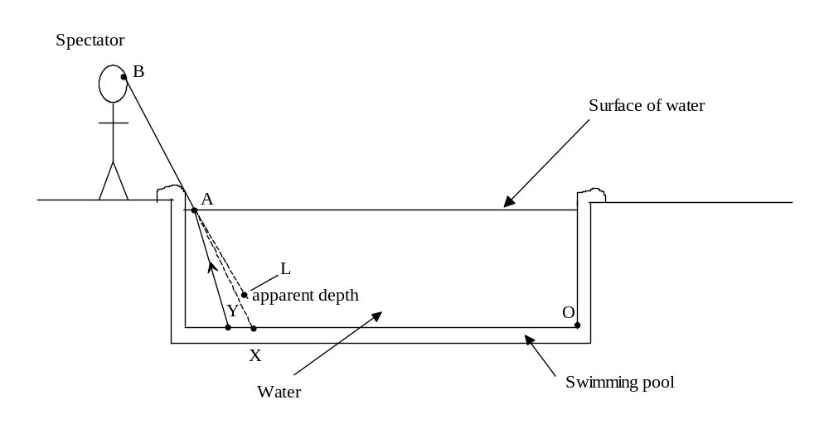
A ray of light originating at Y will be refracted at the surface so it follows the path AB to the spectator’s eye. Similarly any point between X and Y can be seen in this way. Light originating at point O may not be seen because depending on the spectator’s line of sight, the ray may be totally internally reflected.

- c = f x λ
c = 5.77 x 10¹⁴ x 3.82 x 10⁻⁷
= 2.20 x 10⁸ m s⁻¹

- n = c_{o} / c_{w}

n = 3 x 10⁸ / 2.2 x 10⁸

n = 1.36

- See diagram above.

3b 1/f = 1/u +1/v

1/0.05 = 1/u + 1/0.066

1/u = 1/0.05 - 1/0.066

u = 21 cm

So the object needs to be placed 21 cm from the lens to produce a focused image on the film.

4a acceleration

b constant speed

c The parachute opens at a time of 20 s after its release.

d 5.0 m s⁻¹

e acceleration = (20 - 110) / (35 – 22) = - 7 m s⁻²

f Distance travelled = 10 x 5 = 50.0 m

5a
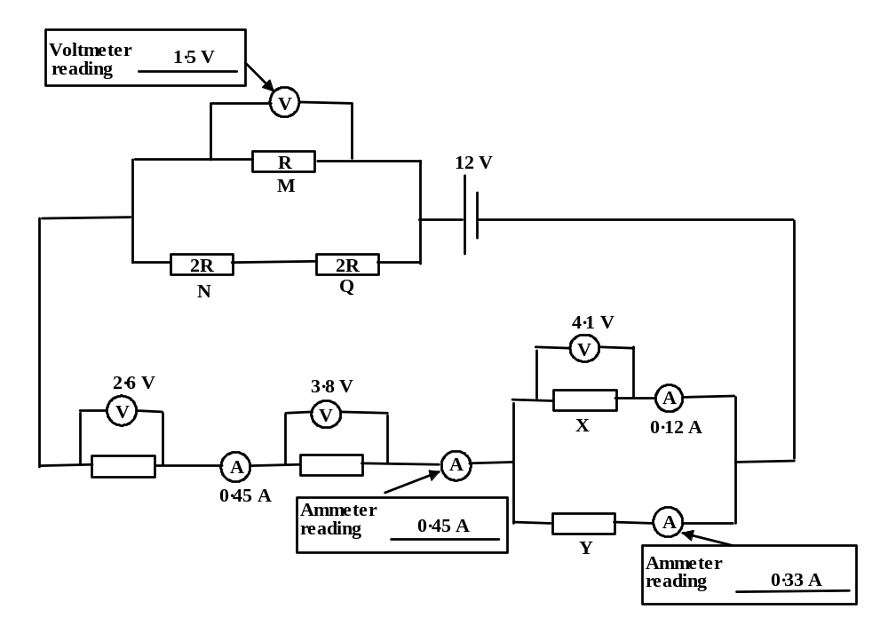

b R_{x} = 4.1 / 0.12 = 34.2 Ω

c Q = I x t
Q = 0.33 x 5.0 x 60 = 99 C

d V = I x R
1.5 = 0.45 x R

R = 3.33 Ω

e 1/R _{total} = 1/R +1/4R = 5/4R
so R _{total} = 4R/5 = 3.33

4R = 16.65
so the resistance of R is 4.2 Ω

f Ratio of current flowing through the two branches of resistors is 1 : 4

Total current is 0.45 A so the current through N is 0.09 A

g Energy = I x V x t
1.4 x 10⁶ = 0.45 x 12 x t
t = 1.4 x 10⁶ / (0.45 x 12)
time is 2.59 x 10⁵ s = 72 h

6a The area under the graph represents impulse OR change in momentum.

b An airbag, seat belt or crumple zones built into the car could have saved the driver from injury.

c The area under the curve represents the change in momentum. A triangle can be assumed which will give a good approximation of the value.
p = m(v - u) = 0.5 x 80 x 10⁴ x 0.1 = 4.0 x 10⁴ kg m s⁻¹

p = 1.2 x 10³ (v - 0) = 4.0 x 10⁴

v = 4.0 x 10⁴ / 1.2 x 10³

velocity is 33.3 m s⁻¹ compared to the speed limit of 28 m s⁻¹ (100 km h⁻¹) so the car was exceeding the speed limit.

d Weight of car is 1.2 x 10³ x 9.8 = 11 760 N

Maximum safe load crane can lift = 1.4 x 10⁴ N
1.4 x 10⁴ = 11 760 + (1.2 x 10³ x a)
a = (14000 - 11 760) / 1200

Safe acceleration of the lifting crane = 1.87 m s⁻²
7a
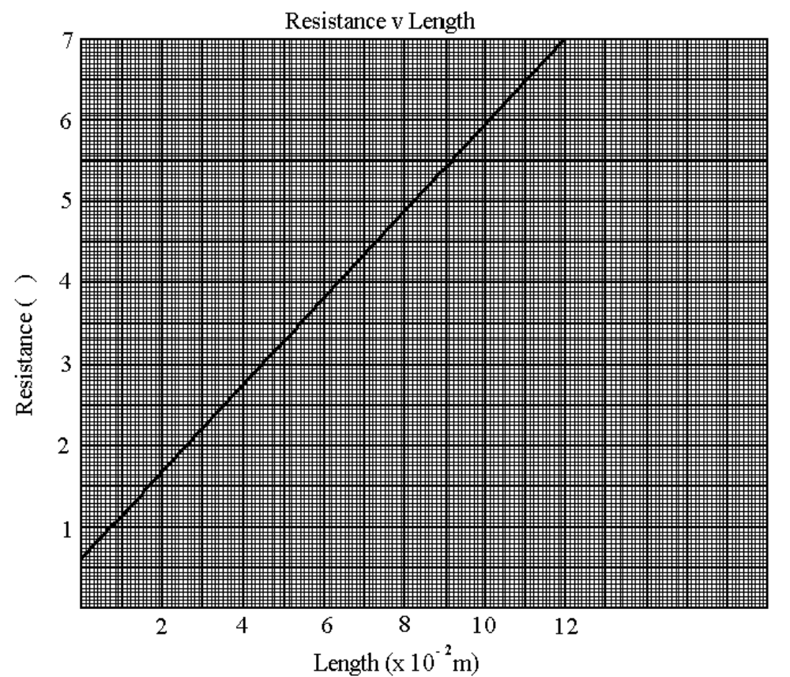
(Ω)
b R = 53 l + 0.7 (in the form of y = mx + b)

c The gradient is 5.3 / 10 x 10⁻² = 53

d The y intercept is 0.7

e 53 = ρ / (Π x (10⁻³)²)

ρ = 53 x Π x 10⁻⁶

ρ = 1.66 x 10⁻⁴ Ω m

The resistivity is 1.66 x 10⁻⁴ Ω m

The value of R_{o} is 0.7 Ω

Section C

Question 1 Smoke Detectors

- When air molecules become ionised an electron is separated from the gaseous molecule resulting in a positively charged ion and a negative electron.

- Negative ions are attracted to the positive electrode.

- The smoke particles absorb the alpha particles.

- All the radiation is stopped within a few centimetres of air so within that small region it is intense. Smoke would not stop β or γ reaching the detector.

- An alpha particle is actually a nucleus of helium.

- Half life is the time taken for half of the radioactive substance to decay into a non radioactive substance or a different radioactive nucleus, or for the original substance to have its activity reduced by half.

- The radioisotope used in smoke detectors should have a long half life so the device can be used for many years without replacing the radioisotope.

- Alpha particles are stopped by a few centimetres of air and certainly by the plastic cover so the particles are contained within the detector and are harmless in a domestic situation.

Question 2 - Calculating Heat Loss

1 (i) Joules per second (J s⁻¹)

(ii) Joules per second per metre ² per celsius degree (J s⁻¹ m⁻² ºC⁻¹)

2 Double brick wall with cavity insulation / plaster

- Heat loss depends upon the difference in temperature between two situations.
The greater the temperature difference the greater the rate of heat loss. The difference in temperature is greater between inside and outside than it is between rooms within a house.

4 (i) P = U x A x ΔT

P = 3.24 x ( 2.5 x 5.0 x 4) x (20 – 5)

P = 2.43 x 10³ J s⁻¹

P = 5.6 x (1.5 x 2.5) x (20 - 5)

P = 315 J s⁻¹

5 The likely cause of dampness and condensation in a room could be due to people breathing, water evaporating due to cooking, large ranges in temperatures overnight, an evaporative cooler operating in a room, a gas heater.

6 The kitchen usually has cooking facilities which would produce heat and cooking odours which need to be removed. A bedroom would not be a place where there is excessive heat or odours.

7 Air is a very good insulator so if it is trapped between two layers of glass it will reduce the quantity of heat being conducted through the window.

8 The U value for a ceiling could be reduced by insulating the cavity between the roof and
the ceiling with a suitable insulating material such as fibre glass, wool or aluminium foil.

