These test papers are copyright and must not be reproduced in any way.
©
This paper should be withdrawn after use in the examination or classroom and retained by the teacher until Friday 9th December.
Test papers may not be used for private tutoring in the year of publication.



PHYSICS

YEAR 11

2005

INSTRUCTIONS TO CANDIDATES

TIME: 2½ Hour Paper: MARKS: 160

Attempt questions 1 to 15 Section A
Attempt questions 1 to 6 Section B
Attempt question 1 Section C

TIME: 3 Hour Paper: MARKS: 200

Attempt ALL questions

STRUCTURE OF THE PAPER

Section | No. of  Questions | No. of questions  to be attempted | No. of marks  out of 200 | Proportion of  exam total
A: Short Answers | 15 | ALL | 60 | 30%
B: Problem Solving | 8 | ALL | 100 | 50%
C: Comprehension and  Interpretation | 2 | ALL | 40 | 20%

Note: Above refers to 3 hour paper. For less than 3 hours refer to front cover.

INSTRUCTIONS TO CANDIDATES

Write your answers in the spaces provided beneath each question. The value of each question (out of 200) is shown following each question.

The enclosed Physics: Formulae and Constants Sheet may be removed from the booklet and used as required.

Calculators satisfying conditions set by the Curriculum Council may be used to evaluate numerical answers.

Answers to questions involving calculations should be evaluated and given in decimal form. Quote the final answer to not more than four significant figures. Despite an incorrect final result, credit may be obtained for method and working, providing these are clearly and legibly set out.

Questions containing specific instructions to show working should be answered with a complete, logical, clear sequence of reasoning showing how the final answer was arrived at; correct answers which do not show working will not be awarded full marks.

Questions containing the instruction "Estimate" may give insufficient numerical data for their solution. Students should provide appropriate figures to enable an approximate solution to be obtained.

Section A: Short Answers

Marks allocated: 60 marks out of a total of 200 (30%)

Attempt ALL 15 questions in this section. Each question is worth 4 marks.
Answers are to be written in the space below or next to each question.

- 1 Use one (or more) of Newton’s Laws to explain why:
      - a). When two stationary ice skaters push against each other they move off in opposite directions.

  - b). You feel yourself being pushed back into your seat when the car or bus accelerates.

- 2 A bowler bowls a 145.0 g cricket ball due south towards the batter at 105 km h⁻¹. The batsman hits the ball due north at 85.0 km h⁻¹. What is the change in the cricket ball's momentum? (You must give magnitude and direction.)

3 Explain why the plutonium in a nuclear bomb is in the form of several small, well separated, lumps, and why and how this arrangement is changed to cause an uncontrolled chain reaction that leads to an explosion.

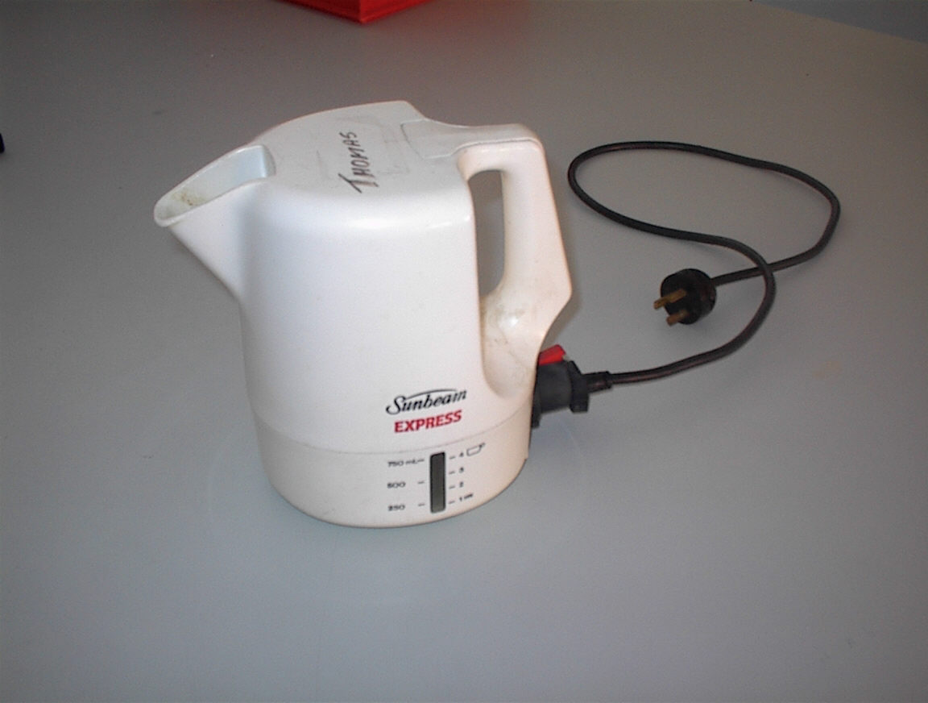
- Estimate the quantity of electrical energy required to bring to the boil 2 L of tap water in an electric jug which is 60% efficient.

5 A small potato is taken out of boiling water, where it had come to equilibrium at 100 ºC, and placed in a calorimeter containing water at 0 ºC. The mass of` the potato is equal to the mass of water and the specific heat capacity of the potato is about half that of the water. Ignoring any transfer of thermal energy to the container, estimate the equilibrium temperature of the potato and water?

6 Radon has a half life of 3.80 days. How long will it take a sample of radon-222 of mass 2.00 g to reduce to 0.125 g?

7 Pressurised spray cans, such as insecticide, contain a highly volatile liquid under pressure, in equilibrium with the gas in the space above. As the nozzle of a spray can is held down gas is allowed to escape into the atmosphere, which is at a lower pressure. As this occurs the can becomes cooler. Explain why.

- A gauge is used to monitor the thickness of a polythene sheet produced in a factory, as shown below.

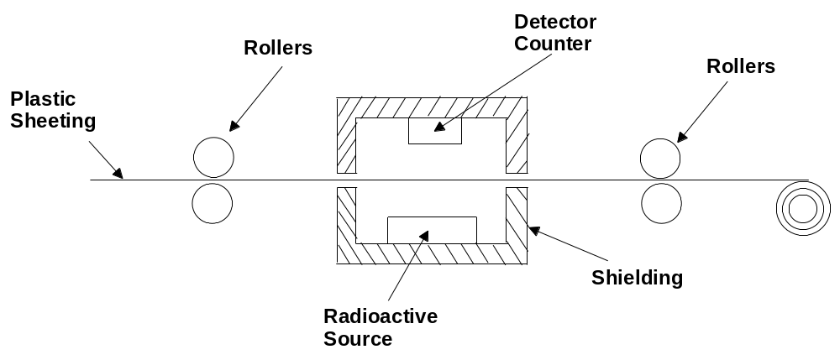

The radioactive source emits β-particles.

- How is the number of β -particles recorded by the counter used to detect variations in the thickness of the polythene sheet?

- Why would neither alpha nor gamma radiation be suitable for use in this thickness gauge?

- 9 A ray of light passes from water (n = 1.33) into glass (n = 1.53) at an angle of incidence of 37°. Add the path of the ray of light to the diagram below, clearly labelling the direction, then determine the angle of refraction for the light ray.
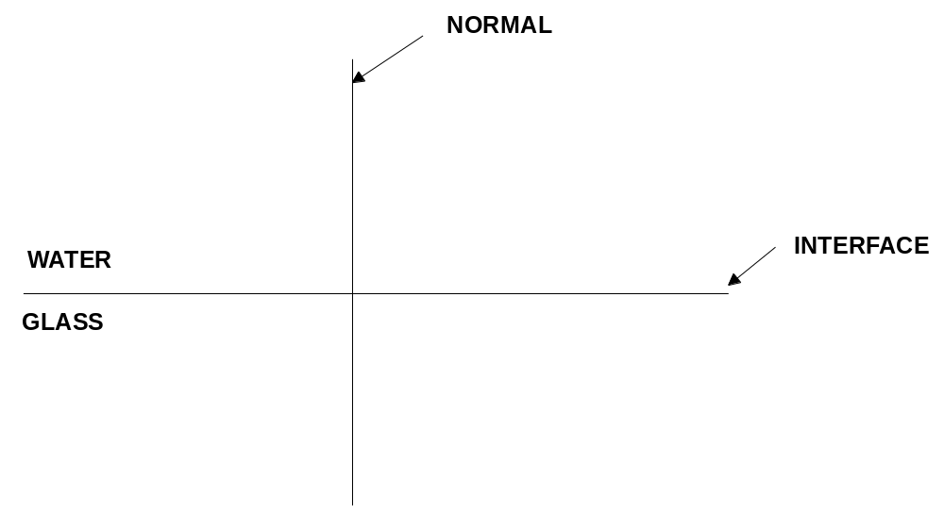

10 A worker loading goods onto a storage platform that is above the ground, slides a box filled with sawdust up a ramp, inclined to the horizontal. See the diagram below.
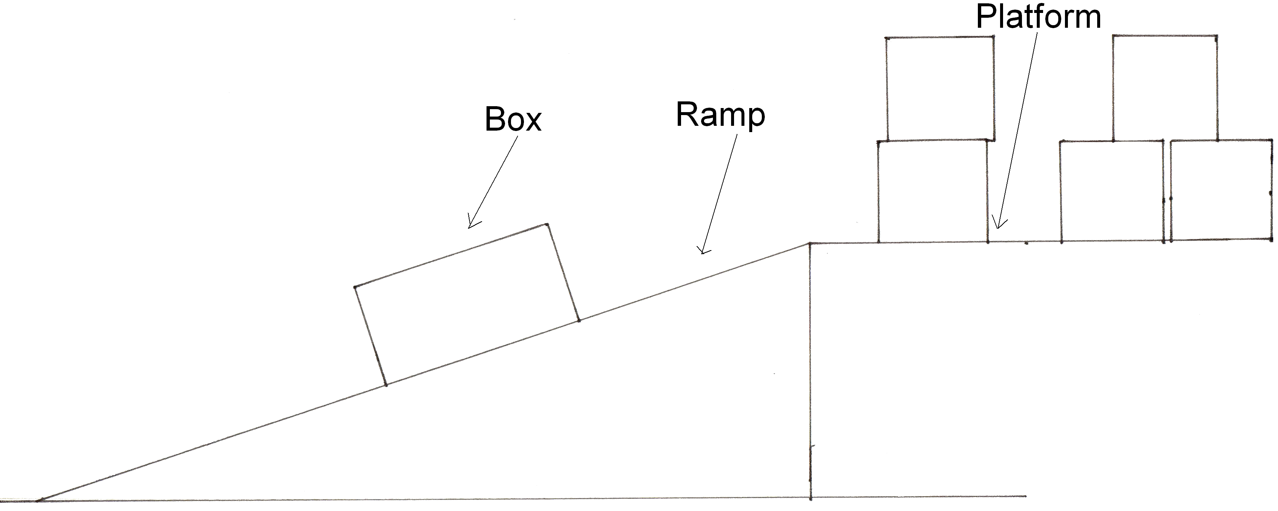

a) On the diagram above draw an arrow to show the direction of the frictional force opposing the movement of the box. Label the arrow (F). (1 mark)

(b) On the same diagram draw an arrow to show the weight of the box. Label the arrow (W) (1 mark)

(c) On the same diagram draw an arrow to show the direction of the minimum force a worker would need to exert to slide the box up the ramp. Label the arrow (M). (2 marks)

- 11 A class of students was asked to determine the type of glass from which a slab of glass was made. Seven different groups made careful measurements of the angle at which total internal reflection just occurred within the slab.
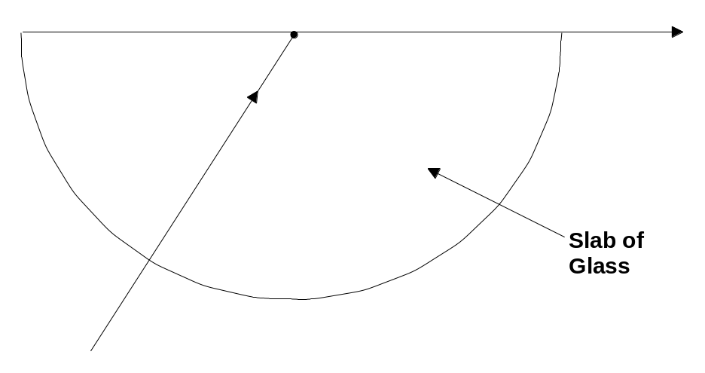

Readings from the seven groups were as follows: 41.4, 41.0, 41.3, 41.2, 40.0, 43.0, 41.0.

A table of refractive indices for different types of glass is shown below:
Lead crystal | 1.693 | Sheet glass | 1.510
Light flint | 1.578 | Borosilicate | 1.458

- From these data determine the most likely type of glass from which the sample is made.

- 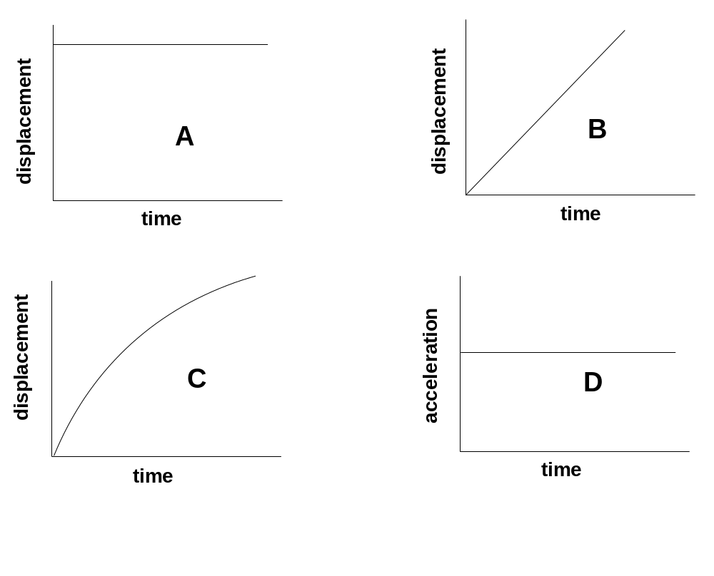12 From the graphs represented below (A-D), depict four events involving motion. Match the appropriate graph to the description below.

Event | Graph(s) that represent  the event
a. A parked car.

b. A car moving at a constant
velocity along a straight road.

c. A bus accelerating uniformly from
a standing start.

d. The brakes of a train bring the train
to rest with a uniform deceleration.

13 A beam of white light enters a triangular prism (as shown in the diagram below), and emerges as a divergent series of monochromatic rays.
  - a). Complete the diagram, labelling the violet and red end.
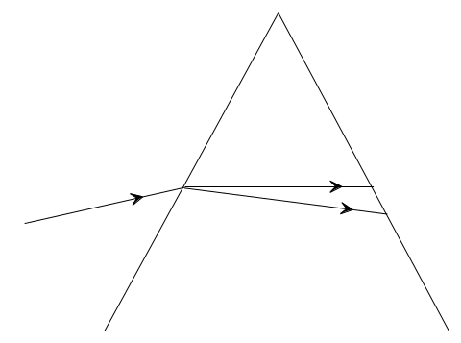

  - b). State simply why this occurs, and the name given to it.

14 2.0 kg of water at 25.0°C is placed in a refrigerator where it cools to 4.0ºC in a period of 1.5 h.

Calculate:

a) the energy lost by the water as it cools to 4.0°C.

(b) the power output of the refrigerator required to cool only the water.

- 15 A portable stereo runs off four 1.50 V cells connected in series. The total resistance of the stereo when used to play music is 18.0 Ω.
  - a) How much current does the stereo draw from the cells?

      - b) If it is used for half an hour how much charge flows through the electric circuit of the stereo?

Section B: Problem Solving

Marks allotted: 100 marks out of a total of 200 (50%)

This section contains 8 questions.

You should answer: ALL of the questions 1, 2, 3, 4, 5, 6, 7 and 8

Answer the questions in the spaces provided.

- 1 (14 Marks)
A thermodynamics student heated an 11.3 kg sample of a solid in an insulated container in which an electrical heating coil supplies heat at a rate of 255.0 W.
She measured the temperature of the substance at one minute intervals. The following graph shows the changing temperature over 14.0 minutes.

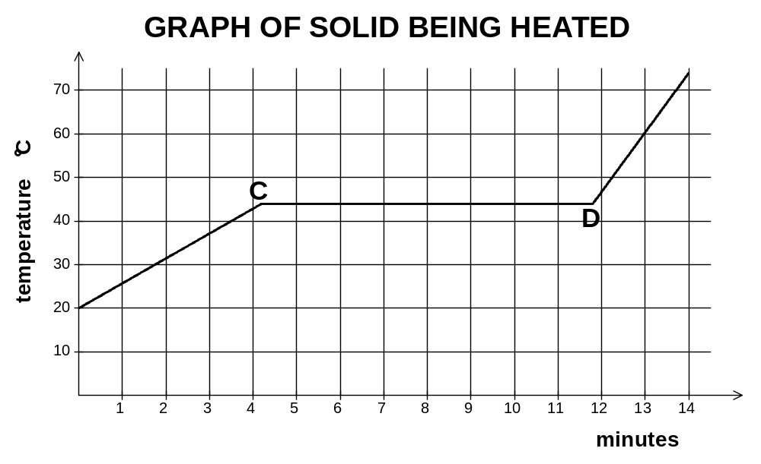

(a) What is the melting point of the solid? (1 mark)

(b) What phase(s) is/are present between points C and D on the graph? (1 mark)

(c) Once the melting point was reached, how long did the solid take to become completely liquid? (1 mark)

- (d) How much heat energy was absorbed while the solid was melting? (3 marks)

(e) Calculate the latent heat of fusion for the substance. (2 marks)

- (f) Which is greater, the specific heat of the solid or that of the liquid? Explain without using a
- calculation (2 marks)

(g) Calculate the specific heat for the substance in the solid phase. (4 marks)
2. (12 Marks)

Carbon-14 is formed in the upper atmosphere by the interaction of nitrogen and cosmic rays that results in the N-14 atom of 7 protons and 7 neutrons absorbing a high speed neutron and ejecting a proton, hence being transformed into a C-14 atom of 6 protons and 8 neutrons.
Living creatures take in C-14 as part of the carbon in their CO₂ intake (plants) or food intake (animals).
The decay curve for a typical sample of C-14 is given below.
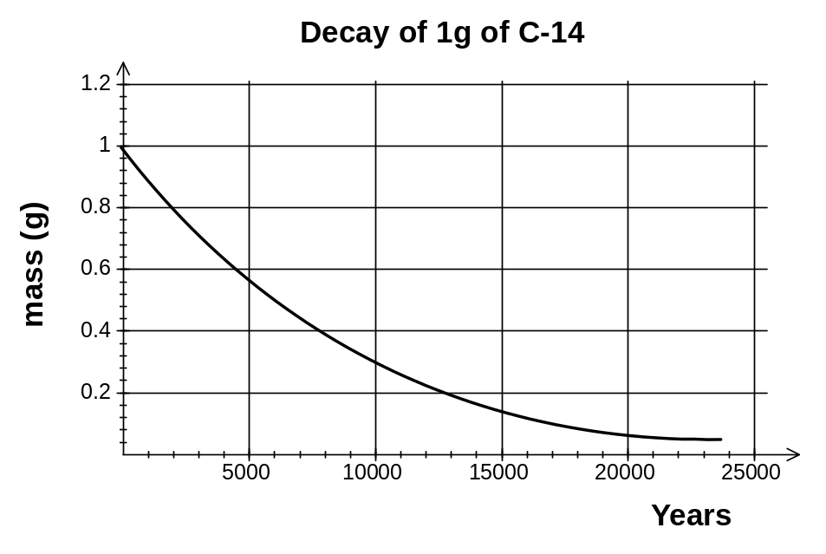

- (a) Write an equation to show the process involved in the formation of C-14. (2 mark)

(b) From the graph above estimate a value for the half-life of C-14. (1 mark)

(c) Based on your estimate of half-life for C-14, estimate the age of a spoon found in an Egyptian tomb if one gram of carbon from the spoon yields 117 counts on a Geiger tube in one hour, given that a the same amount of carbon from a modern spoon has an activity of 0.26 Bq. (3 marks)

(d) Explain why it is necessary to use the spoon from the tomb to date the age, rather than gold or rock carvings found together with the spoon. (2 marks)

(e) An average diet would see a person consume 100 g of carbon per day. Given that C-14 undergoes beta decay, and comprises less than 0.001% of the mass of naturally occurring carbon, estimate the dose equivalent that an average person would receive every day as a result of their diet, given that a beta particle has an energy of approximately 5x10⁻²⁰ J. (4 marks)

3 (15 marks)
Lenses allow light to be focused to form a clear image of objects.
(a) Show how this is achieved by completing the ray diagram below. (3 marks)
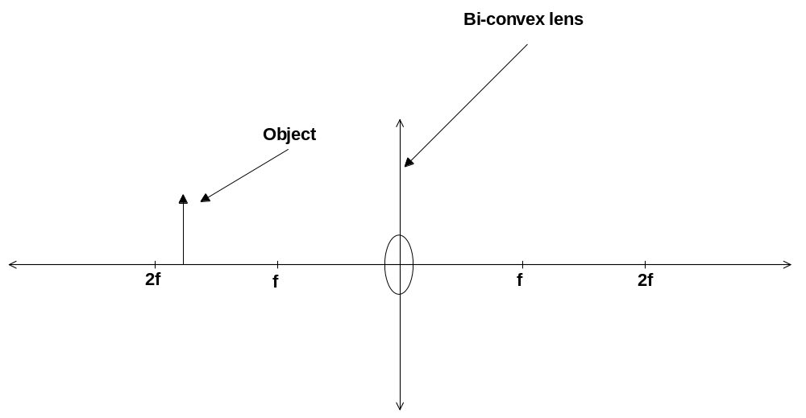

(b) Calculate the distance the image would appear to be away from the lens given that the object is placed 8.0 cm away from a lens of focal length 5.0 cm. (3 marks)

(c) Describe the nature of the image using the usual descriptors (3 marks)

Lenses are used in many applications including the correction of visual defects in people. Myopia (short sightedness) is one such defect that may be corrected by the use of the appropriate lens.

(d) Explain what myopia is and what may cause the condition. (3 marks)

(e) Use the diagram of an eye below to show how the use of an appropriate spectacle lens may alleviate the symptoms of myopia. Clearly show the path of light rays before and after the lens is used. State the type of lens that is used. (3 marks) 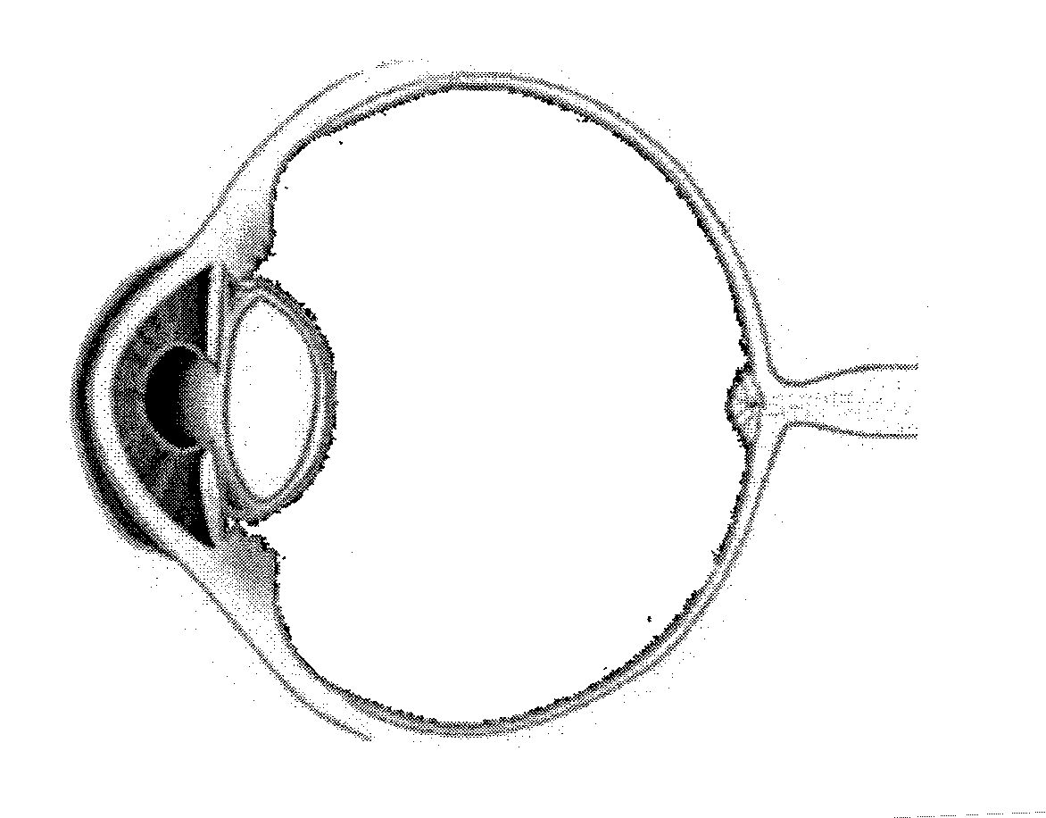

- 4. (10 Marks)

A school girl, whilst playing tennis, returned a tennis ball weighing 57.0 g, which was travelling towards her horizontally at a speed of 17.5 m s-1, back towards her opponent at the same height with a speed of 22.5 m s-1. The ball leaves the tennis racquet horizontally at a height of 0.950 m above the ground. You can assume air resistance has no effect on the ball.

- (a) If the impact took 0.05 s, what acceleration does the ball experience? (Specify magnitude and direction) (3 marks)

(b) What magnitude of impulse was provided by the racket to the ball? (3 marks)

(c) Given that the player hit the ball horizontally, there will be no initial vertical component of velocity. As such she will not hit the ball above the net. If the tennis net is 91.4 cm tall at the centre strap, how fast must she hit the ball horizontally in order to clear the net if she hits the ball from 12.0 m away? Justify your answer with a calculation, and comment on whether this is a realistic value. (4 marks)

- 5. (17 Marks)

A group of physics students were asked to find the value of the resistance of a device in a circuit.
The table below shows the generated results.
Potential difference (V) | 1.2 | 1.8 | 2.2 | 3.0 | 3.4 | 3.7 | 4.2 | 4.8
Current (mA) | 140 | 210 | 256 | 350 | 410 | 430 | 490 | 560

- (a) Using correct symbols draw a circuit diagram to show a simple experimental setup the students were likely to have used to have attained the data above. (4 marks)

(b) Graph the data on the axes below and comment on what information the shape of the graph provides. (5 marks)



(c) Show working to calculate the resistance of the device as determined in the experiment.
(3 marks)

(d) Would it be safe to assume that the resistance of the circuit would remain constant above 5.0 V? Explain. (2 marks)

(e) If the battery stores 100.0 C of charge, how long will the circuit operate at 4.0 V. (3 marks)

6 (12 marks)
The movement of a train travelling on the Perth –Fremantle line is analysed and graphed. It takes 3.0 minutes for the train to travel between two stations on the line. Study the graph and answer the questions that follow.
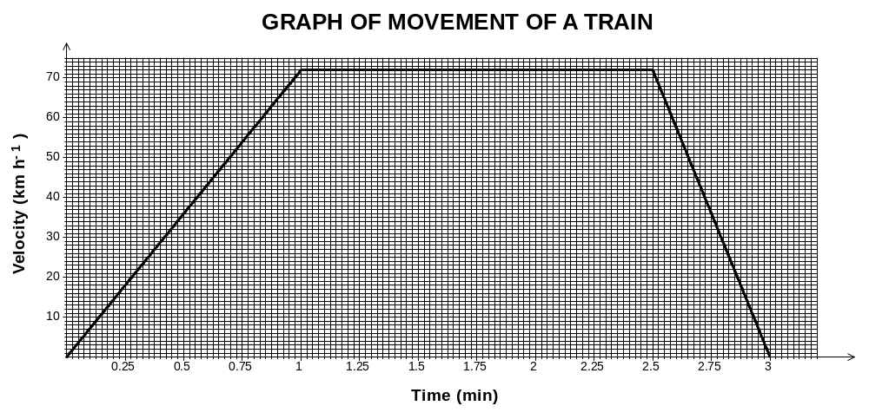

(a) How can you tell that the train is undergoing acceleration for the first minute of the journey? (1 mark)

(b) Is the acceleration uniform? Explain your answer? (2 marks)

(c) What is the value of the train’s acceleration during the first minute of the journey? (2 marks)

(d) How would you describe the train’s movement during the second minute of its journey (1 mark)

(e) How would you describe the train’s movement during the final 30.0 s of its journey (1 mark)

(f) What maximum velocity does the train reach in metres per second? (2 marks)

(g) What is the distance between the two stations? (3 marks)

7 (11 marks)
One tiny metal ball, Ball A, carries a charge of +5 nC. A second ball, Ball B, of identical size, shape, and material, has a charge of -15 nC. The balls are suspended 30.0 mm apart.
- (a) Draw the electric field associated with the spheres. (2 marks)

(b) What is the size of the force between the balls? Is it attraction or repulsion?
(4 marks)

- The balls are brought together and touched. Explain what happens to the charge and why. (3 marks)

- (d) The balls are then separated again to a distance of 30 mm. What now is the size of the force between the balls? Is it repulsive or attractive? (2 marks)

8 (9 marks)
A student sets up a circuit represented by the circuit diagram below.
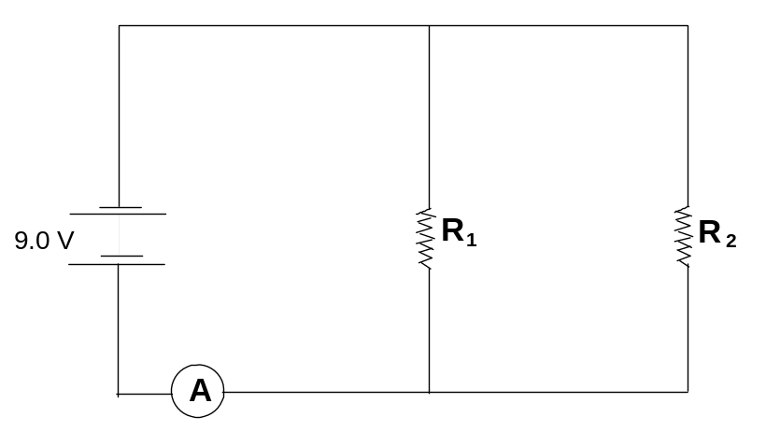

The reading on the ammeter is 1.35 A. The resistance of R ₂ is 10.0 Ω but the resistance of
R ₁ is unknown.
(a) Calculate the current flowing through R ₂. (2 marks)

(b) Calculate the current flowing through R ₁. (1 mark)

(c) Calculate the resistance of R ₁. (3 marks)

(d) Calculate the effective resistance of the circuit. (3 marks)

Section C: Comprehension and Interpretation

Marks allotted: 40 marks out of 200 (20%)

BOTH questions should be attempted. Each question is worth 20 marks.

Read each passage carefully and answer all of the questions at the end of each passage.
You are reminded of the need for clear and concise presentation of answers. Diagrams (sketches), equations and /or numerical results should be included as appropriate.

Question 1

(Paragraph 1)
A radical way to use the water in a lake to cool a city has been suggested by a scientist working in the field of energy conservation. He is suggesting that by piping the water from a nearby lake he can reduce the overall annual power usage of a 600MW power station, by more than 40 megawatts and greenhouse gas emissions by nearly 40,000 metric tons for a city of 1.5 million people. This is equivalent to taking 8 000 cars off the road.
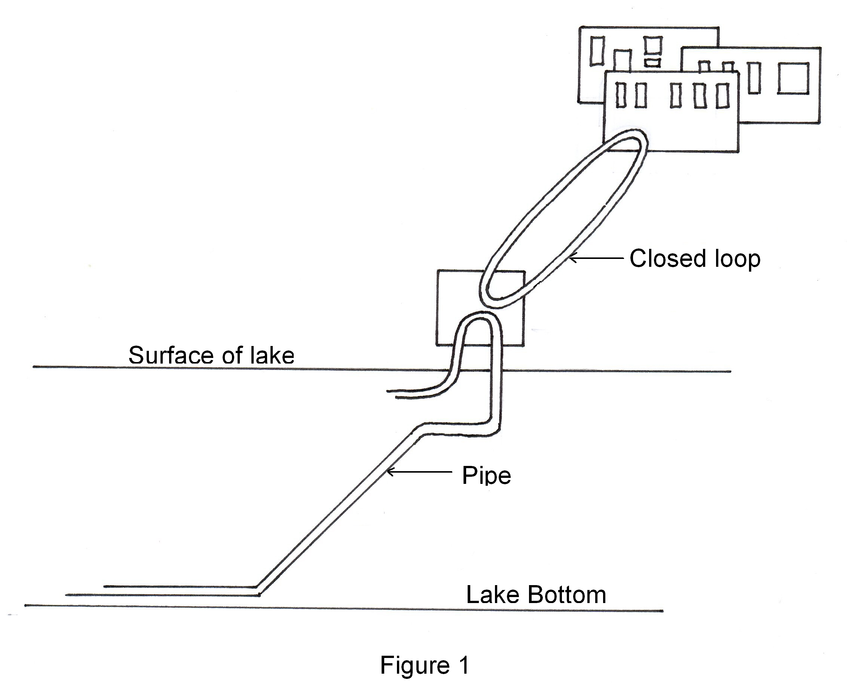

(Paragraph 2)
The new system is an example of Deep Lake Water Cooling (DLWC), an alternative to air-conditioning systems dependent on fossil fuels and electricity. The process relies on a simple premise: heat flows from hot to cold. A closed loop of chilled water flows through buildings, taking with it heat removed by air conditioning. Often expensive chillers use refrigeration to remove this excess energy but with the DLWC a cold lake could remove the heat. In a model to demonstrate the system a smaller lake near a university was used to cool the buildings on campus. In the demonstration water drawn from the lake was between 4 and 5 ºC but when it returned it was slightly warmer, averaging about 8 ºC during winter and 13 ºC in summer. This has resulted in a decrease in energy utilization for air conditioning by 10% .

(Paragraph 3)
The full scale project would be more ambitious in scope. Water would be removed from 80 meters below the surface of a lake and pumped through a pipe to a filtration plant. From there it travels through heat exchangers to chill the closed water-supply loop that is distributed to households.

(Paragraph 4)
When it was first proposed the idea met with opposition from environmentalists who questioned the potential effects the system would have on a lake’s ecosystem. Any system that used natural resources would be subject to an analysis that would consider the advantages and disadvantages. The proponents of the system are confident that the benefits to the community are superior to any disadvantages the environment would suffer.

Questions
- (para 1)
If a 600 megawatt electricity plant burns 4 000 tonnes of coal per day, estimate how much coal would be saved annually if a DLWC facility is fully operational (5 marks)

- (para 1-2)
How much water would be needed to be cycled through a system each day in order to achieve power reduction of 40 MW quoted in paragraph 1, assuming that heat transfers are 100% efficient? (Calculate based on summer conditions). (5 marks)

3 (para2)
Explain with reference to heat flow, why would water return to a lake warmer in summer than in winter? (2 marks)

4 (para 3)
What would be the purpose of a heat exchanger in the proposed system? (2 marks)

5 (para 1-3)
Why is water coolest on the bottom of a lake, and why does it stay at one temperature all year round? (3 marks)

6 (para 5)
Where will heat removed from buildings end up? (1 mark)

7 [Figure 1]
On the diagram below place the following labels: (2 marks)
Heat exchanger
Intake pipe
Chilled water
Outlet pipe

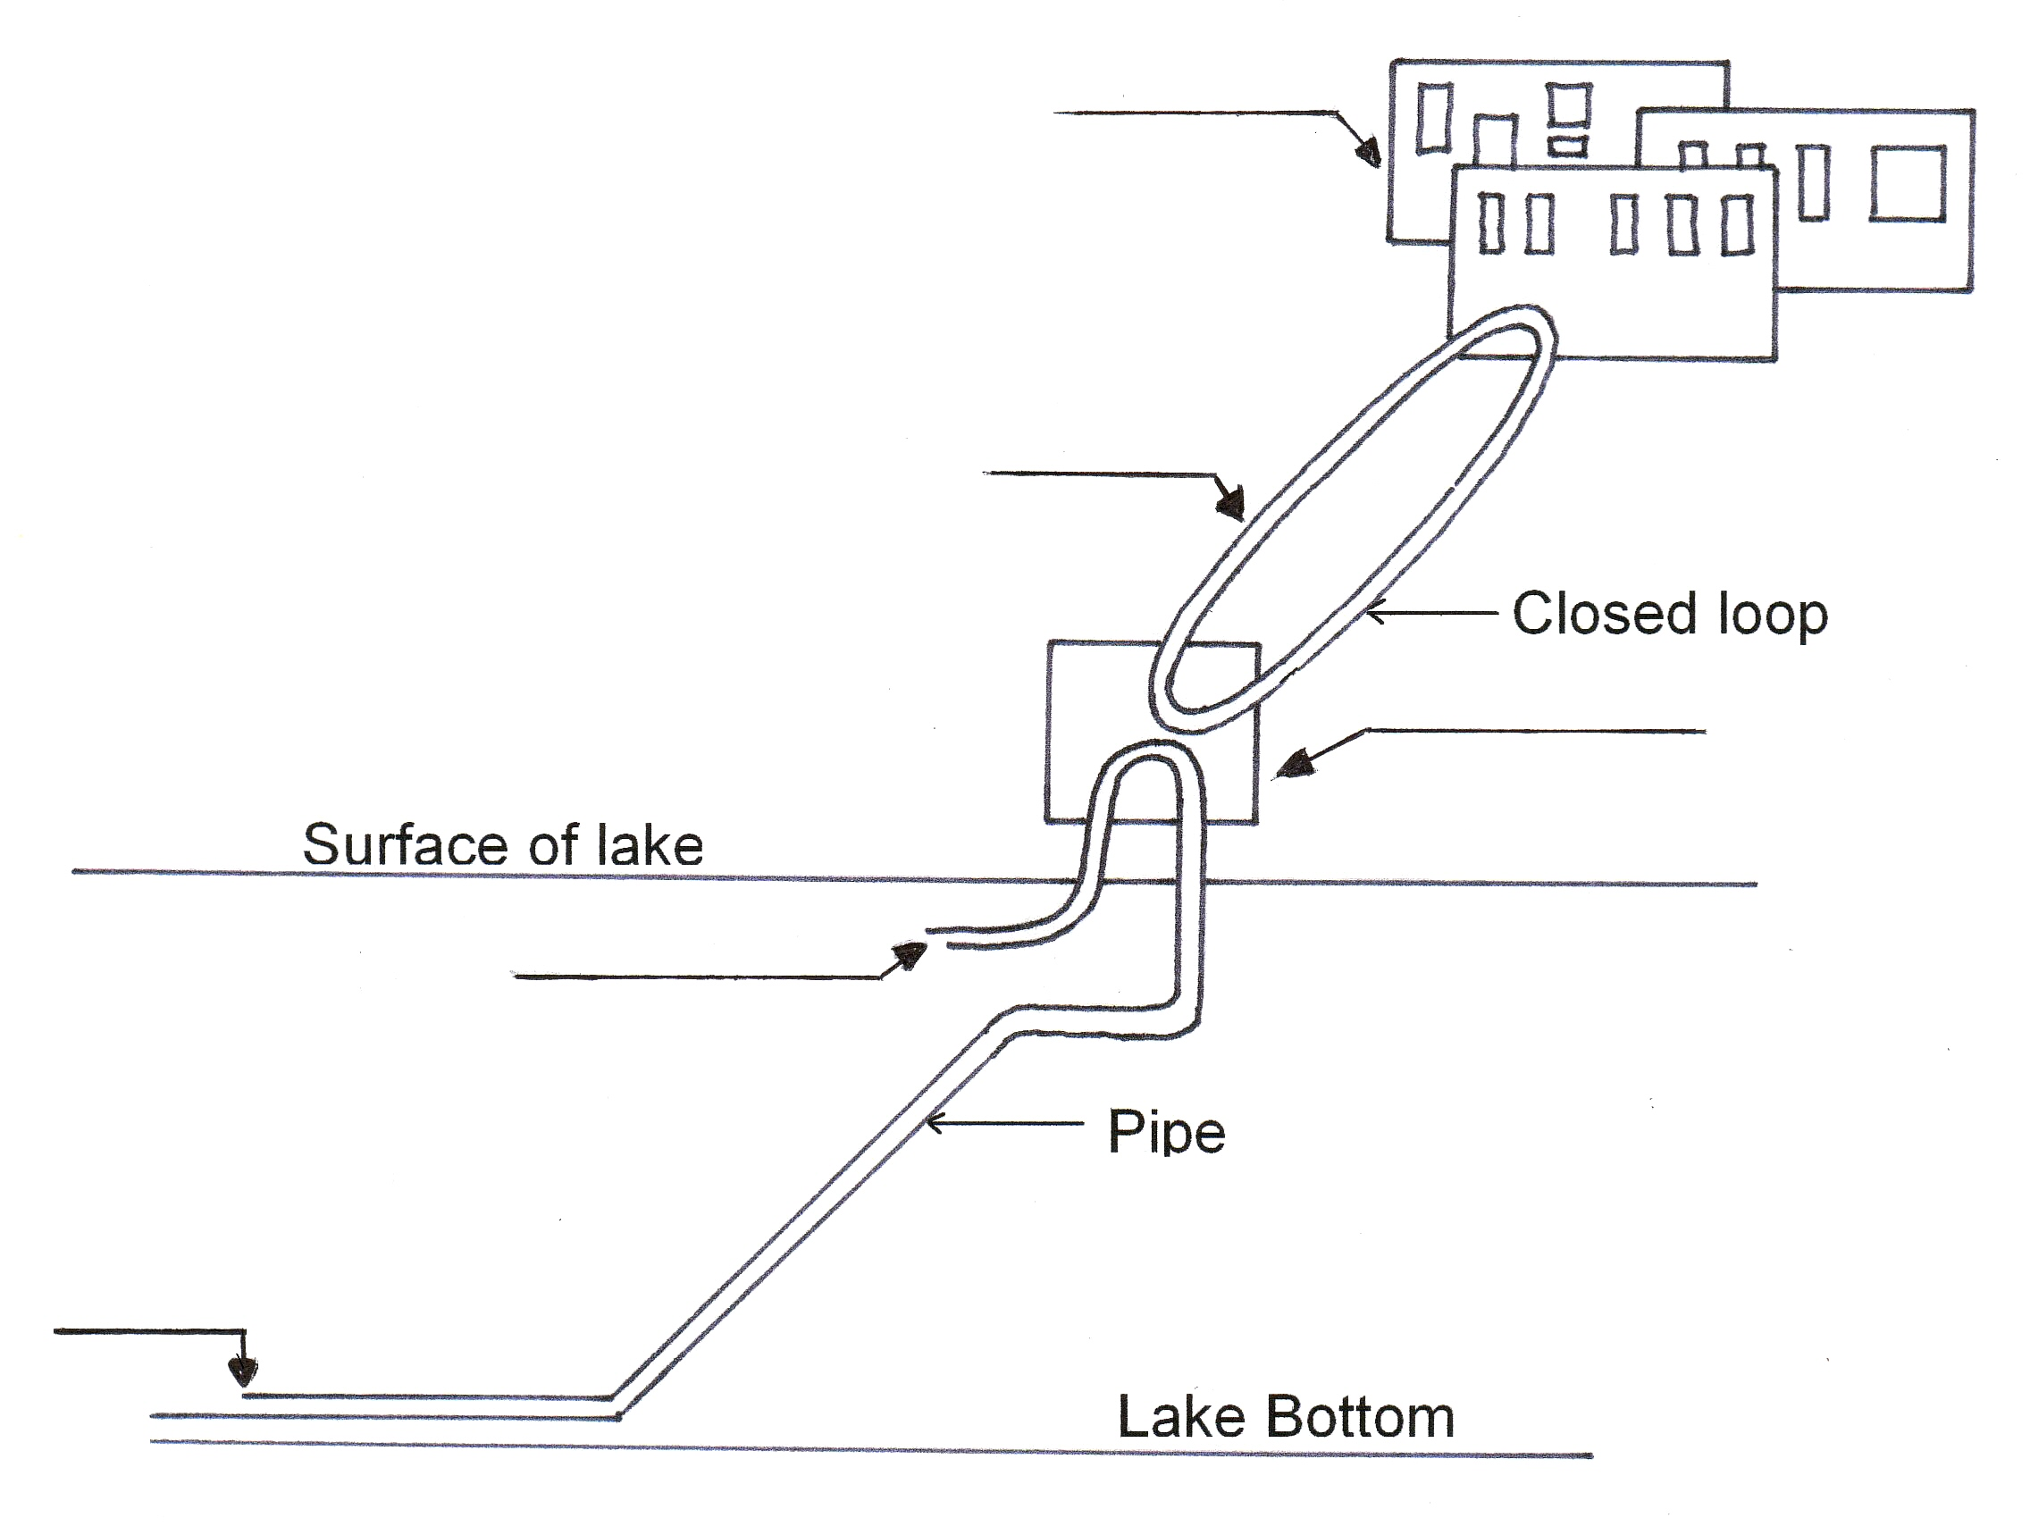

Question 2

FOOD IRRADIATION

(paragraph 1)
Each year a few hundred thousand tonnes of food products and ingredients are irradiated worldwide. This amount is small in comparison to the total volumes of processed foods and not many of these irradiated food products enter international commerce.

(paragraph 2)
The type of radiation used in processing materials is limited to radiations from high energy gamma rays, X-rays and accelerated electrons. These radiations are also referred to as ionizing radiations because their energy is high enough to dislodge electrons from atoms and molecules and to convert them to electrically-charged particles called ions.

(paragraph 3)
Only certain radiation sources can be used in food irradiation. These are the radionuclides Cobalt-60 or Cesium-137; X-ray machines having a maximum energy of five million electron volts (5 MeV) (an electron volt is the amount of energy gained by an electron when it is accelerated by a potential of one volt in a vacuum); or electron accelerators having a maximum energy of 10 MeV. Energies from these radiation sources are too low to induce radioactivity in any material, including food.

(paragraph 4)
The radionuclide used almost exclusively for the irradiation of food by gamma rays is Cobalt-60. It is produced by neutron bombardment in a nuclear reactor of the metal Cobalt-59, then doubly encapsulated in stainless steel “pencils” to prevent any leakage during its use in an irradiator.
Cobalt-60 has a half-life of 5.3 years; the gamma rays produced are highly penetrating and can be used to treat full boxes of fresh or frozen food. Cesium-137 is the only other gamma-emitting radionuclide suitable for industrial processing of materials. It can be obtained by reprocessing spent, or used, nuclear fuel elements and has a half-life of 30 years. However, there is no supply of commercial quantities of Cesium-137. Cobalt-60 has therefore become the choice for gamma radiation source; over 80% of the Cobalt-60 available in the world market is produced in Canada. Other producers are the Russian Federation, the People’s Republic of China, India and South Africa.

(paragraph5)
High energy electron beams can be produced from machines capable of accelerating electrons to near the speed of light by means of a linear accelerator. Since electrons cannot penetrate very far into food, compared with gamma radiation or X-rays, they can be used only for treatment of thin packages of food and free flowing or falling grains. X-rays of various energies are produced when a beam of accelerated electrons bombards a metallic target. Although X-rays have good penetrability into food, the efficiency of conversion from electrons to X-rays is generally less than 10%, and this has hindered the use of this type of radiation source so far.

(paragraph 6)
A recent risk analysis conducted by an international expert study group appointed by FAO, IAEA and WHO showed that food treated according to good manufacturing practices (GMPs) at any dose above 10 kGy is also safe for consumption, making irradiation parallel to heat treatment of food. The maximum dose of 10 kGy recommended by the Codex General Standard for Irradiated Foods is equivalent to the heat energy required to increase the temperature of water by 2.4°C. Irradiation is often referred to as a “cold pasteurization” process as it can accomplish the same objective as thermal pasteurization of liquid foods, for example milk, without any substantial increase in product temperature.

1 (para 2)
State what general type of radiation is necessary for food treatment, and why this type of radiation is required. (3 marks)

- (para 3)
Why might X-Rays be required to be less than 5 MeV, whilst electron beam where used have a maximum permitted energy of 10 MeV? (2 marks)

- (para 3)
What is the value of 10 MeV expressed in joules? (2 marks)

4 (para 4)
Write balanced nuclear equations for:
- The production of Co-60, (2 marks)

- The decay of Co-60. (2 marks)

5 (para 4)
List two properties of Co-60 that make it suitable for irradiating food. (2 marks)

6 (para 5)
Suggest a reason why electrons cannot penetrate very far into food (2 marks)

7 (para 6)
Irradiation can achieve the same results as thermal pasteurization of liquid foods without raising their temperature. For this reason it is often referred to as what type of pasteurization?
(1 mark)

- (para 5)
What factor has reduced the effectiveness of X-rays in the irradiation of food? (1 mark)

- (para 6)
What is a ‘risk analysis’ and why does it need to be conducted? (3 marks)

END OF EXAMINATION

